ML session 5

inspired by slides and the web ( sponsored by medium)

Firstly, what are neural networks in intuitive terms?

Neural networks are set of algorithms inspired by the functioning of human brain. Generally when you open your eyes, what you see is called data and is processed by the Neurons(data processing cells) in your brain, and recognises what is around you. That’s how similar the Neural Networks works. They takes a large set of data, process the data(draws out the patterns from data), and outputs what it is.
ANN’s are composed of a large number of highly interconnected processing elements (neurons) working in unison to solve specific problems.
ANNs, like people,like child, they even learn by example. An ANN is configured for a specific application, such as pattern recognition or data classification,Image recognition, voice recognition through a learning process.

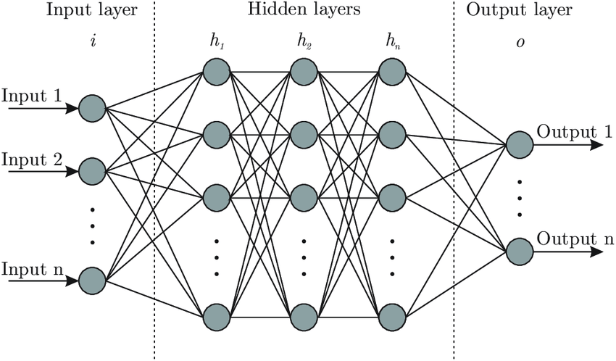
Input Units: activity of the input units represents the raw information that is fed into the network

Hidden units : the activity on these units is determined by the activies of the input units and the weights on the connection between the input and hidden units.

Output units:- The behaviour of the output units depends on the activity of the hidden units and the weights between the hidden and output units.

Going more specifically into each unit of a network:
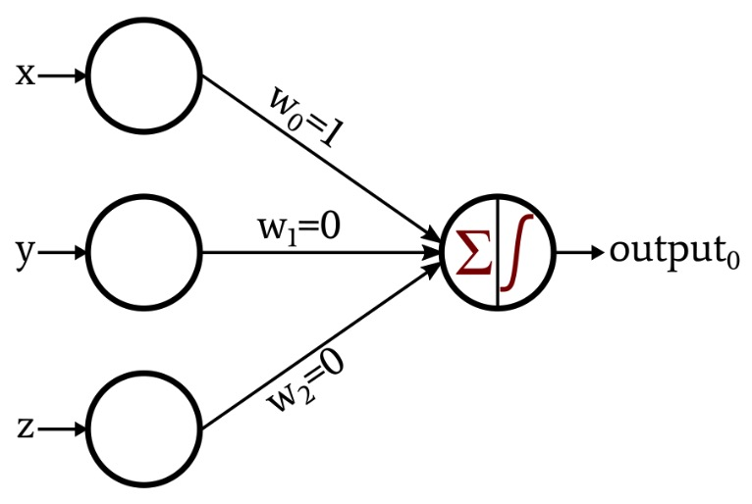

this is the basic unit for building neural networks, x y z are the inputs parameters each one fed to a neuron and combined as a weighted sum, the output is computed by using an activation function ( will talk more about this later) can be sigmoid or smthn like that. Not to forget there is usually another input which is the bias term with a weight b normally

For activaction functions there are some as follows:

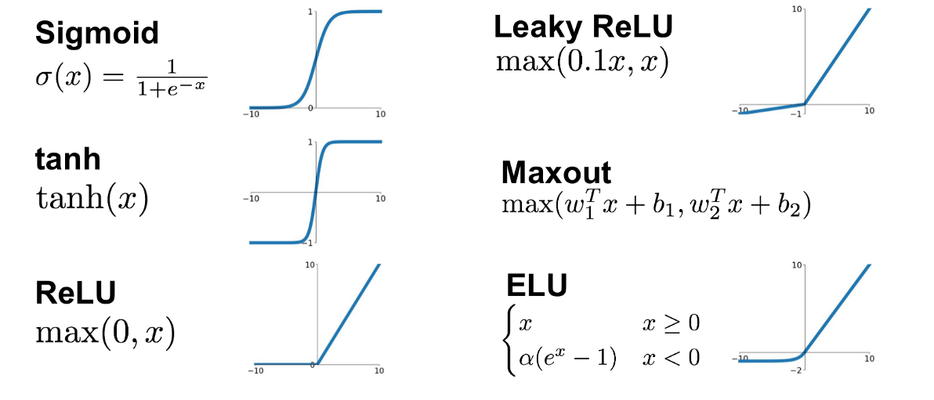
Identity function can also be used for the output neuron, af(x) = id(x) = x

The function f is non-linear and is called the Activation Function. The purpose of the activation function is to introduce non-linearity into the output of a neuron. This is important because most real world data is non linear and we want neurons to learn these non linear representations.
Every activation function (or non-linearity) takes a single number and performs a certain fixed mathematical operation on it. Let’s talk a bit more in depth of sigmoid: it takes a real-valued input and squashes it to range between 0-1
the softmax function , ensures that the outputs are probabilities and they add up to 1. Takes a vector of arbitrary real values scored and squashes it to a vector of values between zero and one that sum to one,
the tanh takes a real valued input and squashes it to the range between -1 and 1
ReLU: ReLU stands for Rectified Linear Unit. It takes a real-valued input and thresholds it at zero (replaces negative values with zero)

Importance of Bias: The main function of Bias is to provide every node with a trainable constant value (in addition to the normal inputs that the node receives). Bias is just like an intercept added in a linear equation. It is an additional parameter in the Neural Network which is used to adjust the output along with the weighted sum of the inputs to the neuron. Moreover, bias value allows you to shift the activation function to either right or left.A simpler way to understand bias is through a constant c of a linear function
y =mx + c
It allows you to move the line down and up fitting the prediction with the data better. If the constant c is absent then the line will pass through the origin (0, 0) and you will get a poorer fit.

Neural Networks have 3 main parts, on the calculation

Forward Propagation, Gradient Descent and Backwards Propagation

Ok so the first step on computing our output is forward propagation when given the

iTaking into account the input values and its weights , the values are calculated into an activation function. But if we only take this values into consideration, the calculation errors will be high and soo sthere must be a way to minimize this loss. So firstly we need to train the network. The task of learning as it is represent in the slides goes like this:
Given:
-The structure and activation functions of the neural network
- the training examples ( input and output)
- loss function measuring the error between the target values t and the output values o
loss(t,o)
our goal is:
find the weights w that minimize the loss over the training examples:

This can be calculated with squred error, log loss or cross entropy.

The general function for the loss is

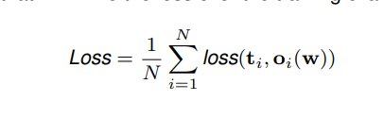

“loss” parameter can be each any of those functions above.
For the log-loss this is the maths formula behind it, where y is a binary classifcator saying if the label is correct or not and p the models predicted probability that observation o is of that class or not.

For the cross entropy the maths formula is the following:

and well, for the squared is just the square of the difference between the target and the output.

So after we understand why we need a loss function we need to apply it on a function, for this we use gradient descent:

w0 = w − η∇wLoss(w)

its like in maths where u calculated the global minimum. In here u pick a random starting point ( a weight) and calculate the gradient ( loss) u move in the opposite direction of the gradient until convergence ( depending on the learning rate η )

For the Back Propagation :

Recall chain rule :

∂f(g(x)) / ∂x = ∂f(g(x)) ∂g(x) ∂g(x)/ ∂x

note:(check internet for sigmoid function derivative & relu etc)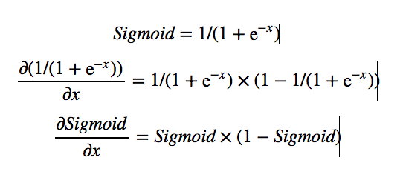

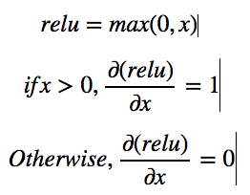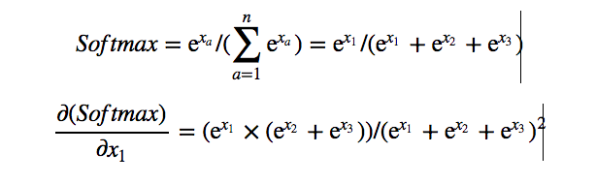

above are the derivatives for the loss functions

soo in this step, basically we backtract through all the previous steps by making use of the chain rule. Its hard to explain this by words soo here is an example. But basically back propagation is used to recalculate the new weights taking into account the loss function.
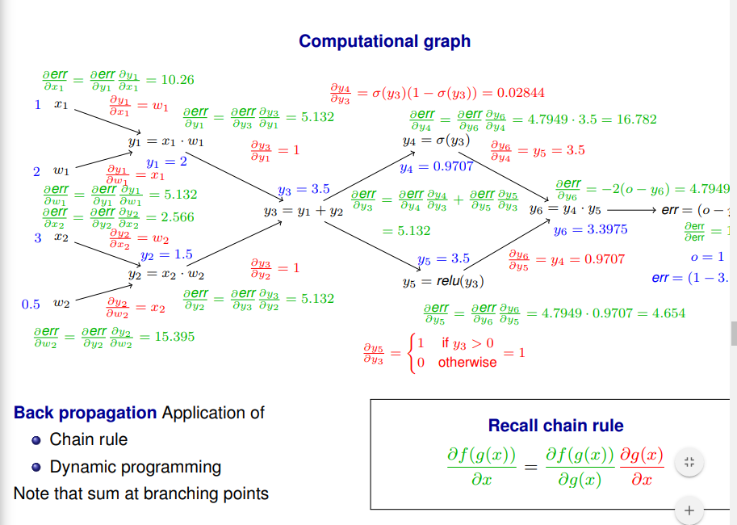
This are the basic steps behind a neural network.

Lets just talk of a few more detailed parts, we can use momentum on gradient descent . What is momentum? Descent with Momentum considers the past gradients to smooth out the update. It computes an exponentially weighted average of your gradients, and then use that gradient to update your weights instead. It works faster than the standard gradient descent algorithm.

Large variations in the second-order derivatives can be problematic for gradient descent.

First-order methods (like standard gradient descent) only rely on the gradient when optimizing the parameters.

Stochastic gradient descent

Idea :Approximate the expectation using a small batch of samples x (1) , . . . , x (B) with B held fixed as sample size grows. This is done because it gets an estimation , very close one without needing the computational power of running it in an entire network.

For a batch size of 1 the above approach is referred to as stochastic gradient descents. Otherwise, we have mini-batches and the method is referred to as mini-batch gradient descent

Getting an unbiased estimate :The mini-batches must be selected randomly and should be independent of each other

setting the learning rate: Because the stochastic gradient is noisy, the learning rate η should decrease over time to ensure convergence.

Regularization - In order to improve upon generalization (avoid overfitting), one can employ regularization during training (possible at the expense of increasing training error). Parameter norm penalties L˜(w) = L(w) + αΩ(w), where α balances the loss L and the norm penalty term Ω

Penalizes solutions with extreme values
Tend to produce “smoother” functions

Dropout provides an inexpensive way of handling an ensemble of neural networks formed by removing non-output units: Units can be “removed” by multiplying weights with 0.

L2 regularization uses Ω(w) = 1 2 kwk 2 2 to drive the weights towards the origin:
Alternatively: L1 regularization drives the weights towards zero more sparsely connected network structures.

