Selfstudynotes

decision region: a specific region within the input space which corresponds to a unique output class. All points within this region contain one and only one output class. Note that the input space can have multiple decision regions corresponding to multiple output classes.

Iris dataset

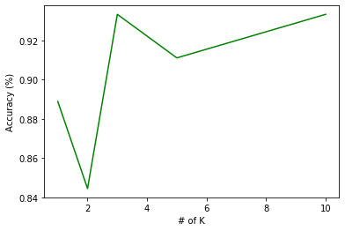

featuire 1 and 2 are not linearly separable, feature 2 and 3 you can manage to get accuracy results up to 93

class:
- Iris-Setosa
- Iris-Versicolour
- Iris-Virginica

the 3 classes

with 10 neighbours and 4 features

(105, 4) (105,)
(45, 4) (45,)
[[13 0 0]
[ 0 18 0]
[ 0 1 13]]
Score: 0.9777777777777777

(45, 4) (45,)
[[13 0 0]
[ 0 17 1]
[ 0 3 11]]
The 1st one is the easiest , always right!

