Classification
All instances (data points) have:
known values for a set of features (a.k.a. predictors, attributes, . .
a known or unknown class label

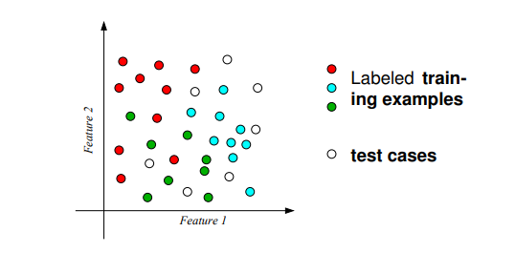

Regression:
Learning to predict (continuous target):
◮ Based on demographic data, previous click patterns and searches; what is the CTR (click-through rate) for an online ad?
◮ Based on stock prices in the past; what will the price be tomorrow?
◮ Based on observed symptoms; how many years will a patient survive?

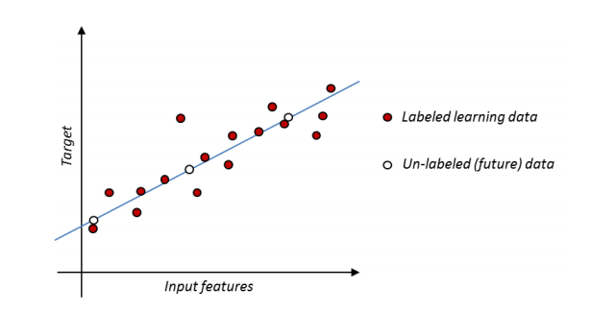
KNN - Principle: near neighbors tend to have the same label

Data - Set of labeled training instances (x1, y1), . . . , (xN , yN ) consisting of D-dimensional feature (attribute) vectors xi = (xi,1, . . . , xi,D), and a class label yi

Required: distance function d(x, x ′ ) to measure distances between attribute vectors (e.g. Euclidean distance if all attributes are real numbers, so that x ∈ RD).

With the above mentioned you can classify the new instance:
Let (xj1 , yj1 ), . . . , (xjK , yjK ) be the K training instances whose attribute vectors are closest to x. - Predict for (x, ?) the class label that occurs most frequently among yj1 , . . . , yjK .

Decision Regions:

Instance space(input space) : space of all possible values for the input features X.

A few thoughts on picking a vlue for K:

Best way of knowing this value is to try them out a lot.

Low values for K can be noisy and subject to the effect of outliers.

Large values of K smooth over things, but you dont want k to be soo large that a category with only a few sample in it will always be out voted by other categories.

Perceptro and naive bayes

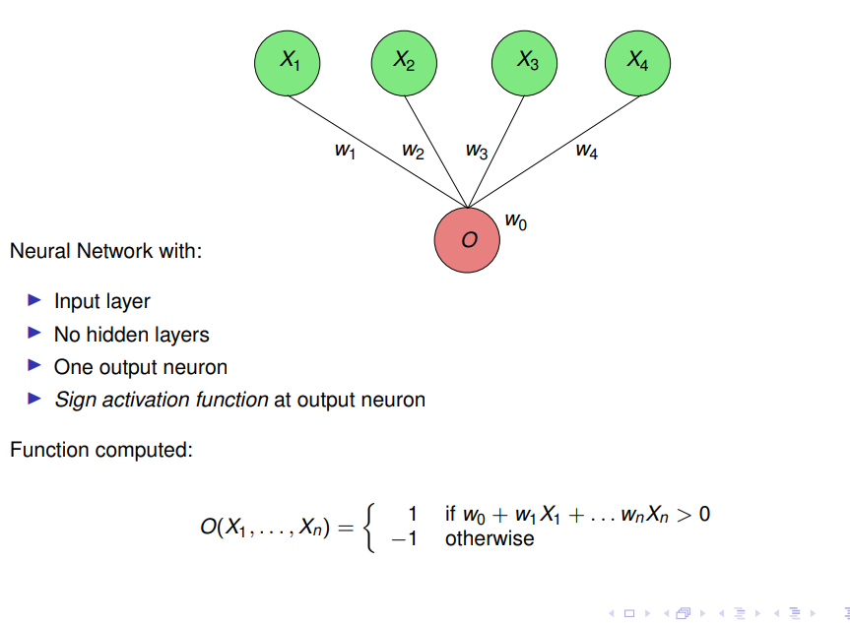
The perceptron can be used to classify binary classes variables based on numeric predictor attributed x1,xn .

The decision regions defined by a perceptron are always separated by a linear hyperplane:

Naive Bayes Model: attributes are independent, given the class label:

Prediction: Binary Class/Atrributes:

If Y and all Xi are binary: classify instance as ⊕ if P(⊕ | X1, . . . , Xn) ≥ P(⊖ | X1, . . . , Xn)

Overfitting

When the models tries to learn every feature of the training data and ends up not generalizing. When it is tested with unseen data it behaves poorly. Thats the basic concept I would say.

‘official” definition:

Given a hypothesis space H, a hypothesis h ∈ H is said to overfit the training data if there exists some alternative hypothesis h ′ ∈ H, such that h has smaller error than h ′ over the training examples, but h ′ has a smaller error than h over the entire distribution of instances

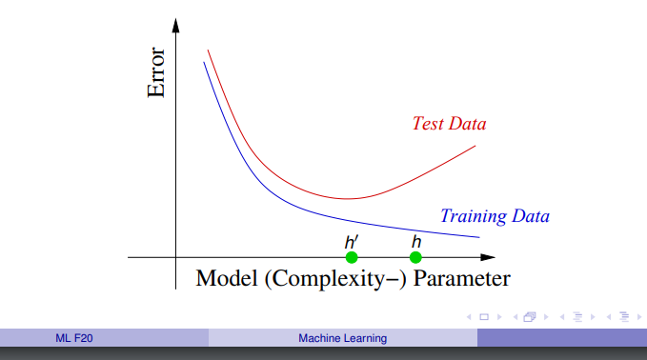
for example a lot of layers can lead to overfit on NN, small number of K on KNN and on naive bayes, well its more complex but it can overfit aswell

regarding naive bayes models : “So the answer is "yes" you can overfit a sample using a Bayesian method, particularly if you have a small sample size and improper priors. The second answer is "no" Bayes theorem never forgets the impact of prior data, though the effect could be so small you miss it computationally.”

Soo why linear models?
Unlikely to overfit
Easy to learn from data
Well understood
Are a central building block also for more complex non-linear models

Diversity

are based on different objective functions that are optimized in learning
◮ Perceptron: minimize an error function
◮ Naive Bayes: maximize likelihood function

choosing the class with the highest posterior probability

Linear Functions

Vector Notation y(x1, . . . , xD) = w0 + w1x1 + . . . + wDxD = w0 + w · x
where w = (w1, . . . , wD), x = (x1, . . . , xD), and w · x is the inner product (or dot product) of vectors in R D.

Decision Regions

A linear function partitions the input space into this decision regions:

R1 = {x | y(x) ≥ 0}
R2 = {x | y(x) < 0}

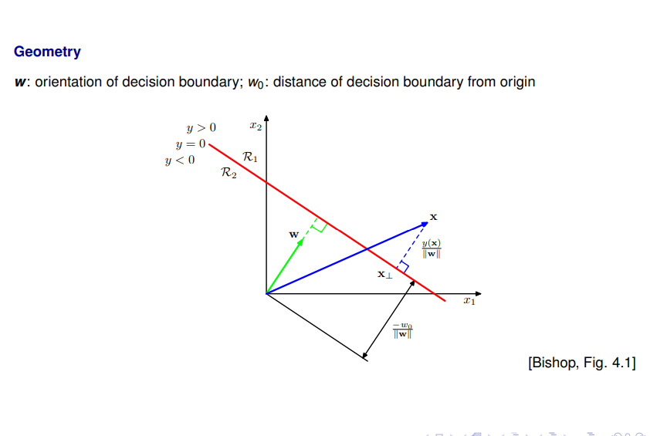

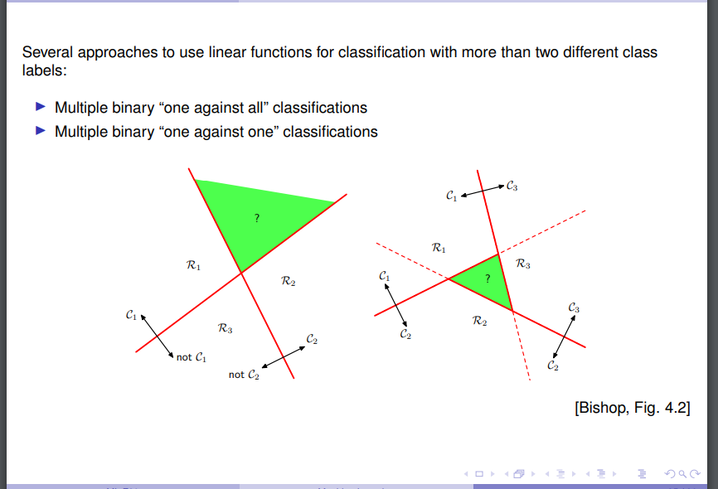

construct one linear Discriminant Function yk for each class label k

classify x to belong to class k for which yk (x) is maximal

y1(x) = w1,0 + w1,1x1+ . . . +w1,DxD = w1,0 + w1 · x ( for example)

In vector matrix notation: y(x) = w0 + WT x

(these are matrixes)

Sum-of-squares error (minimization)

Still has problems like outliers:

