Selfstudy2 notes

Images taken are in the folder.

Firstly ran all the models and took the results.

logistic regression moves with non-linear function hence can work with linearly and non-linearly separable problems. It can be used for predicting the probability of an event. But using l1 regularization it manages to separate the data good enough.

For gaussian mixture data:

firstly gaussian mixture models explained , tweaked the weights to make the points more sparse, used only 2 components and had to adjust the mean to make it linearly separable.

Results:

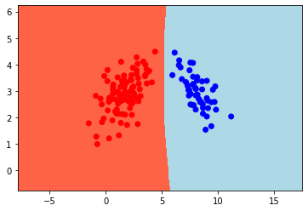

GaussianNB

LDA

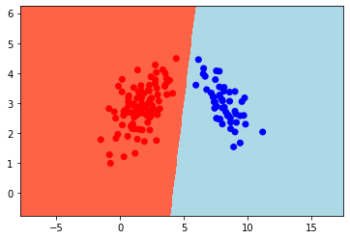

SVC

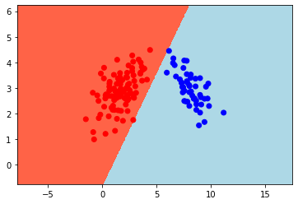

Why is this not such an easy task for the datasets and classifiers we consider her? Not a lot of training data soo it cant generalize that much and it ends up learning all the features of the training making it harder to get a better result on the test data

when increasing the weights for example the data remains linearly separable

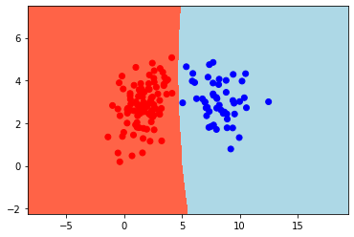

gaussian can do it with no problems , but for example if u do LDA in here

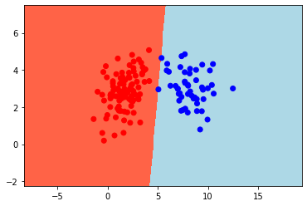

it misclassifies 2 of the points because as the dat is more sparse the mean is aswell.
Increasing the data:

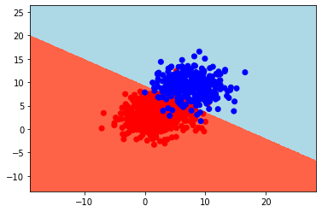

we dont get linearly separable anymore

MI DATA:

images on the folder

Exercise 2

Boston dataset

Logistic regression: Accuracy train: 0.8733509234828496
Accuracy test: 0.9133858267716536

SVC : Accuracy train: 0.8680738786279684
Accuracy test: 0.8976377952755905

LDA: Accuracy train: 0.8575197889182058
Accuracy test: 0.8582677165354331

Gaussian; Accuracy train: 0.7651715039577837
Accuracy test: 0.7874015748031497

Regarding the parameters:

GaussianNB: theta_, sigma_
LDA: means_
Logistic regression: coef_
SVC: coef_

(priors=(0.9,0.1)) adding priors increases the accuracy meaning that some classes meaning the classes are unbalanced.

### -- LDA
#coef - coef_array, shape (n_features,) or (n_classes, n_features) Weight vector(s).
#means- means_array-like, shape (n_classes, n_features) Class means.

Normalization by transforming the range of each input to [0,1] equally weights all inputs. If inputs have vastly different scales then the larger inputs dominate smaller ones. The classic example is evaluating credit risk using age in years [18,120] and income in dollars [$0,$10,000,000]. Absent normalization, income would swamp age during training. Some inputs are way more important than other ones

Choosing the most important features and then assigning weights accordingly should increase the accuracy

from the scores we see the best attributes are 9 (- - PTRATIO pupil-teacher ratio by town) / ZN proportion of residential land zoned for lots over 25,000 sq.ft.

0
0 1019.305413
1 2640.411736
2 474.729689
3 8.666445
4 2.475553
5 10.302295
6 1316.167368
7 53.761071
8 517.172000
9 7146.288995
10 27.158021
11 1082.991588
12 895.521918
scores

