Linear models for classification II

Least Squares regression

Linear Discriminant Analysis

Logistic Regression

U have 2 approaches to learn how to classify a data instance x , if it belongs to a class K or not.

Generative Approach

- Define a joint distribution for the attributes X = x1,…,Xd and a class variable Y with values 1,…,K. Usually factored as P(Y,X)=P(Y) P(X|Y)


-Compute

E.g Naive Bayes, LDA

Discriminative Approach

Directly learn the conditional distribution

P(Y|X)

Example: Logistic Regression, Neural Networks

The main criterion for learning probabilistic models is maximizing the likelihood.

Main differences between the 2 models: Generative model is based on the joint probability, p( x, y), of the inputs x and the label y, and make their predictions by using Bayes rules to calculate p(y | x), and then picking the most likely label y. Discriminative classifiers model the posterior p(y | x) directly, or learn a direct map from inputs x to the class labels . A Generative model assumes that all the features are conditionally independent , while discriminative model does not assume anything related to the independence of features.

Always required: a parametric model for the (conditional) distributions, i.e. specific functional forms. The normal distribution is a simple example of a parametric model. ... Other distributions that can be used for parametric modeling include: The Weibull distribution, which has the parameters λ, α and μ

Gaussian Mixtures

Gaussian Attributes

Assume

P(y) multinomial
P(x|y) Gaussian for all k =1 ,…, K.( super fked up formula)

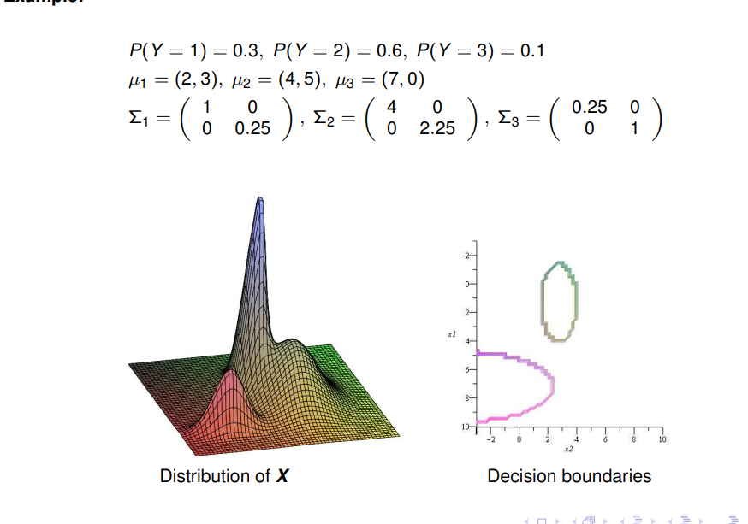
There is also more examples on the slides ( need to see vídeos of this shit, insane maths)

Logistic Regression

P(Y = 1 | X = x, w) / P(Y = 0 | X = x, w) = e^w·x

log(P(Y = 1 | X = x, w) / P(Y = 0 | X = x, w) ) = w · x

The linear function w · x defines the log-odds of class 1 against class 0.

How do u learn the logistic regression model?

- Maximize the likelihood

-Take the log: maximize
- Set derivative to zero ; find root to derivative using numerical methods, often Netwon-Rhapson

isto e tipo calculo secundario e o crl

IMPORTANT table

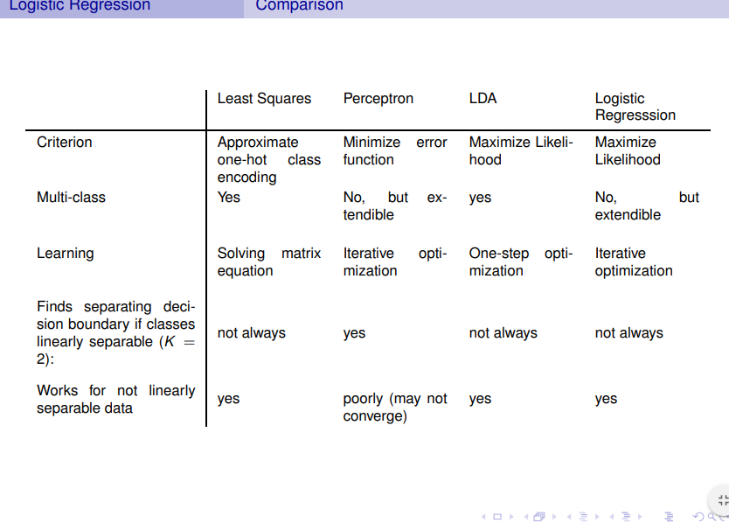
Reviewing

Least Squares Regression aka Linear Regression:
Important concept – we want to minimize the square of the distance between the bserved values and the line
We do this by taking the derivative and finding where it is equal to 0
The final line minimizes the sums of squares( it gives the least squares) between it and the real data.

Linear Discriminant Analysis:
Technique to reduce dimensionality follows the assumption of PCA

https://machinelearningmastery.com/linear-discriminant-analysis-for-machine-learning/

Logistic Regression:
Logistic regression is a classification algorithm traditionally limited to only two-class classification problems. Predicts if something is true or not instead of predicting something continuos and instead of using a line to fit the data it uses a logistic function. Sigmoid it uses maximum likelihood to measure how well it fits the data. Basically pick a probability scaled by weight of seen that observation and u use that to calculate the likelihood of each observation and multiply them all together. So the maximum likelihood is the value that has the highest probability
of observing the data we observed

