Markov Networks

Markov Networks Basics

Directed models (Bayesian Networks): good for causal dependencies
Undirected models (Markov Networks): good for mutual, non-causal dependencies

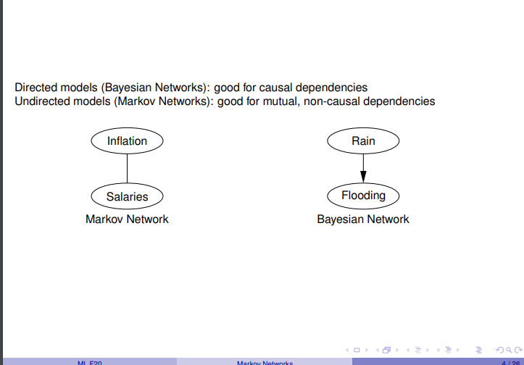

Potential Functions
Edges between the variables(nodes) on a graph

Core definitions
Notation For a (random) variable X: Val(X) is the set of possible values for X.
E.g.: ◮ Val(X) = R (numeric variable)
◮ Val(X) = {true, false} (Boolean)
◮ Val(X) = {red, blue, green} (categorical)

For a tuple of variables X = (X1, . . . , Xl ): Val(X) = Val(X1) × · · · × Val(Xl )

Markov Network

Let X1, . . . , Xn be random variables.
A Markov network for X1, . . . , Xn consists of
◮ an undirected graph G whose nodes are the variables X1, . . . , Xn,
◮ a set of clique potentials φi : Val(Yi ) → R + (i = 1, . . . , k) where the variables Yi ⊆ X form a fully connected subgraph (clique) in G

Inference
If (G, (φi (Zi ))) is a MN defining PN , then PN (X | Y = y) is represented by the MN (G ↾ X \ Y, (φi ↾ Y = y)), where
◮ G ↾ X \ Y is the subgraph of G induced by the nodes X \ Y
◮ φi ↾ Y = y is the potential on Zi \ Y obtained by restricting φi to the cases with Y = y

Gibbs Sampling

Video https://www.youtube.com/watch?v=ER3DDBFzH2g&t=6s

Slide notes

MCMC methods
◮ . . . all estimate a probability P(Z = z) from a sequence of samples X 1 , X 2 , . . .
◮ . . . differ with regard to how X t+1 is drawn given the previous sample X
Gibbs sampling pseudo code:
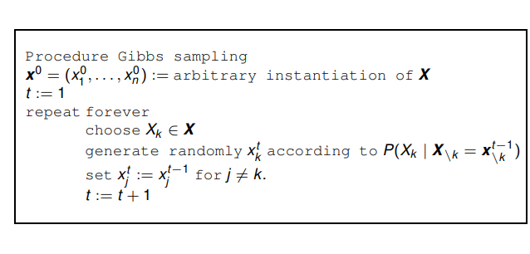

Gibbs sampling for network prediction

Random Variables
◮ for each pair of nodes i, j: a binary random variable Ei,j representing the existence of an edge i → j.
◮ for each node i, and each node attribute A, a random variable Ai representing the value of A for node i.

Clique Potentials

Potential functions can model typical properties of the type of networks under consideration.

Fully observed: Nodes and their connections
Partially observed: Node attribute A with values blue,green
Task: predict unobserved node attributes. Collective classification: what is predicted for one node influences prediction for other nodes.

Model:

