ML Session 6

- images are numbers composed by pixels, basically what the computer sees is a matrix with numbers.
Regression - output variable takes continuous value
Classification- output variable takes class label. Produce probabily of beloging to a particular class

The first approach with neural networks to classify an image would be with a fully connected neural network, having a 2D image as input, it would transform it into a vector of pixels. This becomes infeasiable in practice because when u squash the matrix into a 1d vector the spatial information is lost and u need to define a lot of parameters, each neuron needs a weight.

So how to use the spatial structure and inform the architecture of the NN of its existence?
CNNS
apply a set of weights - a filter - to extract local features
Use multiple filters to extract different features
Spatially share parameters of each filter

But what is a convolution? Convolution is basically the operation of applying a filter to a patch lets say a 4x4 size on the input matrix and by shifting it by a certain width, multiplying each element of the patch with the filter matrix (kernel) . But the most important part is that it learns the features of a certain image. Lets say a dog image isnt always the same, so it cant just memorize a matrix, it needs to learn the features of a dog image, like the eyes/nose/etc.

Different feature weights can be used to produce new feature maps.

How can we use this, to build a neural network for image processing? Computer Vision?

3 most important operations on a CNN are:

Convolution - apply the filters with learned weights to generate feature maps
Non Linearity - ReLU to learn complex features
Pooling - Downsampling operation on each feature map ( reduce the size )\
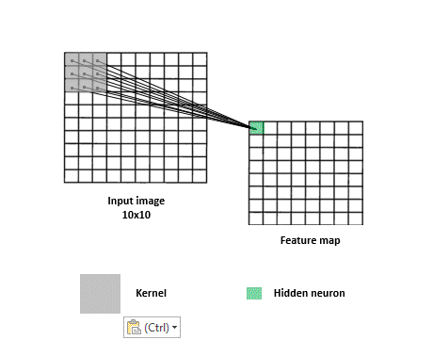 Convolution Operation

For each of the neurons in the hidden layer, take the input from the patch, compute the weighted sum and apply the bias.

Non-linearity is necessary because images are very complex types of data. You can think of it sort as a treshholding, for example reLu replaces all negative values by zero, this is important because this kind of values are bad for the feature detection.

When it comes to pooling basically its reducing the size of the input matrix,.

Considering now a more practical example, a CNN for image classification can be broken down in 2 major parts, feature learning and classification.

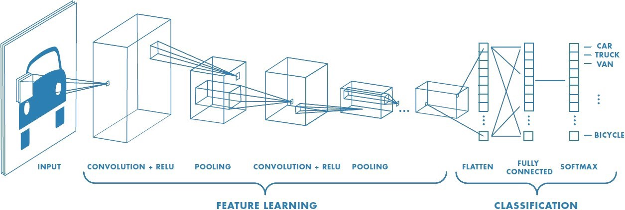
Feature learning is already what we talked about, when it comes to classification it takes the features ( high level ) from the 1st part and then uses them on fully connected layers to actually classify them, they output a probability distribution, in layman terms, how likely it is that this image is abraham lincoln? A common way is using a softmax function.

How to train? Backpropagation.

Learn weights for convolutional filters and fully connect layers

Beyond classification there are 3 main tasks one can overtake whilst using CNNs

Segmentation:

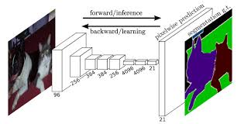

in here it uses FCN – Fully Convolutional Network, it is used on autonomous driving for example.

Object Detection:

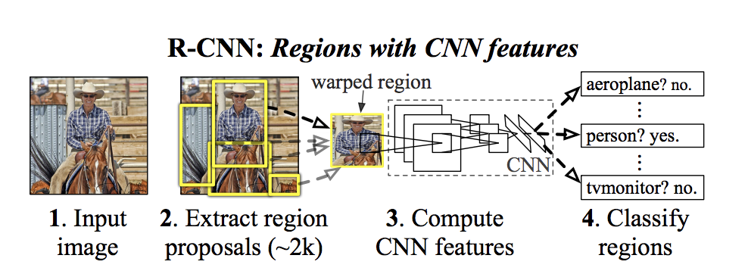

Image Captioning:

Uses RNNs

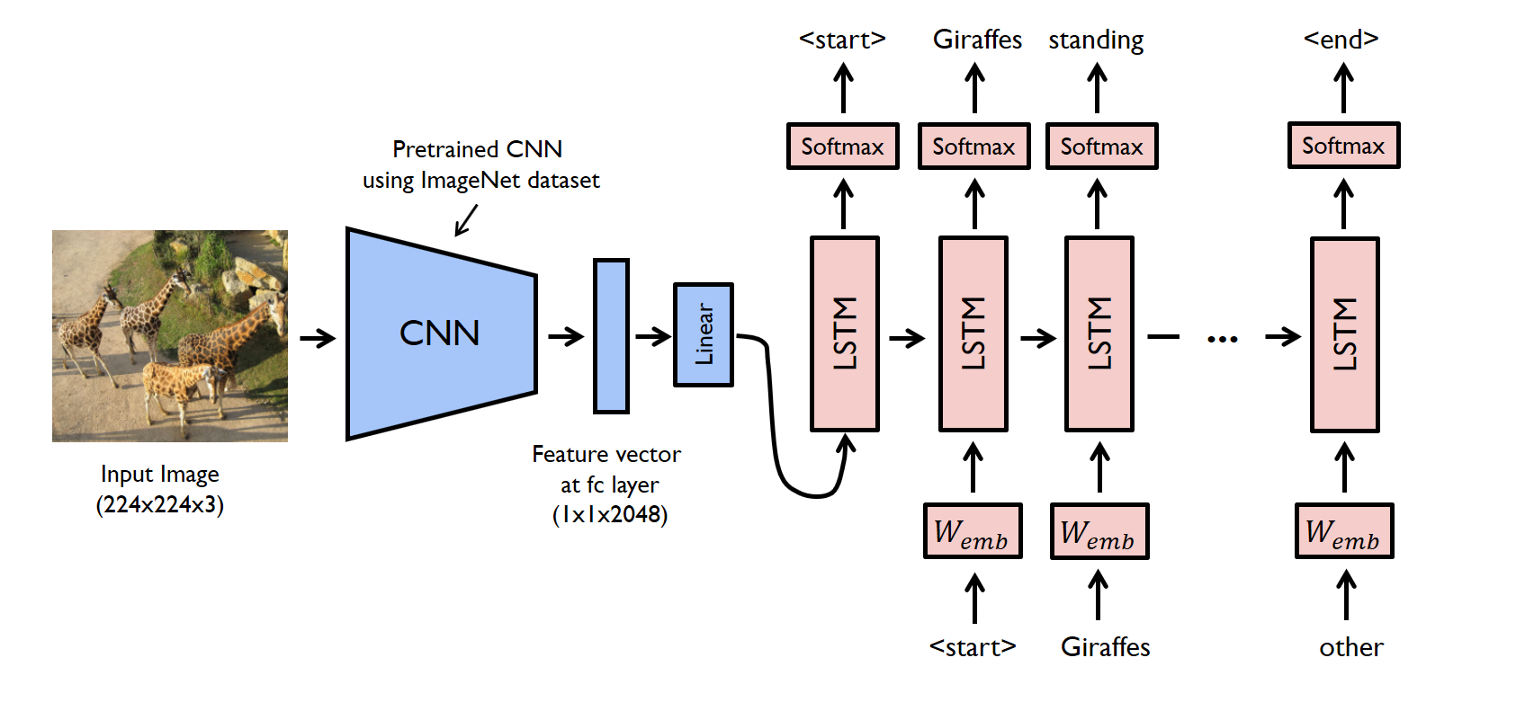

This one is way harder, needs some work to understand

Now after this general picture lets look at the slides,

Talking about stuff that is more practice related like the regularization parameters, momentum alreadfy mentioned in last session. Also mentioning the structures and when to use each output units

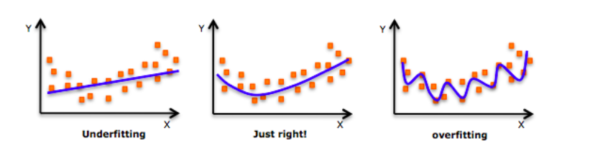
As we move towards the right in this image, our model tries to learn too well the details and the noise from the training data, which ultimately results in poor performance on the unseen data. So the complexity of the model increasing means that our model tries to model every single complex feature and the training set error decreases but it fails to generalize and soo the test error will increase.

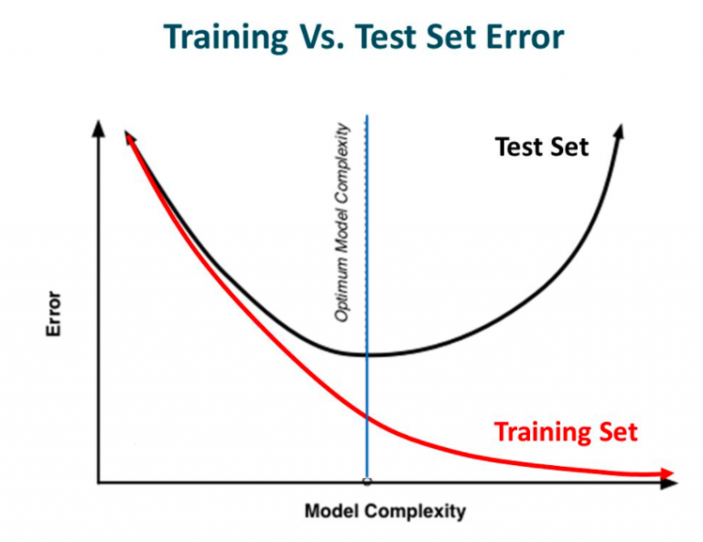
Soo this is where NN’s come in, being such complex models they are prone to overfitting. Regularization comes in to save the day by making slight modifications to the learning algorithm such as the model generalizes better. Thus, improving the performace of the model on unseen data.

Regularization penalizes the coefficients in machine learning, when it comes specifically to deep learning it penalizes the weights of the network. But for example if we have a very high regularization, the weights will go down to a nr close to zero and this will not help our model aswell.

There are 2 types of regularization L1 & L2:

These update the general cost function by adding another term known as regularization term:
Cost function = Loss (say, binary cross entropy) + Regularization term
By adding this term the values of the weights in a matrice decrease because it assumes that the neural network with smaller weights matrices leads to simpler models. And soo, it will also reduce overfitting to quite an extent.

But there are differences in the terms between L1 and L2:
in L2 we have:
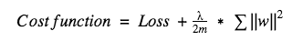

here lambda is the regularization parameter. It is the hyperparameter whose value is optimized for better results. Also known as weight decay as it forces the weights to decay towards zero.

In L1 we have that:

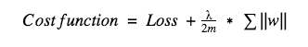

Unlike L2, the weights may be reduced to zero here. Hence, it is very useful when we are trying to compress our model. Otherwise, we usually prefer L2 over it.

Dropout
So what does dropout do? At every iteration, it randomly selects some nodes and removes them along with all of their incoming and outgoing connections as shown below. It can also be thought of as an ensemble technique in machine learning.
Ensemble models usually perform better than a single model as they capture more randomness. Similarly, dropout also performs better than a normal neural network model. But what exactly is an ensemble in machine learning?
Ensemble methods is a machine learning technique that combines several base models in order to produce one optimal predictive model ( taken from medium >P)
Interpreting the hidden layers in a deep classification model:
The output computes a linear classification model as a function of the feature vector defined by the last hidden layer
The hidden layers can be understood as an incremental/hierarchical feature construction

when to use the different output units? As it is stated on the slides :

Linear Units
With features h, a linear output produces yˆ = WTh + b.\
Often used to produce mean of Gaussian Distribution
Does not saturate (In the neural network context, the phenomenon of saturation refers to the state in which a neuron predominantly outputs values close to the asymptotic ends of the bounded activation function.Saturation damages both the information capacity and the learning ability of a neural network.)
Sigmoid
- Predicts the value of a binary/discrete variable
- z = Wt h + b
softmax(z)i = exp(zi) /
P i exp(zi)

Maximum likelihood learning mitigates the saturation effect of the sigmoid/exponential function.
Rectified Linear Units
- Typically combined with an affine transformation:
h = max(0,WTx + b)
- Initialized with elements of b being small and positive
- Non differentiable at 0 but usually not a problem
- Doesnt Saturate ( if u use LeakyRelu i think)
Sigmoid and hyperbolic tangent:
Closely related: tanh(z) = 2 · σ(2 · z) − 1:
-Saturates, careful when using as hidden unit
-Used in more elaborate models (than the feedforward network)

Going back to CNNs :
Convolutional networks are basically just NN that uses convolution in place of general matrix multiplication in one of its layers. Scale up neural networks to process very large images / video sequences. Sparse connections Parameter sharing Automatically generalize across spatial translations of inputs Applicable to any input that is laid out on a grid (1-D, 2-D, 3-D, . . . ) Everything else stays the same, Maximum likelihood, Back-propagation etc.

Convolution networks typically have sparse interactions between the layers (since the kernel is smaller than the input) Whilst the normal NN has more dense connections. This is the local connectivity idea, a neurons wont be connected to all the predecent inputs but only to the ones that represent a certain region in an image
The convolution kernel is used at every position of the input:
So, convolution shares the same parameters across all spatial locations.
Traditional matrix multiplication does not share any parameters
Talking more in depth of this subject , units organized in the same feature map share parameters, hidden units within a feature map cover different positions in the image. So the hidden units get segmented and use the same parameters ( filter) they got from its inputs to discover the features on the image. This allows for a reduced number of parameters.
Max Pooling,
Max pooling gives the maximum output within a local neighborhood.
Representation invariance to small translations
Pooling can learn transformation invariance
Supports down-sampling through strides
So in here this idea is by making pools soo to say in the features matrix u get the max from each of those pools and then down sample them into a smaller matrix. The image above should make it clearer

Zero-padding is used to control the size of the representation
No zero-padding : If input has width m and kernel has width k then the output has width m-k+1
-This limits the number of layers
With zero-padding:
- Different Strategies:
- Zero padding soo that the size of the input equals the size of the ouput
- zero pad also enables every pixel to be visited k times

See the vídeo on yt about padding, here we make sure we dont lose information when applying the filter during the convolution. By adding padding on the matrix input

Recurrent Networks
Based on slides this part:
Recurrent neural networks are designed for processing sequences of values x1, . . . , xτ : Can handle sequences of varying lengths Employs parameter sharing across ’time’
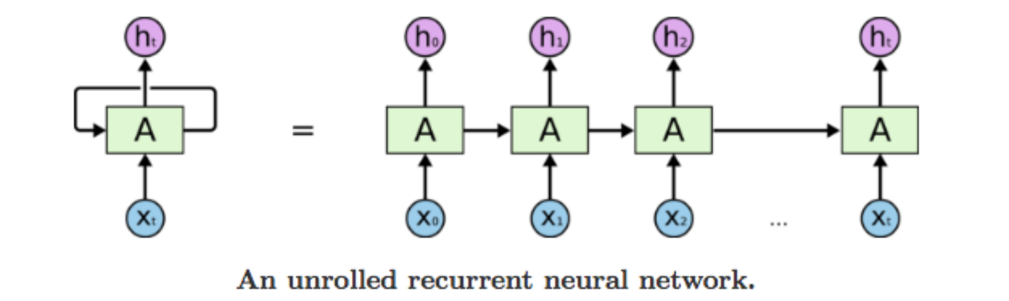
Example: A recurrent neural network with no output: input x is incorporated into the state h which is passed forward. h functions as a lossy summary of the past observations h can be used for making predictions.
There are different structures for this type of NN :
One to one: Vanilla (no recurrence)
One to many: Image captioning takes an image and outputs a sentence
Many to one: Sentiment analysis
Many to many: Machine translation
Many to many: Video classification
The peoblem with RNNs and long term dependencies is that gradients over many stages tend to either vanish or explode. Soo thats why there is Gated Recurrent Neural Networks, the idea is to create paths through time where the derivatives neither vanish nior explode called LSTM ( memory is stored in the cell state weights conditioned on context (input/hidden)

this is a problem that happen when doing the backwards pass if the largest singular value is bigger than one when u go through this pass the value will continue to increase and increase, affecting the learning in a negative way. The same occurs when u have a a singular value less than 1, thats called the vanishing gradient it happens but with the opposite effect
One of the nasty but used hacks is gradient clipping. Instead of doing this ªfixª by using a LSTM we kinda of rearrange this in a way that the gradients have better flow. The difference between the vanilla RNN and a LSTM is that instead of just saving the hidden state like in the normal type, it saves a variable we will denominate as ct which stands for cell state.
But how does this work? So with our lstm we are giving the input which is the hidden state. In the cell state we have information só we know what “gate” to take. This gates stand for IFOG , Input Gate, whetever to write to cell , Forget gate whetever to erase cell, Output gate how much to reveal cell, Gate gate, how much to write to cell. This was taken from a stanfordl lecture on RNNs

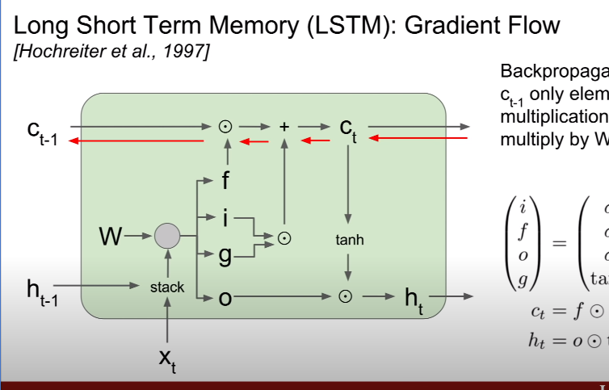
Soo the weight will be fed as input, our previous hidden state h1-1 stack them with our current input xt and multiply with the weight matrix to compute our 4 gattes figo, the F gate multiplies with the previous cell state, the I and G are mulplied and added with the precious operation between the F gate andthe cell state and that gives us the new cell state. This new cell state is squashed on a tanh activation function and then multiplied with the output gate to get the new hidden state

With the update rate, the error becomes additive instead of multiplicative, due to the u.a+(1−u).b formula. |x|*n is much easier to keep in reasonable range.
Intuive explanation.

