ML session 7

Probabilistic Graphical Models

( slides and internet based)

Statistical Semantics

Given a collection of texts:

Goal: automatically learn semantic descriptors for documents and words, that support document clustering, text understanding, information retrieval …

Statistical Machine Learning

Advantages of probabilistic/statistical methods:

-Principled quantification of prediction uncertainties
-Robust and principled techniques to deal with incomplete information, missing data
-Provides a general model of the domain that can in principle be used to answer any inference query
- Enables integration of domain knowledge
- Transparent and explainable

Need: probabilistic models that . . . can represent models for high-dimensional state spaces
and support efficient learning and inference techniques

Probabilistic Graphical Models . . .
support a structured specification of high-dimensional distributions in terms of low-dimensional factors
structured representation can be exploited for efficient learning and inference algorithms (sometimes ...)
graphical representation gives human-friendly design and description possibilities

Markov properties ⇔ Factorisation property.

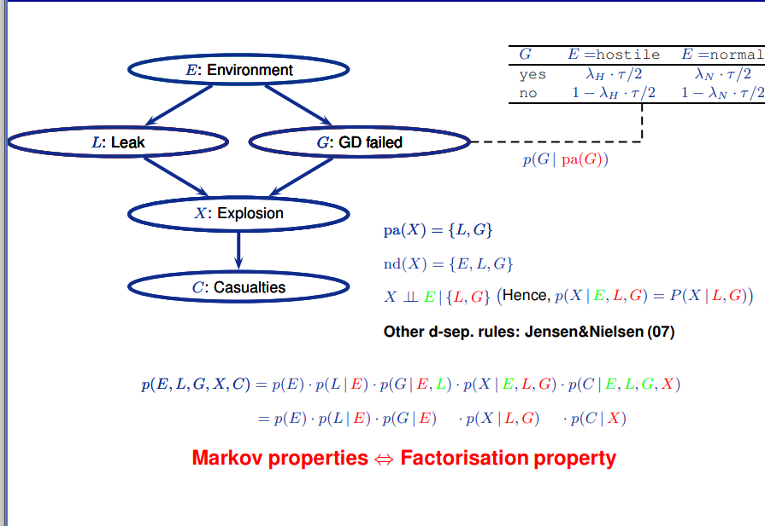

Nondescendant Criterion: Xi is independent of its non-descendants given its parents

Bayesian network syntax:

Let X1, . . . , Xn be a collection of random variables. A Bayesian network over X1, . . . , Xn ,consists of :
- a directed acyclic graph G = {V, E} whose nodes V are the variables X1, . . . , Xn
-a set of local conditional distributions, P = {p(Xi | pa(Xi)), Xi ∈ V}, where pa(Xi) are the parents of Xi in G as defined by the edges E

Bayesian network semantics
A Bayesian network N with nodes X1, . . . , Xn defines a joint distribution
pN (X1, . . . , Xn) = (produtorio)1 p(Xi | pa(Xi))

Conditional probability = P(A|B) = P(A ^ B)/P(B)

Probabilistic Inference :
Operations to calculate P(XQ | xe)
Restriction: Restrict domain of a potential (e.g., p(g|E) from p(G|E))
Combination: Multiplication of potentials (e.g., p(l | e) · p(X | l, g))
Marginalisation: Sum/integrate out a variable form a potential, e.g., the operation p(l | e) · p(x | l, g), which removes L from the potential over {L, X, E, G} and results in p(x | e, g) over {X, E, G}.

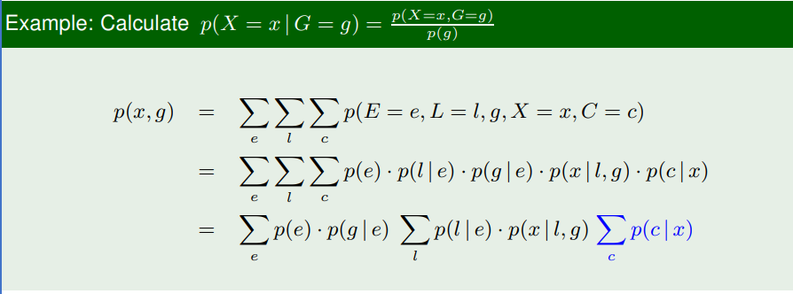

Worth mentioning the part in blue means its not relevant because it doesnt belong to the ancestors of our needed variables.

Parameter learning

Having as base the thumbtack example: We have tossed a thumb tack 100 times. It has landed pin up 80 times, and we now look for the probability θ of pin up ( model that best fits the observations/data):
We can measure how well a model fits the data using the likelihood: p(data|θ) = p(pin up, pin up, pin down, . . . , pin up|θ) = p(pin up|θ) · p(pin up|θ) · p(pin down|θ) · . . . · p(pin up|θ).

maximum likelihood is explained on the slides:

They first do it with the logarithm of the function. Verify when the derivative is equal to 0 and then that is the argmax we want. On the thumbtack example, but when looking at MLE in Bns:
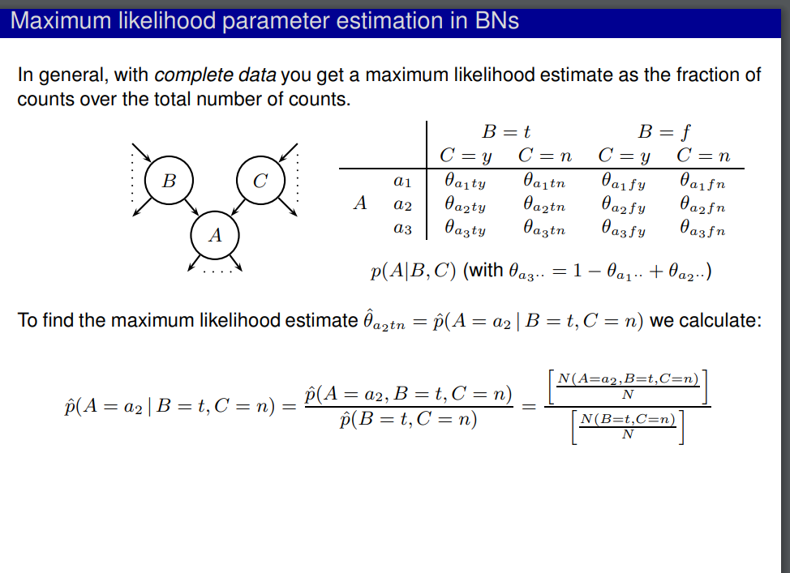
WITH complete data

this turn into a ‘simple” counting problem.

Baysesian parameter learning

Basis

Parameters are modeled as random variables and information about them can be included prior to observing data
By Bayes’ rule, the prior information is combined with the likelihood, yielding a posterior distribution that is used for making inferences about the parameter

More formally, Parameter learning amounts to calculating the posterior distribution over the parameters given the data D = (x1, . . . , xN )

Posterior predictive distribution
For making predictions about future cases we use
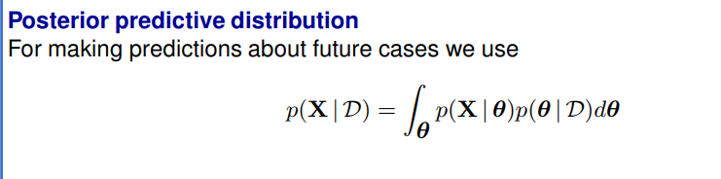

in regard to the bayesian estimation:

an example:
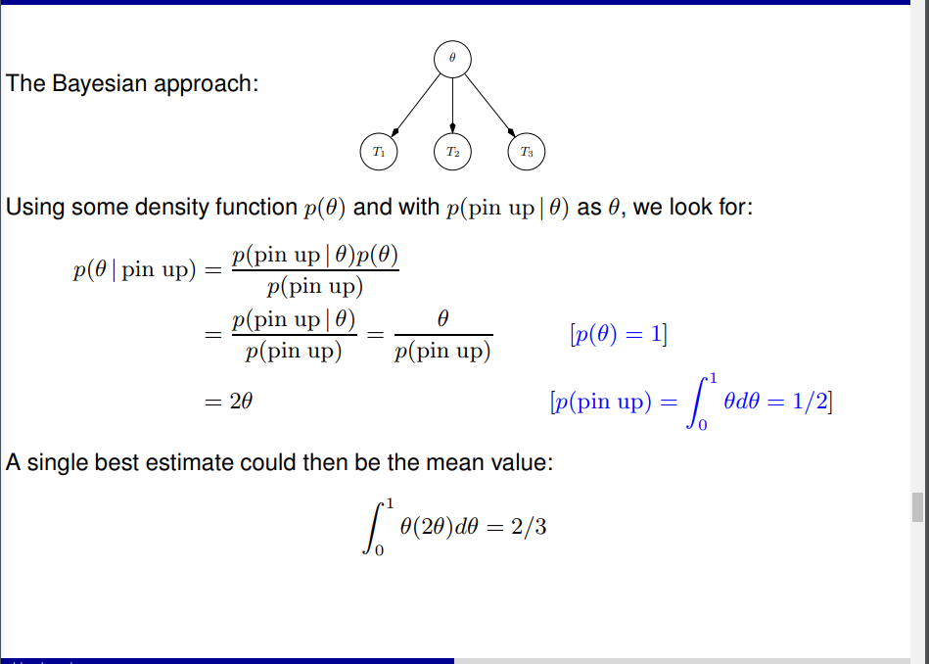

Instead of using priors , e.g p(teta) = 1, we can use beta priors like depicted in the slides. They follow beta distributions. You can calculate the posterior distributions by using the beta priors and predictive aswell by applying integral ( verify formulas on the slides).

The method above is also known as fully Bayesian approach
Parameters are treated as latent variables
Parameter learning reduces to inference in graphical models
Rather than computing the full posterior, we may settle for a point estimate such as
ˆθ = arg max θ log p(x1, . . . , xn|θ) + log p(θ)
known as the (maximum a posteriori) MAP estimator
Note that we could also choose
ˆθ = arg max θ log p(x1, . . . , xn|θ)
which is actually the maximum likelihood estimator

Plate Notation

The principal idea is to avoid repeated substructres. In has the same data that wants to be transmitted to the reader but in a more “concise” way

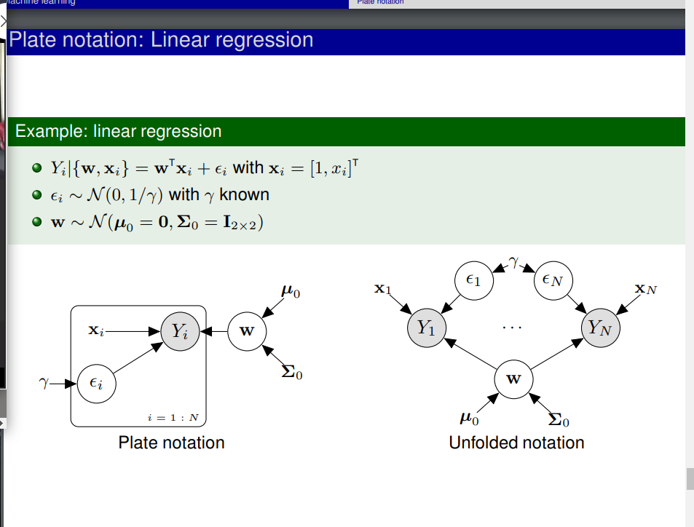
Factor analysis is a statistical model used to summarize a high-dimensional observation X of correlated variables by a smaller set Z of factors that a priori are assumed independent.

Example: X is a set of scores a subject gets from some intelligence-test, Z models different types of intelligence (e.g., sense of logics, verbal skills, . . . ).

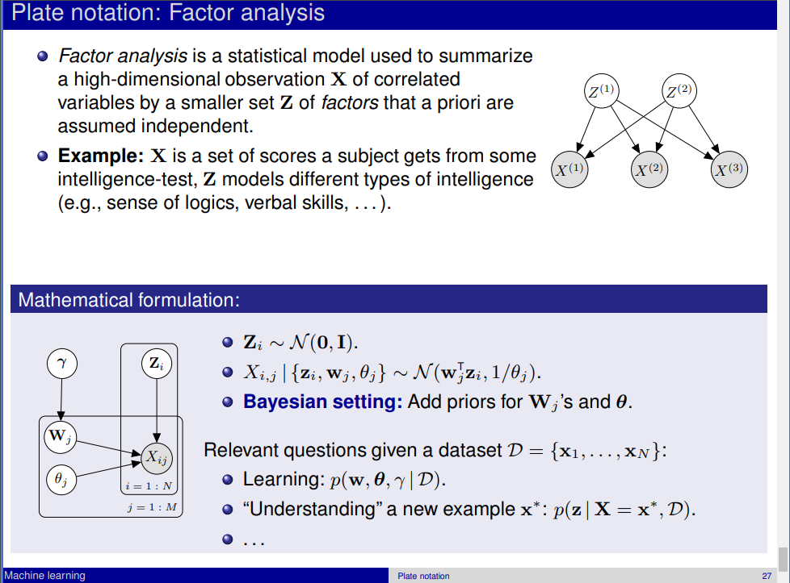

( there are more complex models like gaussian and shit)

Probabilistic Modeling and inference

-specify prior beliefs
- provide a probabilistic description/explanation of how the data is generated.

Approximate inference: Variational Inference

In variational inference , imagine we want to approximate a true posterior distribution p(z|x) with a variational distribuion beloging to a tractable family of distributions. So the task is to try and fit the variational parameters soo that the KL divergence(measure for the distance between distributions) is minimzed.
Actually used this in the project, KL divergence is not that good because is not symmetric. It usually understimates the variance in our probability distribution.

How can we manipulate KL divergence? ELBO evidence lower bound, its on the slides because elbo is way easier to manipulate compared to KL. Slide of ELBO, we wil have to maximize a function that depends on q only. Check the slide where the transformation occurs.

You can think of this as a regularization term in the neural networks.
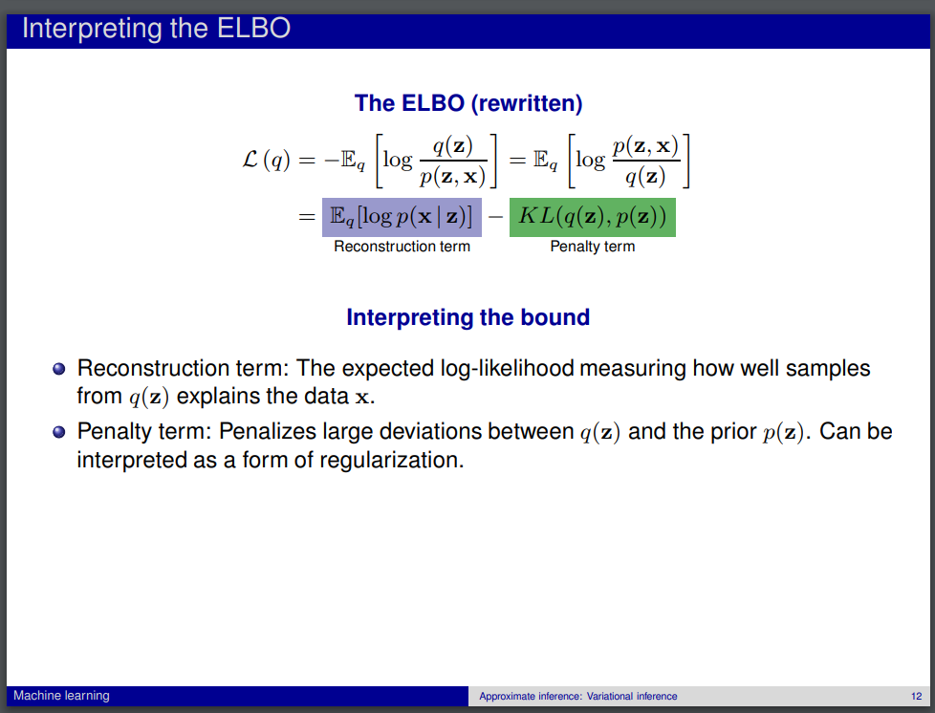
Mean field assumption is a constraint , factorizes very complex distribution.

Variational bayes inference for learning

we posit a model p(y|0) and want to learn 0 from a certain dataset D = {d1….,dn}.
We cast the problem in a bayesian setting by including a prior p(0)
We seek the posterior p(θ | D), which is approximated by
qˆ(θ) = arg min q∈Q KL (q(θ)||p(θ | D)).
This is identical to maximizing L (q) – a lower-bound of p(D)

Things to take notice of: When using variational Bayes to approximate p(θ | D), the resulting qˆ(θ) is chosen as the q ∈ Q that makes the data most probable. The ELBO objective is therefore reasonable in a learning-setting. The ELBO is a natural “quality score”, much like expected log likelihood is in an EM-setting. Because it works as a lower bound, and u trying to maximize your evidence lower bound on the model.

The sanity check, ( notebook) ran for 25 times. This coordinating updating rules can be handcrafted forr model that are relatively simple, for more complex model we cant do this. So thats why we need black box variational inference, where we do optimization of elbo without doing the tedious handcrafting of the optimization of the parameters
.
VI inference as optimization , minimize the KL divergence by maximizing the ELBO.

Vanilla black box variational inference is basically what we did with gradient descent , but the opposite instead of minimizing we are maximizing soo its gradient ascent , we will have a plus sign instead of a minus sign

BBVI – calculating the gradient (we dont have to do all the pencil pushing , maths manipulation).
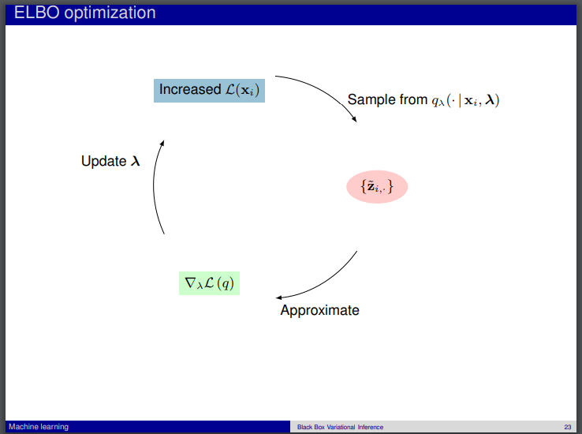
The most important part is that we want to manipulate the formula it order to be easier to calculate, to do that we do sampling of the expection ( check slides) This is all maths stuff basically.

This is the cycle of gradient ascent.

Probabilistic gradient descent

Pyro

