Rest API

# What is a rest API

A Rest API also known as a RESTful API is a type of API known for being contained to the style and architecture REST and interacting with RESTful web services. REST stands for Representational State Transfer.

# What is REST architecture?

# What is an API?

API stands for Application Programming Interface, which defines the rules or p you will go through in order to communicate with other software systems. It allows an application to communicate with another application without knowing how the application is implemented. This allows for development to be more efficient and less time-consuming. API in other words helps to simplify how developers integrate new applications.

# How do API’s work?

APIs are a simplified way of connecting to one's own infrastructure through cloud-native app development. They allow the company to share data with other external users and companies.

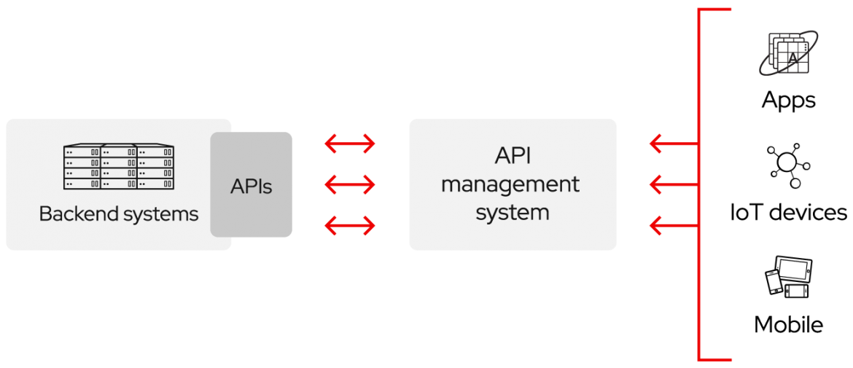

**What is cloud native app development?**

# 