NUTRITIONAL PROFILES OF BRANDED FOOD PRODUCTS
Beyond the Overview: Outlier Cleaning, Nutrient Density, Clustering, and Intra-Category Analysis
Jean Batista
Juniata College
DS 580
Dr. Jianyuan Ni
April 2026

Abstract
This paper does exploratory data analysis of 175,000 USDA branded food products. First, it applies explicit thresholds to flag and remove impossible nutrient values, then measures the effect on summary statistics. Second, it introduces a Nutrient Density Score to rank products and categories on a composite index rewarding protein and fiber while penalizing sodium, saturated fat, and sugar. Third, it applies k-means clustering to identify natural nutrient archetypes in the branded food supply. Fourth, it examines nutritional variation within three specific categories: cheese, snacks, and yogurt.

Introduction
Four analytical questions structure the work. The first is a data integrity question: after removing physically impossible values, what changes in the summary statistics? The second is a measurement question: if you represent nutritional quality as a single score, what does the distribution of that score reveal about the branded food supply? The third is a structural question: do products cluster into natural nutrient archetypes, and do those archetypes match the USDA category system? The fourth is a granularity question: how much nutritional variation exists within a single food category?

Before these questions are addressed, a fundamental data issue requires attention. The USDA database includes cooking ingredients alongside ready-to-eat foods. Salt, spices, vanilla extract, and cooking oils appear in the same dataset as pizza, almonds, and yogurt. These ingredients are not consumed independently. No person eats a serving of table salt or a tablespoon of vanilla extract as a meal. Their nutritional profiles are extreme in ways that reflect their function as cooking inputs, not their contribution to dietary intake. This paper filters those categories before any comparative analysis and explains that decision in full.

Data
The dataset is the same 175,000-product random sample used in Project 1. It contains 16 variables: three categorical identifiers, two serving size fields, and 11 per-serving nutrient values. The data assembly from four USDA source files is described in Project 1.

Ingredient Exclusions
Before comparative analysis. The eleven categories were excluded from the: Seasoning Mixes, Salts, Marinades and Tenderizers (3,283 products); Herbs and Spices (762); Herbs/Spices/Extracts (120); Baking Additives and Extracts (339); Vegetable and Cooking Oils (various); Cooking Oils and Fats; and related extract and seasoning subcategories. In total, 5,917 products were removed, leaving 169,083 products for analysis.

Methodology
Outlier Detection and Removal:
Impossible values were identified by applying per-nutrient upper limits derived from known biological constraints. A single serving cannot exceed 5,000 kcal, 500g of protein, 500g of carbohydrates, 500g of fat, 100g of fiber, 10,000 mg of sodium, 2,000 mg of cholesterol, 200g of saturated fat, 50g of trans fat, 400g of total sugar, or 400g of added sugar. Values above these limits were set to missing rather than deleted, preserving the rest of the product record. The analysis compared mean, median, and standard deviation before and after removal for each variable.

Nutrient Density Score
The Nutrient Density Score (NDS) scores each product on how much nutritional benefit it delivers per 100 kcal. It follows the structure of the Nutrient Rich Foods index (Drewnowski, 2009). Two beneficial nutrients contribute positively: protein and dietary fiber, each expressed as a percentage of the FDA daily value (50g for protein, 28g for fiber). Three limiting nutrients contribute negatively: sodium, saturated fat, and total sugar, expressed as percentages of their FDA daily values (2,300 mg, 20g, and 50g). The raw NDS equals the sum of the two beneficial percentages minus the sum of the three limiting percentages, divided by calories per serving and multiplied by 100 to yield a score per 100 kcal. Scores are clipped at the 1st and 99th percentiles to limit distortion from extreme values. A positive NDS means a product delivers more beneficial nutrients than limiting ones per 100 kcal. Category-level NDS uses the median across all products with 50 or more entries in a category.

K-Means Clustering
K-means clustering ran on a 40,000-product random sample using seven variables: calories, protein, carbohydrates, fat, sodium, total sugar, and fiber. All variables were z-score normalized before clustering. Five clusters were selected after reviewing inertia patterns and confirming each cluster was interpretable and distinct from the others. Each cluster profile reports median values and the three most frequent USDA categories within it. Two-component PCA reduced the data for a two-dimensional visualization, explaining 61.8% of total variance.

Intra-Category Deep Dives
Three categories were selected for product-level analysis: cheese (7,020 products), snacks (five subcategories totaling approximately 20,000 products), and yogurt (3,861 products). Cheese, snacks, and yogurt products were classified into subtypes by keyword matching on product names.

Results

Section 1: Outlier Detection and the Cleaned Dataset
Applying per-nutrient thresholds flagged 2,189 individual values accounting for 0.11% of all values. Sodium accounted for 1,786 of those flags, or 82% of the total. Carbohydrates (82 flags), cholesterol (135), and total sugar (58) account for most of the remainder. Protein, fat, saturated fat, and trans-fat each had fewer than 20 flagged values.

The effect of cleaning was large for sodium and negligible for most other variables. The sodium mean fell from 1,620 mg to 453 mg, a 72% reduction. The maximum dropped from 25,833,333 mg to 10,000 mg. The sodium median shifted only from 278 mg to 274 mg. A small number of entries with impossible values drove the mean upward without distorting the central distribution. For calories, the mean moved from 271.6 kcal to 270.0 kcal, a negligible difference, and the maximum dropped from 37,600 kcal to 5,000 kcal. Table 1 presents the full comparison across all 11 nutrient variables.

Table 1. Summary Statistics Before and After Outlier Removal (n = 175,000)
Variable | Raw Mean | Clean Mean | Raw Max | Clean Max | Flagged
Calories (kcal) | 271.6 | 270.0 | 37,600 | 5,000 | 53
Protein (g) | 7.7 | 7.6 | 3,800 | 500 | 16
Carbs (g) | 34.1 | 33.7 | 6,160 | 500 | 82
Fat (g) | 12.5 | 12.5 | 2,157 | 500 | 13
Fiber (g) | 3.0 | 2.9 | 1,200 | 100 | 18
Sodium (mg) | 1,620 | 453 | 25,833,333 | 10,000 | 1,786
Cholesterol (mg) | 77.4 | 68.1 | 716,667 | 2,000 | 135
Sat Fat (g) | 4.9 | 4.9 | 1,000 | 200 | 12
Trans Fat (g) | 0.04 | 0.04 | 600 | 50 | 5
Total Sugar (g) | 15.9 | 15.7 | 5,560 | 400 | 58
Added Sugar (g) | 15.9 | 15.8 | 1,333 | 400 | 11

Figure 1 shows the sodium distribution before and after cleaning. In the raw data, the distribution extends far beyond the visible plot range because of a handful of entries recording values in the tens of millions. After cleaning, the distribution fits within a normal plot window and follows a right-skewed shape consistent with sodium levels in packaged foods. Figure 2 shows flagged value counts by variable. Figure 3 compares mean, median, and standard deviation before and after cleaning for the three most affected variables.

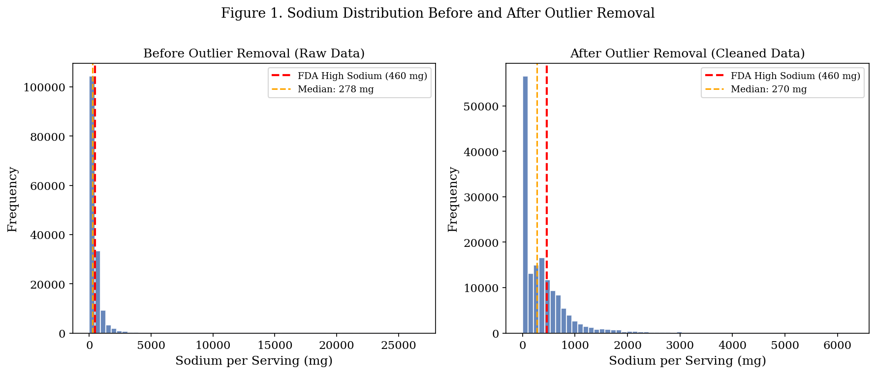
Figure 1. Sodium distribution before (left) and after (right) outlier removal. The red dashed line marks the FDA high-sodium threshold at 460 mg.

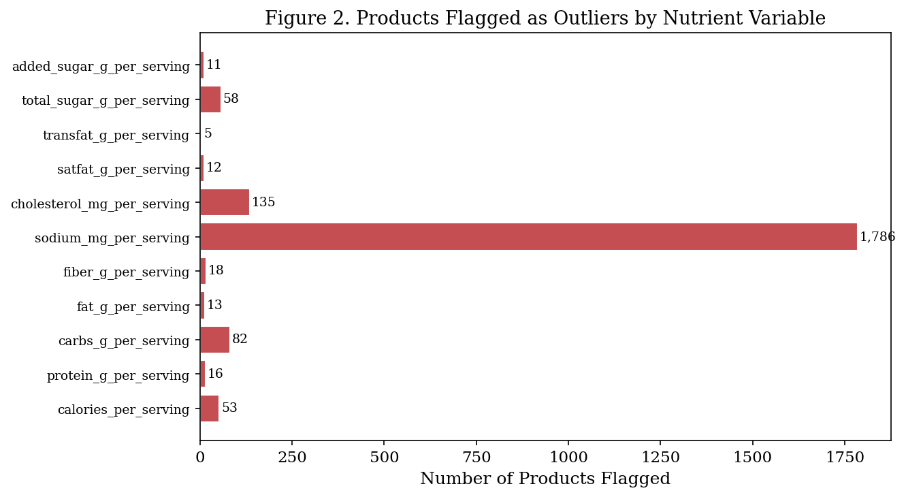
Figure 2. Products flagged as outliers by nutrient variable. Sodium accounts for 82% of all flagged values.

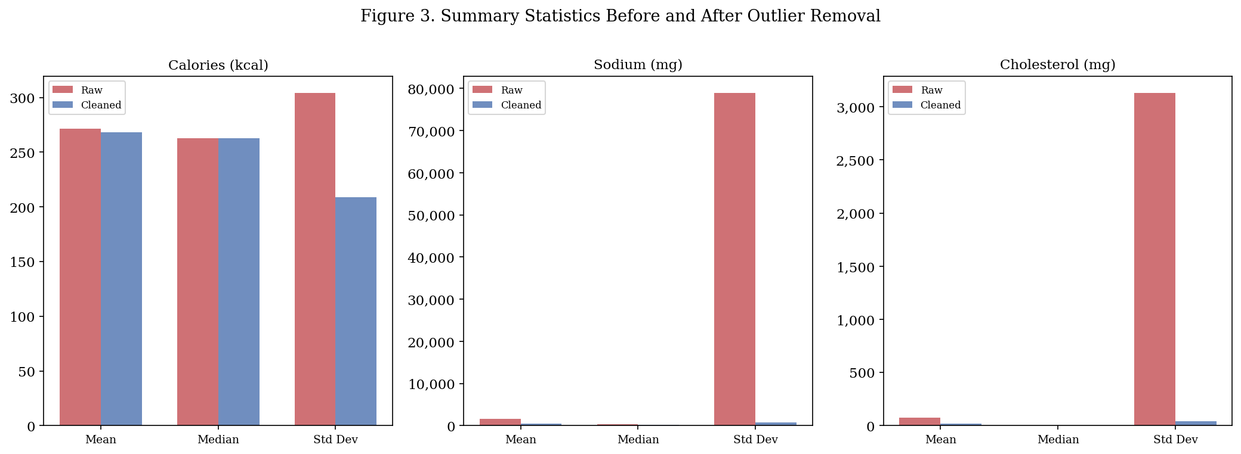
Figure 3. Mean, median, and standard deviation for calories, sodium, and cholesterol before and after cleaning.

Any analysis using means, correlations, or regression-based models should use the cleaned dataset. The raw data inflates the sodium mean by a factor of 3.6. The source of this inflation appears to be a small number of entries where per-100g values were recorded in per-serving fields, or where unit conversions were applied incorrectly. The median is an alternative to the mean when outliers are present, but cleaning the data is the more reliable and replicable approach.

Section 2: Nutrient Density Scoring
The NDS was computed for 121,171 products after excluding ingredient categories and restricting to products with complete data on all five component nutrients and a positive calorie count. The score ranges from -118.6 at the 1st percentile to 38.4 at the 99th percentile. The median is -14.9 and the mean is -16.3. A total of 79.5% of products score negative.
A negative NDS means the product delivers more limiting nutrients than beneficial ones per 100 kcal. The 79.5% figure tells you the limiting side of the ledger outweighs the beneficial side for most branded foods in this database, on a per-calorie basis.

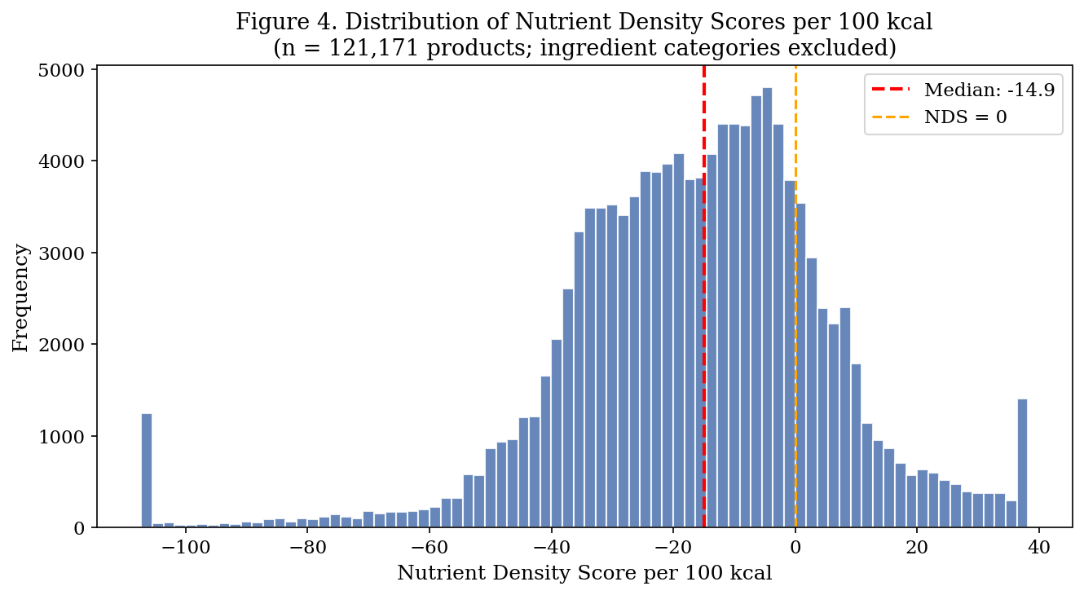
Figure 4. Distribution of Nutrient Density Scores per 100 kcal (n = 121,171 products; ingredient categories excluded). The red line marks the median (-14.9). The orange line marks NDS = 0.

Figure 5 ranks categories by median NDS, the bottom of the list reflects foods whose limiting nutrients genuinely dominate their nutritional profile. Condiments and sauces score lowest among the remaining categories: ketchup, mustard, BBQ sauce, and similar products combine high sodium with low protein and fiber relative to their calorie content. Granulated sugar and honey score near -53 because they deliver sugar calories with no beneficial nutrients to offset them. Soda scores near -49 for the same reason.

At the top, canned tuna reaches a median NDS of 27.2. Unprepared fish categories score between 30 and 32. These products combine high protein with near-zero sugar and low sodium per 100 kcal. Vegetable and lentil mixes (26.1) and frozen fish and seafood (16.8) also score well. The top-scoring categories share two properties: high protein relative to calories and low penalty from sodium or sugar.

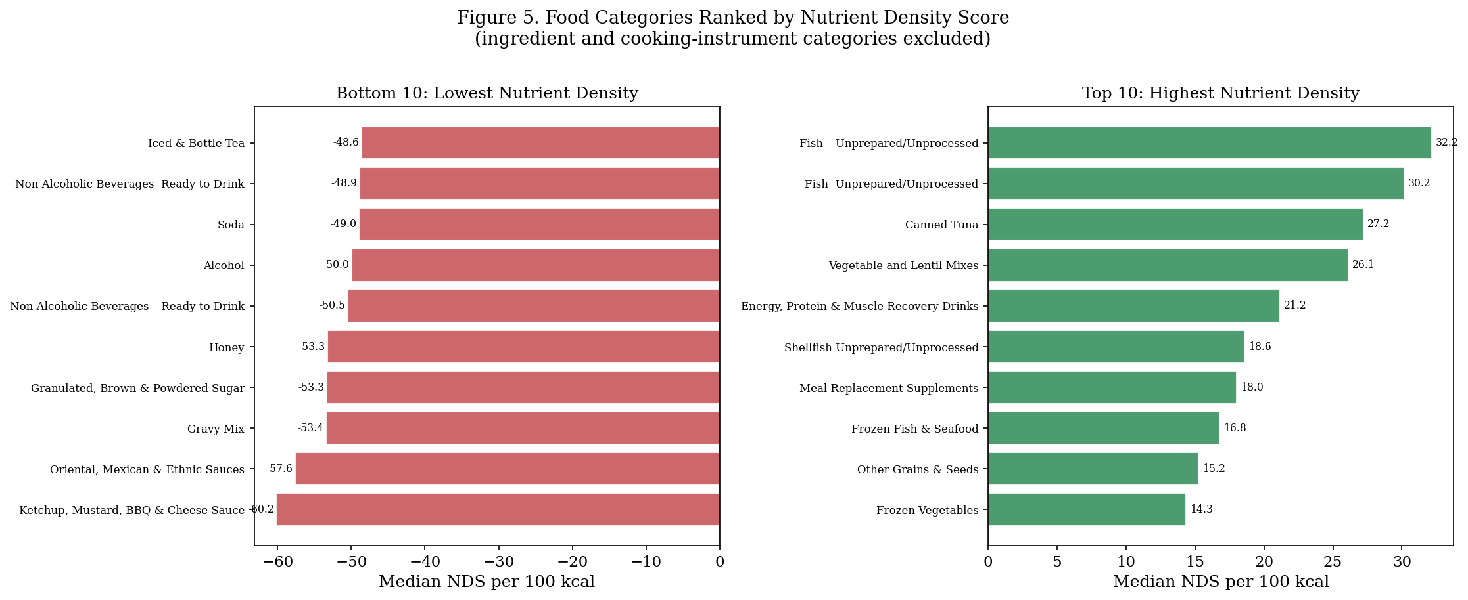
Figure 5. Food categories ranked by median NDS per 100 kcal. Left: ten lowest-scoring. Right: ten highest. Ingredient and cooking categories excluded. Minimum 50 products per category.

Figure 6 breaks the NDS into its component parts for eight selected categories. The breakdown shows why total scores alone are insufficient for understanding nutritional character. Canned tuna earns its high NDS from a large protein contribution with almost no limiting nutrient penalty. Chips and pretzels score near zero because their sodium and saturated fat penalties roughly cancel their protein contribution. Soda and candy both score poorly, but for different reasons. Soda receives its entire penalty from sugar with no beneficial nutrients at all. Candy at least has trace protein in some products, which reduces the deficit slightly. The component view tells you where a product falls short and where intervention would make the most difference.

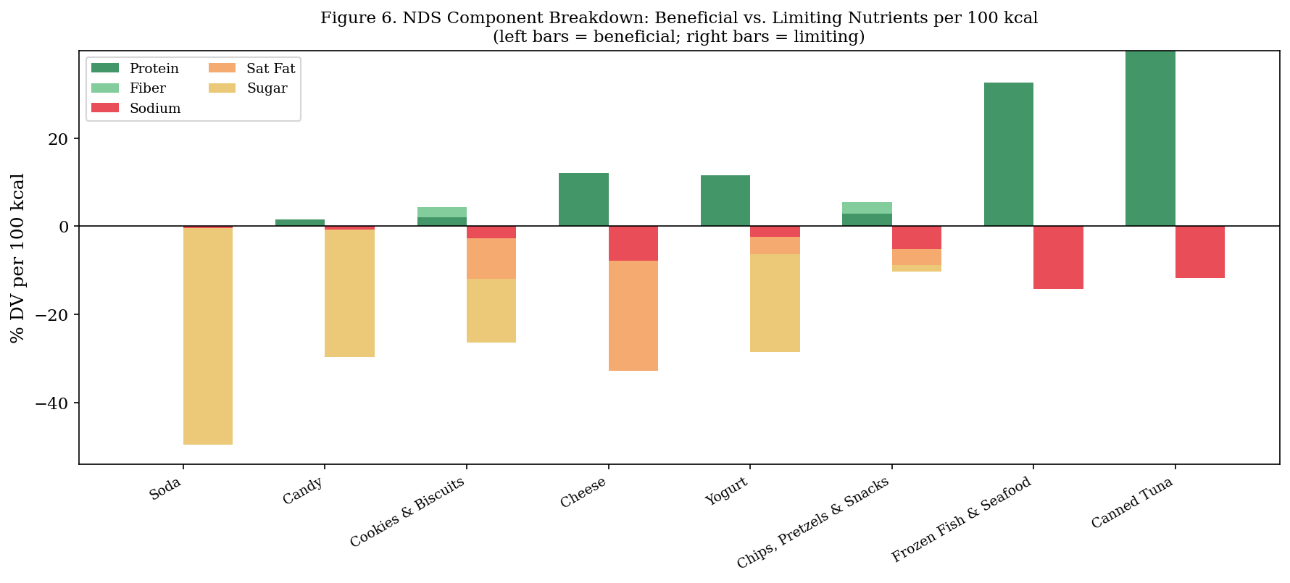
Figure 6. NDS component breakdown for eight categories. Left bars show beneficial contributions (protein, fiber). Right bars show limiting nutrient penalties (sodium, saturated fat, sugar). All values are per 100 kcal.

Section 3: Nutrient-Based Clustering
K-means clustering on a 40,000-product sample produced five groups with distinct nutritional profiles. Table 2 presents median values for each cluster. The groups align with recognizable food types, but they do not follow USDA category boundaries.

Table 2. K-Means Cluster Profiles: Median Nutrient Values (n = 40,000 sample)
Cluster | Label | n | Calories | Protein (g) | Carbs (g) | Fat (g) | Sodium (mg) | Sugar (g)
0 | Calorie-Dense: Nuts and Bars | 3,484 | 536 | 17.9 | 36.7 | 37.5 | 250 | 6.2
1 | Light / Moderate | 15,878 | 89 | 3.0 | 11.7 | 1.6 | 157 | 3.5
2 | Sweet Processed | 7,370 | 415 | 3.8 | 67.4 | 16.1 | 168 | 44.6
3 | Starchy and Savory | 7,641 | 372 | 8.0 | 62.1 | 8.8 | 488 | 3.6
4 | High-Protein / High-Fat | 5,627 | 304 | 18.3 | 3.6 | 21.4 | 722 | 0.0

Cluster 0 (Calorie-Dense: Nuts and Bars) has the highest total calories (536 kcal) and fat (37.5g), alongside meaningful protein (17.9g) and the highest fiber of any cluster (10.0g). This profile belongs to whole nuts and seeds, combined with protein and granola bars. Despite the high calorie count, the favorable protein and fiber content produces a better NDS than the sweet or savory starchy clusters.

Cluster 1 (Light/Moderate) is the largest group at 15,878 products. Its median calorie count is 89 kcal per serving. Fat is 1.6g and sodium is 157 mg. Ice cream, yogurt, and frozen dinners are its top categories. These categories appear together not because they are nutritionally similar per gram, but because small manufacturer-defined serving sizes keep per-serving values low across all three. This is a direct illustration of why serving size standardization matters for cross-product comparisons.

Cluster 2 (Sweet Processed) captures the sugar-dominant segment. Median sugar per serving is 44.6g and carbohydrates are 67.4g. Candy, cookies, and chocolate drive this group. Sodium is low (168 mg), which separates this cluster from the savory starchy group.

Cluster 3 (Starchy and Savory) sits at moderate calories, high carbohydrates, and moderate sodium. Chips, bread, and pasta anchor this group. The combination of grain-based carbohydrates and salt defines its nutritional character.

Cluster 4 (High-Protein/High-Fat) has the highest protein content (18.3g), the lowest carbohydrates (3.6g), and the highest sodium (722 mg) of any cluster. Cheese, pepperoni, and sausages are its dominant categories. The cluster treats these three as equivalent because they share the same macronutrient structure: high protein, high fat, minimal carbohydrates, and elevated sodium from curing and processing.

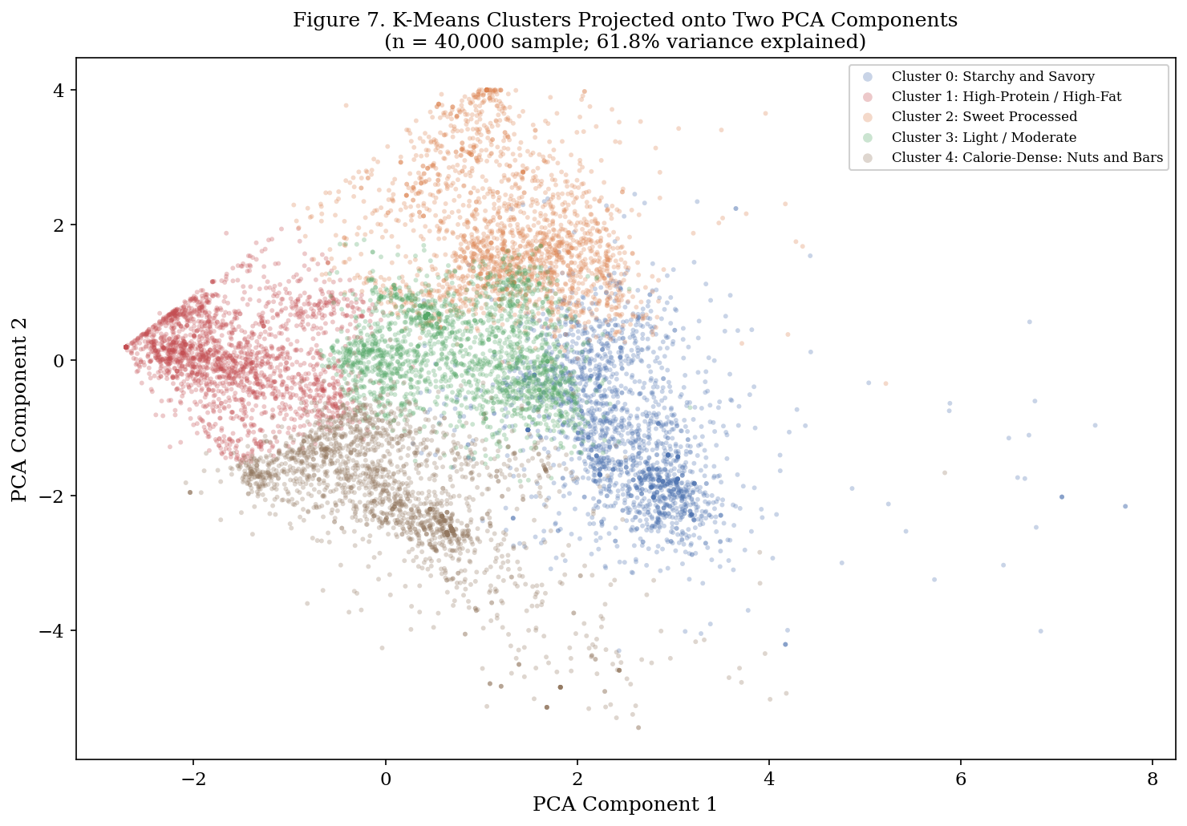
Figure 7. K-means clusters projected onto two PCA components. Each point is one product. Two components explain 61.8% of total variance (n = 40,000 sample).

The PCA projection in Figure 7 shows that clusters separate most clearly along the axis contrasting sweet and protein-dense products. The light/moderate cluster occupies a distinct low-value region. The starchy/savory and calorie-dense clusters overlap in the center, reflecting their shared high-calorie structure..

Section 4: Intra-Category Analysis
The NDS and clustering analyses show that category labels are imprecise guides to nutritional content. This section goes one level deeper and asks: within a single category, how much variation exists between products? The answer has direct implications for dietary guidance. Telling someone to eat more cheese, more yogurt, or more snacks is not a nutritional recommendation. It is a category label. The nutritional content depends entirely on which product within the category you choose.

4.1 Cheese
The cheese category contains 7,020 products. The category-level median is 357 kcal per serving. Table 3 presents per-serving profiles for 12 subtypes identified across 4,012 typed products.

Table 3. Cheese Subtype Profiles per Serving
Cheese Type | n | Calories | Fat (g) | Protein (g) | Sodium (mg)
American | 211 | 444 | 31.7 | 23.3 | 1,781
Cheddar | 1,458 | 393 | 32.1 | 25.0 | 643
Parmesan | 141 | 393 | 28.3 | 32.1 | 1,143
Swiss | 216 | 393 | 32.1 | 28.6 | 253
Gouda | 128 | 388 | 28.6 | 25.0 | 821
Blue | 100 | 357 | 28.6 | 21.4 | 1,082
Brie | 74 | 357 | 32.1 | 17.9 | 607
Cream Cheese | 330 | 286 | 24.9 | 6.2 | 375
Mozzarella | 534 | 286 | 21.4 | 25.0 | 679
Feta | 117 | 250 | 21.4 | 17.9 | 1,143
Ricotta | 100 | 69 | 4.4 | 4.4 | 58
Cottage | 318 | 20 | 0.5 | 2.6 | 88

The calorie range across subtypes runs from 20 kcal for cottage cheese to 444 kcal for American cheese. Fat content among hard and semi-hard cheeses is remarkably consistent. Cheddar, Swiss, gouda, blue, and brie all cluster between 28 and 32g of fat per serving. Caloric differences in this group are small (357 to 393 kcal). If your goal is to reduce fat or calories by switching between hard cheese varieties, the data does not support an expectation of meaningful change.

Protein content shows more useful variation. Parmesan delivers 32.1g of protein per serving, ahead of Swiss (28.6g) and cheddar (25.0g). For someone prioritizing protein intake from cheese, parmesan is the most efficient option in this dataset. Mozzarella matches cheddar on protein (25.0g) while containing less fat (21.4g vs. 32.1g), making it a better choice when both protein and fat content are relevant.

Sodium shows the widest variation of any variable in this table. Swiss cheese has a median of 253 mg of sodium per serving. American processed cheese has 1,781 mg. These two products have nearly identical calorie and fat profiles, with a sevenfold difference in sodium. That difference comes from processing method, not dairy composition. For a person managing sodium intake, the choice between cheese subtypes is more important than the decision to include or exclude cheese from their diet.
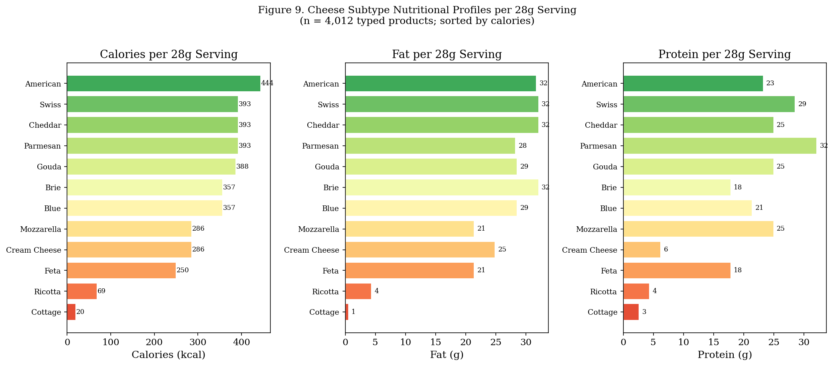
Figure 9. Cheese subtype profiles for calories, fat, and protein per serving. Sorted by calorie content (n = 4,012 typed products).

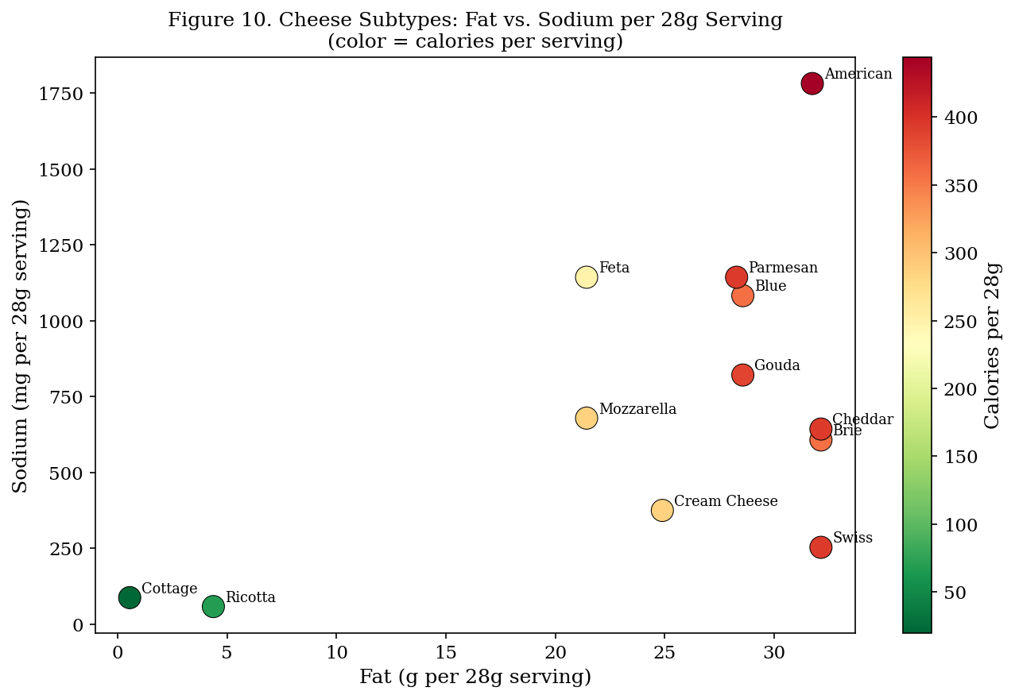
Figure 10. Fat vs. sodium per serving for cheese subtypes. Color indicates calories. Swiss and ricotta stand out for low sodium relative to their fat content.

4.2 Snacks
Five snack subcategories were analyzed: popcorn, peanuts, seeds, and related snacks (7,015 products); chips, pretzels, and snacks (3,999); cookies and biscuits (4,138); crackers and biscotti (1,467); and snack, energy, and granola bars (3,094). These subcategories have meaningfully different nutritional profiles.

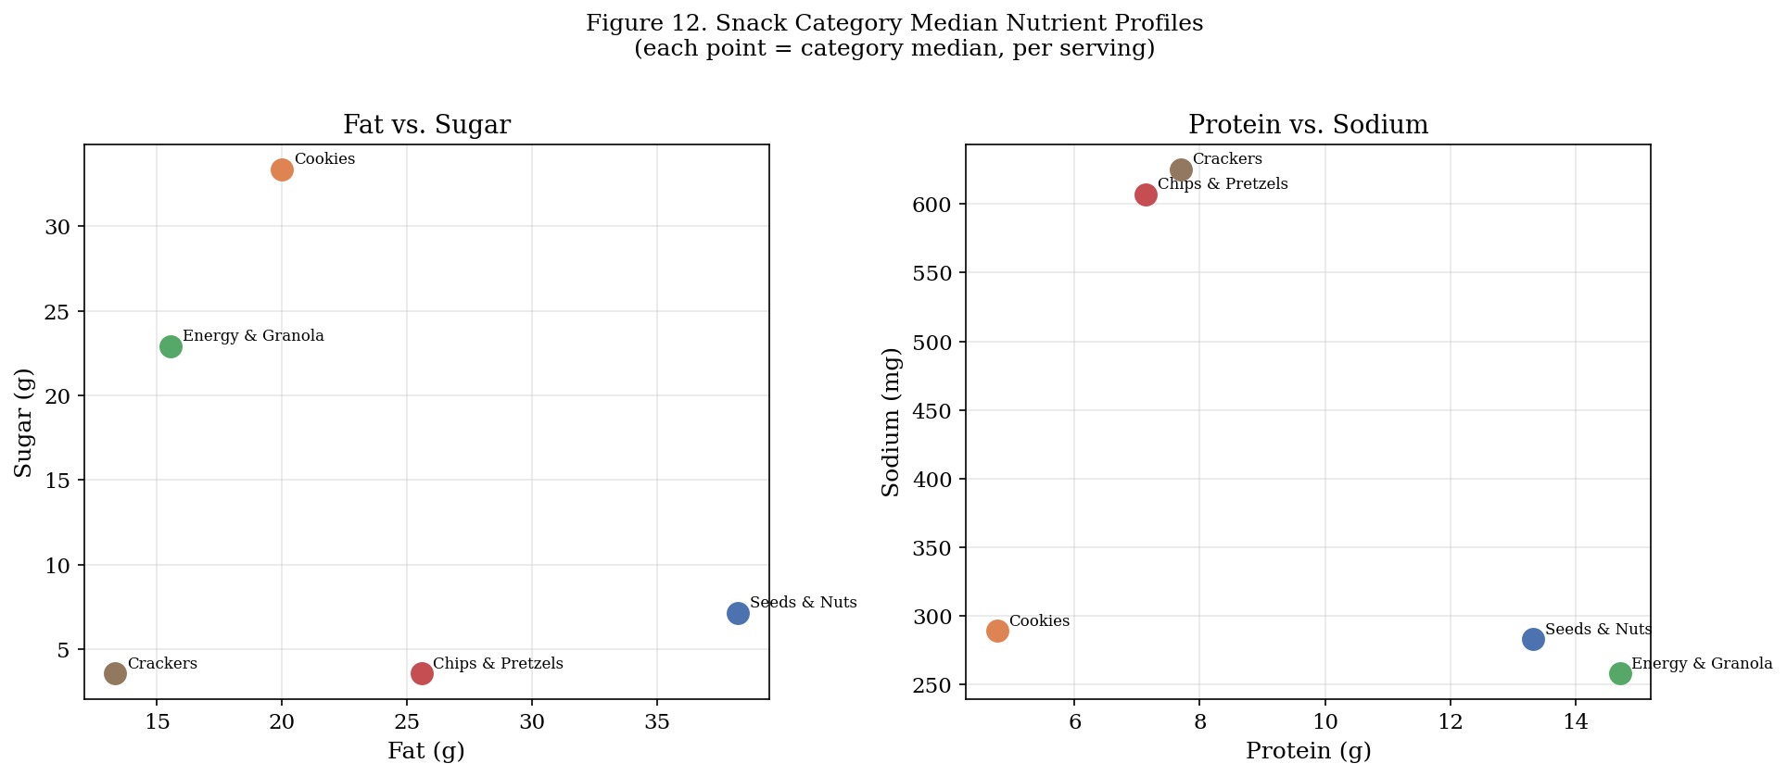
Figure 12. Snack subcategory median nutrient profiles. Fat vs. sugar (left); protein vs. sodium (right). Each point represents one subcategory median.

Crackers carry the highest sodium (625 mg) and derive most of their calories from carbohydrates (60.7g per serving). Chips & Pretzels follow a nearly identical pattern: 68.8g of carbohydrates and 607 mg of sodium. These two subcategories represent the high-sodium, grain-based end of the snack space. Cookies occupy the opposite end on sugar (33.3g) with moderate sodium (289 mg). Energy and granola bars sit between these extremes, with the second-highest protein (14.7g) and a sugar load (22.9g) that falls between cookies and savory snacks.

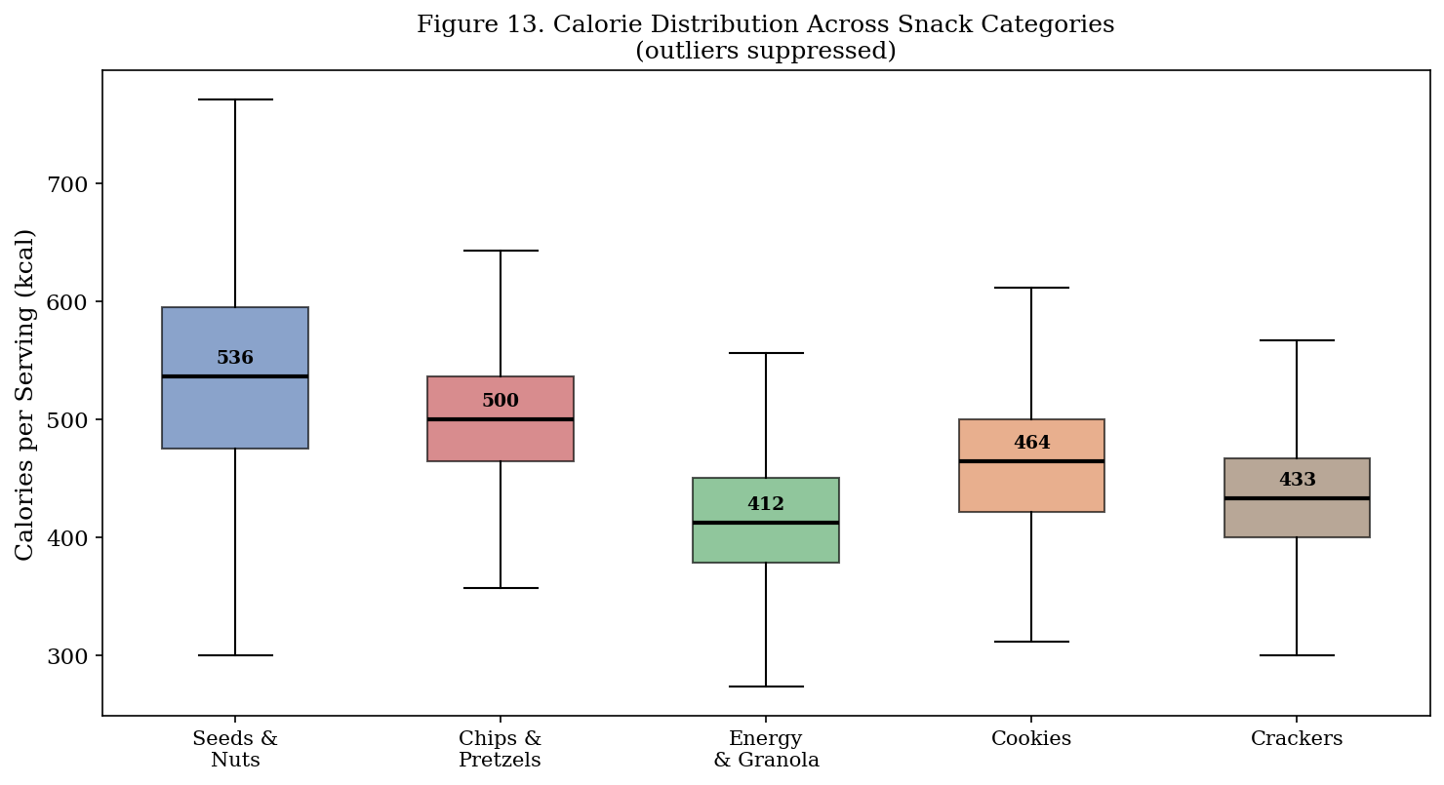
Figure 13. Calorie distribution across snack subcategories (outliers suppressed). Medians labeled above each box.

Seeds and nuts have the highest median calories (536 kcal per serving) and the highest fat (38.2g). They also have the highest protein (13.3g) and the lowest sodium (283 mg) of any snack subcategory. The combination of high energy density, meaningful protein, and low sodium produces a favorable NDS despite the calorie count. If your goal is to add protein to your diet through snacking, seeds and nuts deliver more protein per serving than any other snack subcategory while keeping sodium low.

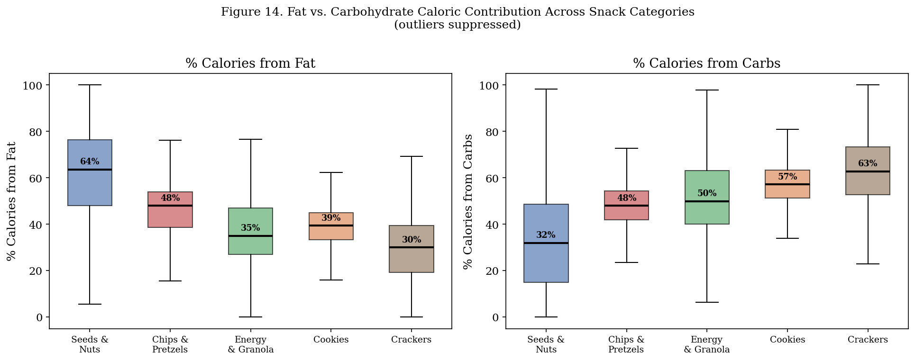
Figure 14. Percentage of calories from fat (left) and carbohydrates (right) across snack subcategories.

Figure 14 makes the macronutrient split explicit. Seeds and nuts get approximately 60% of their calories from fat and under 25% from carbohydrates. Cookies and crackers get roughly 55% from carbohydrates and 35 to 40% from fat. Two products with identical calorie counts from different snack subcategories carry completely different macronutrient structures. Also there is an inverse relationship, as calories from fat decrease, calories from carbohydrates increase. This is the same pattern we find in the correlation findings.

4.3 Yogurt
Yogurt analysis covered 3,861 products from the Yogurt and Yogurt/Yogurt Substitutes categories. Keyword classification produced five types: flavored (1,897 products, 49%), Greek (1,131, 29%), plain (169, 4%), drinkable and kefir (198, 5%), and Skyr/Icelandic (72, 2%).
Protein content is the clearest differentiator. Skyr and Icelandic yogurts lead at 10.0g of protein per serving. Greek yogurt follows at 8.0g. Plain yogurt delivers 4.7g, close to the drinkable format (3.8g). Flavored yogurt, the largest segment of the category, delivers the least protein at 3.5g. The gap between Greek-style and conventional yogurt reflects the straining process, which removes whey and concentrates protein. Skyr undergoes more aggressive straining than Greek yogurt, which accounts for the slightly higher protein.
The sugar comparison produces a result worth examining. Figure 11 uses calories from sugar rather than grams, allowing a direct comparison with total calories on a common unit. For flavored yogurt, the median total calorie count is 87 kcal per serving, and calories from sugar account for 42 of those calories, or 48% of total energy. For Greek yogurt, 37 of 81 kcal (46%) come from sugar. Plain yogurt at 69 kcal total has only 20 kcal from sugar, or 29% of total energy. The plain and Skyr formats deliver a meaningfully lower sugar fraction than either Greek or flavored options.

Most Greek yogurts in this dataset are flavored. The straining process concentrates protein, but added sugar in flavored products raises the sugar load to levels close to conventional flavored yogurt. If reducing sugar is the goal, the plain or Skyr format is a more reliable selection criterion than the Greek label.

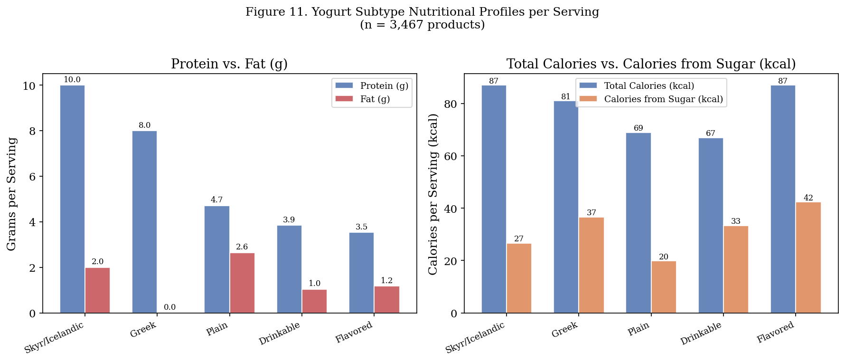
Figure 11. Yogurt subtype profiles per serving. Left: protein and fat in grams. Right: total calories vs. calories from sugar (both in kcal for a fair unit comparison).

Discussion
Labels and Categories Are Insufficient
The findings in this paper point to a consistent problem in how people apply nutritional information. Food labels usually only inform you what group a product belongs to, and they are often marketed to highlight their strengths and disregard their weaknesses. First, a difference in nutritional breakdown can be observed with most precision at the product level, not category; purchasing on label alone can result in worse results for a specific diet goal. As many products contain labels with similar advertising and branding, consumers would have to be careful with the product they choose.

Doing this analysis beforehand can save a substantial amount of time handpicking products and looking at the back for the nutrition label. Since we have done the research, we know which products contain the nutrients we want, vs which products contain harmful nutrients. If I wanted to select a group of products I wanted to purchase based on their nutrition value, I can simply run the nutrient density score on a product level for each category to point to exactly which products are worth purchasing. As marketing is less about transparency and more for sales, this program allows you to skip the marketing tactics and get exactly what you’re looking for.

Now consider how dietary advice often works in practice. Someone is told to eat more yogurt for protein. They buy flavored Greek yogurt. That product delivers 8g of protein per serving, which is accurate for Greek yogurt. It also delivers 37 kcal of sugar, which is close to what a serving of conventional flavored yogurt provides. The health framing of the Greek label did not translate into a low-sugar choice.

The same logic applies to cheese. Someone is told that cheese provides protein and calcium. They buy American processed cheese. Per serving, that product delivers 23g of protein and 1,781 mg of sodium. If they had chosen Swiss, they would get 28.6g of protein and only 253 mg of sodium. The difference is not between eating cheese and not eating cheese. The difference is between two products that carry the same category label.

The food pyramid and similar dietary frameworks group foods by biological similarity without accounting for the variation inside each group. Dairy is one group. Grains are another. Proteins are another. This grouping made sense as a communication tool designed for broad public guidance. It breaks down when applied at the individual product level, which is where actual food choices happen.

The soda category illustrates this well. Reducing soda intake is a common dietary goal. The soda category includes standard sweetened sodas, diet sodas with near-zero calories, and protein-sodas with meaningful protein content. Treating all soda as equivalent when setting a dietary goal produces a different outcome depending on which product in the category a person replaces.

Category Driven Decision vs Product Driven Decisions
The NDS framework in this paper assigns each product a score based on its actual nutrient composition, not its category membership. Clustering assigns each product a nutrient archetype based on its macronutrient structure. Both tools operate at the product level and produce rankings that are invisible at the category level.

For a consumer, the actionable takeaway from this analysis is specific. If you want to reduce sodium from cheese, choose Swiss over American. If you want more protein from yogurt, choose Skyr or plain Greek rather than flavored. If you want a snack with meaningful protein and low sodium, seeds and nuts outperform chips, crackers, and cookies on both dimensions. These recommendations require knowing the nutritional content of individual products, not just the category they belong to.

For researchers building dietary models on this dataset, the practical takeaway is different. Category membership is a weak predictor of nutrient content. Cluster membership is a stronger one. A model predicting sodium from category labels alone will produce large errors for within-category products like American and Swiss cheese. A model using cluster membership as a feature captures the shared macronutrient structure of products that carry different category labels, and will generalize better.

The NDS Is a Starting Point
The Nutrient Density Score developed here rewards protein and fiber and penalizes sodium, saturated fat, and sugar. It aligns with current dietary guidance and produces interpretable rankings. It is not a complete measure of nutritional quality. Iron, calcium, vitamin D, and other micronutrients are absent from this dataset. Dairy products score poorly on sodium in the NDS but are significant calcium sources. Fortified cereals score poorly on sugar but deliver meaningful micronutrient contributions.

The 79.5% negative NDS rate reflects a real pattern: most branded food products deliver more limiting nutrients than beneficial ones per 100 kcal. It does not mean that 79.5% of branded foods are unhealthy. A negative NDS is a comparative signal within the five dimensions the score measures. Extending the NDS to include micronutrient data would make it a more complete index and likely change the rankings for dairy and fortified categories.

Limitations
The ingredient category exclusions were defined manually using a fixed list of category names. This approach correctly removes the most distorting categories, but it is not exhaustive. Individual products within retained categories, such as cooking wine in the alcohol category or pure lemon juice in the beverages category, function as ingredients rather than standalone foods. A more complete filtering approach would operate at the product level, using product descriptions or ingredient lists to identify single-ingredient cooking inputs. The current approach removes the most obvious distortions and is transparent about what it excludes.

The NDS weights beneficial and limiting nutrients equally. Protein and fiber each contribute equally to the positive side. Sodium, saturated fat, and sugar each contribute equally to the negative side. There is no empirical basis for this equal weighting. A version calibrated against dietary outcome data or developed with nutritional experts would produce a more reliable index.

Added sugar data is missing for 69.6% of products and was excluded from the NDS. Total sugar was used as a proxy. This overstates the limiting-nutrient penalty for products where a meaningful portion of sugar is naturally occurring, including dairy and fruit-based products.

Conclusions
This paper produced four analytical outputs from the USDA branded food dataset. Outlier removal reduced the sodium mean by 72% by eliminating a small number of entries with physically impossible values. The Nutrient Density Score ranked 121,171 products and 343 food categories after excluding ingredient and cooking categories, showing that 79.5% of branded food products deliver more limiting nutrients than beneficial ones per 100 kcal. Intra-category analysis for cheese, snacks, and yogurt documented nutritional variation within categories large enough to matter for individual dietary decisions.

The tools developed in this paper operate at the product level and produce specific, actionable rankings. Extending this analysis across all branded food categories would produce a complete product-level nutritional breakdown of the branded food supply and close the gap between population-level dietary guidelines and the individual choices people make at the grocery store.

References
Drewnowski, A. (2009). Defining nutrient density: Development and validation of the Nutrient Rich Foods index. Journal of the American College of Nutrition, 28(4), 421S-426S.

U.S. Department of Agriculture, Agricultural Research Service. (2024). FoodData Central. https://fdc.nal.usda.gov/

U.S. Food and Drug Administration. (2022). Sodium in your diet. https://www.fda.gov/food/nutrition-education-resources-materials/sodium-your-diet

U.S. Department of Agriculture and U.S. Department of Health and Human Services. (2020). Dietary Guidelines for Americans, 2020-2025 (9th ed.). https://www.dietaryguidelines.gov/

U.S. Food and Drug Administration. (2016). Changes to the Nutrition Facts label. https://www.fda.gov/food/food-labeling-nutrition/changes-nutrition-facts-label

Batista, J. (2025). Juniata College, R exploratory analysis: Cheese products variation in nutrition profiles. https://www.jbatist.com/products%20variation%20in%20nutrition%20profiles.pdf

