TRIBHUVAN UNIVERSITY
INSTITUTE OF ENGINEERING
KATHMANDU ENGINEERING COLLEGE

DEPARTMENT OF COMPUTER ENGINEERING

MINOR PROJECT PROPOSAL
ON
H-MATE: THE HOSPITAL APPLICATION
[Code No: CT 654]
By:
Aditya Gnawali [KAT077BCT005]
Bhuwan Shrestha [KAT077BCT014]
Jyoti Bhusan Dahal [KAT077BCT028]
Mohit Raj Aryal [KAT077BCT030]

Kathmandu, Nepal
June, 2023

ABSTRACT

H-mate is a mobile application designed to assist users in finding suitable doctors based on their symptoms which also facilitates direct appointment bookings. By entering their symptoms, users receive recommendations for doctors who specialized in relevant medical conditions. The application’s recommendation system considers the location of the user to ensure relevant suggestions. Additionally, H-mate enables users to book appointments with their preferred doctors. H-mate aims to provide a valuable resource for individuals seeking medical assistance, offering a seamless and efficient platform for symptom-based doctor recommendations and appointment bookings. With its user-friendly interface and recommendation system, H-mate changes the way individuals can access healthcare. By empowering users to make informed decisions about their health, the application plays a crucial role in promoting timely medical assistance. H-mate not only simplifies the process of finding suitable doctors but also encourages individuals to prioritize their well-being, ultimately leading to healthier lives.

Keywords: mobile application, appointment, booking, specialized, medical, symptoms, doctors

TABLE OF CONTENTS

ABSTRACT……………………………………………………………….. ii
TABLE OF CONTENTS………………………………………………… iii
LIST OF FIGURES……………………………………………………….. v
LIST OF ABBREVIATIONS…………………………………………..... vi
CHAPTER 1: INTRODUCTION………………………………………... .1
  - Background Theory………………………………………………………….. .1
  - Problem Statements………………………………………………………….. .1
  - Objectives……………………………………………………………………. .2
  - Scope and Applications………………………………………………………. 2
CHAPTER 2: LITERATURE REVIEW……………………………….... 4
2.1 Existing Hospital Applications in Nepal……………………………………… 5
2.2 Limitation of Existing Systems……………………………………………….. 6
2.3 Solutions proposed by our system……………………………………………. 6
CHAPTER 3: METHODOLOGY………………………………………... 7
3.1 Process Model………………………………………………………………… 7
3.1.1 Incremental Development Mode..……………………………………...... 7
3.2 System Block Diagram……………………………………………………...... 9
3.3 Algorithm…………………………………………………………………… 10
3.4 Flowchart……………………………………………………………………. 12
3.5 Tools to be Used…………………………………………………………….. 13
CHAPTER 4: EPILOGUE……………………………………………… 15
4.1 Expected Output…………………………………………………………….. 15
4.2 Gantt Chart………………………………………………………………….. 16
REFERENCES…………………………………………………………... 17

LIST OF FIGURES

Figure 3.1: Block Diagram of Incremental Development Model………………………… 7
Figure 3.2: System Block Diagram……………………………..………………………… 9
Figure 3.3: Flowchart……………………………………………...……………………. 12
Figure 4.1: Gantt chart…………………………………………………………………. 16

LIST OF ABBREVIATIONS

CAGR – Compound Annual Growth Rate
ITU – International Telecommunication Union
JS – JavaScript
REACTJS – React JavaScript
RDBMS – Relational Database Management System

CHAPTER 1: INTRODUCTION

1.1 Background Theory

H-Mate is a mobile-based application that provides basic health-related services like doctor appointments, and doctor recommendations and assists in addressing and treating various health-related issues. H-Mate reduces the hassle of taking medical services by systematically managing the appointments and reducing the manpower required to manage the health services. The app aims to bond patients and healthcare providers.

Medical applications have become increasingly common in the healthcare industry, revolutionizing the way individuals interact with healthcare providers. It increases access to health services to more individuals. Medical applications also provide a means for frequent interactions and remote monitoring of health conditions. The application also acts as an awareness medium for individuals about common health-related issues and their precautions.

We believe that such applications can help the everyday citizens of Nepal in the current time where the majority of individuals have access to smartphones.

1.2 Problem Statement
In Nepal, there is a lack of proper medical care for people whose salary is less than the average. The long waiting hours for medical services and a tight schedule with a lack of ability for timely and routine checkups. Moreover, there is a lack of awareness of diseases and their control measures. The geographical condition of Nepal makes it difficult to provide proper health services to people due to lack of mobility.
Currently, medical services in Nepal are predominantly managed by private sectors, which tend to be expensive, or through government-funded hospitals. The significant costs associated with infrastructure, transportation, and manpower pose challenges in delivering affordable healthcare. However, this is where H-Mate comes into the picture. H-Mate is a solution that aims to reduce costs and manpower requirements in the healthcare sector.

1.3 Objectives

The major objectives of this project are:
-To provide a platform for everyone to book an appointment with a specialist doctor based on their symptoms.
-To make a hospital management system where hospital staff can keep a record of patients.

1.4 Scope and Application

Hospital-based application is not a new concept in Nepal as it has been in use for a few years. With the success of some hospital-based applications or websites like Hamro Doctor, Nepal Mediciti, Okhati, and others, it is clear that the people of Nepal are quite interested in hospital-based applications. As these models work relatively well, we believe that our new approach to designing hospital-based applications will work quite well. In our application, every user will be able to solve most of their problems related to their health condition in a very effective, efficient, and user-friendly way.

The main motive of this project is to create a mobile application that will work as a doctor recommendation system as well as a hospital management system.

The application of this software is to schedule appointments for patients and ensure timely access to healthcare services. This software can also manage different medical files and resources for doctors and hospitals. The main application of this software is used to enhance patient experience, streamline workflow, and effective resource management, which ultimately contributes to the overall effectiveness and quality of healthcare delivery.

CHAPTER 2: LITERATURE REVIEW

With the invention of the smartphone, an interest in creating unique mobile applications was sparked worldwide. From games to social medial apps the possibilities became endless. It didn’t take long for medical health apps to pop up from general health to tracking to condition-specific apps. Mobile health apps have been developed over the year aside from the mode of care, there has been additional tools to aid in improving the accessibility of health care and information, better diagnoses, tracking of conditions, better medical training, and more.
Digital technologies are becoming an important resource for health series delivery and public health. Mobile wireless technologies are particularly relevant, due to their ease of use, broad reach, and wide acceptance. According to ITU, in 2015 there were more than 7 billion mobile telephone subscriptions across the world, over 70% of which were in low-or middle-income countries [1]. The study indicates the scope of mobile health services.
The global mHealth apps market size was valued at USD 43.5 billion in 2022 and is expected to expand at a compound annual growth rate (CAGR) of 11.6% from 2023 to 2030[2]. There are numerous mobile applications worldwide that offer personalized healthcare to patients. Some popular apps include Aetna and ADA, which provide patients with information about their health conditions and offer step-by-step guidance for treatment. In the context of Nepal also there exists applications like Hamro Doctor, and Okhati which provide health-related services. The Covid-19 crisis has raised people’s awareness about the challenges that can arise during a pandemic. Additionally, it has resulted in the wider adoption of smartphones making them more accessible to a larger population and making a health-related application handy to a huge audience.

2.1 Existing Hospital-Based Application in Nepal

Some of the existing hospital-based applications in Nepal that are similar to our H-Mate are listed below:
1. Hamro Doctor: Hamro Doctor is a popular healthcare application in Nepal that offers different health services such as doctor recommendations, blood donor requests, and stored medical records for future reference. Hamro Doctor is the first online healthcare service provider from Nepal where patients can enjoy different kinds of health services.

2. Okhati: Okhati is a healthcare platform in Nepal that connects patients with hospitals and doctors. It is a smart software for clinics, labs, and hospitals that consists of features like patient-flow management, billing, accounting, reporting, bulk messaging, and doctor recommendations based on patients’ preferences and requirements. Patients can also search for doctors by their specialty, and locations and also view doctor profiles with patient reviews.

3. Saral Health: Saral Health is a health and wellness application in Nepal that provides a doctor recommendation service. Patients have features like searching doctors by their specialty, location, and experience level. This application also includes the features such as appointment booking, health tips, and medical news.

2.2 Limitations of Existing Systems

Hospital-based applications in Nepal have been around for quite some time now and are also popular nowadays and common among the users of Nepal. While the current hospital-based applications have been doing a good job of awaring users about the advantages and benefits of using these applications. But in a while, these applications are neither introducing any new kind of features nor can meet some extra requirements of the users.

2.3 Solutions Proposed by Our System

How our application improves on all the current existing applications is that it provides users extra features like recommending specialist doctors according to their symptoms. Our project will also be user-friendly so that users can easily use the application without any difficulties as the UI used in the application will be simple and user-friendly. As the users want all the features included in one single application, users are less likely to use different applications for different purposes. So, we believe that our project can improve and capitalize on these facts.

CHAPTER 3: METHODOLOGY

3.1. Process Model

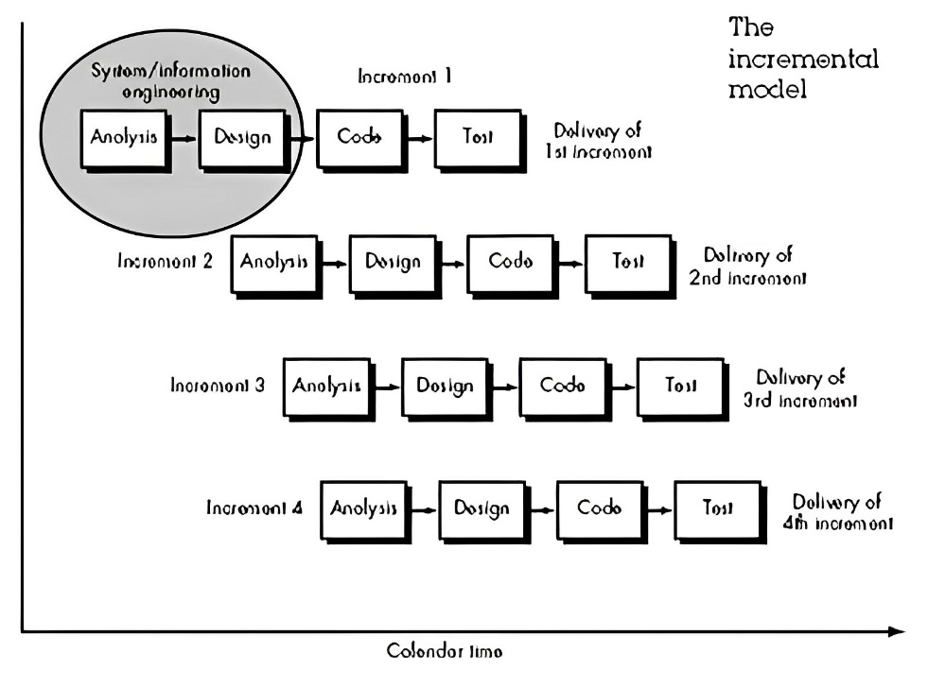
3.1.1 Incremental Development Model

Fig 3.1: Block diagram of Incremental Development Model

The incremental model applies linear sequences in a staggered fashion as calendar time progress. Each linear sequence produces a deliverable “increment” of software. When an incremental model is used, the first increment is often a core product. That is, basic requirements are addressed, but many supplementary features (some known, others unknown) remain undelivered. The core product is used by the customer (or undergoes detailed review). As a result of use and/or evaluation, a plan is developed for the next increment. The plan addresses the modification of the core product to better meet the needs of the customer and the delivery of additional features and functionality. This process is repeated following the delivery of each increment until the complete product is produced. The various phases of the incremental model are as follows:
Requirement analysis: In the first phase of the incremental mode, the product analysis expertise identifies the requirements. The system’s functional requirements are understood by the requirement analysis team.
Design and Development: In this phase, the design of the system functionality and its development methods are finished with success.
Testing: In the incremental model, the testing phase checks the performance of each existing function as well as additional functionality. In the testing phase, various methods are used to test the behavior of each task.
Implementation: After the software is fully tested and is free of errors and defects, the client reviews the test results and approves the deployment. It involves the final coding that is designed in the designing and development phase and testing the functionality in the testing phase.
We have picked the incremental model because of its flexibility and adaptability during the development process as it enables us to make changes and adjustments based on feedback and evolving requirements. Since we are not certain about the number of features that could be designed and implemented within the timeframe. The incremental model allows us to include the core features of the app in the first increment and later on increment features as per the requirements. Furthermore, since projects face risks and uncertainties the incremental model assists in risk mitigation by breaking down the development process into smaller, independent increments. For above mentioned reasons we believe that the incremental model is the right model for our project.

3.2 System Block Diagram

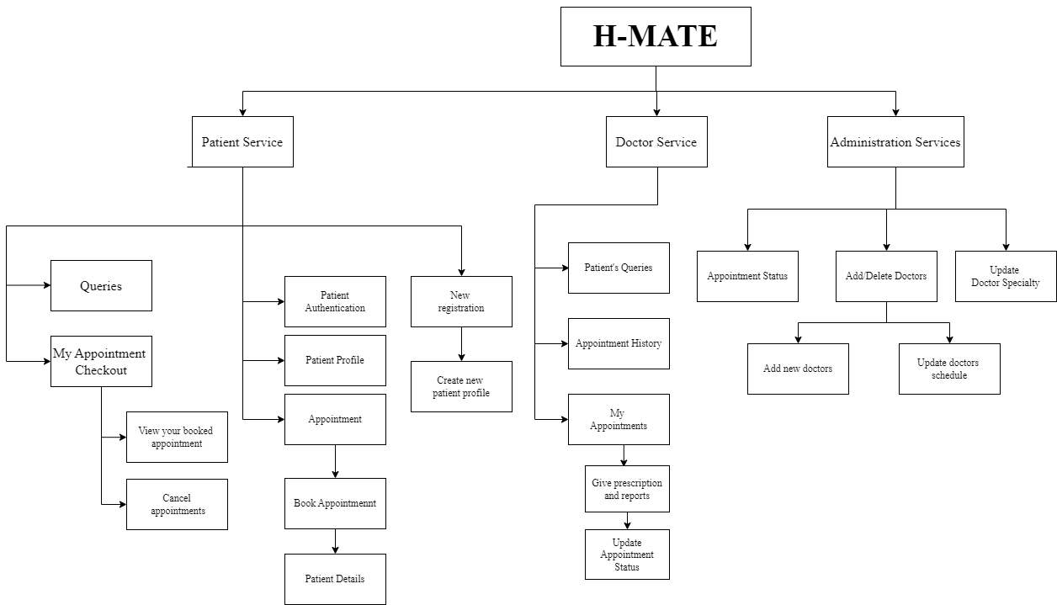

Fig 3.2 System Block Diagram

3.3 Algorithm

Patient
Step 1: Start
Step 2: If the patient has already an account, go to step 3.
Else register a new account then go to step 3.
Step 3: Open the login interface.
Step 4: If the username and password are not valid ask the patient for valid information.
Else go to step 5.
Step 5: View the patient’s home page and show the features they can use.
Step 6: If the patient wants to book an appointment, go to the appointment.
Step 7: If the patient doesn’t want a doctor recommendation, then go to step 8.
Else, 7.1: Enter the patient’s details and symptoms.
7.2: If all the information is provided then recommend the disease specialty doctor and doctor’s schedule.
Step 8: Select the doctor and time.
Step 9: If the patient is confirmed then book an appointment else go to step 8.
Step 10: Logout
Step 11: Stop

Doctor
Step 1: Start
Step 2: Open the login interface.
Step 3: If the username and password are not valid ask the doctor for valid information.
Else go to step 4.
Step 4: View the Doctor’s home page and show the features they can use. If the doctor
want to log out go to step 8.
Step 5: If the doctor wants to check pending appointments, go to my appointment.
Step 6: If there are pending appointments let the doctor view and update the appointment
with a report of patients. Else go to step 7.
Step 7: If the doctor is done working then go to step 4. Else go to step 5.
Step 8: Logout
Step 9: Stop
Admin
Step 1: Start
Step 2: Open the login interface.
Step 3: If the username and password are not valid ask the admin for valid information.
Else go to step 4.
Step 4: View the admin’s home page and show the features they can use. If the admin
want to log out go to step 6.
Step 5: If the admin wants to perform activities, then take to respective features. Else
go to step 6.
Step 6: Logout
Step 7: Stop

3.4 Flowchart
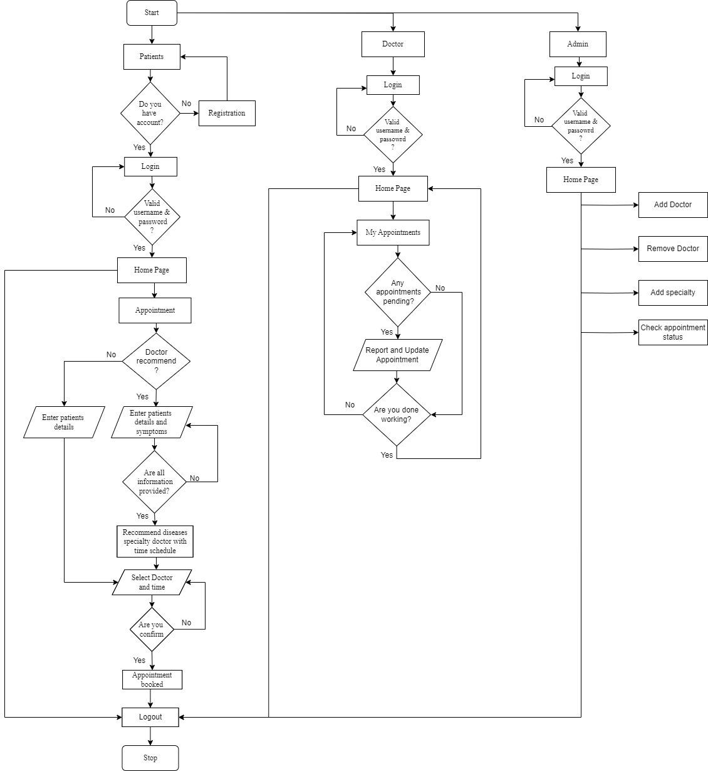

Fig 3.4 Flowchart
3.5 Tools to be Used
- Python
Python is a high-level, general-purpose programming language known for its simplicity, readability, and versatility. Python is easy to read and write which emphasizes code readability with its clean and intuitive syntax. As python is a general-purpose language which means it can be used for a wide range of applications, such as web development, artificial intelligence, automation, etc.

- JavaScript
JavaScript is a versatile programming language that allows users to implement complex features on web pages. It is a powerful scripting language that runs in web browsers enabling interactive and dynamic behavior on websites. It allows users/developers to manipulate the web page contents, and handle user interactions.

- React Native
React Native is an open-source framework that lets the developer build cross-platform mobile applications using JavaScript and React.js. It provides a core set of platform-agnostic native components like view, text, and image that map directly to the platform's native UI building blocks. It allows developers to create mobile applications that run natively on both iOS and Android platforms using a single codebase.

- ReactJS
React is a free and open-source front-end JavaScript library for building user interfaces based on UI components.

- Git
Git is a free and open-source distributed version control system that helps developers manage, and handle, changes to their codebase efficiently. It allows coders or developers to work together in groups on the same project simultaneously with keeping track of each change made and providing tools to merge them into one and resolve the conflicts.
- GitHub
GitHub is a web-based platform that provides hosting for Git repositories. It helps developers to store and manage their code, as well as track and control changes to their code. It also provides features like repository hosting, collaborations among members for the project, issue tracking, project management, and so on.

- MySQL
MySQL is an open-source relational database management system (RDBMS) known for its reliability and performance. It is one of the most popular database management systems which is very commonly used. It is also known for its scalability, allowing users to handle large amounts of data and high-traffic applications. It also provides security features that will protect data, including access control, user authentication, etc.

CHAPTER 4: EPILOGUE

4.1 Expected Output
The purposed project will produce a cross-platform mobile application where you would be able to interact and take appointments with the doctors based on the symptoms of the diseases described. The project also acts as a platform for doctors to share their expertise, market themselves and check patients.
Patients will have the ability to log in to our portal and access various services offered on the platform. They can easily view the available services and chose specific features, such as scheduling appointments. Once they select the appointment feature, they will interact with the provided information, and the application will perform the necessary functionality to book the appointment. Additionally, the system will save the appointments for future reference to the user.
The doctors will also have a similar ability as patients to log in to the portal and access the services offered on the platform however the doctors already have most of the information and services on the go provided to them like the appointments and queries from the patients. Doctors can review and update with the provided features making changes as per their schedule and time.
4.2 Gantt Chart
 | 5th SEM |  |  |  |  | 6thSEM
Task | Jun | July | Aug | Sep | Oct | Nov | Dec | Jan | Feb | Mar
Documentation
Requirement Analysis
Design
Development
Testing
Implementation

Fig 4.1 Gantt chart

REFERENCES

[1]” Use of appropriate digital technologies for public health” 26 March 2018 by WHO Director-General
https://apps.who.int/gb/ebwha/pdf_files/WHA71/A71_20-en.pdf

[2]” mHealth Apps Market Size, Share & Trends Analysis “by Grand View Research
https://www.grandviewresearch.com/industry-analysis/mhealth-app-market

