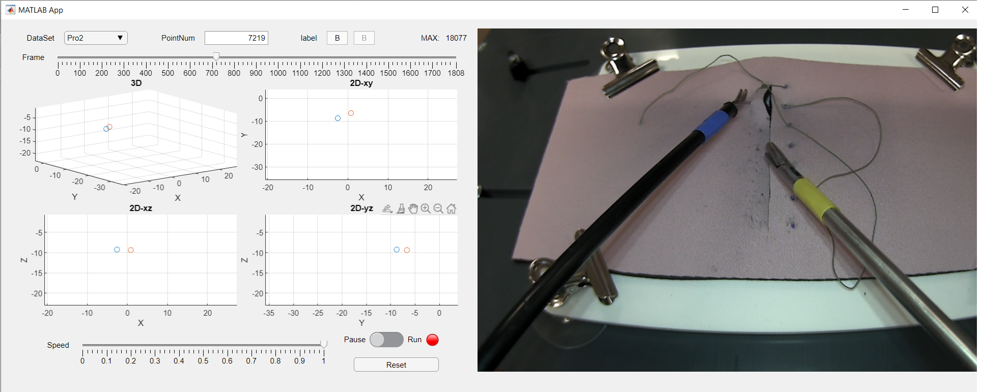

State

Speed controller

3D points

Video

Total frames

Raw(black) and Predict(gray) label

Frame now

9 Datasets in total