

Asia Pacific College

School of Computing and Information Technologies

**IRIS: A Customer Relationship Management (CRM)**

**System with Electronic Direct Mail (eDM)**

Submitted by:

Noelle Shierene V. Cervantes (Project Manager)

Shella Mae B. Gutierrez (Project Developer)

Mary Hazel Kate T. Comia (System Analyst)

Jeline B. Eclipse (Documenter)

Norrie B. Peñaverde (Programmer)

Submitted to:

Ms. Maricel Naviamos

(Professor)

July 21, 2017

Table of Contents

1.0. Introduction 1

1.1 Project Context 1

1.2 Purpose and Description 3

1.3 General Objectives 4

1.3.1 Specific Objectives 4

1.4 Scope and Limitations 5

2.0. Review of Related Literatures or Systems 6

2.1 Existing Customer Relationship Management 6

2.2 Existing Customer Relationship Management with Electronic Direct Mail (eDM) 23

2.3 Automated Electronic Direct Mail 29

3.0 Hardware and Software Requirements 31

3.1 Servers 31

3.2 Database 31

3.3 Operating System 31

3.4 Tools the application is integrated with 32

3.5 Programming Languages 32

4.0 Diagrams 34

4.1 Use Case 34

4.1.1 Use Case Diagram 34

4.1.2 Fully-dressed Use Case 35

4.2 Gantt Chart 50

4.2.1 Gantt Chart 50

4.2.2 Gantt Chart 51

4.3 Conceptual Framework of Existing Customer Relationship Management 52

4.4 Context Diagram 54

4.5 Data Flow Diagram 56

4.5.1 Diagram 0 56

4.5.2 Diagram 1.0 57

4.6 Entity Relationship Diagram 61

4.6.1 Entity Relationship Diagram of Proposed System 61

4.6.2 Data Dictionary 63

4.7 Activity Diagram 73

4.7.1 General Activity Diagram 73

4.8 Class Diagram of Proposed System 83

4.9 Conceptual Framework of Proposed System 84

4.10 Sequence Diagram 85

4.10 Gap Analysis 86

5.0 Data Dictionary 88

**Chapter I**

**Introduction**

# **1.0. Introduction**

## 1.1 Project Context

With regards to information systems, a Customer Relationship Management (CRM) refers to strategies, technologies, and practices that organizations make use of in managing and analyzing customer data and interactions all throughout the customer lifecycle. The system aims to improve business relationships with companies’ valued customers, assist in retention of customers, and drive sales growth. In the event that a CRM is implemented, users may expect the system to provide customer segmentation groupings, event monitoring, personalization, what-if scenarios, as well as predictive modeling. With an iterative process of data collection and analysis, business decisions are made contingent on customer feedback from analysis and consequent decisions refined previously. (Techtarget,2014)

SM Hotels and Conventions Corporation (SMHCC) was established to address the vast potential of tourism in the country. It is now developing and operating hotels and convention centers all throughout the archipelago, alongside an approximately 14,000 other hotels nationwide. With a relatively increasing competition among service industries, the foundation of CRM methodologies are deemed to be essential in assisting customer retention and even in making one’s target audience wider.

For service industries like hotels, providing the customer with a great experience is key to success. Often, very small details are what surprise customers and create a lasting positive impression. The foundation of CRM methodologies focuses not only on maintaining relationships with customers, but with profitable customers.

The CRM solution for marketeers, IRIS, makes use of Electronic Direct Mail (eDM) that enables delivering of tailored content to target audiences by means of utilizing analytics. Hence, authors are able to track number of opens, bounced messages, forwards, email responses and click-throughs. With the use of analytics, customer preferences will then be known through the pages a customer visits in an organization’s website. The system is designed to send automated emails to target audiences according to their interests with regards to the facilities or products the hotel has to offer. This information is particularly useful in refining target markets and assisting in customer retention.

It is of utmost importance that the stakeholders will be supportive and not reluctant in providing the project developers essential information as the organization as an entirety is expected to benefit the most in the implementation of the project.

The benefits of the project are improvement of guest experience, broader audience to send promotional emails to, seamless integration to other information systems used by the client, less workload for marketeers, as well asreliable automated sending of promotional contents to target audiences.

## 1.2 Purpose and Description

With regards to service industries, a CRM is just as necessary as its information systems designed solely for profit maximization. CRM is a comprehensive strategy used by businesses to acquire, retain, and partner with selective customers to create superior value for the organization and its customers. It provides value to the organization by means of the information users gather that may eventually be used to increase profitability through customer satisfaction.

The purpose of the project is to conduct an analysis on the current CRM of the organization and to delve into the existing information systems used by the client. This will provide the project developers insight on what systems are connected to the CRM and thus, will provide an insight on what information systems may be connected to the mobile CRM to be implemented.

The system to be implemented enables automatic sending of tailored emails to prospective customers. This is made possible through applying analytics to distinguish different preferences derived from the web-visiting patterns of customers. Moreover, the application enables report generation that provides an analysis contingent on customer’s web usage. This information is useful in refining target markets and optimizing future content as a result of an effective marketing strategy.

## 1.3 General Objectives

The general objectives are to conduct a thorough and in-depth research regarding the current CRM of the organization so as to come up with solutions that will be of importance to the client’s existing information system, and to design a CRM, with eDM as its primary feature, that is compatible with the existing systems of SM Hotels and Convention Corporation (SMHCC).

### **1.3.1 Specific Objectives**

* To create a system that determines web-visiting habits of prospective and existing customers so as to identify customers’ preferences.
* To create a system that determines prospective customers and generate an analysis regarding the customers’ interest.
* To create a system that determines whether an email provided by a customer is still active.
* To create a messaging module that enables automated delivering of tailored contents to target audiences that are contingent on customers’ preferences.
* To create a tracking module that tracks number of opens, forwards, email responses, bounced messages, and click-throughs.
* To create a report generation module that provides an analysis of the emails’ effectiveness to email recipients.
* To create a connection module that enables seamless connection to other information systems of the organization.

## 1.4 Scope and Limitations

The project will be focusing on research and discussion of different Customer Relationship Managament (CRM) solutions used by hotels, and most importantly, the one currently used by the client. The project will also take into consideration the processes of the hotel involving its information systems. This is to be able to recognize CRM’s importance as well as to identify the recurring problems experienced by the organization that the CRM to be implemented may help resolve.

The system comprises of a tool that monitors every web visit made in each page of the client’s website to gather information from prospective clients visiting the site. In the event that necessary information such as customer’s email address and web-visiting habits are collected, the system analyzes customers’ preferences. Afterwards, the application sends an email to prospective and existing customer solely contingent on customers’ interest. Moreover, the application generates email reports containing an analysis of every email sent, ones that bounced, emails that have been forwarded, the number of opens, as well as all the click-throughs made.

**Chapter II**

**Review of Related Systems**

# **2.0. Review of Related Literatures or Systems**

This chapter presents the related systems after the project developers’ thorough and in-depth research. This will also present the synthesis of the art for better comprehension of the Customer Relationship Management (CRM) solution to be implemented.

## 2.1 Existing Customer Relationship Management

One system developed that has been deemed an on-demand Customer Relationship Management (CRM) is the Salesforce cloud. It is a Customer Relationship Management (CRM) suite offering applications for small, midsize and enterprise organizations, focusing on sales and support. The Salesforce application has features including partner relationship management, marketing automation, customer service, and sales management. The capabilities of the application aforementioned help organizations track sales leads, conduct and monitor marketing campaigns, manage customer accounts, and provide service post sale. ( Dudovskiy, J. (2013, June 20). A Brief Literature Review: Customer Relationship Management [online]. Available: http://research-methodology.net/a-brief-literature-review-customer-relationship-management/ )

Salesforce for Outlook enables users to synchronize contacts, calendars, emails and tasks. Salesforce allows users to track sales deals, manage contacts, tasks and events, harvest leads and track performance. The Salesforce enterprise edition layers in call scripts, team-selling functionality, custom applications, business workflow, setup approval and automation, Application Program Interface (API) integrations, and a lot more functionalities considered useful in every organization. ( Dudovskiy, J. (2013, June 20). Salesforce.com CRM Software [online]. Available: http://www.softwareadvice.com/crm/salesforce-profile/ )

Another system is Pipedrive. It is a web-based sales CRM and pipeline management solution that enables businesses to plan sales activities and monitor deals . Built using activity-based selling methodology, Pipedrive streamlines every action involved in converting a potential deal into a successful sale. As a cloud-based application, the solution is accessible from anywhere using any web browser or dedicated mobile application. In addition, Pipedrive provides sales personnel full visibility of different sales pipelines. A robust interface displays the progress stages for each deal with the complete details for next actionable items. Moreover, Pipedrive offers custom sales reporting tools to analyze sales data, generate visual reports, and monitor individual and team level targets. ( (n.d). Do you find it hard to keep track of all your deals? Pipedrive get your sales organized [online]. Available: https://www.pipedrive.com/ )

Deemed as one of the most reliable mobile CRM is Helpshift. Its primary functions involve enabling customers to self-serve with native in-app FAQs - making a reply from an agent unnecessary, proactively sending a push or in-app message to every customer who has downloaded the client’s application, as well as personalized support. ( Wieberneit, T. (2017, March 20). Content Management Systems- The Hidden Secret of Great Custerv [online]. Available: https://lp.helpshift.com/ )

According to iDatalabs, 4,701 companies are using Siebel CRM solutions by Oracle. It is considered the world's most complete CRM solution which helps the organizations achieve maximum top and bottom-line growth and deliver great customer experiences across all channels, touchpoints and devices as exactly defined by Oracle. Its main purpose is to handle sales, relationship with the customers and its business partners to have a sales opportunities in premier enterprise. ( (n.d). Siebel Customer Relationship Management [online]. Available: https://idatalabs.com/tech/products/siebel-customer-relationship-management-crm )

Less Annoying CRM caters to the needs of small businesses, with various configuration options, cloud-based deployment, as well as a dashboard wherein an overview of projects, files, contact information, and other necessary information are made visible. Offering applications for contact management and Sales Force Automation (SFA), it enables businesses to consolidate customer information that is made accessible to the entire organization. The system’s modules are task management, lead tracking, note taking, and calendars. It also has configuration options enabling users to customize sales processes and lead definitions to best align with the user's own business processes and industry needs. ( (n.d). Less Annoying CRM Pricing, Features, Reviews & Comparison of Alternatives [online]. Available: https://www.getapp.com/customer-management-software/a/less-annoying-software/ )

NetSuite is a CRM solution delivering a real-time, 360-degree view of its client’s customers. It enables a seamless flow of information across the whole customer lifecycle - from lead all the way through sales order, support, opportunity, fulfillment, renewal, cross-sell, as well as upsell. In addition to offering standard CRM functionalities, marketing automation, and customer service management, NetSuite CRM delivers sales forecasting, order management, and other ecommerce features. ( (n.d). NetSuite is #1 in Cloud ERP [online]. Available: http://www.netsuite.com/portal/home.shtml )

Claritysoft is primarily developed for midsize and large business enterprises. It features customer service and support, sales and marketing automation, as well as social CRM within one application. It also features a contact management module which enables users to import contact lists from various sources. It also has a feature wherein users are allowed to view contact location in Google Maps, which is helpful in planning sales routes for sales representatives. The email marketing functionality enables users to design email templates and pull contacts from contact lists based on filters and preferences. Moreover, the application allows users to access their stored CRM data in the software’s offline mode, then sync changes with the cloud when the software is online again. ( (n.d). Claritysoft CRM Software [online]. Available: https://claritysoft.com/ )

Top Producer is a web-based CRM solution suited for small companies in Software or IT industries as well as in the Real Estate. The system allows users to manage their clients from initial contact to closing. The application enables users to receive lead notifications via text or email. It also features a countdown clock which starts working as soon as an inquiry or request comes in. In addition, it has a follow-up coach feature assisting users to stay on top of current clients through suggesting appropriate touch points. Users can create personalized emails from templates and send monthly branded newsletters whenever necessary. Moreover, Top Producer CRM solution is compatible with various systems used by today’s agents. ( (n.d). Top Producer [online]. Available: http://www.topproducer.com/products/top-producer-crm)

CallProof is a sophisticated CRM software with myriad of features that efficiently organize every facet of the sales process. Unlike numerous of CRM solutions made available today, this system is fully web-based, and is optimized for companies that utilize a team of sales representatives in the field. It has a feature that enables the application to work seamlessly from any smartphone, as well as almost any device with Internet capabilities. The system is considered unique and essential as it takes an automated approach to sales. When a meeting with a client or prospect is set, the organization’s sales representative will check in to that client's location. This check-in will then be logged as an interaction with the client, and is automatically entered into the client's profile. Calls with clients are also recorded as an interaction within the system. Sales managers use a map interface that allows tracking of current location of each member of sales team. This process assures users that all interactions are recorded. Thus, improving data quality and minimizing the work of sales teams. ( (n.d). The best Mobile Lead Tracking Software

for your iPhone & Android [online]. Available: http://callproof.com/ )

SalesNOW is a cloud-based CRM solution that can be used on any connected mobile device via web browser. The system offers applications designed specifically for devices that are of much prevalence in organizations. The application features lead management, contact management, company tracking, sales forecasting, and analytics dashboards. It also includes features that enable users to take sales notes, log calls, as well as capture emails automatically; keep corporate account histories of clients in order to train new employees; view activities of sales representatives and various sales data, including next steps on leads and deals. Moreover, the system also allows users to customize reports and data fields, and provide graphical representations of sales forecasts and activity reports. ( (n.d). SalesNOW [online]. Available: https://www.salesnow.com/ )

LeadMaster is a lead management solution that offers features enabling users to capture, track and follow up with leads. The solution comprises of several modules for CRM, sales force and marketing automation, as well as business analytics. The solution is used across a wide range of large and midsize industries. Other functionalities the solution has are workflow automation, email marketing, marketing analytics, lead nurturing, and a virtual call center. In addition, LeadMaster integrates with a variety of useful tools used by organizations. ( (n.d). Leadmaster [online]. Available: http://www.leadmaster.com/ )

PipelineDeals is another CRM solution enabling users to manage contacts, qualify and track leads. The application provides both CRM and sales engagement while providing real-time deal status updates, daily pipeline snapshots, and 3D charts on a sales dashboard. With this software, users are enabled to access pages containing a wide range of activities, people, documents, as well as events related to a single deal. In addition, the system sends emails that are easy to track, so users know when someone opens a message, downloads an attachment, or clicks a link. It also allows sales associates to import existing data in bulk from other CRMs while PipelineDeals scans for data redundancy. ( (n.d). Pipeline Deals: Smart Selling Made Simple [online]. Available: https://www.pipelinedeals.com/ )

BNTouch Mortgage is a mortgage-specific CRM solution offering mortgage bankers and brokers alike a robusta as well as dependable solution offering advanced marketing automation functionalities. For each step of the mortgage process, the application offers suitable features – beginning from appropriately marketing to prospects, clients, and partners, until the completion of the loan application process. Moreover, the system can deliver an end-to-end solution providing content, features, and functions that are tailored to fit mortgage industry terminologies. ( (n.d). BNTouch Mortgage CRM Software [online]. Available: http://www.softwareadvice.com/crm/bntouch-profile/ )

Marketing 360 is a marketing platform suited for entrepreneurs as well as small and midsize organizations. The system allows organizations to conduct search engine programs, analyze digital marketing performance, as well as run social media advertising campaigns. In addition, the system provides website templates that are customizable with the use of drag-and-drop feature. It also has a feature that aims to improve websites' search results by tracking keyword volume. Moreover, it analyzes competitors' SEO performance with the same keywords in real-time, providing useful conversion rates. Another feature enables organizations to segment and target clients on the basis of social details. ( (n.d). Capterra: Marketing 360 [online]. Available: http://www.capterra.com/p/148516/Marketing-360/ )

As stated in Software Advice, Infusionsoft is a CRM software used to manage customer relationships and generate new leads for small and medium companies. It is recognized as an “all-in-one” CRM software as it is providing different features that a CRM tool should have, including sales and marketing automation tools to track new possibilities. In addition, users of this software can collect and save both online and offline transaction. ( (n.d.). Infusionsoft CRM Software [online]. Available: http://www.softwareadvice.com/crm/infusionsoft-crm-profile/ )

According to PR NewsWire, Chime is a CRM application which will change the real estate industries. This application helps users achieve higher sales. Being a mobile-friendly application to the users, it makes every work easier. Thus, making it independent on manual processes. ( (n.d.). Chime Launches Next Generation All-In-One Real Estate Platform To Turbocharge Agents' Sales [online]. Available: http://www.prnewswire.com/news-releases/chime-launches-next-generation-all-in-one-real-estate-platform-to-turbocharge-agents-sales-300307453.html )

Base CRM is a software for sales people in small companies. It is a user-friendly application offering all the necessary features of a CRM. Unlike other CRM solutions, its storage is limited and it cannot cater third party applications, particularly marketing and sales management programs. ( Ilao, J. (2017, March 27). Base CRM User Review & Pricing [online]. Available: <http://fitsmallbusiness.com/base-crm-reviews/> )

BlueCamroo is a cloud-based CRM software that helps companies build better relationships with the customers and organizations. By the use of this software, users will be kept updated with the growth of the company. Also, it can cater bills and payments online that will make the transaction faster. ( Matthews, M. (2016, May 5). BlueCamroo CRM [online]. Available: http://technologyadvice.com/products/bluecamroo-reviews/ )

Maximizer CRM is a cloud-based application which can merge with different business applications such as Microsoft Office, Outlook, and Exchange. It is accessible to users because of its in-house databases that make data secure, and access to the customers’ records immediate. ( (n.d.). Maximizer CRM Review [online]. Available: https://reviews.financesonline.com/p/maximizer-crm/ )

Hatchbuck CRM is an inexpensive and easy-to-use software that can be used by small companies. The system makes tracking of deals faster. The system may help small companies be independent on endless records. Thus, generating faster transactions with the customers. ( Bohn, R. (2014, July 10) CRM Review – Hatchbuck [online]. Available: https://sellmorenow.com/crm-review/hatchbuck/ )

According to Landsdale Group, Pivotal CRM allows the user to integrate all customer related transactions that will lead to better sales, marketing and customer services. It can be merged with different Microsoft tools such as Microsoft’s Outlook, SharePoint, and Office. ( (n.d.). Pivotal CRM Solutions [online]. Available: http://lansdalegroup.com/solutions/pivotal-crm-solutions/ )

According to Smallbizcrm.com, Cynergy Help Desk is the most preferred software of support-center organizations. Its features enable holding different needs of the customers and linking to different databases and system management tools including scanning and asset management. ( (n.d.). Cynergy Help Desk [online]. Available: http://www.smallbizcrm.com/profile-directory/cynergy-help-desk/ )

eWay-CRM is a software integrated in Microsoft Outlook that is specifically built to aid companies on how to handle businesses. The software solution can manage email communications, arrange contacts, and projects. ( Matthews, M. (2016, July 25). eWay-CRM [online]. Available: http://technologyadvice.com/products/eway-crm-reviews/ )

1CRM is a software that allows arrangement of business the way users intend to. It can be mixed with different tools like Google Apps, Facebook, and Wordpress. Also, it allows users in the business to access the same information within a single platform for a faster response to customer service. ( Louis, S. (2016, August 10). 1CRM [online]. Available: https://crozdesk.com/customer-service-crm/crm-software/1crm )

The KNOVA KM CRM is supporting the customer's telecommunications, financial services and IT help desk to find a solution for customer issues immediately. The service offers ease of use for the managers and users to have a detailed context and intent about customer problems. It not only focuses on satisfying the customer needs, but on different functionalities as well, such as on resolutions where you can search anything and find a resolution. The value and customer satisfaction function brings resolution immediately and accurately. ( (n.d.). Aptean CRM Solutions - KNOVA KM [online]. Available: http://www.aptean.com/solutions/application/crm-solutions )

The nutshell CRM is a mobile CRM that has a few features like instant access to a mobile device, multi-tasking for faster transaction, simple interface for the users, and a mobile business card scanner that allows creating new contacts with a single button. This application can be managed on a mobile device anywhere and on the go. ( (n.d). Nutshell CRM - Mobile CRM [online]. Available: https://www.nutshell.com/mobile-crm-for-small-business/ )

Infoflo CRM is one of the simplest CRM solutions where a manager can access all the data in just one click and monitor all the business relationship with the customers. All the information is automatically shared and synchronized to a specific contact or company. Infoflo allows users to track leads, reviews and sales growth for a good business solution. ( Infoflo CRM (2017, March 21). CRM Review [online]. Available: https://reviews.financesonline.com/p/infoflo/ )

Relenta is an automated CRM for email, contact manager, email marketing and calendar for a company. All the data from email accounts and user inboxes with all the customer information in a browser and application. Emails that shared with any company or person are saved permanently on a CRM record and the contact timelines, it shows the completed tasks and email marketing history in a team and creates a chronological order for each customer relationship. ( (n.d.). Relenta CRM [online]. Available: http://findaccountingsoftware.com/directory/relenta/relenta/ )

Bitrix24 CRM provides an interaction with new and existing clients, to connect smoothly and integrate the contacts. The reports are generated by carrying out analysis and import/export contacts to the customers as requirements. A dashboard is a picture of report for sales activities and to view the deals, leads and invoices. ( (2012). Bitrix24 CRM [online]. Available: https://www.bitrix24.com/features/crm.php )

GoldMine CRM has different features like email linking for sending consistent emails to the customer and web and mobile access for the convenience of the customers in accessible platform. Sales forecasting and opportunity management to monitor the sales activities and business leads. GoldMine is a cloud based solutions for the seamless storage that will process the data privately and to secure the user information. ( (2017). GoldMine CRM Premium CRM [online]. Available: https://www.goldmine.com/goldmine-premium/ )

Prophet CRM is a set of different systems that is installed in MS Outlook for the data and activities that the business conducted. Sales automation is designed to allow the managers to keep track of sales and reduce the repetitive tasks in notifying sales. It has a mobile CRM integration for synchronization of emails that is accessible on any device. Reports and analytics feature has capabilities of tracking, analyzing and generating sales and performance reports. ( (n.d.). Prophet CRM [online]. Available: https://www.avidian.com/features )

Soffront is one of the pioneer CRM solutions in the market with key features of sales automation to track the leads and products, email marketing for faster advertising of the events and sales, customer service management for the problems that customer encounter and for coming up with a solution, and employee help desk for technical support of the employees. Soffront CRM is one of the most user-friendly and customizable platforms and has the best practices for utilizing the features of customer relationship management. ( (2017, June 9). Soffront CRM [online]. Available: https://www.getapp.com/customer-management-software/a/soffront-crm/ )

InStream focuses on interaction tracking, lead management, contact management and social media integration. With these features, the InStream CRM is capable of monitoring, synchronizing and helping the customers set appointment effortlessly. The software allows the users to have a more reliable medium of communication to set a meeting and events efficiently. ( InStream CRM (2017, March 5). InStream Review [online]. Available: https://reviews.financesonline.com/p/instream/ )

According to Shukla, P. (2016), a microsoft dynamic CRM professional, Microsoft has their very own CRM which they called MS Dynamic CRM. In 2013, MS CRM upgraded and created a mobile application, integrating it to help their sales department have better mobile communication. In 2016, they added more features for it to be useful to both its customers and sales department. ( Shukla, P. (2016). MS CRM 2016 Mobile App Configuration. [online]. Available: https://community.dynamics.com/crm/b/prashantshuklamscrm/archive/2016/09/26/ms-crm-2016-mobile-app-configuration )

Contactually is the best CRM that suites the requirement of a project. It has features where email templates are customizable enabling emails to be sent faster. It can also send bulk emails all at once. In addtion, the CRM has an intelligent technology for making new templates for the client the user is conversing with. (Contactually, Inc. (2017). Contactually CRM- Product features. [online]. Available: https://www.contactually.com/product-features/ )

Nimble CRM is a CRM that works easily in merging, searching, sorting and pulling off contacts to create a more personalized and unique profile for each client. It also has a feature wherein in just a one tap, users can make calls, send emails and text messages, use maps, social networks and websites. The system also efficiently handles communications documentation. ( SmallBizCRM.com (2017). Nimble CRM Review [online]. Available: http://www.smallbizcrm.com/crm-software-reviews/nimble-crm-review/ )

Hubspot is a CRM that caters the inbound marketing of the company. It has features that help improve the analytical processing of marketing investments. Hubspot has a feature that can track emails and manage multiple accounts from the same application. (Robb, 2016) Hubspot can also be used to visit websites, do blogs, and monitor tags of the company name in social media. ( Hubspot, Inc. (2017). Hubspot [online]. Available: https://www.hubspot.com/products/marketing )

Insightly CRM is one of the top CRM solutions in the market. It is a powerful CRM that is integrated with Google features. Insightly establishes customer relationship and project management in just one application. It automatically finds contacts in the user’s social network accounts. In addition, the system can also be a collaboration tool to see the team’s email, notes, and tasks. In doing some task management, advance reports and other work needs can be easily handled by this software solution. ( Guay, M. (2014). Insightly [online]. Available: https://zapier.com/zapbook/insightly/review/ )

Podio CRM claims in having all the functionalities users want to run in business. It has its own social network and chat feature improving communication with the whole company. Also, it has a web and mobile application for ease of use. ( Guay, M. (2014). Podio Available: https://zapier.com/zapbook/podio/review/ )

Track Via is a mobile-based CRM that is easy to use. It uses a mobile workflow management platform that quickly transforms enterprise operations, processes and business data into the application. This CRM makes the office work easier. Tasks such as adding relationships to link data, filtering and sorting data, and calculating the values in forms to add data automatically is performed easily using this application. Creating reports and dashboards are also one of its features. Track Via uses roles to know who is authorized to see specific confidential data. It has its own database where it can store all the data imported by the user. ( Guay, M. (2014). Track Via [online]. Available:https://zapier.com/zapbook/trackvia/review/ )

Odoo CRM is an open-source multi-functional CRM. This CRM has a high rating in terms of the comparison of lead management, lead acquisition, sales pipeline, relationships, sales, marketing, reporting, productivity and usability, and user interface. It claims that users can run everything in business with the use of Odoo CRM alone (Guay, 2014). Also, it can generate accurate forecasts. ( (n.d.). Oddo Apps [online]. Available: http://www.odoo-bs.com/page/odoo )

According to Conrad, A. and Wood, C. in Captiva Website, one good open-source CRM is Zurmo. It is one of the famous open-source CRM solutions in the market. According to a review in financeonline.com, this CRM can be customized according to the preference of the user. Also, it makes the import and export of CSV and other formats easy. In addition, it improves the interaction and communication with its clients. Moreover, it can fully automate the cycles and processes of the sales department. Zurmo CRM has a lot of features that a CRM must contain so it is considered one of the best open-source CRM systems. ( (n.d.). The 10 Best Free and Open Source CRM Software Solutions [online]. Available: http://blog.capterra.com/free-and-open-source-crm/ )

Agile CRM has capabilities of providing contacts, task and opportunity management, and tracking emails. Agile CRM also has helpdesk options and can create basic reports. In addition, it can organize online engagements with customers. The application has a smooth user interface that enables users to easily create reports and automations, as well as filter data fast. Agile has collaborated with Google, making use of its google calendar. Such feature is necessary for upgraded updates of the schedule of the user. The system’s functionalities can address small businesses needs, despite the fact that it is free. ( Wen, C. (2016). Top 10 Free CRMs for Small Business that Offer a Mobile App [online]. Available: https://getvoip.com/blog/2016/11/28/free-crm-small-business/ )

Zoho is an online CRM System that helps sales and customer relationship improve. The following are some benefits of Zoho CRM: First, it automates daily sales activities reports which are customizable to meet the specific needs of the business. Second, it gives access to important data in real time because tracking tool, allows you to see where the customer is in the sales cycle and access data in its easy, accurate, and dynamic reports and dashboards feature. Third, it allows users to go mobile because it helps customers stay in control even while on the go because it has the capability of searching the customers nearby. Lastly, it integrates with Google Apps. Thus, connecting the application to Gmail, Calendar, Docs, Contacts, and Activities. ( (n.d). Zoho CRM Review: Best Free CRM Software [online]. Available: http://www.businessnewsdaily.com/7842-best-free-crm-software.html )

SkyCRM is a cloud-based software solution that boosts relationship between the suppliers and its customers, and provides information of the customers to the staff along with the past transactions details. SkyCRM allows the employers to handle schedules through the tasks list, calendars, and alerts. Also, it permits management to forecast the needs of future resources and sales. The users of SkyCRM can schedule meetings online and can open the leaderboards showing sales leaders. The members of the team are updated about sales performance through the automated email function of the application. ( (n.d). SkyCRM Software [online]. Available: http://www.softwareadvice.com/crm/skyCRM-profile/ )

The cloud-based CRM tool, ProsperWorks, saves user’s customer data automatically. The document that is sent using email is stored in a contact’s portfolio instantly. All past transactions, schedules, events, calls and meetings are recorded in the program. Activities can be seen in Gmail. The system’s management feature uses the drag and drop functionality to control the users sales pipeline. ( (n.d). ProsperWorks CRM Software [online]. Available: http://www.softwareadvice.com/crm/prosperworks-profile/ )

AmoCRM sales management service can only be accessed using a network. The users can expand the capacity of amoCRM with the use of integrations and open API. The functionalities of amoCRM includes allowing users to create unique tags to arrange contacts and deals; giving users an update on meetings, calls, and emails; and connecting directly to platforms like Dropbox, Facebook, Zendesk, and MailChimp. AmoCRM also has mobile application that can be downloaded in Playstore and App Store. The system also has a friendly interface that allows users to reduce time for contact handling, and control the sales process easily. ( (n.d). amoCRM Software [online]. Available: http://www.softwareadvice.com/crm/amocrm-profile/ )

Capsule is an online CRM application that tracks all of the people the users have business with. It also resolves the customer’s request using the ticket management module and provides personalized options to meet the requirements of different organizations, companies or businesses including the specified label and brands. ( (n.d). Capsule Software [online]. Available: http://www.softwareadvice.com/crm/capsule-profile/ )

Apptivo CRM has features of tracking activities, monitoring sales pipeline, and helping the desk ticketing. The application is customizable and user-friendly. It enables users to manage and track customers, contacts, orders, and projects. The Apptivo solution is mixed with the human resource, finance, and project management. In addition to its standard CRM capabilities, the application also has an accounting system and a reporting tool. ( (n.d). Apptivo [online]. Available: http://www.capterra.com/customer-relationship-management-software/spotlight/120697/Apptivo%20CRM/Apptivo )

Salesbox is an intelligent, agile and mobile sales tool. It works in mobile, Outlook or Gmail, and in any computer. It helps users reach its target gap, so the user does not have to fret about what it takes to reach the target. Also, it inspects all the new items and records then compare it with other files to avoid redundancy. In addition to that, the application tracks the sales team performance, goals, accounts, revenue, and contacts. Moreover, the system has a feature allowing for report generation to take less than a minute. Users can also compare the performance of contacts with each other as it has records of every detail of the delivery and meetings, making the system record a complete communications history. ( (n.d). Salesbox [online]. Available: http://www.capterra.com/customer-relationship-management-software/spotlight/140885/Salesbox/Salesbox )

SalesJunction CRM is a web-based CRM and SFA Software. It is a dependable online CRM service that meets the requirements of the customers. This sales automation software keeps contacts and opportunities organized, and offers workflows to automate the sales process. SalesJunction states that data is safe and private using the SalesJunction CRM. It can handle the accounts, build pipeline, generate forecast, as well as share calendar and documents. Also, it is customizable for all types of industries. This software sends reports daily, weekly or monthly automatically, which ensures that the team members are always updated. The application can be accessed using a mobile phone or a computer, but the mobile application of this CRM is only limited to Apple phones having iOS 4.3 and above. Thus, making it unavailable for Android devices. ( (n.d). SalesJunction [online]. Available: http://www.capterra.com/customer-relationship-management-software/spotlight/15443/SalesJunction/SalesJunction )

PeopleVine is available on mobile phones, tablets, and computers. It has over 2,500 features. It offers features that enables users to reach customers anywhere using email, SMS messaging, and through social media. Also, the application integrates with the API and can be used in appointments and reservations. ( (n.d.). PeopleVine [online]. Available: https://peoplevine.com/page/features )

## 2.2 Existing Customer Relationship Management with Electronic Direct Mail (eDM) as Primary Feature

Constant Contact software is expensive but has a good features that help business to send emails. Its built-in templates is a great material for those who are new in using an eDM software. Next is it has an access to gmail and outlook to gather all the contacts. It also has a free trial for companies who are comparing eDM for their company. Like the email brain it also use the google analytics for it report generation. Lastly it is also available in mobile devices. ( PCMag. (2017). Constant Contact Email Marketing [online]. Available: http://sea.pcmag.com/constant-contact-email-marketing/14884/review/constant-contact )

Email Brains is a type of EDM that can send emails and also send text messages to the customer. Like other EDM it has many templates to choose from. Users can store files and images in the same software. It also has the same functionality like the objectives of this project which is to generate a report on how many emails it has sent and how many of those messages contacts have opened, forwarded, clicked through or unsubscribed from. Also, this EDM is integrated with Google Analytics to analyze the customers’ habits including information on specific links they have clicked. EmailBrain has two user interfaces: Express Mail, which is used by beginner staffs that perform basic task and functionalities and Advanced Mail that is designed for staffs with more expertise when it comes in creating an email. ( TopTenReviews (2017). Emailbrain Review [online]. Available: http://www.toptenreviews.com/business/marketing/best-email-marketing-services/email-brain-review/ )

Mad MIMI EDM is the most cutest and beautiful in terms of design of the templates, but even though it is simple it will attract more customers. Its has mobile- friendly emails and has a clean interface that makes it more easy to use. It has layouts that helps the novice in creating an exquisite emails immediately. It also has the popular report statistics of the emails open and clicked rates. Mad MIMI is always compared to MailChimp because they say that mad mimi is the cheap version of mailchimp. Singleton, C. (2017) Like Mad MIMI the developers want a statistics of the open rate and clickthroughs, but unlike the Mad MIMI the system also will have the statistics for forwards and the emails that are inactive. ( Singleton, C. (2017). Mad MIMI Review [online]. Available: http://stylefactoryproductions.com/blog/mad-mimi-review#.WVUmDoiGPIU )

The freshmail is a mass mailing system that has a feature of email creation tools, different templates, anti spam analysis and expanded reporting enables to marketer to deliver a response to customers through email. It saves time to make a template because it has a ready-made template and easy way to create like a professional designer. The anti spam analysis helps to check if the email will be sent as spam and reports are generated to know the preferences of the customers. ( Adamczyk, A. (2014, June 29). The 12 features of the mass mailing system [online]. Available: https://freshmail.com/blog/12-features-of-good-mass-mailing-system/ )

Moosend is an email tool for marketers to communicate with the customers as well as it serves as a marketing strategy to promote the products. With the different features of the software, it supports cloud and a web services, it has a bounce tracking to check if the email has bounced or not and click-through tracking to know all the details of the email promotions or campaign in one click. ( Vaswani, J. (2017, May 09). Email marketing review – Moosend [online]. Available: http://www.bloggersideas.com/moosend-review/ )

Firsthive is one of the simplest marketing software that creates a specific data where you can have the open and click rate of the specific activity. It is integrated with other system such as zoho crm and SMS to sync the sales and marketing activities along with a message to keep updated about the campaign. The focused of this software is to collect and identify the target customer using the modern marketing techniques that will lead to have a better decision. ( Team firsthive. (2016, February 26). Your favorite marketing platform [online]. Available: https://firsthive.com/blog/index.php/2016/02/26/your-favorite-marketing-platform-just-got-more-powerful/ )

Yesware is a software that helps the business to be organized and maintain a good relation with the customer. Features are organization and structure, reporting capabilities, advanced reporting, template standardization and easy template sharing. The sales representative saves time for generating report about the prospect activity and tracking the emails sent and the team’s performance. ( Andrew. (n.d.). Features Functionality [online]. Available: http://www.yesware.com/blog/features/team-functionality/ )

Mailchimp is one of the popular email marketing software that enables the big businesses to handle a huge number of emails. It has a feature of email templates, reports, automation and track leads and paying customer these can be used by marketer to send campaigns for customer. Also it is a mobile software that can be work on both operating system such as android and ios. The mailchimp has different design and variety of email templates that saves time in designing and can track leads that create a segments to the new customers. ( Berger, B. (2017, February 24). Advanced features - Mailchimp [online]. Available: http://www.brittanyberger.com/advanced-mailchimp-features/ )

Dotmailer is a simple and helpful platform for automation of the emails. It has functionality of marketing automation, campaign management, strategic services and custom integrations that will improve existing functionalities. The productivity increases because it makes the team fast and productive with the drag and drop template and effective campaigns. ( (2016, December 15). Dotmailer [online]. Available: https://reviews.financesonline.com/p/dotmailer/ )

EmailDirect is an email marketing tool that includes templates for more personalized emails, monitor preferences to send related emails, use database tools in sorting mailing lists and many more. ( Guay, M. (2015 January 28). EmailDirect Review [online]. Available: https://zapier.com/zapbook/emaildirect-da11/review/ )

FireDrum use an Application Programming Interface (API), a set of rules and an instrument in creating or making a software application, and the .csv import process to import customers email addresses, and also an internet-based application with free templates that are customizable depends on the client needs or requirements. It has Drag and Drop Email Studio that makes the email fun and allows to operate with the programming languages like Php, Java and other programming languages. It is also integrated with Google Analytics. It can keep the data updated, import and export customers, combine or connect to the other system. The click-throughs and opens of the customer are reported and monitored. It is also integrated with Google Analytics. ( (n.d). Email Marketing Features [online]. Available: https://www.firedrumemailmarketing.com/email-marketing-features/ )

Objectives of the Exact Target are to boost the sales of the company, maximize marketing investments, and to make the customer relationship improve. Exact Target is good for a large company that wants to send numerous emails to the customers and specializes in reporting and tracking. Predictive analysis is used. It monitors the most opened, links clicked and the results of a survey. It also gives automated marketing and analytics software. It also collects customer’s taste data and purchasing routine. ( (n.d). Exact Target [online]. Available: https://www.crunchbase.com/organization/exacttarget )

Features of Informz are: automatically detecting invalid customer email addresses, can connect to any database with a use of Informz API, tracks forwards and send-a-friend messages and click-throughs on the web page. Shows the inactive and active users. Also, can contain unlimited users, contacts, templates, report history, and system upgrades and integrated with Google Analytics. Inform target is to get the interest of the customers. ( (n.d). It Informz Features List [online]. Available: http://www.informz.com/wp-content/uploads/2011/Landing_pages/features_list.pdf )

Gammadyne Mailer is an automated business marketing software that improves the customer’s response rate, and manages the customer’s information. Also, It doesn’t need to import or export the data because it can be directly edited data in the database. It converts all customer’s email addresses i0nside the database lowercase, and uppercase. It reports and tracks open and clicks. Also, the location, and language that they use, and the customer’s interest. It helps you to boost sales. It runs on the Windows XP or the latest version of Microsoft. ( (n.d). Windows Software [online]. Available: http://www.gammadyne.com/ )

Mailrelay tracks customer’s opens and clicks in the newsletter and get or access the location of the customer, browser used and others. It gives and creates customer’s interest reports, and it also improves the delivery speed. It has an SMTP stands for Simple Mail Transfer Protocol server. ( (n.d.). Mailrelay [online]. Available: https://mailrelay.com/en/features )

Benchmark email is a simple software that does the same job as the other softwares. It is easy to send emails and has its autoresponder messages. It can also make polls and survey sheets that will help in data gathering. It can also integrate plugins to utilize the functionality of the eDM. The UI of the benchmark email has many range of languages to choose from. It is also a handy app because it is also available in iOS and Android phones that can help in sending emails on the go. ( Guay, M. (2015). Benchmark Email [online]. Available: https://zapier.com/zapbook/benchmark-email/review/ )

Get response is one of the eDM that uses the drag-and-drop method in creating the email template. It can store images that can be use in the the future emails. It has a real time reports on the email functionalities. It is also integrated to social media sites that can help in the promotion of the business. It can also run in mobile phones that makes the life easier to the marketing people. It has a feature where it can track, gauge, and analyze emails immediately. It can make smart decisions to compare follow-ups, measure site conversions, and segment subscribers. ( Get App. (2017). GetResponse Pricing, Features, Reviews & Comparison of Alternatives [online]. Available: https://www.getapp.com/marketing-software/a/getresponse/ )

## 2.3 Automated Electronic Direct Mail

Streamsend is an Electronic Direct Mail (eDM) that has an advanced behavioral automation, trigger-based messaging and list segmentation. It also has a functionality of having a Private IP address. In addition, Streamsend can share email to social networking sites. From one dashboard it can track email, social and video campaigns. Moreover, it has an email analyzer wherein it can run the email in 9 spam filter before sending it to the client. ( Jones, S. (2017). StreamSend Reviews: The Automation Experts? [online]. Available: https://www.werockyourweb.com/streamsend-reviews/ )

The existing Customer Relationship Management (CRM) solutions have features such as handling sales, lead tracks, and integration of information systems in a seamless flow to help the client determine customer’s feedback. CRM solutions with Electronic Direct Mail (eDM) offer features such as sending and generating newsletter, handling mailing lists and triggered-based messaging, to mention a few. These functionalities keep customers updated on the campaign or promotions the organization has to offer.

The related literature and systems and their corresponding functions aforementioned may all be considered necessary in the development of IRIS. Streamsend CRM is an application that resembles the system to be implemented. It has much similarity with the project, including its functionalities and features that a typical CRM has. However, the project to be developed has more functions of relevance with Electronic Direct Mail (eDM) that makes it unique and important in the organization. These features include automated delivering of tailored contents, tracking of opens, bounced messages, forwards, email responses and click-throughs that makes it easy for marketeers to promote products and services in real-time.

**Chapter III**

**Hardware and Software Requirements**

# **3.0 Hardware and Software Requirements**

## 3.1 Servers

The CRM application supports all web servers that systems used by the client such as Opera and Fidelio support. For example, Oracle WebLogic Server and IBM WebSphere Server. However, the system does not support all web servers on all operating systems. The system can be installed on the same server where the client’s server is located, or on a different server. If the application is installed on the same web server as other system servers used by the client, additional hardware resources such as memory may be required.

## 3.2 Database

The application supports a subset of the database systems that most CRM supports. This includes Microsoft SQL Server 2008, Oracle 11g and IBM DB2 (UDB) 9.5.

## 3.3 Operating System

The application can be installed on a subset of the operating systems that Fidelio and Opera support. Some examples are Microsoft Windows 2008 64 bit; Sun Solaris 10; IBM AIX 6.1 64 bit, Oracle Enterprise Linux 5.5 and Linux Red Hat 5.1; HP-UX Itanium 11.3.

## 3.4 Tools the application is integrated with

Tools that may be integrated with the system for identifying inactive users, keeping track of opened emails, bounced messages, click-throughs, and email responses, and other digital marketing activities are the following:

* **Google Analytics**
* allows developers to track how many visitors are coming to the client’s site, for example, enabling users to know which channels are sending the most traffic and what content is performing best.
* **Quick Email Verification**
* allows real-time email validation API service that protects web forms and prevents unreachable and risky addresses from entering client’s database.
* **Sumo**
* arms developers with a suite of tools that enable users to perform digital marketing activities that are useful in coming up with effective marketing strategies.

## 3.5 Programming Languages

* **PHP**
* widely-used open source general-purpose scripting language that is especially suited for web development.
* **Python**
* widely-used high-level programming language for general-purpose programming. This is also useful in generating reports for the marketeers.
* **R**
* open-source programming language and software environment for statistical computing and graphics.
* **JavaScript**
* one of the three core technologies of World Wide Web content production. It is used to make webpages interactive and provide online programs.

**Chapter IV**

**Diagram**

# **4.0 Diagrams**

## 4.1 Use Case

## https://documents.lucidchart.com/documents/bb7094ca-c95f-43e1-a728-e3a028e0c92c/pages/0_0?a=571&x=77&y=-13&w=1176&h=1166&store=1&accept=image%2F*&auth=LCA%2081522b80f2b3d9ac4649ff27f632f76e25525976-ts%3D1500319095 4.1.1 Use Case Diagram

**Figure 4.1 Use Case Diagram of Proposed System**

### **4.1.2 Fully-dressed Use Case**

**4.1.2.1 Manage Events**

|  |  |  |  |  |
| --- | --- | --- | --- | --- |
| **Use Case ID**  **IRIS-USC01** | | | **Use Case Name**  **Manage Events** | |
| Description  Records events information. | | | | |
| Actor/s  Marketeer | | | | |
| Precondition/s  Marketeer has an account in the system, and has authority to manage events information. | | | | |
| Main Success Scenario: | | | | |
| Step | | Activity | | |
| 1 | | Marketeer initiates a View Events function. | | |
| 2 | | System loads a list of existing events from the database. | | |
| 3 | | System sorts events information according to categories. | | |
| 4 | | Marketeer retrieves sorted events information. | | |
| Alternate Flows: | | | | |
| Step | Alternate Flow | | | Activity |
| * | Marketeer cancels managing events | | | System discards the entire process and ends use case. |
| 1a | Marketeer adds event’s information. | | | 1. Marketeer initiates an Add Event function. 2. System displays a data entry screen containing the following:  * Date the event was created * Description of event * Start date of event’s effectivity * End date of event’s effectivity  1. Marketeer fills in all fields of the events. 2. Marketeer confirms events information. 3. System verifies inputs. 4. System records the entries. 5. Marketeer reviews generated form. |
| 1b | Marketeer updates event’s information. | | | 1. Marketeer initiates an Update Event function. 2. System loads a list of existing events from the database. 3. System displays all existing events from the database. 4. Marketeer chooses a record to update. 5. Marketeer fills in fields to be updated. 6. Marketeer confirms events information. 7. System verifies inputs. 8. System records the entries. 9. Marketeer reviews generated form. |
| 1c | Marketeer deletes event’s information. | | | 1. Marketeer initiates a Delete Event function. 2. System omits information about the event. 3. System updates the database. |
| 1a.5a/  1b.7a | Marketeer fails to fill in required field/s. | | | 1. Marketeer does not fill in a required field. 2. System prompts the marketeer to fill in the field/s. |
| 1a.5b/  1b.7b | Marketeer’s input does not match designated data type. | | | 1. Marketeer inputs a value to a field that does not match its assigned data type. 2. System prompts the marketeer to check field input with errors. |
| Post-conditions   1. System records events information. | | | | |

**4.1.2.2 Manage Promotional Emails**

|  |  |  |  |  |
| --- | --- | --- | --- | --- |
| **Use Case ID**  **IRIS-USC02** | | | **Use Case Name**  **Manage Promotional Emails** | |
| Description  Records promotional email’s information. | | | | |
| Actor/s  Marketeer | | | | |
| Precondition/s  Marketeer should already have an account in the system, and has authority to manage promotional email’s information. | | | | |
| Main Success Scenario: | | | | |
| Step | | Activity | | |
| 1 | | Marketeer initiates a View Email function. | | |
| 2 | | System loads a list of existing emails from the database. | | |
| 3 | | System sorts emails according to categories. | | |
| 4 | | Marketeer retrieves sorted email information. | | |
| Alternate Flows: | | | | |
| Step | Alternate Flow | | | Activity |
| * | Marketeer cancels managing promotional emails | | | System discards the entire process and ends use case. |
| 1a | Marketeer adds promotional emails information. | | | 1. Marketeer initiates an Add Promotional Email function. 2. System displays data entry screen containing the following:  * Date the email is sent * Recipient of email * Content of email * Email template  1. Marketeer fills in all fields of promotional emails. 2. Marketeer confirms promotional emails information. 3. System verifies input. 4. System records the entries. 5. Marketeer reviews generated form. |
| 1b | Marketeer updates promotional emails information. | | | 1. Marketeer initiates an Update Promotional Email function. 2. System loads a list of promotional emails from the database. 3. System displays a list of existing promotional emails. 4. Marketeer chooses a record to be updated. 5. Marketeer fills in fields to be updated. 6. Marketeer confirms promotional emails information. 7. System verifies inputs. 8. System records the entries. 9. Marketeer reviews generated form. |
| 1c | Marketeer deletes promotional email’s information. | | | 1. Marketeer initiates a Delete Promotional Email function. 2. System omits information about the promotional email. 3. System updates the database. |
| 1a.5a/  1b.7a | Marketeer fails to fill in required field/s. | | | 1. Marketeer does not fill in a required field. 2. System prompts the marketeer to fill in the field/s. |
| 1a.5b/  1b.7b | Input does not match designated data type. | | | 1. Marketeer inputs a value to a field that does not match its assigned data type. 2. System prompts the marketeer to check field input with error/s. |
| Post-conditions   1. System records promotional email’s information. | | | | |

* + - 1. **Send Promotional Emails**

|  |  |  |  |
| --- | --- | --- | --- |
| **Use Case ID**  **IRIS-USC03** | | **Use Case Name**  **Send Promotional Emails** | |
| Description  Sends promotional email to the customer. | | | |
| Actor/s  Marketeer | | | |
| Precondition/s  Customer should already have a record in the database and the system should have internet connection. | | | |
| Main Success Scenario: | | | |
| Step | Activity | | |
| 1 | System creates promotional email. | | |
| 2 | System gets information from the events table that are contingent on prospective customer’s preference. | | |
| 3 | System sends promotional email to the customers according to what customer’s preference. | | |
| 4 | Customer receives promotional email. | | |
| Alternative Flow | | | |
| Step | Alternate Flow | | Activity |
| 2 | System cannot find an event. | | System notifies marketeer to create new events regarding customer’s interest. |
| 3 | System cannot send an email to the recipient. | | 1. System notifies the marketeer. 2. System records bounced messages to database. |
| Post-condition/s   1. System sends promotional email to the customer. 2. System saves email information to database. | | | |

**4.1.2.4 Manage Customer Information**

|  |  |  |  |  |
| --- | --- | --- | --- | --- |
| **Use Case ID**  **IRIS-USC04** | | | **Use Case Name**  **Manage Customer Information** | |
| Description  Records existing customer’s information. | | | | |
| Actor/s  Marketeer | | | | |
| Precondition/s  Marketeer should already have an account in the system, and has authority to manage customer information. | | | | |
| Main Success Scenario: | | | | |
| Step | | Activity | | |
| 1 | | Marketeer initiates an View Customer function. | | |
| 2 | | System loads a list of existing customers from the database. | | |
| 3 | | System sorts customer information according to categories. | | |
| 4 | | Marketeer retrieves sorted existing customer’s information. | | |
| Alternate Flows: | | | | |
| Step | Alternate Flow | | | Activity |
| * | Marketeer cancels managing customers’ information | | | System discards the entire process and ends use case. |
| 1a | Marketeer adds customer’s information. | | | 1. Marketeer initiates an Add Customer function. 2. System displays a data entry screen containing the following information:  * First name of customer * Middle name of customer * Surname of customer * Customer’s email address * Customer’s contact number  1. Marketeer fills in all fields of the customer. 2. Marketeer confirms customer information. 3. System verifies inputs 4. System records the entries. 5. Marketeer reviews generated form. |
| 1b | Marketeer updates customer’s information. | | | 1. Marketeer initiates an Update Customer function. 2. System loads a list of existing customers from the database. 3. System displays all existing customer information. 4. Marketeer chooses a customer record to be updated. 5. Marketeer fills in fields to be updated. 6. Marketeer confirms customer’s information. 7. System verifies inputs 8. System records the entries. 9. Marketeer reviews generated form. |
| 1c | Marketeer deletes customer’s information. | | | 1. Marketeer initiates a Delete Customer function. 2. System omits information about the customer. 3. System updates the database. |
| 1a.5a/  1b.7a | Marketeer fails to fill in required field/s. | | | 1. Marketeer does not fill in a required field. 2. System prompts the marketeer to fill in the field/s. |
| 1a.5b/  1b.7b | Input does not match designated data type. | | | 1. Marketeer inputs a value to a field that does not match its assigned data type. 2. System prompts the marketeer to check field input with error/s. |
| Post-conditions   1. System records customer’s information. | | | | |

**4.1.2.5 Manage Prospective Customer**

|  |  |  |  |  |
| --- | --- | --- | --- | --- |
| **Use Case ID**  **IRIS-USC05** | | | **Use Case Name**  **Manage Prospective Customer** | |
| Description  Records prospective customer’s information. | | | | |
| Actor/s  Marketeer | | | | |
| Precondition/s  Marketeer should already have an account in the system, and has authority to manage customer information. | | | | |
| Main Success Scenario: | | | | |
| Step | | Activity | | |
| 1 | | Marketeer initiates an View Prospect function. | | |
| 2 | | System loads a list of existing prospects from the database. | | |
| 3 | | System displays list of existing prospects sorting according to categories | | |
| 4 | | Marketeer views sorted prospective customer’s information. | | |
| Alternate Flows: | | | | |
| Step | Alternate Flow | | | Activity |
| * | Marketeer cancels operations | | | System discards the entire process and ends use case. |
| 1a | Marketeer adds prospective customer’s information. | | | 1. Marketeer initiates an Add Prospect function. 2. System displays data entry screen containing the following information:  * First name of prospect * Middle name of prospect * Surname of prospect * Prospect’s email * Prospect’s contact number  1. Marketeer fills in all fields of the prospect. 2. Marketeer confirms prospective customer information. 3. System verifies inputs. 4. System records the entries. 5. Marketeer reviews generated form. |
| 1b | Marketeer updates prospective customer’s information. | | | 1. Marketeer initiates an Update Prospect function. 2. System loads a list of prospective customers from the database. 3. System displays data entry screen containing prospective customer’s information. 4. Marketeer chooses a record to be updated. 5. Marketeer fills in fields to be updated. 6. Marketeer confirms prospective customer’s information. 7. System verifies inputs. 8. System records the entries. 9. Marketeer reviews generated form. |
| 1c | Marketeer deletes prospective customer’s information. | | | 1. System omits information about the prospect. 2. System updates the database. |
| 1a.5a/  1b.7a | Marketeer fails to fill in required field/s. | | | 1. Marketeer does not fill in a required field. 2. System prompts the marketeer to fill in the field/s. |
| 1a.5b/  1b.7b | Input does not match designated data type. | | | 1. Marketeer inputs a value to a field that does not match its assigned data type. 2. System prompts the marketeer to check field input with error/s. |
| Post-conditions   1. System records prospect’s information. | | | | |

**4.1.2.6 Manage Email Report**

|  |  |  |  |  |
| --- | --- | --- | --- | --- |
| **Use Case ID**  **IRIS-USC06** | | | **Use Case Name**  **Manage Email Report** | |
| Description  Records email reports information. | | | | |
| Actor/s  Marketeer | | | | |
| Precondition/s  Marketeer should already have an account in the system, and has authority to manage email reports information. | | | | |
| Main Success Scenario: | | | | |
| Step | | Activity | | |
| 1 | | Marketeer initiates a View Email Report function. | | |
| 2 | | System loads a list of existing email report from the database. | | |
| 3 | | Marketeer sorts email reports according to categories. | | |
| 4 | | Marketeer retrieves sorted email reports. | | |
| Alternate Flows: | | | | |
| Step | Alternate Flow | | | Activity |
| * | Marketeer cancels managing email reports. | | | System discards the entire process and ends use case. |
| 1a | Marketeer creates an email report. | | | 1. Marketeer initiates a Create Email function. 2. System displays a data entry screen containing the following information:  * Email Date * Email Recipient * Email Content * Email Template  1. Marketeer fills in all fields of email report. 2. Marketeer confirms email report information. 3. System verifies inputs. 4. System records the entries. 5. Marketeer reviews generated form. |
| 1b | Marketeer updates email report information. | | | 1. Marketeer initiates an Update Email Report function. 2. System loads a list of email reports from the database. 3. System displays data entry screen containing email reports. 4. Marketeer chooses a record to be updated. 5. Marketeer fills in fields to be updated. 6. Marketeer confirms email report information. 7. System verifies inputs. 8. System records the entries. 9. Marketeer reviews generated form. |
| 1c | Marketeer deletes email report information. | | | 1. Marketeer initiates a Delete Email Report function. 2. System omits information about the prospect. 3. System updates the database. |
| 1a.5a/  1b.7a | Marketeer fails to fill in required field/s. | | | 1. Marketeer does not fill in a required field. 2. System prompts the marketeer to fill in the field/s. |
| 1a.5b/  1b.7b | Input does not match designated data type. | | | 1. Marketeer inputs a value to a field that does not match its assigned data type. 2. System prompts the marketeer to check field input with error/s. |
| Post-conditions   1. System records email report information. | | | | |

**4.1.2.7 Verify Customer Email**

|  |  |  |
| --- | --- | --- |
| **Use Case ID**  **IRIS-USC07** | **Use Case Name**  **Verify Email** | |
| Description  Determines if an email is active or inactive. | | |
| Actor/s  Marketeer | | |
| Precondition/s  Marketeer should already have a list of email addresses and has the authority to send email to customers | | |
| Step | Activity | |
| 1 | System displays a list of email addresses of the customer from the database | |
| 2 | Marketeer fills in all email fields to send promotional emails | |
| 3 | System verifies the inputs | |
| 4 | Marketeer sends an email to customer | |
| 5 | System validates email addresses to know if it is active or inactive | |
| 6 | Marketeer reviews generated form | |
| Alternate Flows: | | |
| Step | Alternate Flow | Activity |
| * | Marketeer cancels sending email | 1. Marketeer initiates a Cancel sending promotional email function. 2. System cancels the entire process. |
| 2 | Marketeer fills in an invalid character to email field | 1. Marketeer inputs a value to a field that does not match its assigned data type. 2. System prompts the marketer to check the input fields. |
| 5a | System recognizes an email to be inactive | 1. System tags an email as inactive. 2. Delete the email address from all the tables of email database. |

|  |
| --- |
| Post-conditions   1. System deletes emails from the database that are inactive. |

**4.1.2.8 Track Activities**

|  |  |  |  |
| --- | --- | --- | --- |
| **Use Case ID**  **IRIS-USC08** | | **Use Case Name**  **Track Activities** | |
| Description  Tracks the number of web visits. | | | |
| Actor/s  Marketeer | | | |
| Precondition/s  Prospect should visit the website. | | | |
| Main Success Scenario: | | | |
| Step | Activity | | |
| 1 | Prospect/Customer visits the website. | | |
| 2 | Prospect subscribes to the website. | | |
| 3 | System captures web-visiting history of the prospect. | | |
| 4 | System records the following:   * Date of visiting a page * Time when a page was visited * Page URL * Prospect’s IP address * Prospect’s browser’s cookie information | | |
| 5 | System sends an email to the prospect/customer. | | |
| 6 | Prospect/Customer receives promotional email. | | |
| 7 | Prospect/Customer opens promotional email. | | |
| 8 | System tracks open rate. | | |
| 9 | Prospect/Customer initiates forward function. | | |
| 10 | System tracks number of forwards. | | |
| 11 | Prospect/Customer clicks link contained in the email. | | |
| 12 | System tracks click-throughs. | | |
| 13 | Marketeer reviews the form. | | |
| Alternative Flow | | | |
| Step | Alternate Flow | | Activity |
| 2 | Prospect does not subscribe to the website. | | 1. Customer refuses to subscribe. 2. System collects prospect’s cookie information to determine if the prospect already visited the website. |
| 7 | Prospect/Customer does not open promotional email. | | 1. Prospect/Customer refuses to open mail. 2. System does not record any email activity. |
| 9 | Prospect/Customer does not initiate forward function. | | 1. Prospect/Customer refuses to forward email. 2. System does not record a forward email activity. |
| 11 | Prospect/Customer does not click link contained in the email. | | 1. Prospect/Customer refuses to clink the link. 2. System does not record a click-through email activity. |
| Post-condition/s  System records number of web-visits and email activities. | | | |

**4.1.2.9 Subscribe to Website**

|  |  |  |  |
| --- | --- | --- | --- |
| **Use Case ID**  **IRIS-USC10** | | **Use Case Name**  **Subscribe to Website** | |
| Description  Sending confirmation letter when the customer subscribed. | | | |
| Actor/s  Marketeer | | | |
| Precondition/s  The customer must subscribe. | | | |
| Main Success Scenario: | | | |
| Step | Activity | | |
| 1 | Customer visits the website. | | |
| 2 | System generates opt-in form. | | |
| 3 | System prompts the customer to enter email address to subscribe. | | |
| 4 | Customer enters the email address. | | |
| 5 | System sends a confirmation letter through email. | | |
| 6 | Customer receives the confirmation letter. | | |
| 7 | Customer clicks the link from the confirmation letter. | | |
| 8 | Customer is redirected to the website. | | |
| Alternative Flow | | | |
| Step | Alternate Flow | | Activity |
| 2 | The customer does not enter the email address or closes opt-in form. | | Customer views the website. |
| Post-condition/s   1. System sends newsletters to customers who subscribed. 2. System records subscription information. | | | |

## 4.2 Gantt Chart

### **4.2.1 Gantt Chart**

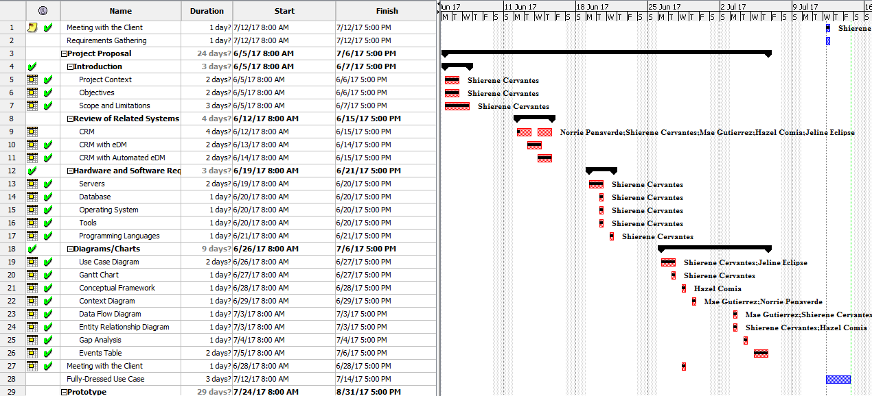

### **4.2.2 Gantt Chart**

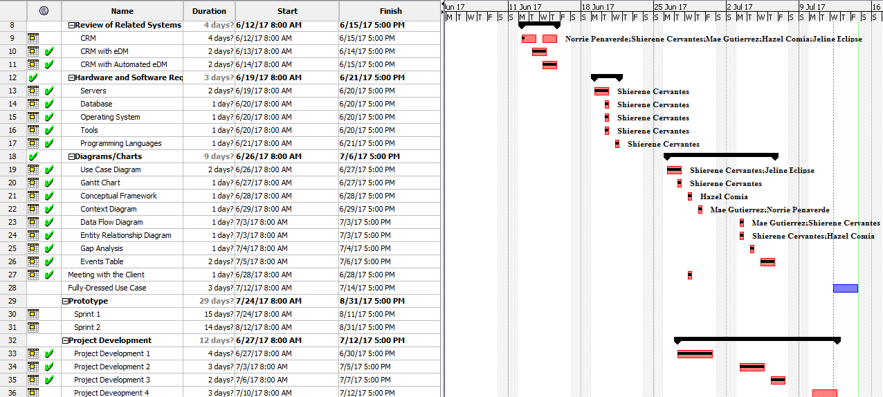

## 4.3 Conceptual Framework of Existing Customer Relationship Management

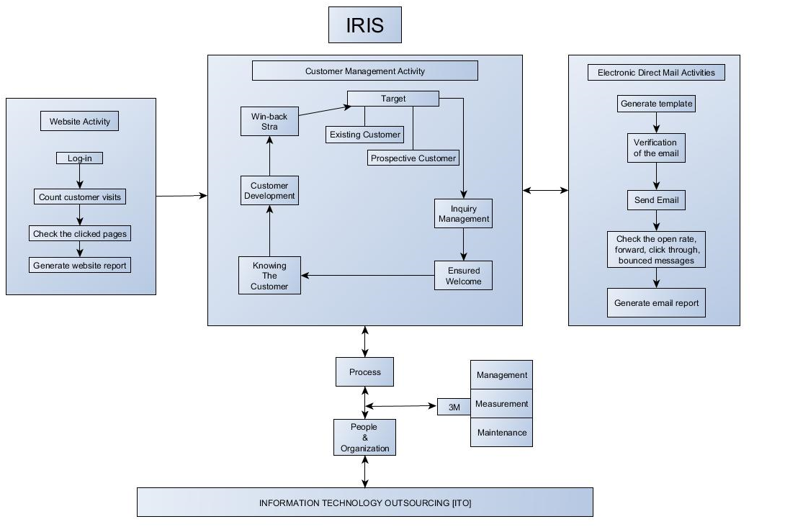

**Figure 4.3 Conceptual Framework of Existing System**

Figure 4.3 shows that ITO sends people and organization in order the process to operate the system properly, which include pre-constraints such as the 3M: Management, Measurement, and Maintenance. In the system, the main targets are the existing and the prospective customers wherein the customers undergo the Inquiry management, which answers all the questions asked by the customers. Next is to ensure that the customer is welcomed and well-accommodated in the website to be able to know the customer preferences. With all of the customer’s information, the hotel uses the customer’s preferences to come up with a good strategy to let the customer to come back again. The system sends a report to the marketeer and the customer preferences are sent to the system as well.

The Customer Module is connected to the EDM module that generates a template for the specific customer preferences. After filling up all the information, the system will verify the email if it is all answered with the correct data types and constraints. The system checks the open rate, forward emails, click-throughs and bounced messages and eventually, the system will generate all the email reports.

The Tracking Module is connected to the Customer module to track the customer preferences. As the customer login to the website, the system counts the visited webpages of the customer. The system also generates the reports from the results of the number of clicked webpages of the customer to identify the customer preferences.

## https://documents.lucidchart.com/documents/eade11a3-91ae-4e2a-9b4d-453d95e46515/pages/0_0?a=1873&x=47&y=-209&w=1165&h=1078&store=1&accept=image%2F*&auth=LCA%20bac4301e86018756bf95eb3edea92bdcb9786886-ts%3D15000890084.4 Context Diagram

**Figure 4.4 Context Diagram of Proposed System**

Based on Figure 4.4 shown above, the system contains three sources, one process, and one data store wherein the marketing department can request data from the Customer Relationship Management System (eDM) to produce reports that the marketeer requested. On the other hand, existing information from the Hotel Management System (Fidelio) can be exported to Customer Relationship Management (eDM) to produce reports that the marketeer requested.

## 4.5 Data Flow Diagram

### **https://documents.lucidchart.com/documents/11b88f70-681c-4015-b1e3-3481042377ca/pages/0_0?a=4652&x=-1347&y=-200&w=2354&h=1331&store=1&accept=image%2F*&auth=LCA%204e031947b34e6aff419cedd778b410dbd9dcc7d8-ts%3D1500318224 4.5.1 Diagram 0**

**Figure 4.5.1 Data Flow Diagram Level 0 of Proposed System**

Based from Figure 4.3.1, the system contains three sources, seven processes, and one data store wherein Hotel Management System(Fidelio) will generate customer information to be stored in the Customer Relationship Management(eDM) system. A marketeer can manage prospective customer and events that will be consolidated to the CRM(eDM) system as well as managing and sending promotional emails that will be sent to the customer. On the other hand, CRM (eDM) system can generate email reports and verify customer emails to check if it is active or inactive.

### **4.5.2 Diagram 1.0**

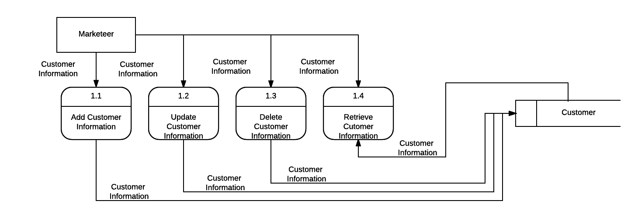 **4.5.2.1 Diagram 1.1**

**Figure 4.5.2.1 Data Flow Diagram Level 1 of Manage Customer**

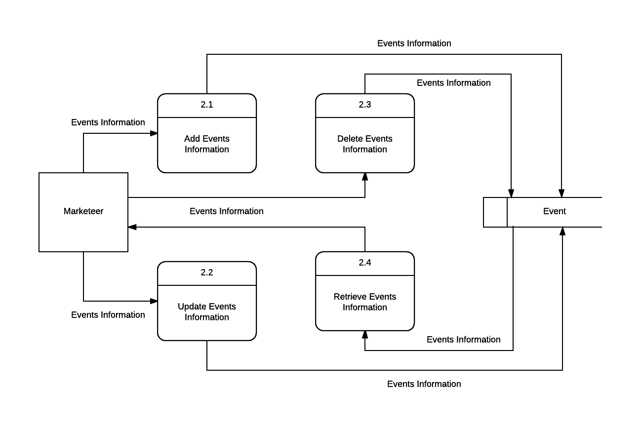 **4.5.2.2 Diagram 2.1**

**Figure 4.5.2.2 Data Flow Diagram Level 1 of Manage Events**

**4.5.2.3 Diagram 3.1**

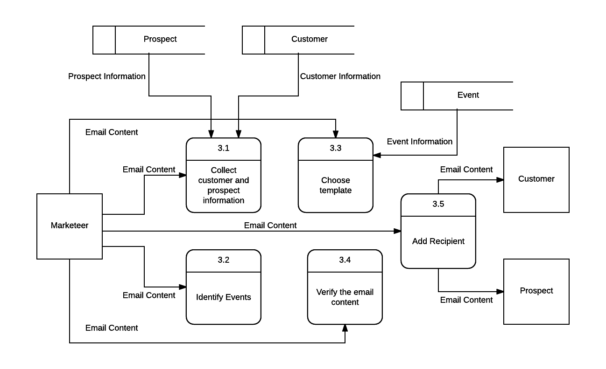

**Figure 4.5.2.3 Data Flow Diagram Level 1 of Send Promotional Emails**

**4.5.2.4 Diagram 4.1**

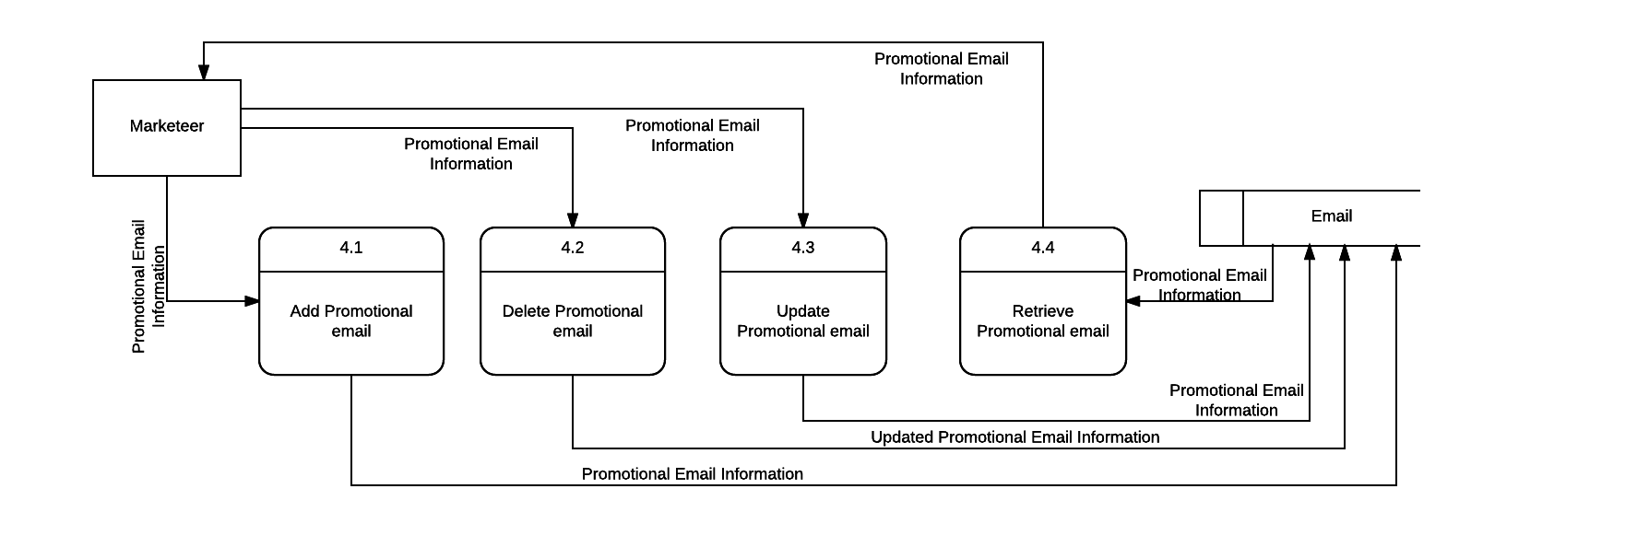

**Figure 4.5.2.4 Data Flow Diagram Level 1 of Manage Promotional Email**

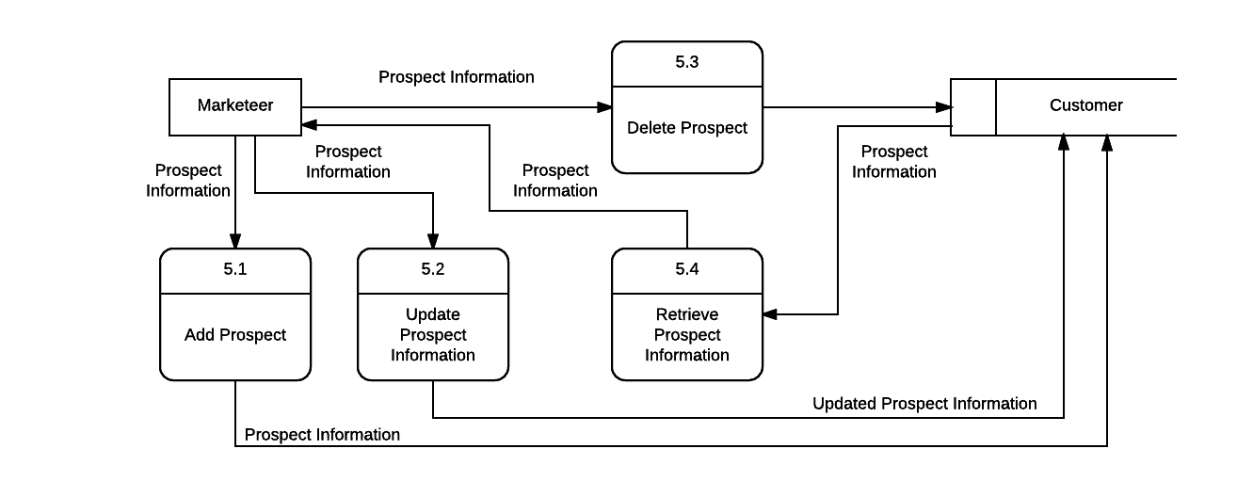**4.5.2.5 Diagram 5.1**

**Figure 4.5.2.5 Data Flow Diagram Level 1 of Manage Prospect**

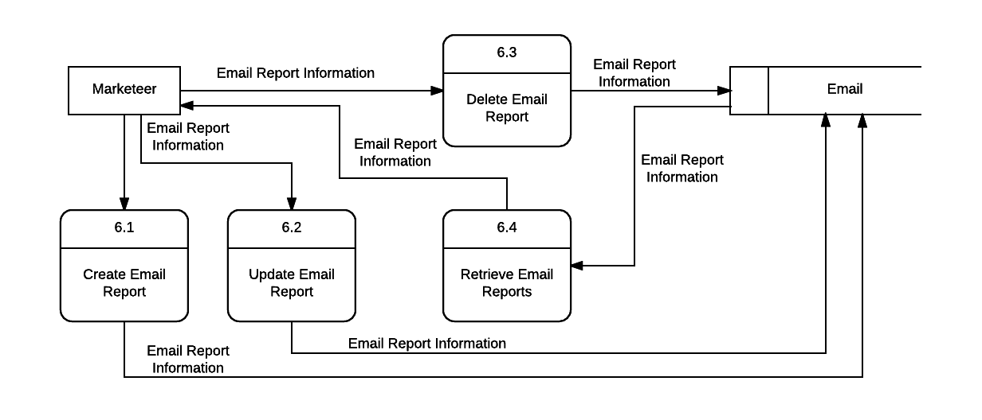**4.5.2.6 Diagram 6.1**

**Figure 4.5.2.6 Data Flow Diagram Level 1 of Manage Email Reports**

# **4.6 Entity Relationship Diagram**

### **4.6.1 Entity Relationship Diagram of Proposed System**

**Figure 4.6.1 Entity Relationship Diagram of Proposed System**

Figure 4.6.1 shows the entities alongside their relationships with one another. MARKETEER is one parent entity that has relationships with EMAIL and REPORT entities. Both entities are dependent and optional on the parent entity; thus, it is not mandatory for the parent entity to have a matching value in EMAIL and REPORT tables. In between EMAIL and CUSTOMER tables is an associative entity referred to as EMAIL_CUSTOMER, this is necessary as a many-to-many relationship exists between EMAIL and CUSTOMER, which means an email may be sent to a lot of customers, and a customer may receive more than one email. CUSTOMER table is connected to both WEB-VISIT HISTORY and CUSTOMER_HISTORY, both of the tables contain information regarding the customers’ activities together with information relevant to customers’ habits involving the client. Lastly, there exists an entity named PROSPECTIVE, which refers to the type of customer that have been visiting the client’s website but have not visited the hotel yet.

### **4.6.2 Data Dictionary**

**Customer Table**

|  |  |  |  |  |
| --- | --- | --- | --- | --- |
| **Field Name** | **Data Type** | **Field Length** | **Constraint** | **Description** |
| Customer_ID | Integer |  | Primary Key | Auto-generated |
| Customer_FName | VARCHAR | 45 | Not null | First Name |
| Customer_MName | VARCHAR | 45 |  | Middle Name |
| Customer_LName | VARCHAR | 45 | Not null | Last Name |
| Customer_Preferences | VARCHAR | 45 | Not null | Customer Preferences |
| Customer_Email | VARCHAR | 45 | Not null | Customer Email |
| Customer_ContactNumber | Integer |  | Not null | Contact Number |

**Figure 4.6.2.1 Data Dictionary for Customer Table**

**Email Table**

|  |  |  |  |  |
| --- | --- | --- | --- | --- |
| **Field Name** | **Data Type** | **Field Length** | **Constraint** | **Description** |
| Email_ID | INT |  | Primary Key | Auto-generated |
| Email_Date | DATE |  | Not null | Date when email was created |
| Email_Recipient | VARCHAR | 45 | Not null | Name of customer |
| Email_Content | VARCHAR | 300 | Not null | Content of the email |
| Email_Template | VARCHAR | 45 | Not null | Template used for the email |
| Marketeer_ID | INT |  | Foreign Key | Derived from Marketeer table |

**Figure 4.6.2.2 Data Dictionary for Email Table**

**Email_Customer Table**

|  |  |  |  |  |
| --- | --- | --- | --- | --- |
| **Field Name** | **Data Type** | **Field Length** | **Constraint** | **Description** |
| Email_ID | INT |  | Primary Key | Derived from Email table |
| Customer_ID | INT |  | Primary Key | Derived from Customer table |

**Figure 4.6.2.3 Data Dictionary for Email_Customer Table**

**Web_Visit History Table**

|  |  |  |  |  |
| --- | --- | --- | --- | --- |
| **Field Name** | **Data Type** | **Field Length** | **Constraint** | **Description** |
| WVH_ID | Integer |  | Primary Key | Auto-generated |
| Prospective_ID | Integer |  | Foreign Key | Derived from Prospective table |
| Customer_ID | Integer |  | Foreign Key | Derived from customer table |
| WVH_Date | DATE |  | Not null | History Date |
| WVH_Time | DATETIME |  | Not null | History Date and Time |
| WVH_IP_ADD | Integer |  | Not null | History IP Address |

**Figure 4.6.2.4 Data Dictionary for Web-visit History Table**

**Customer_History Table**

|  |  |  |  |  |
| --- | --- | --- | --- | --- |
| **Field Name** | **Data Type** | **Field Length** | **Constraint** | **Description** |
| CH_ID | INT |  | Primary Key | Auto-generated |
| CH_CheckIn | DATETIME |  | Not null | Check in date and time |
| CH_CheckOut | DATETIME |  | Not null | Check out date and time |
| CH_NumberDays | INT |  | Not null | Number of days a customer stayed |
| CH_Goods | VARCHAR | 45 | Not null | Goods availed |
| CH_Services | VARCHAR | 45 | Not null | Services availed |
| Customer_ID | INT |  | Foreign Key | Derived from Customer table |

**Figure 4.6.2.5 Data Dictionary for Customer_History Table**

**Marketeer Table**

|  |  |  |  |  |
| --- | --- | --- | --- | --- |
| **Field Name** | **Data Type** | **Field Length** | **Constraint** | **Description** |
| Marketeer_ID | INT |  | Primary Key | Auto-generated |
| Marketeer_FName | VARCHAR | 45 | Not null | First Name |
| Marketeer_MName | VARCHAR | 45 |  | Middle Name |
| Marketeer_LName | VARCHAR | 45 | Not null | Last Name |
| Marketeer_Birthdate | DATE |  | Not null | Birth Date |
| Marketeer_ContactNumber | Integer |  | Not null | Contact Number |

**Figure 4.6.2.6 Data Dictionary for Marketeer Table**

**Prospect Table**

|  |  |  |  |  |
| --- | --- | --- | --- | --- |
| **Field Name** | **Data Type** | **Field Length** | **Constraint** | **Description** |
| Prospect_ID | INT |  | Primary Key | Auto-generated |
| Prospect_FName | VARCHAR | 45 | Not Null | First Name |
| Prospect_MName | VARCHAR | 45 |  | Middle Name |
| Prospect_LName | VARCHAR | 45 | Not Null | Last Name |
| Prospect_Email | VARCHAR | 45 | Not null | Prospective Customer’s Email |
| Prospect_Preferences | VARCHAR | 45 |  | Prospective Customer’s Preferences |
| Prospective_ContactNumber | VARCHAR | 45 | Not null | Prospective Customer’s Contact Number |

**Figure 4.6.2.7 Data Dictionary for Prospect Table**

**Preference Table**

|  |  |  |  |  |
| --- | --- | --- | --- | --- |
| **Field Name** | **Data Type** | **Field Length** | **Constraint** | **Description** |
| Preference_ID | Integer |  | Primary Key | Auto-generated |
| Preference_Category | VARCHAR | 45 | Not Null | Category of preference |
| Preference_Description | VARCHAR | 45 | Not null | Preference description |
| Prospect_ID | Integer |  | Not Null | Derived from Prospect table |
| Customer_ID | Integer |  | Not null | Derived from Customer table |

**Figure 4.6.2.8 Data Dictionary for Preference Table**

**Event Table**

|  |  |  |  |  |
| --- | --- | --- | --- | --- |
| **Field Name** | **Data Type** | **Field Length** | **Constraint** | **Description** |
| Event_ID | Integer |  | Primary Key | Auto-generated |
| Event_DateCreated | VARCHAR | 45 | Not null | Date of event’s creation |
| Event_Description | VARCHAR | 400 | Not null | Description of event |
| Event_StartDate | DATETIME | 45 | Not null | Start of event’s effectivity |
| Event_EndDate | DATETIME |  | Not null | End of event’s effectivity |
| Marketeer_ID | Integer |  | Not null | Derived from Marketeer table |
| Email_ID | Integer |  | Not null | Derived from email table |

**Figure 4.6.2.9 Data Dictionary for Event Table**

**Customer_Preference Table**

|  |  |  |  |  |
| --- | --- | --- | --- | --- |
| **Field Name** | **Data Type** | **Field Length** | **Constraint** | **Description** |
| Customer_ID | INT |  | Primary Key | Derived from Customer table |
| Preference_ID | INT |  | Primary Key | Derived from Preference table |

**Figure 4.6.2.10 Data Dictionary for Customer_Preference Table**

**Prospect_Preference Table**

|  |  |  |  |  |
| --- | --- | --- | --- | --- |
| **Field Name** | **Data Type** | **Field Length** | **Constraint** | **Description** |
| Prospect_ID | INT |  | Primary Key | Derived from Prospect table |
| Preference_ID | INT |  | Primary Key | Derived from Preference table |

**Figure 4.6.2.11 Data Dictionary for Prospect_Preference Table**

**Email_Activity Table**

|  |  |  |  |  |
| --- | --- | --- | --- | --- |
| **Field Name** | **Data Type** | **Field Length** | **Constraint** | **Description** |
| EmailActivity_ID | INT |  | Primary Key | Auto-generated |
| EmailActivity_Date | Date |  | Not null | Date the email was sent |
| Email_Activity_Time | Datetime |  | Not null | Time the email was sent |
| EmailActivity_Status | VARCHAR | 45 | Not null | Status of email |
| Email_ID | Integer |  | Foreign Key | Derived from Email table |

**Figure 4.6.2.12 Data Dictionary for Email_Activity Table**

# **4.7 Activity Diagram**

## https://documents.lucidchart.com/documents/6bd37fcf-929e-48f5-8a32-2e9fcafde7d4/pages/0_0?a=1734&x=73&y=-62&w=1474&h=1762&store=1&accept=image%2F*&auth=LCA%205ab6e8b4b8a4017eb554837783d028ed60b65fd5-ts%3D1500455155 4.7.1 General Activity Diagram

**Figure 4.7.1 General Activity Diagram**

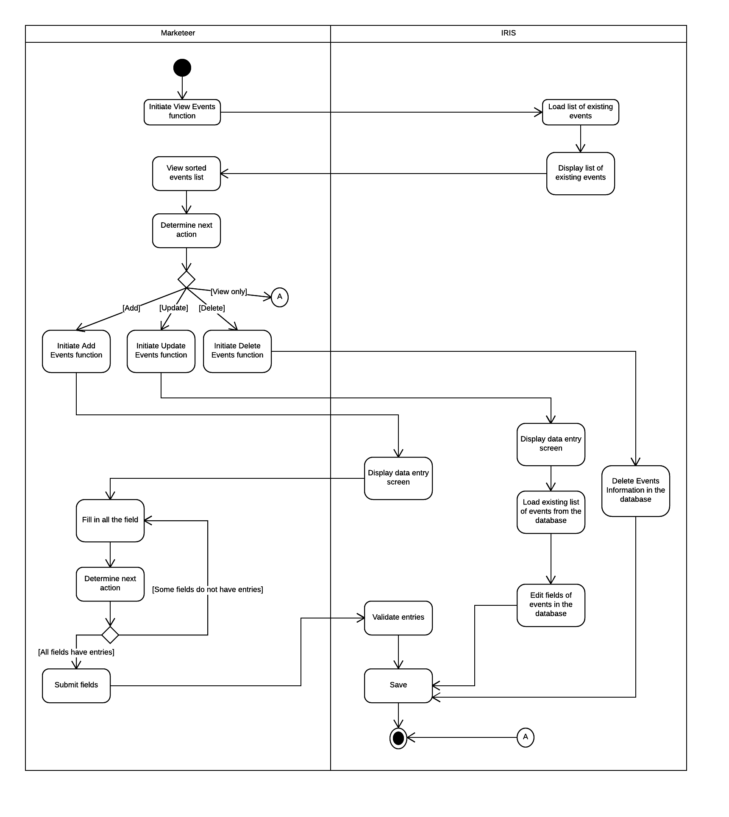 **4.7.2 Activity Diagram 1.0 – Manage Events**

**Figure 4.7.2 Activity Diagram of Manage Events**

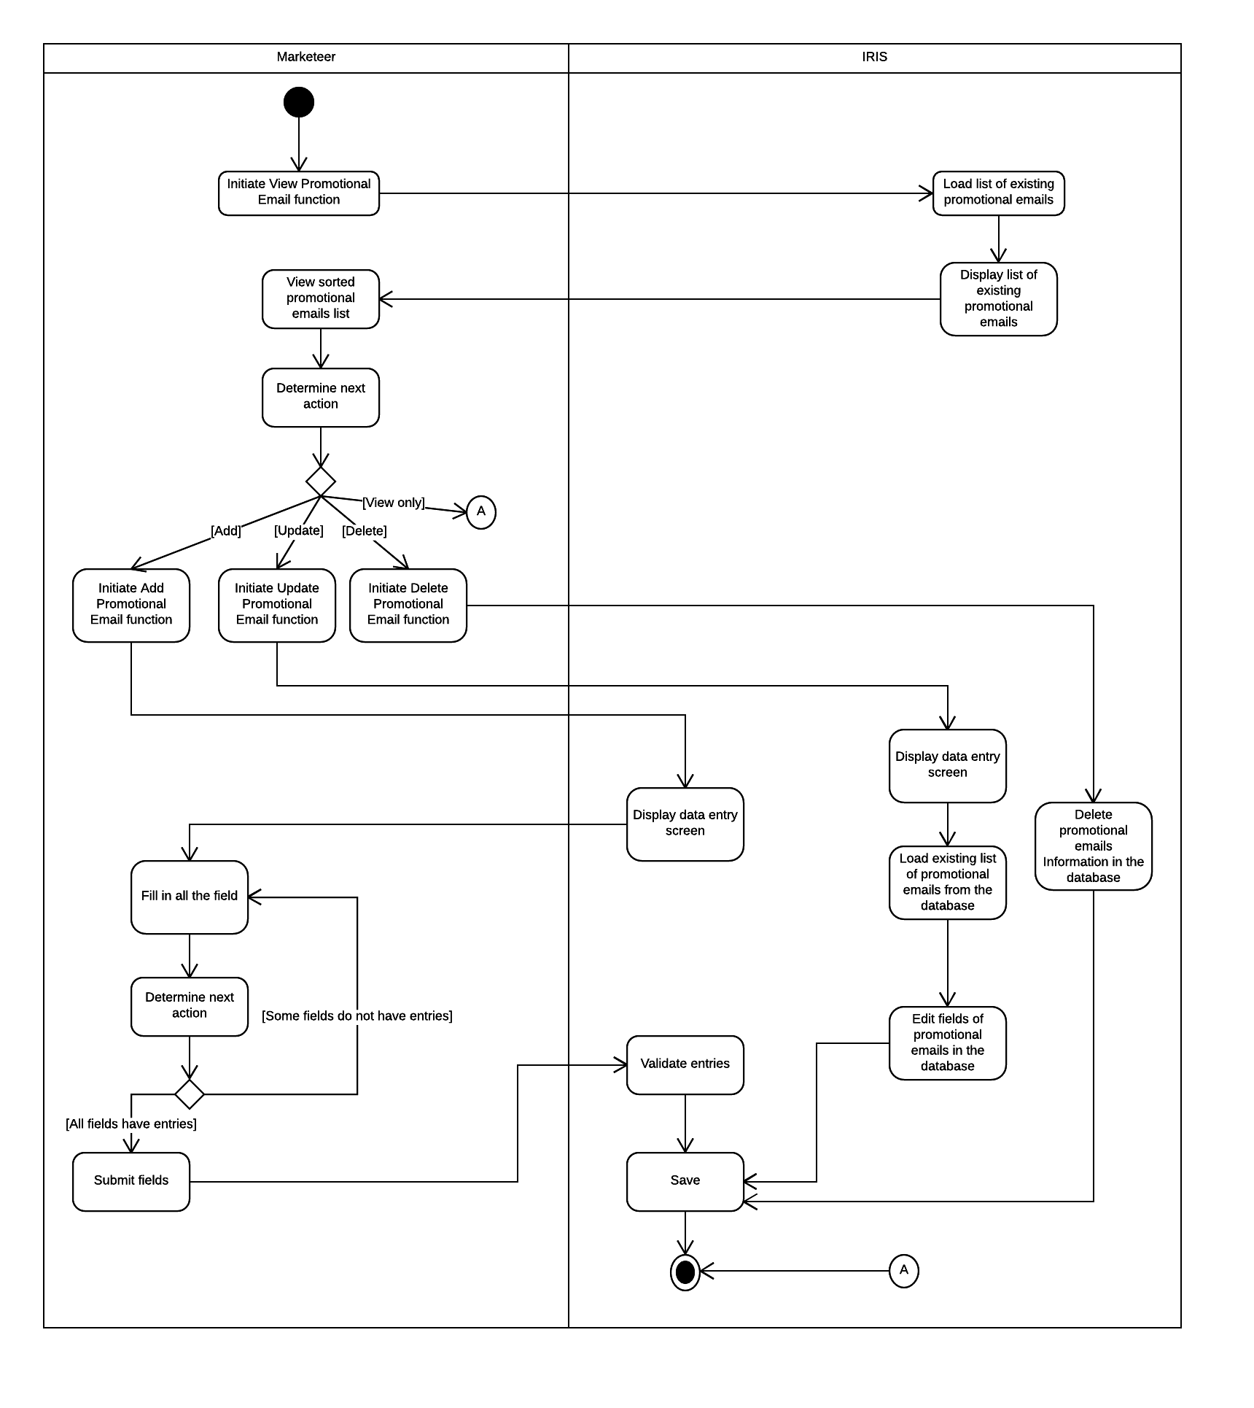**4.7.3 Activity Diagram 2.0 – Manage Promotional Emails**

**Figure 4.7.3 Activity Diagram of Manage Promotional Emails**

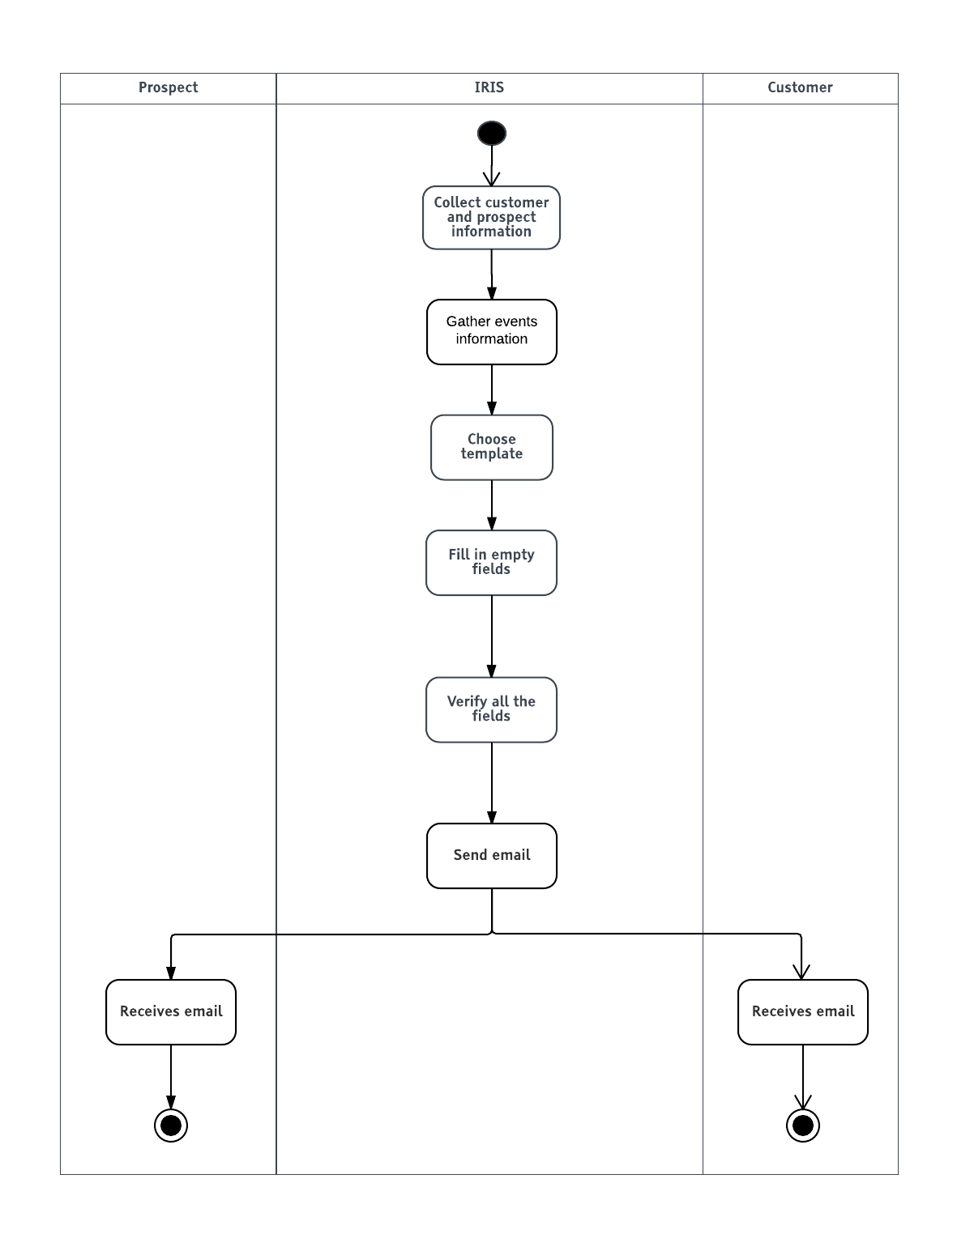**4.7.4 Activity Diagram 3.0 – Send Promotional Email**

**Figure 4.7.4 Activity Diagram of Send Promotional Emails**

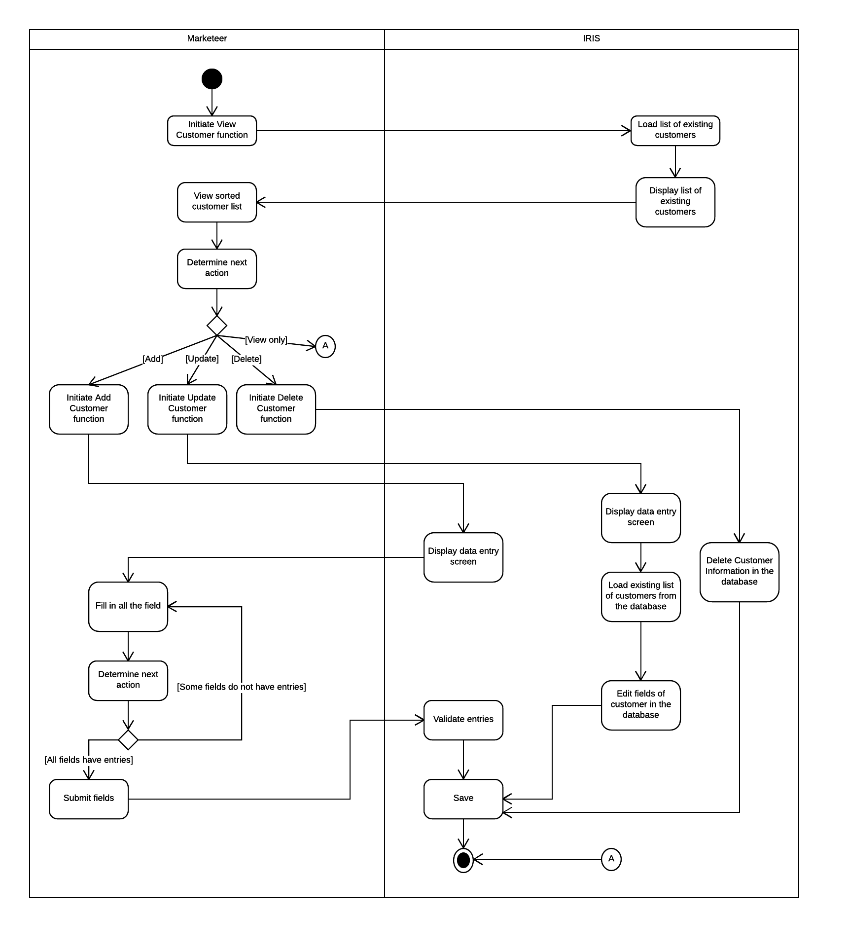**4.7.5 Activity Diagram 4.0 – Manage Customer Information**

**Figure 4.7.5 Activity Diagram of Manage Customers**

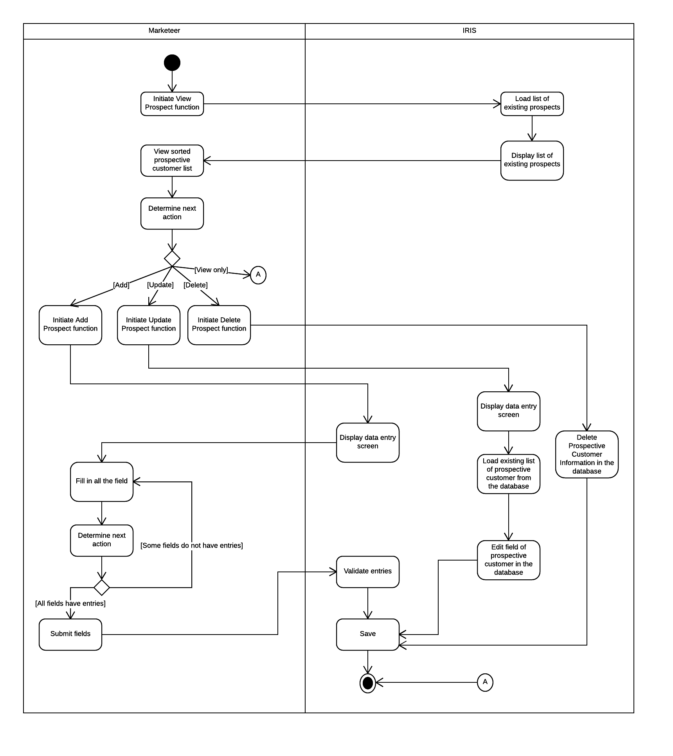**4.7.6 Activity Diagram 5.0 – Manage Prospective Customers**

**Figure 4.7.6 Activity Diagram of Manage Prospects**

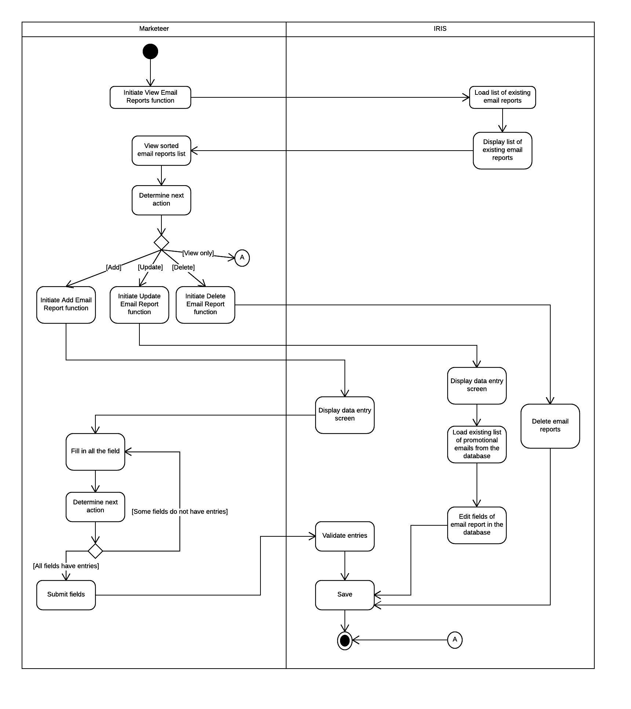**4.7.7 Activity Diagram 6.0 – Manage Email Reports**

**Figure 4.7.7 Activity Diagram of Manage Email Reports**

**4.7.8 Activity Diagram 7.0 – Verify Customer Email**

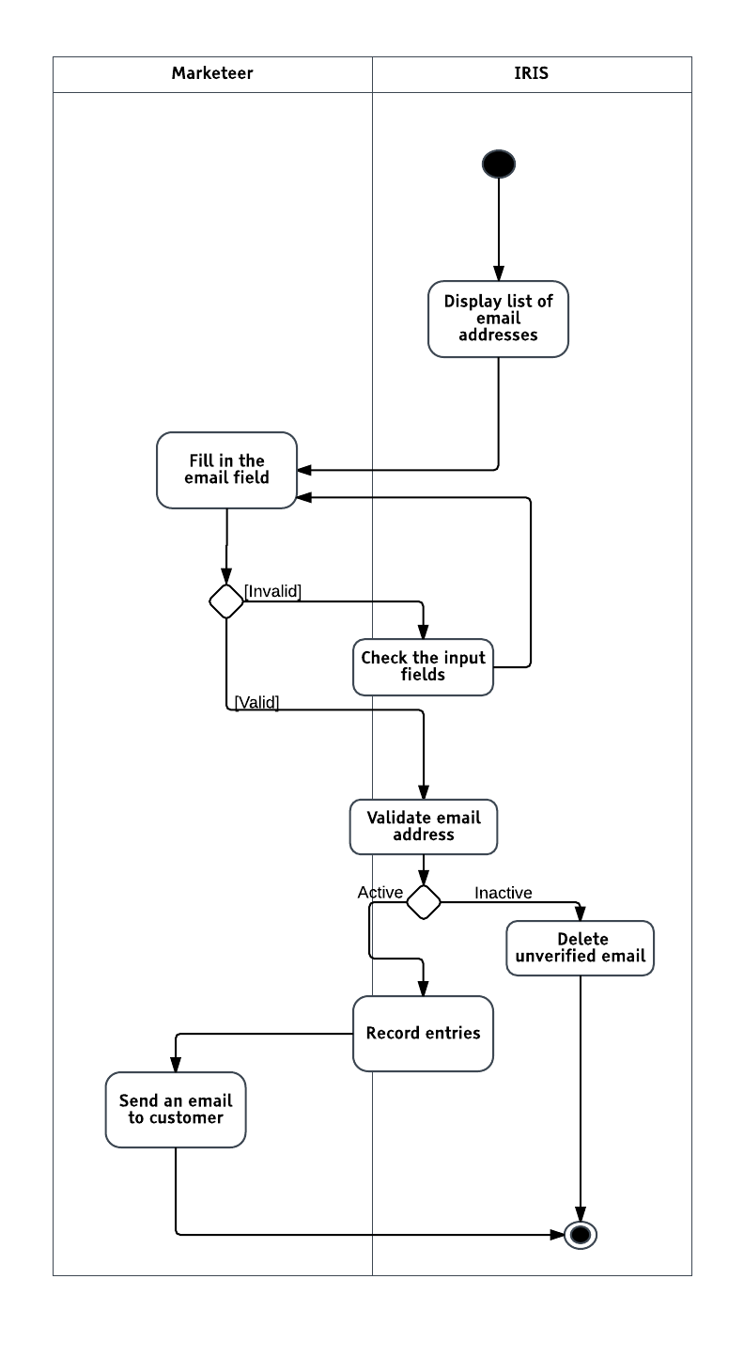

**Figure 4.7.8 Activity Diagram of Verify Customer Email**

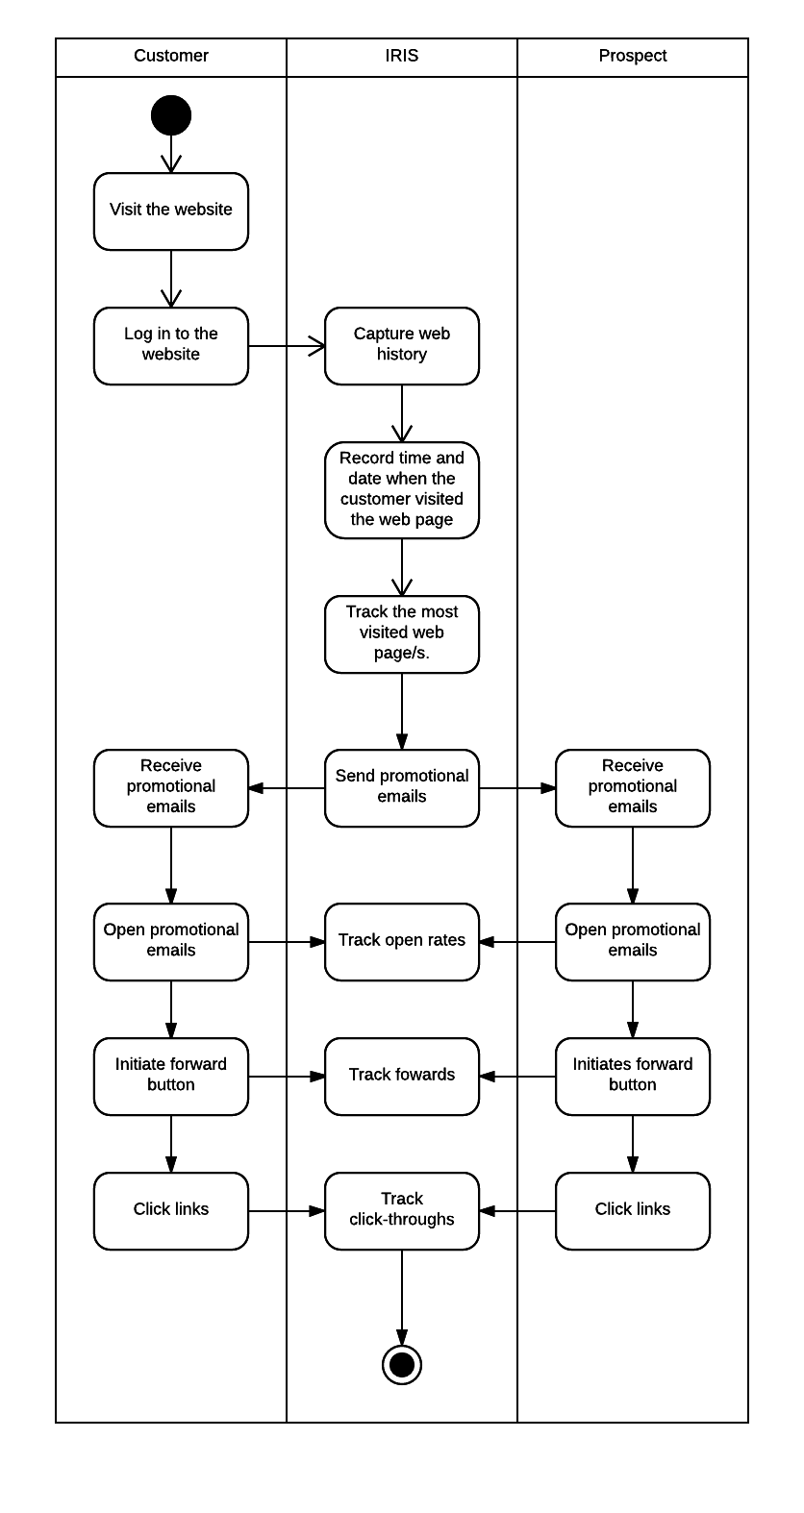 **4.7.9 Activity Diagram 8.0 – Track Activities**

**Figure 4.7.9 Activity Diagram of Track Activities**

**4.7.10 Activity Diagram 9.0 – Subscribe to Website**

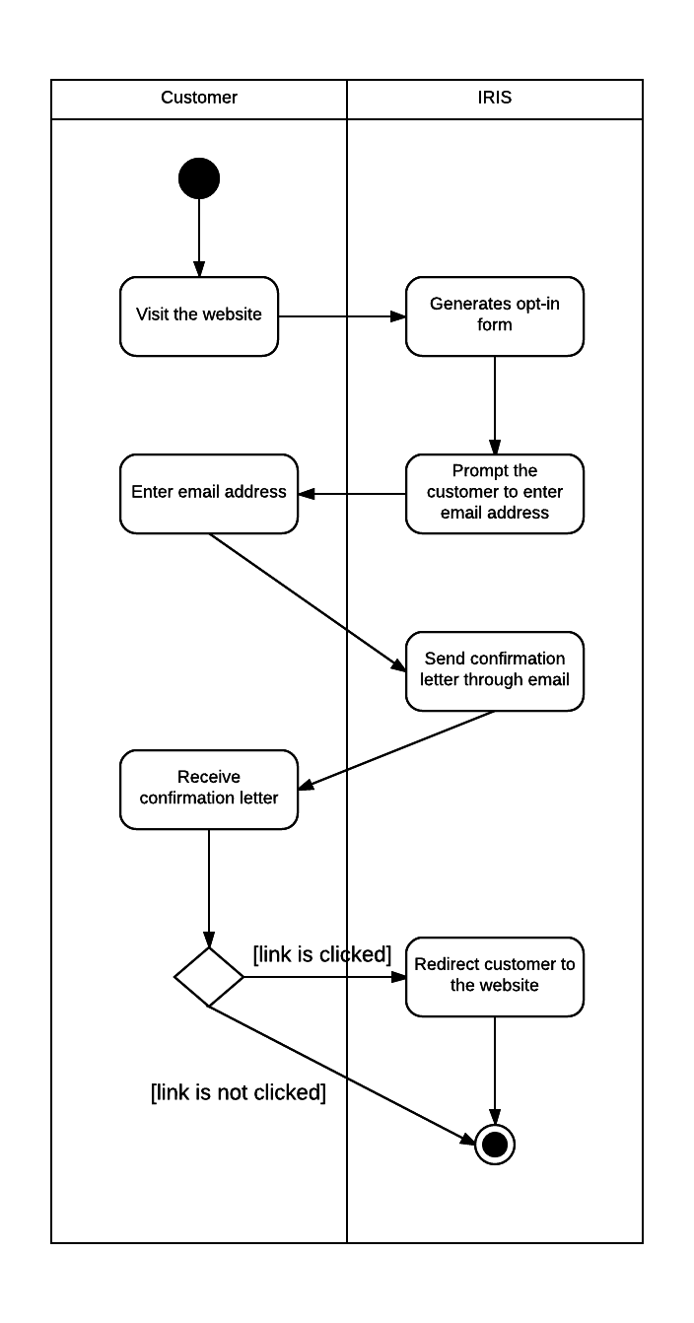

**Figure 4.7.10 Activity Diagram of Subscribe to Website**

# **https://documents.lucidchart.com/documents/7c4befc6-0b12-40c1-952b-5d4a00472248/pages/0_0?a=3826&x=-1803&y=-1021&w=2266&h=2233&store=1&accept=image%2F*&auth=LCA%20b456fac7b2d529ea5976707e5e8a4644bddb25e5-ts%3D15004565284.8 Class Diagram of Proposed System**

**Figure 4.8 Class Diagram of Proposed System**

# **4.9 Conceptual Framework of Proposed System**

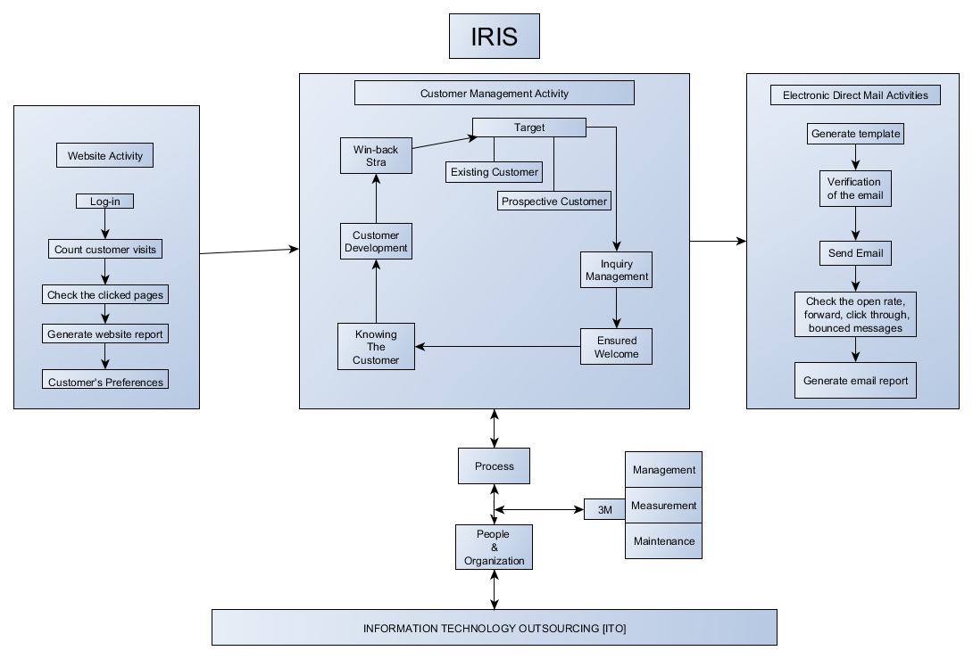

**Figure 4.9 Conceptual Framework of Proposed System**

# **4.10 Sequence Diagram**

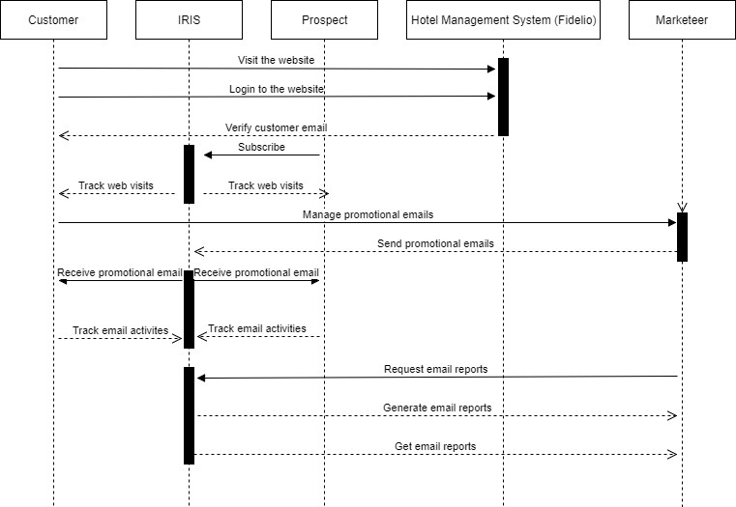

**Figure 4.10 Sequence Diagram**

# **4.10 Gap Analysis**

|  |  |  |  |
| --- | --- | --- | --- |
| **Messaging Module** | | | |
| **User Requirements** | **Current System** | **Proposed Changes** | **Remarks/Impact** |
| Marketeer sends promotional emails | Marketeer may send emails to existing customers alone. | Marketeer may send promotional emails to both existing and prospective customers. | Less workload for the marketeers |
| Marketeer creates emails | Marketeer manually chooses a template as well as email contents to be sent to customers. | Marketeers do not have to choose a template and contents will automatically be added to the template that are solely contingent on customer’s/prospect’s preferences. | Less workload for the marketeers |

**Figure 4.10.1 Gap Analysis for Messaging Module**

|  |  |  |  |
| --- | --- | --- | --- |
| **Tracking Module** | | | |
| **User Requirements** | **Current System** | **Proposed Changes** | **Remarks/Impact** |
| Track email activity | Client subscribes to an eDM offering a tracking email activity feature. | System is integrated with other information systems and has an eDM functionality. | Less cost for software subscription |
| Track web visit | Track most visited pages, clicked web pages without the web-visitors’ identity | System is capable of tracking web-visiting habits of both existing and prospective customers | Wider audience for marketeers’ contents |

**Figure 4.10.2 Gap Analysis for Tracking Module**

|  |  |  |  |
| --- | --- | --- | --- |
| **Connection Module** | | | |
| **User Requirements** | **Current System** | **Proposed Changes** | **Remarks/Impact** |
| System connects to Hotel Management System (HMS) | CRM is not integrated with other information systems of the hotel | System is connected to HMS for faster retrieval of customers’ information and preferences provided by the customers | System is capable of connecting directly to HMS in order to gather existing customer’s infromation. |

**Figure 4.10.3 Gap Analysis for Connection Module**

**Chapter 5**

**Data Dictionary**

# **5.0 Data Dictionary**

**API (Application Program Interface)**

* Is a set of routines, protocols, and tools for building software applications. An API specifies how software components should interact. Additionally, API**s** are used when programming graphical user interface (GUI) components. (Webopedia. (2017). API - Application Program Interface [online]. Available: [http://www.webopedia.com/TERM/A/API.html)](http://www.webopedia.com/TERM/A/API.html)

**Application**

* An application program is a [program](http://searchsoftwarequality.techtarget.com/definition/program) designed to perform a specific function directly for the user or, in some cases, for another application program. (Techtarget. (2017). Application [online]. Available: [http://searchsoftwarequality.techtarget.com/definition/application)](http://searchsoftwarequality.techtarget.com/definition/application)

**Bounced messages**

* Bounce e-mail (sometimes referred to as *bounce mail*) is electronic mail that is returned to the sender because it cannot be delivered for some reason. (Techtarget. (2017). Bounce email [online]. Available:  [http://searchexchange.techtarget.com/definition/bounce-e-mail)](http://searchexchange.techtarget.com/definition/bounce-e-mail)

**Click through**

* The process of clicking through an online advertisement to the advertiser’s destination. (Marketing terms.com. (n.d.). Click Through [online]. Available: [http://www.marketingterms.com/dictionary/clickthrough/)](http://www.marketingterms.com/dictionary/clickthrough/)

**CRM (Customer Relationship Management)**

* Refers to the principles, practices and guidelines that an organization follows when interacting with its customers. From the organization's point of view, this entire relationship encompasses direct interactions with customers, such as sales and service-related processes, and [forecasting](http://terms/f/forecasting.asp) and analysis of [customer](http://terms/c/customer.asp) trends and behaviors. (Investopedia. (n.d.). Customer Relationship Management-CRM [online]. Available:  <http://www.investopedia.com/terms/c/customer_relation_management.asp#ixzz4nKb7ASNP>)

**Database**

* A database is a collection of information organized to provide efficient retrieval. The collected information could be in any number of formats (electronic, printed, graphic, audio, statistical, combinations). There are physical (paper/print) and electronic databases. (Board of Regents of the University System of Georgia. (2017). What is database [online]. Available: [http://www.usg.edu/galileo/skills/unit04/primer04_01.phtml)](http://www.usg.edu/galileo/skills/unit04/primer04_01.phtml)

**Electronic Direct Mail (EDM)**

* An increasingly popular communication channel that uses email to deliver tailored content to target audiences at a relatively low cost. Also, it enables a high level of instant measurement; authors are able to track number of opens, email responses, bounced messages and click-throughs. ((n.d.). Electronic Direct Mail (EDM) [online]. Available: <https://www.adelaide.edu.au/brand/digital/edm/>)

**Electronic mail (E-mail)**

* The exchange of computer-stored messages by telecommunication. (Rouse M. (n.d.) Email Electronic Mail or E-mail [online]. Available: <http://searchexchange.techtarget.com/definition/e-mail-electronic-mail-or-email>)

**Information Technology Outsourcing or ITO**

* Is a company's outsourcing of computer or Internet related work, such as programming, to other companies. It is used in reference to business process outsourcing or BPO, which is the outsourcing of the work that does not require much of technical skills. (Wikipedia. (n.d). Information technology outsourcing [online]. Available: <https://en.m.wikipedia.org/wiki/Information_technology_outsourcing>)

**Marketeer**

* A specialist in promoting or selling a product or service. (Merriam Webster. (n.d.). Marketeer [online]. Available: <https://www.merriam-webster.com/dictionary/marketeer>)

**Operating system (OS)**

* Is system software that manages computer hardware and software resources and provides common services for computer programs. All computer programs, excluding firmware, require an operating system to function. (Wikipedia. (n.d.) Operating System [online]. Available: <https://en.m.wikipedia.org/wiki/Operating_system>)

**Programming Language**

* A programming language is a formal language that specifies a set of instructions that can be used to produce various kinds of output. Programming languages generally consist of instructions for a computer. Programming languages can be used to create programs that implement specific algorithms. (Wikipedia. (n.d). Programming Language [online]. Available: <https://en.m.wikipedia.org/wiki/Programming_language>)

**Server**

* A computer or computer program that manages access to a centralized resource or service in a network. (Bradley Mitchell. (2017, May 5). Simple mail transfer protocol [online]. Available: <https://www.lifewire.com/servers-in-computer-networking-817380>)

**SMTP**

* Simple Mail Transfer Protocol is an Internet standard for electronic mail (email) transmission. To facilitate the sending and receiving of messages ((n.d.). Simple mail transfer protocol [online]. Available: [http://searchexchange.techtarget.com/definition/SMTP)](http://searchexchange.techtarget.com/definition/SMTP)

**Software**

* Is a general term for the various kinds of [program](http://searchsoftwarequality.techtarget.com/definition/program)s used to operate [computer](http://searchwinit.techtarget.com/definition/computer)s and related devices. ((n.d.). Software [online]. Available: <http://searchmicroservices.techtarget.com/definition/software>)

**System**

* A set of detailed methods, procedures and routines created to carry out a specific activity, perform a duty, or solve a problem. ((n.d.). System [online]. Available: <http://www.businessdictionary.com/definition/system.html>)

**Web Visiting Habits**

* Activity of a single Web visitor for a defined period of time. (Jason Burby, Angie Brown & WAA Standards Committee. (2007, August 16). Web visiting habits [online] Available: https://www.digitalanalyticsassociation.org/Files/PDF_standards/WebAnalyticsDefinitionsVol1.pdf )