**How have homeownership rates changed between 2018-2022?**

The national average homeownership rate went from 25.09% in 2018 to 26% in 2022. National homeownership rates have increased year over year in almost all years between 2018 and 2022 except between 2020 and 2021. This could be an effect of the pandemic on the economy. The West and Southwest did not see the same stall in homeownership rates that the rest of the nation did.

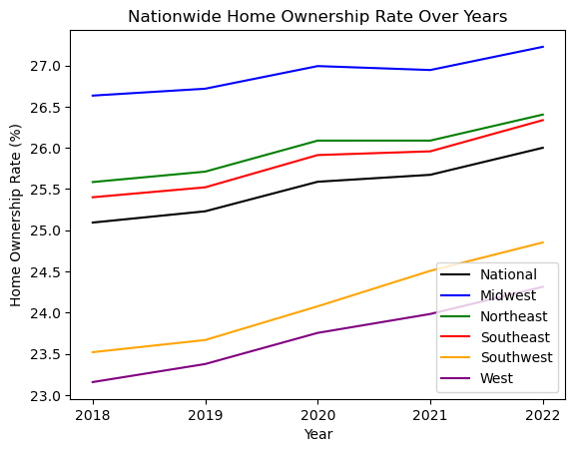

We can look at the median household income over the same period to see if there are any correlations we can make.

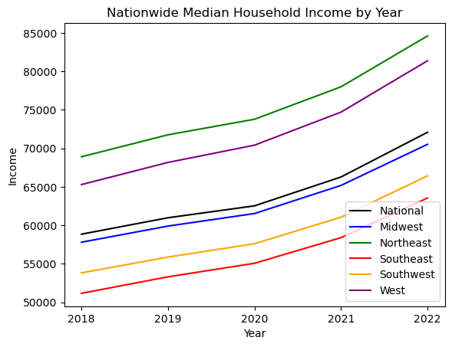

All regions saw a comparable increase in median household income over the same period. While there is a large difference in median household income between regions, the income does not seem to be correlated with homeownership rates and their change over time. While the Southwest and West did see an increase in homeownership rates during the time other regions didn’t, they did not see a statistically significant increase in household income compared to the other regions.

We also looked at the correlation between each field we had access to and the homeownership rate. No other field we analyzed had a statistically significant correlation to help explain this difference in homeownership rates between regions.

In order to answer this question fully, we would need to find data outside of the data available from the census.

**How does having a mortgage affect monthly expenses?**

**Income with a mortgage and monthly housing costs:**

Null Hypothesis: There is no significant difference between median income and housing monthly housing costs with a mortgage.

Alternative Hypothesis: There is a significant difference between median income and monthly housing costs with a mortgage.

Outcome: Reject null hypothesis and accept the alternative. We have a low P-value of 9.776050911302425e-198 which is less than 0.05 and high correlation > 0.93. There is a significant statistical difference between the median household income and the median monthly housing costs for homes with a mortgage.

**Income without a mortgage and monthly housing costs:**

Null Hypothesis: There is no significant difference between median income and monthly housing costs without a mortgage.

Alternative Hypothesis: There is a significant difference between median income and monthly housing costs without a mortgage.

Outcome: Reject null hypothesis and accept the alternative with a low P-value of 1.1224760732553063e-184 which shows a significant difference between the median household income without a mortgage and the median monthly housing costs without a mortgage. Even though there is more variation we still have a strong correlation of ~ 0.79.

What does this mean? Households without mortgages are tied to lower monthly costs and income while households with mortgages have higher costs due to the loan but they also are aligned with higher incomes. The one region that is least like the others is the Northeast where monthly housing costs are greater overall at low and higher income levels.

**How have home values changed between 2018-2022?**

Median Home Values nationwide have steadily gone up year over year from 2018 to 2022.

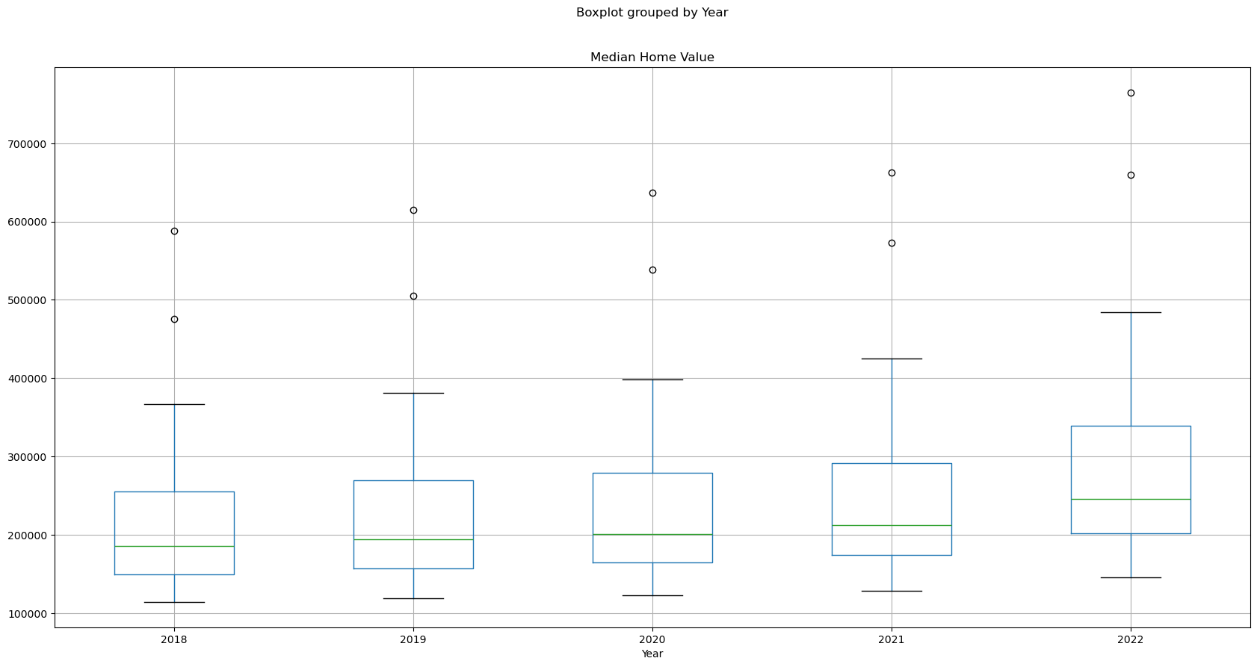

The greatest correlation between fields that include Median Home Value is Median Monthly Cost with Mortgage. This correlation is 0.88. This means that as the monthly costs associated with a mortgage increase there is a noticeable increase in the home value.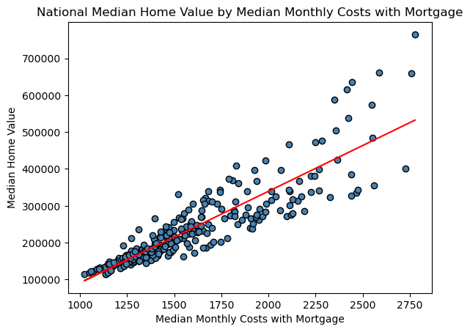

This correlation is not as strong between median home value and monthly costs without a mortgage. This correlation drops to only 0.52.