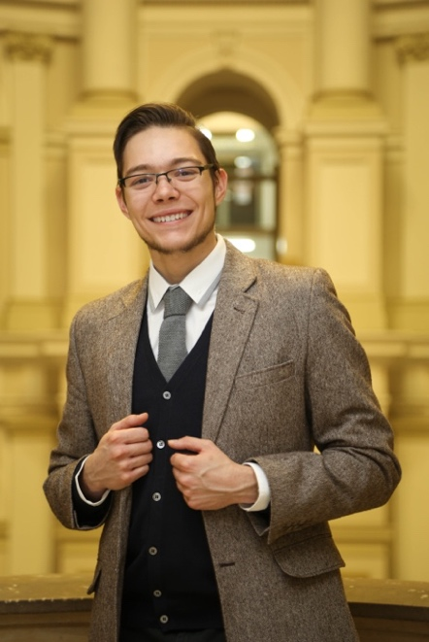**CURRICULUM VITAE**

JĘDRZEJ LEWANDOWSKI

Medical student and software developer

Zimna 2, 00-138, Warsaw, Poland • +48508173995 • [jedrzejblew@gmail.com](mailto:jedrzejblew@gmail.com)

<https://github.com/jblew> • <https://jedrzej.lewandowski.doctor>

Motto: "Man Has No Good in Himself and Can Glory in Nothing" ~ Thomas. A. Kempis, The Imitation of Christ.

# **EDUCATION**

## 2011 - 2014 — jacek kaczmarski high school in olsztynek, poland.

Specialty: Physics and Maths   
High school finals results: Chemistry (advanced level) — 97%, Biology (advanced level) — 90%, Physics and astronomy (advanced level) — 87%, English (advanced level) — 74%, Maths (basic level) — 88%.

## 2014 - present — Medical University of warsaw, second faculty of medicine, poland.

Currently studying medicine, expected to graduate in 2020.

# **MEDICAL WORK EXPERIENCE**

## Summer internships:

* 2015 — Pediatric Allergology Ward in Voivodeship Rehabilitation Hospital for Children in Ameryka, Poland.
* 2016 — Emergency Department in Czerniakowski Hospital in Warsaw, Poland and Public General Practice Outpatient Clinic in Olsztynek, Poland.
* 2017 — Internal Medicine and Endocrinology Ward in Public Central Teaching Hospital in Warsaw, Poland and Hand and Wrist Day Surgery Clinic in Voivodeship Rehabilitation Hospital for Children in Ameryka, Poland.
* 2018 — Pediatric Infectious Diseases Ward in Hospital of Infectious Diseases in Warsaw, Poland and Clinic of General, Gastroenterological and Oncological Surgery in Public Central Teaching Hospital in Warsaw, Poland.

# **IT WORK EXPERIENCE**

## 2004 - 2017 — Self-taught programmer.

I was passionate about software development and studying algorithms since childhood, did thousands of hours of hobby programming. Important projects from this period include:

**2006 - 2016 — designing websites for local organizations.** Starting in primary school, I have designed more than ten websites for local schools, non-profit organizations, and clubs. I have learned to cooperate with clients and improved skills in web design and typography.

**2009 — implementing a mailing system in a local hospital** (Voivodeship Rehabilitation Hospital for Children in Ameryka, Poland). As a 13 year old, I have helped out an IT specialist to finish the project on time. This project was very demanding and allowed me to learn perseverance, precision, and how to conduct end user training.

**2009 - 2010 — conducting research into basic artificial neural networks.** I have acquired knowledge about the lowest level basics of neural networks (the networks were built from scratch), pattern recognition and basic probability theory.

**2008 - 2012 — developing a text-based online multiplayer game (MUD).** I have wanted to make a game which would allow me to play with my blind friend. The project included writing almost 60000 lines of code across five versions of this software. Thanks to the project, I have improved in designing software architecture, team collaboration and management, advanced Java SE, concurrent (multithreaded) programming, algorithmics (the project facilitated experimental geo+time+weather simulation models); SVN and GIT code versioning, remote deployment and management of remote servers through ssh.

**2015 — designed a distributed photo library management system.** My family had a collection of almost half a million digital photographs and more than ten terabytes of videos. There was no software that would allow effective and cheap management of such a big collection of digital photographs. I have designed a system with an aim of detecting duplicates, time and event sorting, ordering and synchronizing between primary-backup hard drive pairs. The biggest difficulty was that the data was spread across more than twenty external hard drives and the software had to keep a distributed hash index.

**2015 - current — domestic heating management system.** I have started this project while learning about the principles of hardware development, embedded programming (ESP32, ST ARM) and mesh networking.

## 2016 - 2018 — chief of it department at academic catholic student association ask soli deo (non-profit) .

Projects made at ACS Soli Deo include but are not limited to:

* Designing the website solideo.pl (which required custom backend) and posters for events.
* Implementation of HR and internal assets management system based on NextCloud.
* Music driven lighting system for big events (150+ participants). One of the responsibilities I have had at Soli Deo was to design and supervise lighting and sound equipment at events. As a hobby project, I have created a lighting system for large halls. This was a software and hardware project. A software DSP module was doing spectral analysis and feeding RGB data into a hardware modules. Hardware was the most innovative part of this project. I have developed an extremely cost-effective way of sending real-time RGB signal over long distances with minimal noise (instead of using voltage-driven DMX that requires shielded and capacity-adjusted expensive cabling, the system was using a current-loop circuits for which a flat telephone cable is enough to carry the signal).

## 2018 - today — architect and developer of wise at wise-team.io

Wise-team.io (<https://wise-team.io/>) is a blockchain startup. We run a Steem blockchain witness node and maintain two decentralized apps for Steem blockchain: Engrave and Wise. I am the architect and the leading developer of the WISE system. Wise is a platform that allows steem users to delegate their voting power to others under strictly defined and publicly visible criteria. It consists of a common library, a cli tool, a voting webapp, a delegator webapp, public database api, daemon service for non-technical users and a vault server for cryptographic key management. All services run in a self-deployable and self-managing cluster. All packages are open source and published to npmjs.com registry or to Docker cloud. Wise app: <https://wise.vote/>, the explanation: https://docs.wise.vote/, and the sources: <https://github.com/wise-team>.

I have improved on multiple skills at Wise-team, such as brainstorming and collaborating in a team. I have presented our ideas and the product to the public at the Steemfest conference in autumn 2018. Technical skills mastered at Wise include: Typescript+Javascript full stack, Vue.js, Docker, GIT, continuous integration (Travis CI), continuous deployment (Ansible), TDD.

# **IT SKILLS**

**Best experienced with**

* Javascript/Typescript
* Java SE
* Vue.js
* Concurrent (multithreaded) programming.
* PostgreSQL + query optimization
* TDD
* Webdesign (HTML, CSS, Bootstrap, jQuery).

**Moderately experienced with**

* Blockchain (Steem and EOS) and their complex internal relationships and algorithmics.
* Cloud Computing: Amazon AWS (S3, EC2, IAM).
* Git CVS.
* Docker containers.
* Cloud provisioning: Docker Swarm + bare metal server administration + continuous deployment with Ansible.
* Linux (Debian family) + BASH/ZSH.
* Operating measurement equipment: digital oscilloscope and DDS function generator. (Used this mostly for physics experiments at home.)

**Able to work with**

* Python (scripting, data processing, interactions with hardware like oscilloscopes, DDS, custom sensors).
* Cryptography with an understanding of several algorithms and associated threats. Did experimental implementations of these. I am also currently an administrator of two Hashicorp Vault servers at Wise.
* CI+CD systems:
* Embedded programming of IC families: ARM8, ESP32, STM32.
* Electronic circuit design and board prototyping.
* Lan networks with complicated mesh setup.

# **LANGUAGES**

English B2/C1 (FCE certificate since 2013), passed English high school final exam at advanced level achieving 74%, passed Medical English course at the Medical University of Warsaw, achieving 4/5 grade.

# **INTERESTS AND EXTRACURRICULAR ACTIVITIES**

* Interested in oncology - currently finishing a systematic review on pericytes and angiopoietins.
* Hobbies include algorithmics and programming, surrealistic art and reading psychological sci-fi literature.
* I enjoy small hands-on projects where I first plan out a complex design and then build it by hand. I have built electronic devices that I use in day to day life and art installations (including sculptures). They operate on IT systems and softwares which I have designed.
* Active member and elected Vice-chairman (2016-2017) of Academic Catholic Student Association Soli Deo.