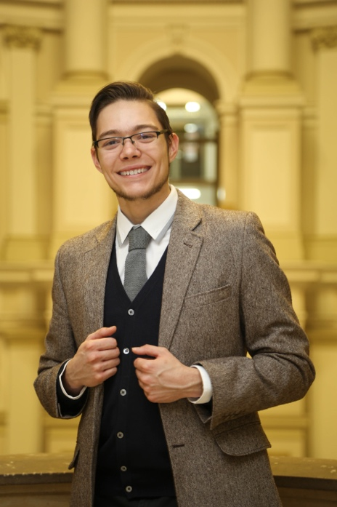CURRICULUM VITAE

JĘDRZEJ LEWANDOWSKI

Medical student and software developer

Zimna 2, 00-138 Warsaw, Poland • +48.508173995 • [jedrzejblew@gmail.com](mailto:jedrzejblew@gmail.com)

<https://github.com/jblew> • <https://jedrzej.lewandowski.doctor>

Motto: "Man Has No Good in Himself and Can Glory in Nothing" ~ Thomas. A. Kempis, The Imitation of Christ.

# EDUCATION

## 2011 - 2014 — Jacek Kaczmarski High School in Olsztynek, Poland

Specialty: Physics and Maths   
High school finals: Chemistry (advanced level) — 97%, Biology (advanced level) — 90%, Physics and astronomy (advanced level) — 87%, English (advanced level) — 74%, Maths (basic level) — 88%

## 2014 - present — Medical University of Warsaw, Second Faculty Of Medicine, Poland

Currently studying medicine, expected to graduate in 2020.

# MEDICAL WORK EXPERIENCE

## Summer internships:

* 2015 — Pediatric Allergology Ward in Voivodeship Rehabilitation Hospital for Children in Ameryka, Poland.
* 2016 — Emergency Department in Czerniakowski Hospital in Warsaw, Poland and Public General Practice Outpatient Clinic in Olsztynek, Poland.
* 2017 — Internal Medicine and Endocrinology Ward in Public Central Teaching Hospital in Warsaw, Poland and Hand and Wrist Day Surgery Clinic in Voivodeship Rehabilitation Hospital for Children in Ameryka, Poland
* 2018 — Pediatric Infectious Diseases Ward in Hospital of Infectious Diseases in Warsaw, Poland and Clinic of General, Gastroenterological and Oncological Surgery in Public Central Teaching Hospital in Warsaw, Poland

# IT WORK EXPERIENCE

## 2004 - 2017 — Self-taught programmer

I was passionate about software and algorithmics since childhood, did thousands of hours of hobby programming. Important projects from this period include:

**2006-2016 — designing websites for local organizations.** Starting in primary school, I designed more than ten websites for local schools, non-profits, and clubs. I learned to cooperate with clients and improved skills in web design and typography.

**2009 — implementing a mailing system in a local hospital** (Voivodeship Rehabilitation Hospital for Children in Ameryka, Poland). As a 13 year old, I helped out an IT specialist to finish the project on time. This project was very demanding and I learned perseverance, precision and how to conduct end user training.

**2009-2010 — conducting research into basic artificial neural networks.** I’ve acquired knowledge about the lowest level basics of neural networks (the networks were built from scratch), pattern recognition and basic probability theory.

**2008-2012 — developing a text-based online multiplayer game (MUD).** I wanted to make a game which we could play with our blind friend. The project included writing almost 60000 lines of code across five versions of this software. Thanks to the project, I improved in designing software architecture, team collaboration and management, advanced Java SE, concurrent (multithreaded) programming, algorithmics (the project facilitated experimental geo+time+weather simulation models); SVN and GIT code versioning, remote deployment and management of remote servers through ssh.

**2015 — designed and distributed a photo library management system.** My family has a collection of almost half a million digital photographs and more than ten terabytes of videos. There is currently no software that allows effective and cheap management of such a big collection of digital data. I designed a system with an aim of detecting duplicates, time and event sorting, ordering and synchronizing primary-backup drive pairs. The biggest difficulty was that the data was spread across more than twenty external hard drives and the software had to keep a distributed hash index.

**2015 - current — domestic heating management system.** Started this project while principles of hardware development, embedded programming (ESP32, ST ARM) and mesh networking. This project was unfinished due to lack of time during my medical school.

## 2016 - 2018 — Chief of IT Department at Academic Catholic Student Association ASK Soli Deo (non-profit)

Projects made at ACS Soli Deo include but are not limited to:

* Design of the website solideo.pl and posters for events. The website required custom backend.
* Implementation of HR and internal assets management system based on NextCloud
* Music driven lighting system for big events (150+ participants): One of the responsibilities I had at Soli Deo was to design and supervise lighting and sound equipment at events. As a hobby project, I created a lighting system for large halls. This was a software + hardware project. A software DSP module was doing spectral analysis and feeding RGB data into a hardware module. Hardware was the most innovative part of this project. I developed an extremely cost-effective way of sending real-time RGB signal over long distances with minimal noise (instead of using voltage-driven DMX that requires shielded and capacity-adjusted expensive cabling the system was using a current-loop circuits for which a flat telephone cable is enough to carry the signal).

## 2018 - today — Architect and developer of WISE at wise-team.io

Wise-team.io (<https://wise-team.io/>) is a blockchain startup. We run a Steem blockchain witness node and build two decentralized apps for Steem blockchain: Engrave and Wise. I am the architect and the leading developer of the WISE system. Wise is a platform that allows steem users to delegate their voting power to others under strictly defined and publicly visible criteria. It consists of a common library, a cli tool, a voting webapp, a delegator webapp, public database api, daemon service for non-technical users and a vault server for cryptographic key management. All services run in a self-deployable and self-managing cluster. All packages are open source and published to npmjs.com registry or to Docker cloud. Wise app: <https://wise.vote/>, the explanation: <https://docs.wise.vote/>, and the sources: <https://github.com/wise-team>.

I’ve improved on multiple skills at wise-team, such as brainstorming and collaborating in a team. I was presenting our ideas and the product to the public at Steemfest conference in autumn 2018. Technical skills mastered at wise include: Typescript+Javascript full stack, Vue.js, Docker, GIT, continuous integration (Travis CI), continuous deployment (Ansible), TDD.

# IT SKILLS

I am skilled, have good knowledge and experience in:  
**Java SE** • **Python** (scripting, data processing, interactions with hardware like oscilloscopes, DDS, custom sensors) • Concurrent (multithreaded) programming • **Typescript/Javascript** full stack • **Docker** containers • **Webdesign** (HTML, CSS, Vue.js, Bootstrap, jQuery).

I use efficiently and have some experience:  
**SQL and no-SQL databases** (Working with blockchain gave me experience in optimizing databases for handling huge amounts of data) • **Cloud computing**: Amazon AWS (S3, EC2, IAM, Lambda), Google Cloud • **Cloud provisioning**: Docker Swarm + bare metal server administration + continuous deployment with Ansible • Operating **measurement equipment**: digital oscilloscope and DDS function generator. (Used this mostly for physics experiments at home.) • **Cryptography** with an understanding of several algorithms and associated threats. Did experimental implementations of these. I am also currently an administrator of two Hashicopr's Vault servers at Wise. • **Blockchain** (Steem and EOS) and their complex internal relationships and algorithmics • **Git CVS** • **Linux** (Debian family) + BASH/ZSH • PHP5 + CakePHP • Frontend: **Vue.js**, bootstrap

I was working with:  
**Embedded programming of IC** families: ARM8, ESP32, STM32 **• electronic circuit design** and board prototyping • **lan networks** with complicated mesh setup • programming languages: **R (statistics), Perl**

# LANGUAGES:

English B2/C1 (FCE certificate since 2013; Passed English High school final exam on advanced level with the result: 74%).

# INTERESTS AND EXTRACURRICULAR ACTIVITIES

* Passionate about oncology- currently finishing a systematic review on pericytes and angiopoietins supervised by Medical University of Warsaw Department of Experimental and Clinical Physiology.
* Hobbies include algorithmics and programming, surrealistic art and reading psychological sci-fi literature.
* I enjoy small hands-on projects where I first plan out a complex design and then build it by hand. I have built electronic devices that I use in day to day life and art installations (including sculptures). They operate on IT systems and software which I had designed.
* Active member and elected Vice-chairman (2016-2017) of Academic Catholic Student Association ASK Soli Deo.