## General Rules

Humans vs Shiva

One word: Natural Selection

Number of Players: 2

Player Age: 18 - 35

Play Time: 30 - 60 minutes

Components:

- This Rulebook and its sections

-General Rules

-Human Rules

-Shiva Rules

-References(for looking up terminology and a proper explanation)

- 8x8 Board

- 42 Shiva Cards

- 1 Hive Card

- 10 Obstacle Cards

- 5 Mech Cards

- 46 Action Cards

- 6 Building Cards

- Status Tokens ( Burn, Stun, and Shield Tokens)

- Health dice (six-sided dice to represent each card’s health)

- Counters for each player

- Reference sheets for all card abilities

**Story:**

It is 2045. Humanity is facing its extinction threat against the group of monsters who they call Shiva. These creatures are gigantic monsters who rise from the ground and they can easily destroy any city they pass through. It would have been impossible for the human to fend off these vicious creatures, but as if the Gods were lending humanity a helping hand, on the day when these monsters started attacking civilization, an army of mechs also surfaced above the earth and humanity quickly learned how to control these mechs to defend against the Shivas. Will you side with the humans and return Earth to its once peaceful state, or will you side with the Shivas and drive mankind to its extinction?

**PLEASE READ ALL OF THIS GENERAL RULES PAGE BEFORE MOVING TO THE RULES FOR EACH FACTION!**

Welcome to the Game!

- Shuffle both the Action Card and Shiva Card decks before you start.

- Each player should pick a team of either Shiva (Red) or Human (Green)

The Shiva player will be sending hordes of creatures to destroy human civilization

The Human player will be trying to defend the last of their species with mechs.

-If there are words that are unfamiliar to the player, the References rule page describes where to find the instructions referring to game terms and their meanings.

-The 4 rows nearest to each player will be considered their half of the board.

**Setup:**

- There are 4 phases involved in setting up the initial state of the board.

1) Buildings: In this phase, the Human player places all 6 of the “Building” cards on their half of the board. See (Human Rules: Buildings Section) for more information.

2) Obstacles: In this step, both players place 5 Obstacle cards each in any unoccupied tiles on the game board. See the Obstacles section for more information on how Obstacles work.

3) Mech Cards: The Human player then chooses 3 Mech cards from the options in the Mech Cards deck. The player can place these Mech cards in any empty space on their half of the board.

4) Hive: The Shiva player lastly chooses any spot on their half of the board to place a Hive. Destroying this is the Human player’s objective so place it well. See (Shiva Rules: Hive Section) for more information.

**Start-up:**

-The Human player draws five cards from the Action deck while the Shiva player draws five from the Shiva deck. This is each player’s starting hand.

-The Shiva player will go first. Go to (Shiva Rules: Turn) for instructions.

**Gameplay:**

**Entities:** This refers to any card that stays on the board, which includes Mech and Shiva cards, Obstacles, Buildings, and the Hive.

**Obstacles:** Obstacles are immovable cards that occupy a single tile until their health is depleted.

-No entity can occupy the same space as an obstacle. Only cards with the Flying attribute can move over Obstacles to reach tiles on the other side.

-Obstacles can only be damaged by direct attacks to them or by having a Mech or Shiva card pushed into them. They are immune to the Burn and Stun statuses.

-Destroyed obstacles are removed from the board.

**Movement**

-Each unit can move once per its side’s turn. Moving can be done before or after other actions are performed on each unit.

-Valid tiles for movement are the 4 tiles directly adjacent to the Mech/Shiva card. No diagonal movement is allowed.

-Units cannot move onto the same tile as obstacles or enemies. Only units with the Flying property can move over the obstacles without having to go around.

-Flying units still cannot occupy the same tile with obstacles, buildings, and the spawning hive at the end of their movement.

-Allied units of the same faction can move through each other, meaning one unit can pass through another unit’s space as long as the unit does not end its movement occupying the same tile.

**Forced Movement (Pushing/Pulling)**

- Pushing and Pulling are both tools that can be used to manipulate the board to a player’s advantage

- If an object is pushed against another entity, both will take 1 damage. Both objects retain their positions.

- The edges of the board do not deal damage when Shiva or Mechs cards are pushed into them. Anything pushed against a board edge simply does not move.

- Pushing an enemy moves them in the opposite direction from where the attack hit them. For example, if the action was targeted at a Shiva card from a Mech card to the right of it. The Shiva card would be pushed to the left. Outside of melee, ranged attacks are just an expansion of how it works up close. If an area of effect pushes enemies then they all move in the opposite direction from where the epicenter of the area is.

- Pulling by default moves the target the entire distance to the user unless the effect states otherwise.

- Objects tagged as Immovable are not subject to the effects of pulling and pushing and cannot be moved from the tile they are in.

**Combat**

- Much of the time will be spent seeing Mech and Shiva cards fighting. When attacking units there are a few key features to keep in mind:

- Health is tracked with the Health Dice. These are d4's that the players should place on all units of theirs on the board. Each player is responsible for tracking the Health of their own units.

- "Damage" takes away Health from the attacked unit equal to the number of damage the attack does.

- "Knockback'' moves the attacked unit away from where the attack hits them. See (Forced Movement (Pushing/Pulling)) for more information.

- Area of Effect(AOE) is important for making sure each attack works well together. Adjacency is used a lot for AOE and in the terms of this game. Adjacent tiles are the ones in the four cardinal directions bordering the tile in question.

- Entities from the same team can friendly fire each other.

-When an entity reaches 0 health, they are removed from the board. However, Mechs are an exception as when a Mech reaches 0 health, it goes into the Downed mode. See (Human Rules: Mech Cards) for detailed information.

**Status Effects**

* Status Effects can be caused by certain actions, which is shown by the appropriate symbol on the card. 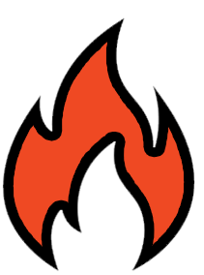

**Burning:** A **Burning** unit receives 1 damage at the beginning of their owner’s turn for as long as the status lasts.

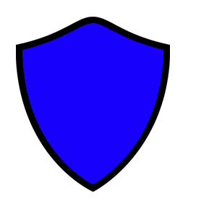

**Shield:** A **Shielded** unit takes 0 damage from the next attack. That attack’s knockback and other effects are also canceled. Upon receiving the attack, the **Shield** is removed.



**Stun: Stunned** units cannot move, attack, or perform any other action during their owner’s turn for 1 turn.

**Turn Overview**

- Players cannot undo their moves.

- At this point, each player should refer to their sections, **Human Rules** and **Shiva Rules**, for detailed turn rules, in addition to card information and unique mechanics.

**Objective:**

-The Shiva player wins if all mechs are downed or all buildings are destroyed.

-The Human player wins if the hive is destroyed.

## Human Rules

**> Relevant Board Elements**

First, observe all the elements of the board.

- The four rows nearest you are "your half" of the board.

- Three decks: Mech cards, Action cards, and Buildings

- Shared deck of Obstacle cards.

- Status tokens on the right

- Health dice on the left

- Action point (AP) counter to track the remaining AP for the Human player each turn. This counter must be manually decremented and reset each turn.

**> Mech Cards**

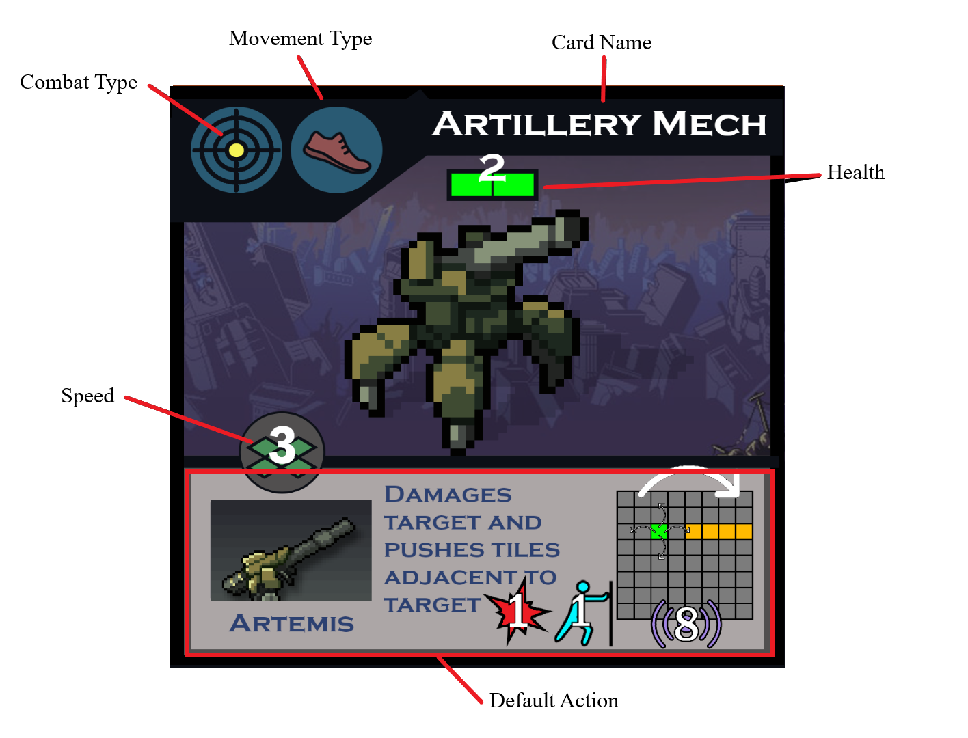

* COMBAT TYPE: A Mech card will have one of three types: Melee, Ranged, or Support. Its combat type will determine its compatibility with certain action cards (see the ‘Actions’ section)
* DEFAULT ACTION: Each Mech has a unique action they may perform. Refer to the provided Card Reference Sheet for action statistics and terminology.

**Downed:** A Mech card is downed if its health reaches 0. Downed Mech cards cannot move or perform actions. They remain on the board as 2 Health obstacles and are removed from the board when this health is depleted. Certain action cards may return it to fighting condition.

**> Turn**

The Human player starts with 8 Action Points (AP) every turn.

At the beginning of their turn, the player can draw up to 5 action cards and discard up to 2 cards from their hand. There is no set order to this; you may alternate between drawing and discarding.

These discarded cards are placed face-down in the discard pile.

They cannot have more than 8 cards in their hand at any time.

**> Actions**

* All actions cost a certain amount of AP to perform.
* A Mech card can perform multiple actions in a turn. For each action, after the first, performed on the same Mech card, increase its AP cost by 1. This increase is reset at the end of the Human player’s turn.

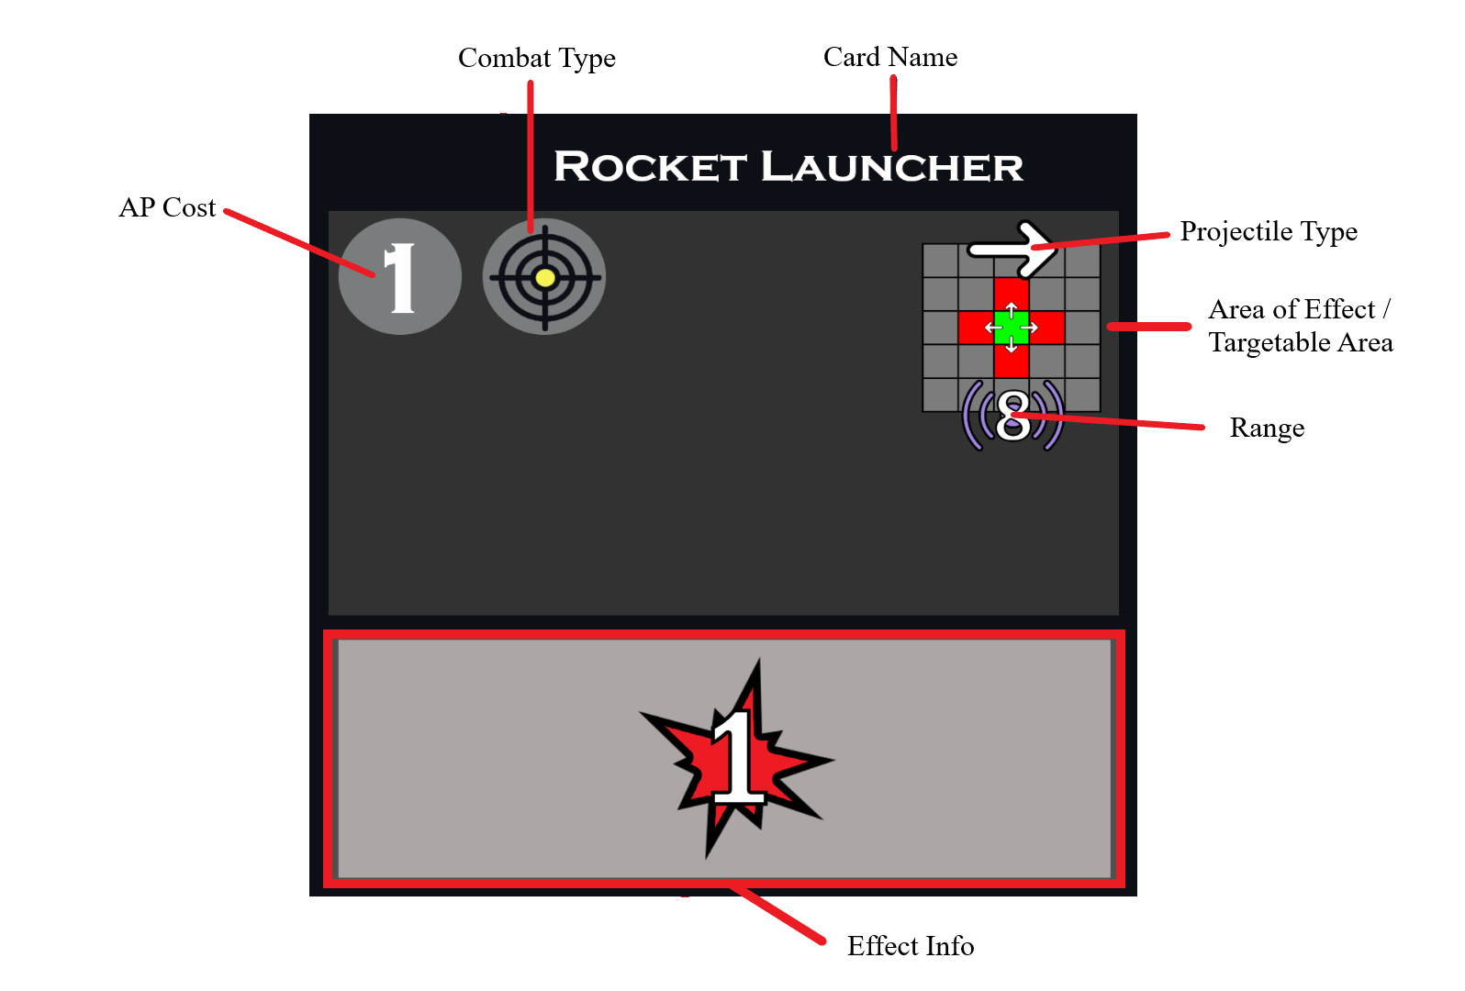

*Refer to the Card Reference Sheet for more details regarding these terms

ACTION CARDS:

* Each action card has a combat type assigned to it: Melee, Ranged, and Support.
* Action cards cost a certain amount of AP to play.
* Using it on a Mech card of a different combat type increases the AP cost by 1.

After playing the card, place it face-down in the discard pile.

If there are 1 or fewer cards left in the action deck, shuffle the discard pile back into the deck.

DEFAULT ACTION:

* Each Mech card has a unique default action that costs 1 AP to perform.
* Performing a default Mech card action costs 1 action, and performing multiple actions with the same Mech card increases the cost by 1 point each time.

REPAIR:

* For an initial AP cost of 1, the Mech card regains 1 Health, but it cannot exceed its initial Health.

**> End of turn**

The Human player can announce the end of their turn whenever they feel ready. Their turn automatically ends if they use up all their AP and have moved each of their Mech cards once already.

## Shiva Rules

**> Relevant Board Elements**

First, observe all the elements of the board.

- The four rows nearest you are "your half", the area where Shiva cards can spawn.

- Cards: Shiva deck, Hive card, Shared Obstacles deck

- Green d10 for tracking spawner health.

- Status tokens on the left

- Health dice on the right

- Tablet on the right is open to the reference sheet for what each Shiva card does

- SP counter to track the number of spawning points the Shiva player has left, this turn. This counter must be manually decremented and reset each turn.

**> The Hive**

This Hive creates a teleportation connection with the mothership and allows Shiva cards to be called into the local area.

Attributes:

- The Hive has 10 Health. It comes with a d10 to track its health on top of the card.

- Destroying your Hive is the enemy's win condition so keep it alive at all costs!

**> Turn**

The Shiva player starts their turn by drawing 3 Shiva cards and then activating their Shiva cards on the board.

The Shiva player goes on the first turn of the game, and on this turn alone they cannot draw Shiva cards at the beginning of their turn.

For the rest of the game and after the Shiva player’s first turn, the Shiva player can draw up to three cards from the Shiva deck.

The Shiva player’s hand size is unlimited.

The Shiva player has 4 Spawning Points (SP) available per turn.

They can then spawn new Shiva cards by spending SP or use the Shiva cards currently on the board.

There is no definite order to these events, so as long as the player doesn't try to use a Shiva card the same turn they are played face-down, they can play their turn in whatever order they like.

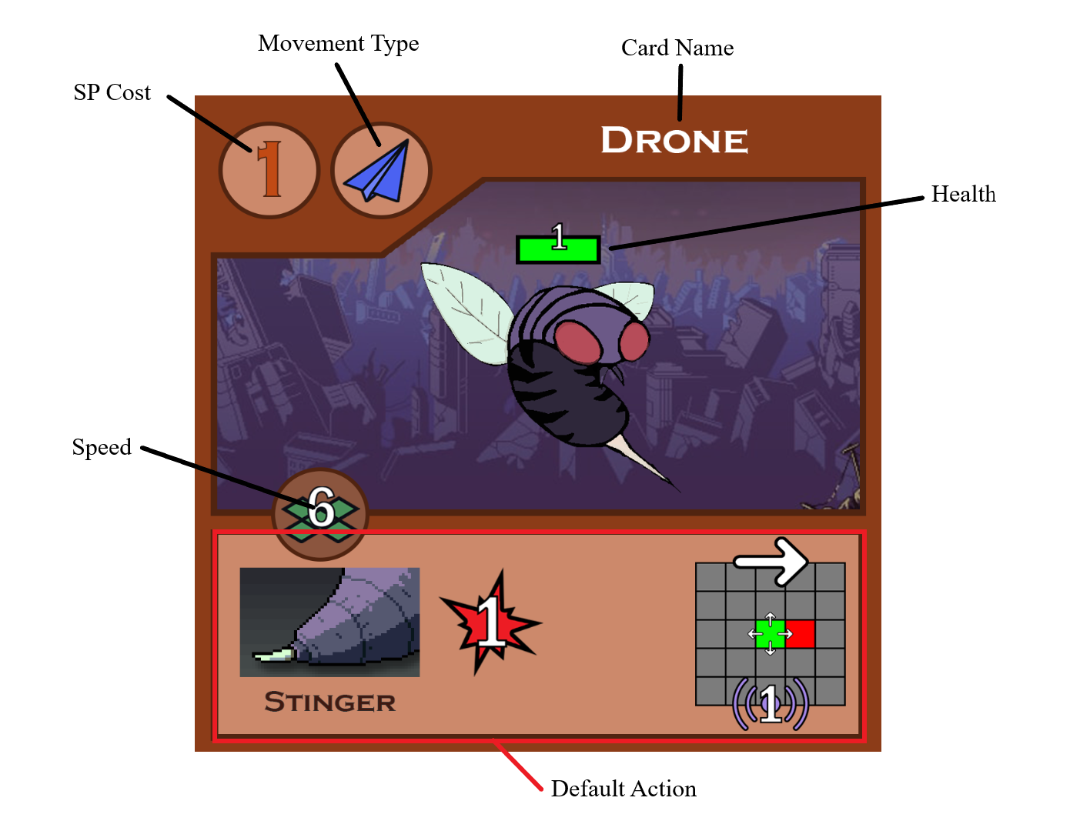

SP COST: The number of spawning points required to play this Shiva onto the board.

DEFAULT ACTION: Each Shiva has a unique action they may perform once per turn. Refer to the provided Card Reference Sheet for action statistics and terminology.

**>Playing Shiva Cards**

Shiva cards are played “underground”, face-down, when placed from the hand. These face-down cards are not obstacles and can be moved over/on top of by other cards.

If no card has been moved on top of the Shiva card then the Shiva will activate, (be flipped face-up), at the start of the Shiva player’s next turn.

If there is another card that is in the same tile as the face-down Shiva card. That card takes one damage and the Shiva’s spawn is delayed to the Shiva player’s next turn.

You cannot attempt to spawn Shiva cards in a tile that is currently occupied by a Mech card.

**> Using Shiva Cards**

Each Shiva card will be able to move and perform its default action once per turn.

When a Shiva card dies you then place it face-up in the discard pile.

When there are 2 or fewer cards left in the Shiva deck, shuffle the discard pile back into the deck.

**> End of turn**

The Shiva player can announce the end of their turn whenever they feel ready. Their turn automatically ends if they use up all their SP and have moved each of their Shiva cards once already.

## References

AP - Action Point, used to perform action on Mechs.

Area of Effect - The area on the board that the effect on the card will apply to. See (General Rules: Combat)

Friendly Fire - Any action being done by a friendly unit can affect other friendly units too, even if it negatively affects them.

Immovable - Cannot be moved from its current tile regardless of what tries to affect it. See (General Rules: Forced Movement)

Knockback - An effect that Shiva actions and Action cards can apply that pushes enemies. See (General Rules: Combat )

Mechs - The units of the Human player to fight back against the Shiva. Have max health, movement, and a default action for each card. See (Human Rules: Mechs)

Movement - A unit can move to the four squares directly adjacent. No diagonal movement is allowed unless by a card effect. See (General Rules: Movement)

Pushing - A mechanic where an action against an enemy unit can force it to move tiles in the opposite direction. See (General Rules: Forced Movement)

Pulling - Similar effect to pushing but it moves the selected enemy towards the player. See (General Rules: Forced Movement)

Shiva - The units of an invading alien species. Have max health, a movement, and action for each card. See (Shiva Rules: Shiva Cards)

SP - Spawning Points, used to spawn additional Shivas.

**Card Reference Sheet**

**Combat Types**

**Melee Support Ranged**

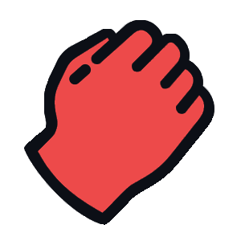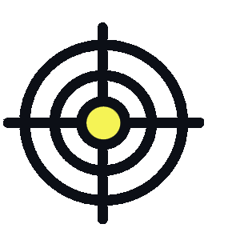

**Movement**

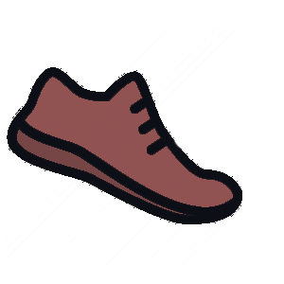

**Grounded -** This unit cannot occupy or move onto the same spaces as enemy units, obstacles, buildings, and the Spawner Hive.

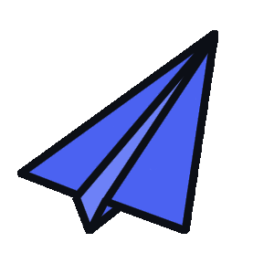

**Flying -** This unit can move over tiles that otherwise restrict **Grounded** units. However, they still may not occupy those tiles at the end of its owner’s turn.

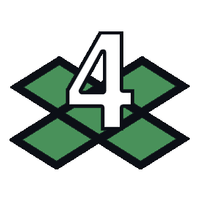

**Speed -** How many tiles the unit can move over per turn.

**Attack Properties**

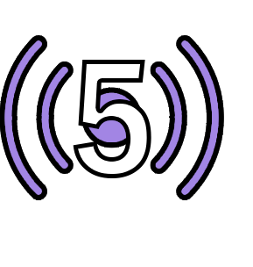

**Attack Range -** How many tiles away the action can hit.

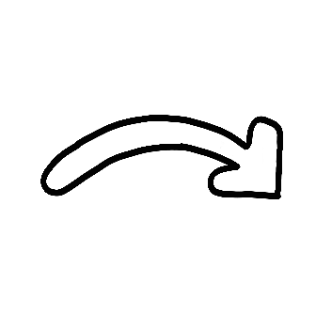

**Arcing -** This action cannot be blocked by obstacles. 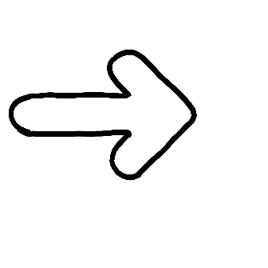

**Straight -** This action can be blocked by entities. If an entity is in the path of the action’s intended target, it receives the attack instead.



**Damage -** The amount of damage this action does.

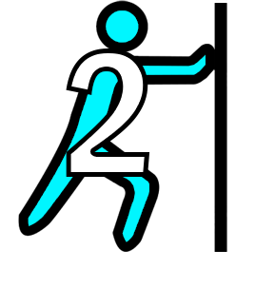

**Knockback -** How many tiles the target is knocked away by this action. The direction of the knockback is the same as the attack’s direction, unless specified on the card.



**Shield -** A **Shielded** unit takes 0 damage from the next attack. That attack’s knockback and other effects are also canceled. Upon receiving the attack, the **Shield** is removed.

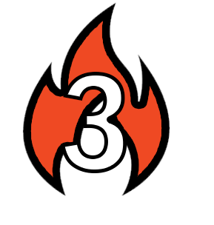

**Burning - Burning** units take 1 damage at the beginning of their owner’s turn. The effect lasts for the indicated number of turns on the symbol.



**Stun - Stunned** units cannot move, attack, or perform any other action during its owner’s turn for 1 turn.

**Targetable Area**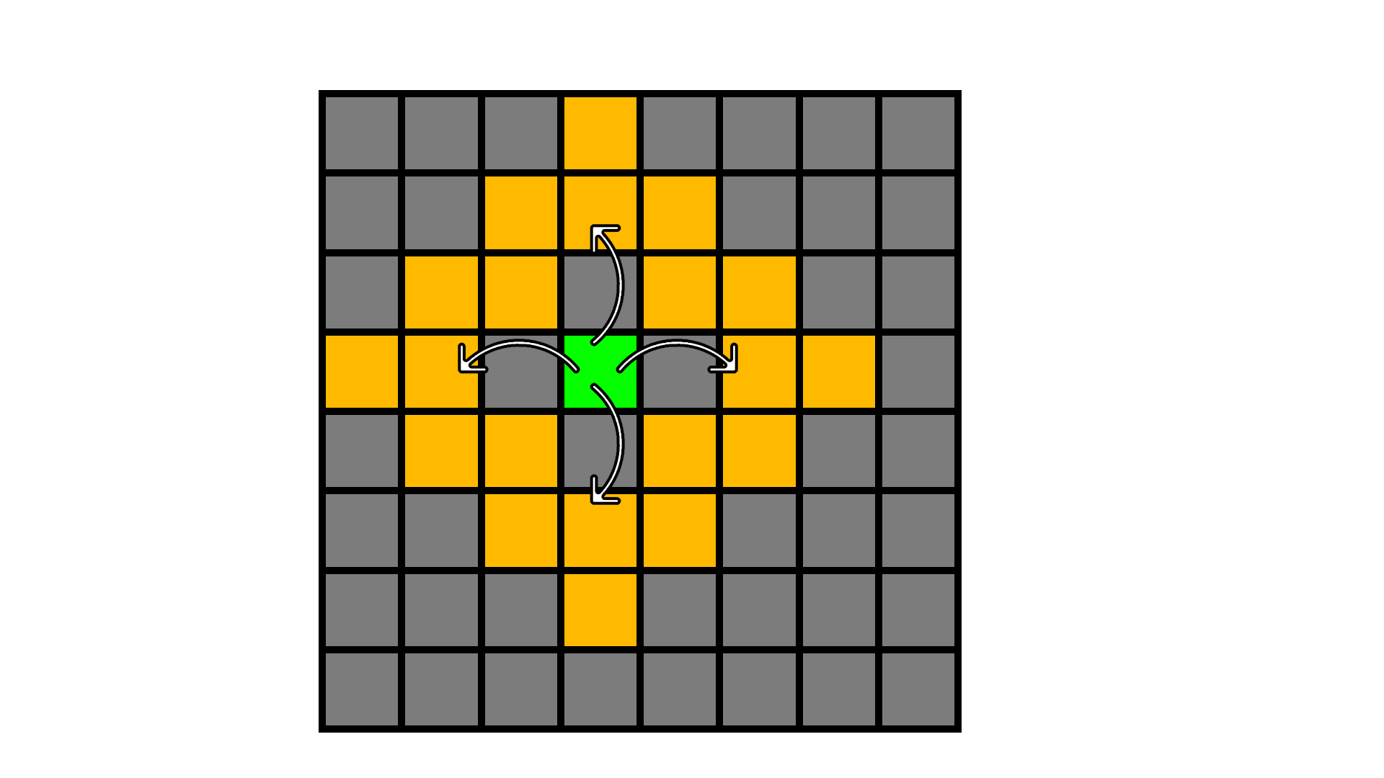

The green square represents the acting entity. The targetable area is shown by the yellow squares. This grid is generally used by actions that target only one square.

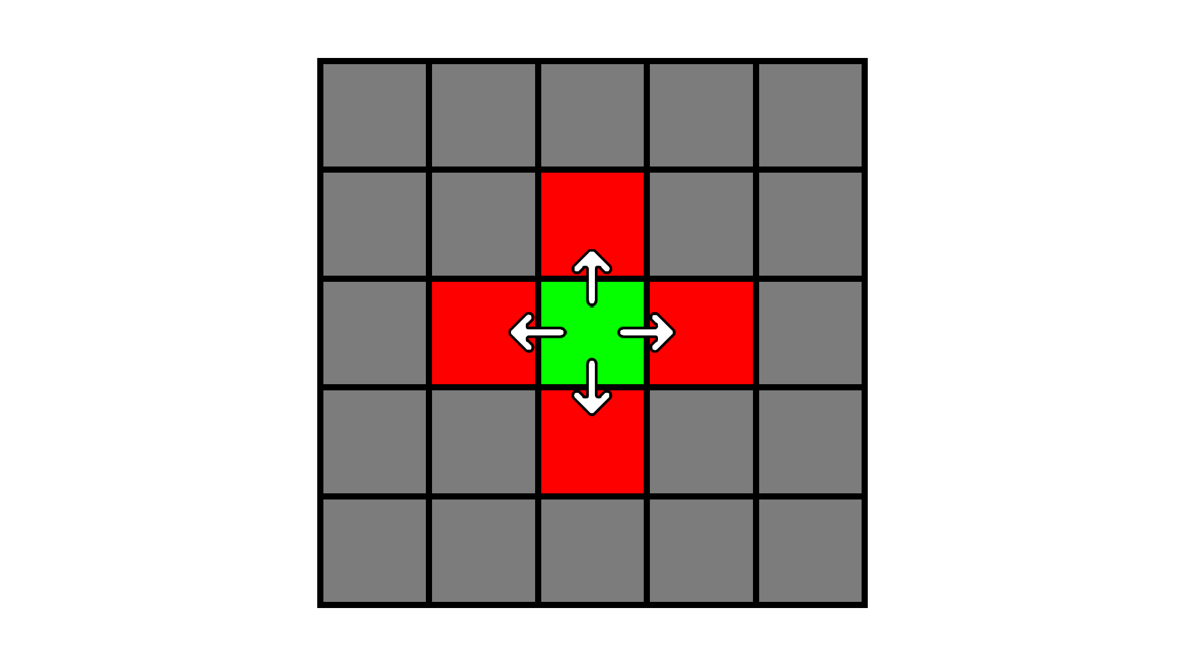

Certain attacks have an **area-of-effect** (AOE), which will use this style of grid. The epicenter of the AOE is represented by the green square, while the AOE is shown in red. Use the action’s **Range** value to determine how far away the epicenter can be targeted from the acting entity.