Artemis Momentum Factor Book
Project-Findings Write-Up — Cross-Sectional Momentum on an Artemis-Sourced Crypto Spot Universe
Date: 2026-05-30 | Status: final deliverable (Stage 5) | Methodology: Project 1 Factor Book Guide
VERDICT: Momentum is a rigorous, regime-dependent statistical NULL on the Artemis spot universe — NO-DEPLOY.
All numbers in this write-up are quoted verbatim from the committed source-of-truth artifacts (docs/report/Artemis_Momentum_Report.md, docs/STAGE2_RESULTS.md, docs/STAGE4_RESULTS.md, docs/AUDIT.md, docs/specs/2026-05-30-artemis-momentum-design.md). Nothing is re-derived or invented.

1. Executive Summary
We tested cross-sectional momentum on an Artemis-sourced crypto spot universe and find no deployable factor. The recommendation is: do not deploy.
- What we tested. Twenty-one momentum variants total — a pre-registered selection family of 7 lookbacks (1, 3, 5, 7, 14, 28, 56 days) at the convention skip of 1 day, plus 14 skip-{2,3} diagnostics reported for transparency but never eligible for deployment. The full Stage-2 significance battery was run on the in-sample slice; a sealed out-of-sample window was opened exactly once in the cost-aware backtest.
- What held up — nothing, at the family level. No selection-family variant is significant on the Newey-West HAC test against the Bonferroni threshold (0.05 / 7 = 0.00714). The strongest, momentum_L5d_S1d, is HLZ-“suggestive” with HAC t = 2.403 and HAC p = 0.0081 — above the Bonferroni threshold. It clears Bonferroni only through the bootstrap-override rule (bootstrap p = 0.0058), and is then disqualified outright by the Stage-2.6 deployment gate because it flips sign across subsamples (holds_sign = no). Its deflated Sharpe is 0.460 and the grid PBO is 0.114.
- Strongest variant, net of cost. Characterized for completeness, momentum_L5d_S1d posts an in-sample net Sharpe of 0.664 (gross 0.789) and an out-of-sample net Sharpe of 0.756 (gross 0.897). The OOS Sharpe did not collapse — but this is a single-regime artifact on a window of ~30 overlapping observations spent exactly once (the 2024 crypto bull), not a stable edge. The academic 4-week comparator momentum_L28d_S1d works only gross of costs: gross Sharpe 0.073 turns to net −0.031 in-sample and net −0.270 out-of-sample.
- Recommendation. Do not deploy momentum on the Artemis spot universe. The suggestive ~5-day signal is a research lead, not a strategy. Capacity (~$36M) is comfortable and is not the binding constraint; the disqualification rests on multiple-testing failure, subsample sign-instability, regime dependence, fragility to the lookback parameter, and the disclosed data limitations.

2. Objective & Scope
Determine, with full statistical rigor and net of realistic trading costs, whether a cross-sectional momentum factor on an Artemis-sourced crypto spot universe has a true positive expected return — as opposed to a sample artifact. The null hypothesis for every test is a true mean factor return of zero. If momentum is insignificant, that honest null is the deliverable.
- In scope: the momentum factor only — construction, the statistical significance battery, in-sample deployment choice plus volatility targeting, a cost-aware backtest, and this research write-up.
- Out of scope: size, short-term reversal, betting-against-beta, and carry as deployed factors; any multi-factor combination. A small-minus-big size control is built solely as a test-only regressor inside the Stage-2.4 spanning regression — it is never formed as a portfolio, never deployed.
- Data source: all data sourced from Artemis. The study follows the Project 1 Factor Book Guide methodology strictly, differing only where the data source forces it; every such deviation is disclosed (Section 10).

3. Data & Universe
The universe is enumerated programmatically from the Artemis /asset catalog (1,013 entries; 846 with any price data), on a daily point-in-time grid spanning 2018-01-01 to 2026-05-30 (2,598,912 panel rows). Eligibility filters (≥90 days history, ≥50% observation density, $10M market-cap floor, trailing-30d median 24H volume above threshold, staleness check, stablecoin and wrapped-token exclusion) are rebuilt as-of each date.
Dead and collapsed coins are kept: 238 of 846 assets (28%) exhibit a terminal >90% drawdown (15 formally delisted + 223 still-printing “zombies”), and every one of their crash returns is carried into the P&L (the LUNA/lunc −99.99% collapse included). Recycled tickers are split into distinct synthetic assets so a revived ticker is never spliced onto a dead one. Holding return is the simple spot price return — Artemis exposes no perpetual funding, so no funding term is modeled (disclosed). Residual survivorship — coins fully purged from Artemis before the query — is an unestimable lower bound; reported factor returns are therefore upper bounds relative to a hypothetically complete universe.
Metric | Value
Artemis /asset catalog entries (as-of-today) | 1,013
Assets with any price data (panel) | 846
Date range | 2018-01-01 → 2026-05-30
Panel rows (date × symbol) | 2,598,912
Total terminal collapses (>90% drawdown, carried) | 238 (28%)
— delisted cohort | 15
— zombie cohort (still printing near-zero) | 223
Left-censored assets (first price = 2018-01-01) | 272
Assets ever eligible | 303
Assets eligible on latest date (2026-05-30) | 226
Table 1 — Universe and survivorship figures (docs/AUDIT.md).

4. Methodology

4.1 Momentum construction
Signal = trailing log-sum return over a fixed lookback, shifted by a skip. The 7-lookback grid is fixed in advance (academic 14/28/56-day plus crypto-short 1/3/5/7-day); skip is a nuisance parameter fixed by convention at 1 day. The eligible universe is sorted into quintiles, long the top 20% / short the bottom 20%, equal-weight within each leg, dollar-neutral. The signal uses data through the close of t; the position is entered at the close of t+1 (a mandatory, unit-tested one-period lag — no look-ahead).

4.2 Stage-2 significance battery
Per variant, the battery runs:
- Newey-West HAC t-stat (autocorrelation-robust) is the reported mean-return test, with bandwidth covering the holding-period overlap; the naive t-stat is shown but flagged biased and is never the headline.
- Lo (2002) Sharpe SE (autocorrelation-corrected when Ljung-Box fires).
- Spanning regression of the factor on {equal-weight market return, small-minus-big size control} reporting the HAC-t alpha (the size control is a TEST-ONLY regressor).
- Bonferroni & Harvey-Liu-Zhu on the pre-registered family of 7 (0.05 / 7 = 0.00714) and HLZ tiers.
- Stationary block bootstrap (arch) as the bootstrap of record; a Newey-West/bootstrap disagreement across the adjusted threshold defers to the bootstrap.
- Subsample sign-stability (halves and thirds) as a hard deployment gate — a sign-flip disqualifies regardless of t-stat.
- Deflated Sharpe (DSR) and PBO/CSCV to quantify selection overfit.
Sealed OOS and cost-aware backtest. The most recent ~30% of rebalance dates (OOS_START = 2023-12-02) were reserved before any statistic was computed and opened exactly once, in Stage 4, under a single-use guard. The backtest applies a 10 bps spot taker fee per side plus size-scaled tiered slippage, executes at the t+1 close, and reports the full net metric set plus a capacity estimate.

5. Significance Results
No selection-family (skip = 1) variant is significant on the Newey-West HAC test at the Bonferroni threshold (0.05 / 7 = 0.00714). The lowest family p-value is momentum_L5d_S1d at 0.0081 — above the 0.00714 threshold. L5d is HLZ-“suggestive” but disqualified by sign-instability (holds_sign = no) and only clears Bonferroni via the bootstrap-override rule (bootstrap p = 0.0058). The visually striking t≈5 diagnostics (e.g. L3d/S3d HAC t = 5.015, L14d/S3d HAC t = 3.949) are NOT in the selection family and were never eligible for deployment.
Was there alpha? Only momentum_L5d_S1d has a spanning-alpha t-stat above 2 (2.206) within the selection family; all other family variants are below 1.62 (the next-highest is L7d at 1.614, then L14d at 1.597). There is no robust alpha. Grid-level overfit controls: PBO/CSCV = 0.114 (below the 0.5 threshold but on a correlated family — Figure 5 shows short lookbacks cluster tightly, so the effective independent-test count is below 7).

5.1 Selection family (skip = 1) — deployment candidates
variant | n | naive t | HAC t | HLZ | ann ret | Sharpe (SE) | autocorr | span α | span α t | HAC p | boot p | disagree | holds sign | power | DSR | survives
momentum_L14d_S1d | 69 | 1.902 | 1.945 | not_significant | 0.5128 | 0.799 (0.425) | no | 0.02310 | 1.597 | 0.0259 | 0.0354 | no | yes | powered | 0.308 | no
momentum_L1d_S1d | 69 | -1.247 | -1.300 | not_significant | -0.3078 | -0.524 (0.422) | no | -0.02502 | -1.457 | 0.9032 | 0.9102 | no | no | powered | 0.000 | no
momentum_L28d_S1d | 69 | 0.911 | 0.955 | not_significant | 0.2791 | 0.383 (0.421) | no | -0.00197 | -0.104 | 0.1698 | 0.1780 | no | yes | powered | 0.060 | no
momentum_L3d_S1d | 69 | 1.606 | 1.533 | not_significant | 0.4098 | 0.674 (0.424) | no | 0.01265 | 0.811 | 0.0626 | 0.0656 | no | no | powered | 0.198 | no
momentum_L56d_S1d | 69 | 0.935 | 0.756 | not_significant | 0.2683 | 0.393 (0.525) | yes | 0.00777 | 0.351 | 0.2249 | 0.2024 | no | no | powered | 0.062 | no
momentum_L5d_S1d | 69 | 2.315 | 2.403 | suggestive | 0.6163 | 0.972 (0.428) | no | 0.04631 | 2.206 | 0.0081 | 0.0058 | yes | no | powered | 0.460 | yes
momentum_L7d_S1d | 69 | 2.068 | 1.887 | not_significant | 0.6209 | 0.868 (0.426) | no | 0.04020 | 1.614 | 0.0296 | 0.0214 | no | yes | powered | 0.352 | no
Table 2 — Selection-family significance battery (docs/STAGE2_RESULTS.md). The shaded row is the strongest candidate, momentum_L5d_S1d: the sole bootstrap-override Bonferroni survivor, disqualified by the §2.6 sign-stability gate (holds sign = no).

5.2 Diagnostics (skip = 2, 3) — reported, not selected
These 14 variants are reported for transparency and were never eligible for deployment. Together with the 7-variant family they make up the full 21-variant trial grid.
variant | n | naive t | HAC t | HLZ | ann ret | Sharpe (SE) | autocorr | span α | span α t | HAC p | boot p | disagree | holds sign | power | DSR | survives
momentum_L14d_S2d | 69 | 2.369 | 2.298 | suggestive | 0.6492 | 0.995 (0.428) | no | 0.03656 | 2.197 | 0.0108 | 0.0140 | no | yes | powered | 0.481 | no
momentum_L14d_S3d | 69 | 3.241 | 3.949 | significant | 0.8988 | 1.361 (0.436) | no | 0.06042 | 3.888 | 0.0000 | 0.0006 | no | yes | powered | 0.805 | no
momentum_L1d_S2d | 69 | 0.075 | 0.069 | not_significant | 0.0288 | 0.032 (0.420) | no | -0.03414 | -1.504 | 0.4724 | 0.4459 | no | no | powered | 0.010 | no
momentum_L1d_S3d | 69 | 3.338 | 2.851 | suggestive | 1.0432 | 1.402 (0.437) | no | 0.07471 | 2.654 | 0.0022 | 0.0054 | no | yes | powered | 0.870 | no
momentum_L28d_S2d | 69 | 0.872 | 0.937 | not_significant | 0.2497 | 0.366 (0.421) | no | 0.00301 | 0.167 | 0.1744 | 0.1758 | no | yes | powered | 0.060 | no
momentum_L28d_S3d | 69 | 1.416 | 1.393 | not_significant | 0.3889 | 0.595 (0.423) | no | 0.01918 | 1.061 | 0.0818 | 0.0804 | no | yes | powered | 0.142 | no
momentum_L3d_S2d | 69 | 2.766 | 2.378 | suggestive | 1.0109 | 1.161 (0.505) | yes | 0.04369 | 2.105 | 0.0087 | 0.0192 | no | no | powered | 0.653 | no
momentum_L3d_S3d | 69 | 4.663 | 5.015 | significant | 1.0807 | 1.958 (0.452) | no | 0.08099 | 4.735 | 0.0000 | 0.0002 | no | yes | powered | 0.985 | no
momentum_L56d_S2d | 69 | 1.217 | 0.990 | not_significant | 0.3780 | 0.511 (0.522) | yes | 0.00903 | 0.412 | 0.1610 | 0.1466 | no | no | powered | 0.099 | no
momentum_L56d_S3d | 69 | 1.075 | 0.891 | not_significant | 0.3159 | 0.451 (0.513) | yes | 0.01069 | 0.517 | 0.1866 | 0.1658 | no | no | powered | 0.081 | no
momentum_L5d_S2d | 69 | 2.508 | 2.588 | suggestive | 0.9616 | 1.053 (0.429) | no | 0.04495 | 2.048 | 0.0048 | 0.0108 | yes | yes | powered | 0.558 | no
momentum_L5d_S3d | 69 | 2.857 | 2.660 | suggestive | 0.8167 | 1.200 (0.432) | no | 0.05033 | 2.179 | 0.0039 | 0.0030 | no | yes | powered | 0.675 | no
momentum_L7d_S2d | 69 | 2.097 | 2.327 | suggestive | 0.6428 | 0.881 (0.427) | no | 0.03496 | 1.681 | 0.0100 | 0.0116 | no | yes | powered | 0.372 | no
momentum_L7d_S3d | 69 | 1.925 | 2.102 | suggestive | 0.5245 | 0.808 (0.426) | no | 0.03522 | 2.075 | 0.0178 | 0.0110 | no | yes | powered | 0.330 | no
Table 3 — Diagnostic variants (docs/STAGE2_RESULTS.md). The high diagnostic Sharpes (L3d/S3d, L14d/S3d) sit outside the pre-registered selection family.

6. Backtest & Out-of-Sample
For completeness we characterized the strongest candidate, momentum_L5d_S1d, net of realistic spot costs. This characterizes the candidate; it does not rescue it — the Stage-2 disqualification stands.

6.1 Gross vs net, in-sample vs out-of-sample
Primary candidate momentum_L5d_S1d:
segment | gross Sharpe | net Sharpe | net ann ret | net ann vol | Sortino | max DD | Calmar | hit rate | ann turnover
in-sample | 0.789 | 0.664 | 0.2490 | 0.3752 | 0.756 | -0.4851 | 0.513 | 0.574 | 24.31
out-of-sample | 0.897 | 0.756 | 0.2469 | 0.3266 | 1.031 | -0.2516 | 0.981 | 0.567 | 28.22
Table 4 — Primary L5d_S1d gross/net, IS/OOS (docs/STAGE4_RESULTS.md).
Academic 4-week comparator momentum_L28d_S1d — “works only gross”: positive gross in-sample (Sharpe 0.073) but net-negative both in-sample (net −0.031) and out-of-sample (net −0.270, gross −0.158). The canonical horizon does not work net of costs.
segment | gross Sharpe | net Sharpe | net ann ret | net ann vol | Sortino | max DD | Calmar | hit rate | ann turnover
in-sample | 0.073 | -0.031 | -0.0134 | 0.4314 | -0.030 | -0.6809 | -0.020 | 0.559 | 23.90
out-of-sample | -0.158 | -0.270 | -0.0818 | 0.3031 | -0.283 | -0.5168 | -0.158 | 0.433 | 26.57
Table 5 — Comparator L28d_S1d gross/net, IS/OOS (docs/STAGE4_RESULTS.md).
- IS − OOS net Sharpe gap = −0.092. The OOS figure exceeds in-sample, but this is a spent-once, ~30-observation, single-regime (2024-bull) artifact — not evidence of a stable edge. A near-zero or negative OOS Sharpe would have been reported as overfitting; the positive figure is reported as-is and interpreted as regime exposure.
- Capacity ≈ $36,044,481 — the AUM at which size-scaled slippage on the actual per-rebalance traded order (~2.0× summed one-way turnover) erases the gross edge (per-rebalance gross edge 0.02436). This is comfortably above a $1M book, so capacity is not the binding constraint.
- Turnover is ~24 (IS) / ~28 (OOS) annualized — high, consistent with a 5-day signal.
Additional net metrics (total return, average win / loss) are reported in the Appendix (Table 9).

6.2 Robustness
2× costs (in-sample, primary): net Sharpe degrades from 0.664 to 0.552 (gross unchanged at 0.789; max DD widens to −0.5219). The edge thins materially under a doubled cost assumption. This is a sensitivity rerun of the deployed construction, not a re-selection.
segment | gross Sharpe | net Sharpe | net ann ret | net ann vol | Sortino | max DD | Calmar | hit rate | ann turnover
1x costs | 0.789 | 0.664 | 0.2490 | 0.3752 | 0.756 | -0.4851 | 0.513 | 0.574 | 24.31
2x costs | 0.789 | 0.552 | 0.2072 | 0.3753 | 0.610 | -0.5219 | 0.397 | 0.574 | 24.32
Table 6 — 2×-cost sensitivity, in-sample (docs/STAGE4_RESULTS.md).
±50% lookback (in-sample, net): the construction is fragile to its one free parameter. A −50% lookback (L2d) flips the candidate net-negative (−0.328) — not robust.
variant | net Sharpe | net ann ret | note
momentum_L5d_S1d (chosen) | 0.664 | 0.2490 | chosen lookback = 5d
momentum_L2d_S1d (−50%) | -0.328 | -0.1155 | lookback halved
momentum_L8d_S1d (+50%) | 0.621 | 0.2645 | lookback up 50%
Table 7 — ±50% lookback robustness, in-sample net (docs/STAGE4_RESULTS.md).
Regime breakdown (in-sample, net mean return per regime):
regime | n | mean net return
bull | 17 | -0.00624
bear | 28 | 0.02195
chop | 22 | 0.03453
Table 8 — Regime breakdown, in-sample net mean return (docs/STAGE4_RESULTS.md).
Caveat (do not over-read): this is a full-sample, descriptive partition, not a walk-forward signal — it could not have been traded ex-ante. The chop bucket is the top-|market-move| tercile, which on this sample skews toward large up moves, so the apparent “negative in bull / positive in bear” contrast is overstated and is an artifact of where the magnitude cut falls. The disqualifying evidence is the Stage-2 §2.6 sign-instability itself, not this descriptive split.
One-shot OOS, single-regime character. The OOS window is 30 overlapping-regime observations spent exactly once; a single favorable stretch (the 2024 crypto bull) carries the positive OOS Sharpe, interpreted as regime exposure, consistent with the sign-flip disqualification.

7. Figures
The five figures below visualize the P&L path, drawdown, rolling Sharpe, per-variant Sharpe, and family correlation. Each takeaway is copied verbatim from the figure-generation script.
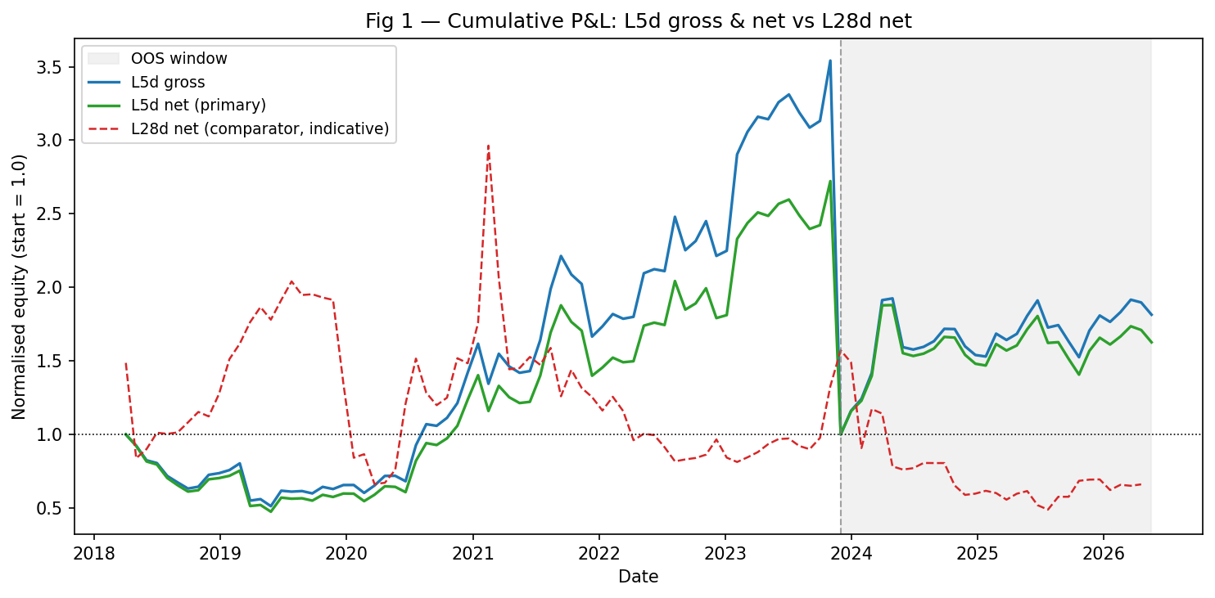
Figure 1 — Cumulative P&L: L5d gross & net vs L28d net.
Takeaway: L5d net grows steadily in-sample but is a regime-sensitive path; L28d net decays to near-zero — the canonical 4-week lookback does not survive costs.
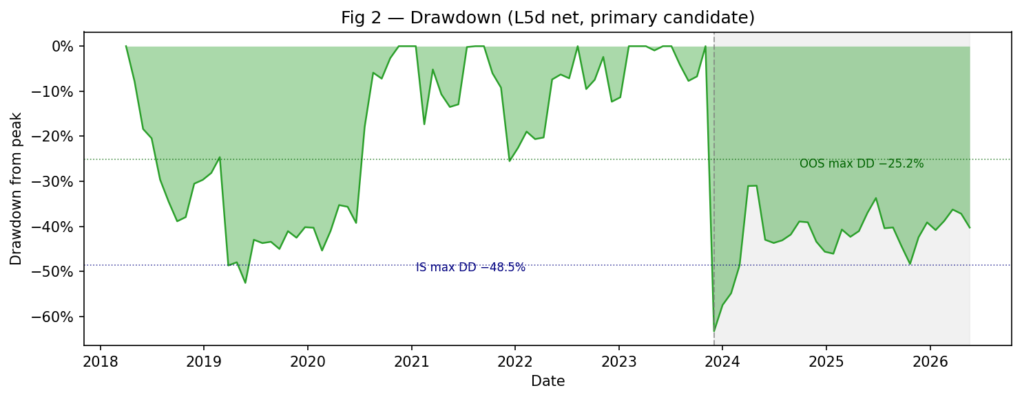
Figure 2 — Drawdown (L5d net, primary candidate).
Takeaway: In-sample max drawdown of −48.5% dwarfs the OOS −25.2%, consistent with the sign-instability finding; drawdown is material relative to returns at both horizons.
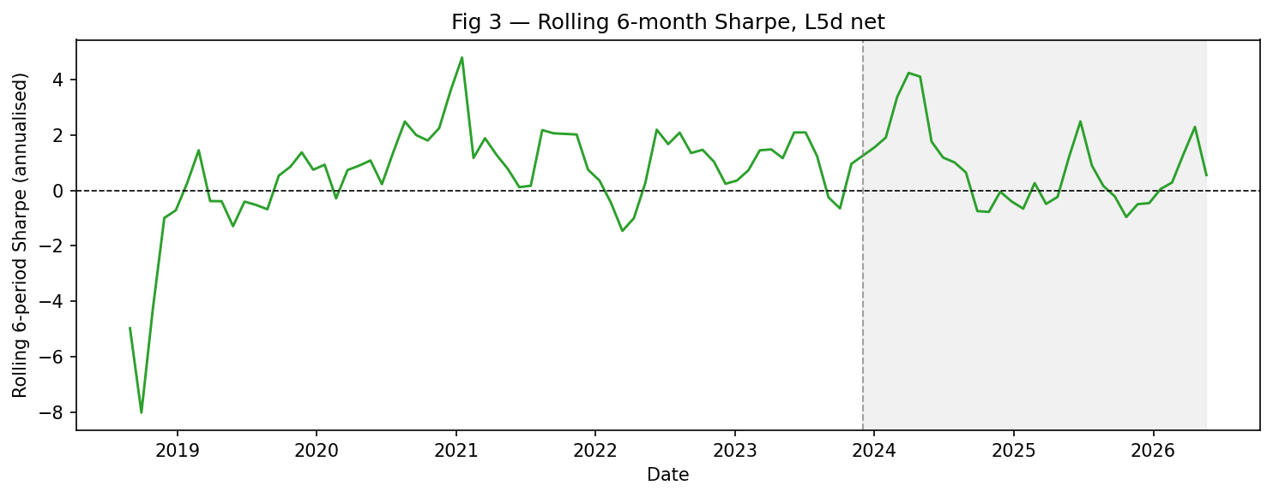
Figure 3 — Rolling 6-month Sharpe, L5d net.
Takeaway: Rolling Sharpe oscillates widely and dips sharply negative in multiple sub-windows, confirming that any positive in-sample/OOS Sharpe is driven by episodic regimes rather than a stable factor.
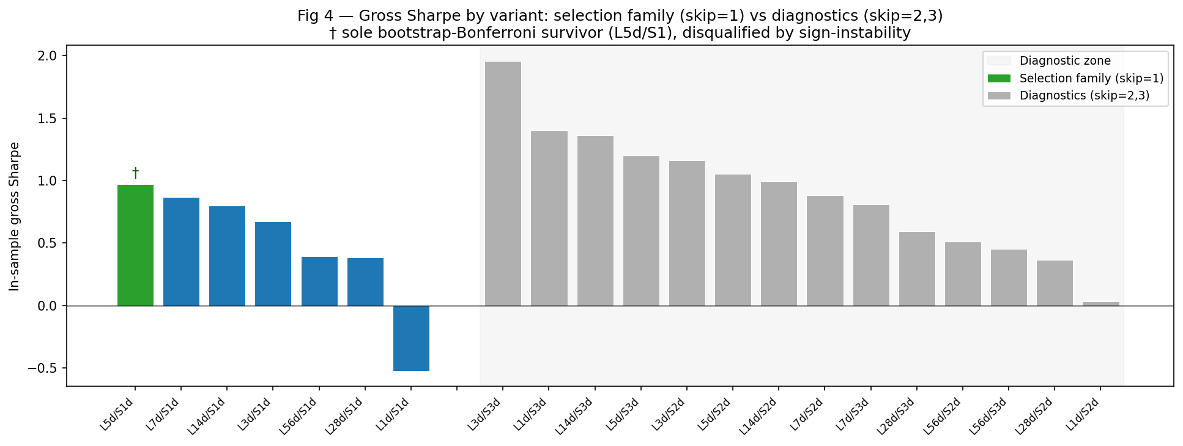
Figure 4 — Gross Sharpe by variant: selection family (skip=1) vs diagnostics (skip=2,3).
Takeaway: No selection-family variant clears the Bonferroni threshold on Newey-West; the eye-catching high Sharpes (L3d/S3, L14d/S3) are in the diagnostic zone and were never eligible for deployment.
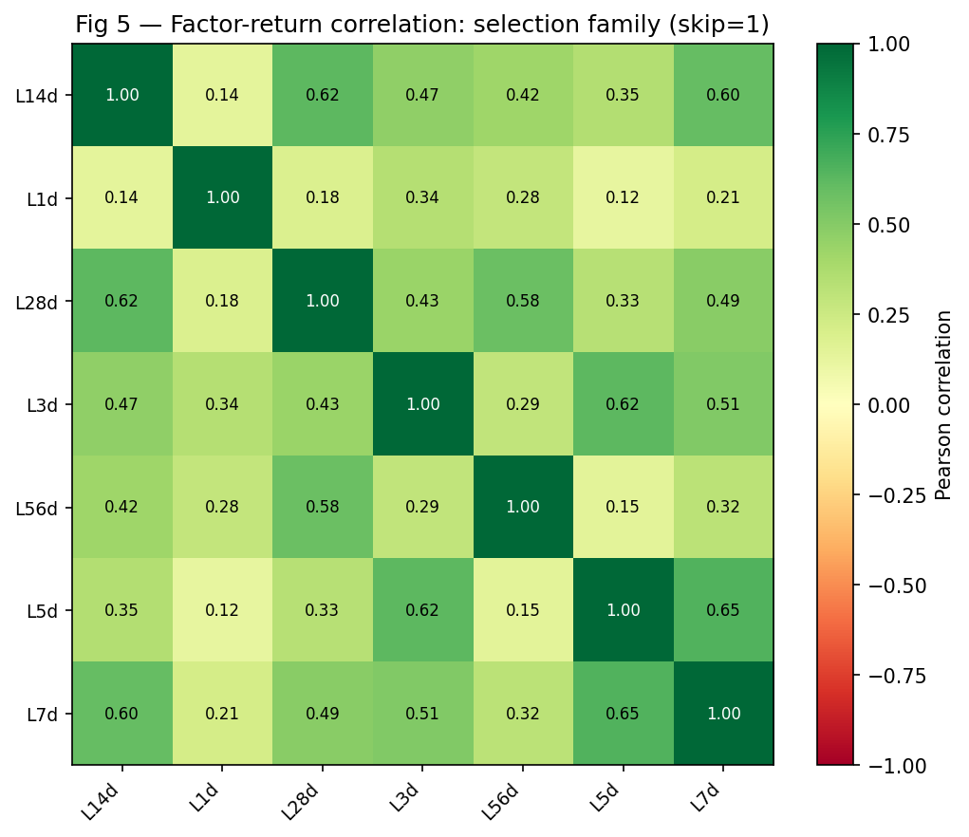
Figure 5 — Factor-return correlation: selection family (skip=1).
Takeaway: Short lookbacks (L1d–L5d) cluster together with high mutual correlation, while longer lookbacks (L14d–L56d) form a separate cluster; the family is far from orthogonal, reducing independent-test count below 7.

8. Conclusion & Recommendation
Do not deploy. Target allocation to a momentum sleeve on the Artemis spot universe: zero.
- Expected Sharpe (range): for the strongest candidate, net Sharpe sits in roughly 0.66–0.76 in the realized sample, but with no statistically reliable edge and a true expected Sharpe indistinguishable from zero once multiple testing, sign-instability, and the single-regime OOS are accounted for. We do not represent this as a deployable expectation.
- The suggestive ~5-day signal is a research lead, not a strategy. It would warrant follow-up only with (a) more independent observations, (b) a cleaner, lower-turnover construction, and (c) a true point-in-time universe that addresses residual survivorship.
- Key risks if (against this recommendation) deployed: regime dependence (the return is regime exposure, not a stable factor); selection / multiple-testing fragility (no family Bonferroni survivor on its own terms); subsample sign-instability (the hard disqualifier); parameter fragility (±50% lookback breaks it); and data limitations (no funding, daily t+1-close execution, volume unreliability, residual survivorship).
- Next steps: treat momentum as closed for deployment on this universe; if revisited, pursue the above three conditions, and consider it only as one input to a broader, properly multiple-testing-controlled research program — never as a standalone sleeve.

9. Limitations & Disclosures
- No funding / spot: Artemis exposes no perpetual funding; returns and costs carry no funding term (the guide's third cost component is N/A and stated).
- Daily, t+1-close execution: Artemis serves daily granularity only; fills are at the t+1 close with slippage applied — a one-period lag, not a costless intraday fill.
- Wrapped-token exclusion: wrapped tokens (WBTC, WETH, stETH, …) are excluded as redundant price exposures of their underlyings — a deliberate, disclosed deviation from the guide.
- Residual (as-of-today catalog) survivorship: the Artemis catalog is an as-of-today snapshot with no listing/delisting dates; coins fully purged before the query are unrecoverable. This is an unestimable lower bound on survivorship bias; reported factor returns are upper bounds.
- Volume reliability: only 24H_VOLUME is historical (30D_VOLUME is real-time only) and is unreliable cross-sectionally; liquidity is gated on a market-cap floor + trailing-30d median 24H volume — a disclosed deviation from the guide's mean-ADV rule.
- Survivorship flows into P&L: a collapsed short-leg coin's crash books as a positive contribution; dead coins are not dropped (238/846, 28% terminal collapses carried).
- Gross vs net, never flattered: spot costs reduce every reported Sharpe; net is never flattered above gross. The OOS window was opened exactly once (single-use guard).

10. Appendix

10.1 Additional Stage-4 net metrics
spec | segment | total return | avg win | avg loss
Primary L5d_S1d | in-sample | 1.7225 | 0.08584 | -0.06745
Primary L5d_S1d | out-of-sample | 0.6266 | 0.07509 | -0.05136
Comparator L28d_S1d | in-sample | -0.4518 | 0.06534 | -0.08526
Comparator L28d_S1d | out-of-sample | -0.2687 | 0.06283 | -0.05991
Table 9 — Additional §4.5 net metrics: total return, average win / loss (docs/STAGE4_RESULTS.md).

10.2 Methodology references
- Newey, W.K. & West, K.D. (1987) — HAC (autocorrelation-robust) standard errors, the reported mean-return test.
- Lo, A.W. (2002) — the statistics of Sharpe ratios (autocorrelation-corrected Sharpe standard error).
- Harvey, Liu & Zhu (2016) — “...and the Cross-Section of Expected Returns” (multiple-testing thresholds / HLZ tiers).
- Bailey & Lopez de Prado — the Deflated Sharpe Ratio and PBO/CSCV (probability of backtest overfitting).
- Politis & Romano — the stationary block bootstrap (implemented via the arch library), the bootstrap of record.
- Project 1 Factor Book Guide — authoritative construction, significance, deployment, and backtest methodology.

10.3 How to reproduce
The pipeline is deterministic and driven by scripts in scripts/ (uv-managed). The stages run in order:
- make probe — live Artemis connectivity + coverage probe (scripts/probe_artemis.py).
- make universe — survivorship-corrected universe panel (scripts/build_universe.py).
- uv run python scripts/build_returns.py — holding returns (crash-carry).
- uv run python scripts/build_factor_returns.py — the 21-variant momentum factor grid.
- uv run python scripts/run_stage2.py — the Stage-2 significance battery → data/stats/significance.parquet.
- uv run python scripts/run_backtest.py — the cost-aware, sealed-OOS backtest → data/backtest/.
- uv run python scripts/build_report_figures.py — the five report figures → docs/report/figures/.
- uv run python scripts/build_report.py — the deterministic research-report PDF.
- uv run python scripts/build_writeup_docx.py — this findings write-up (.docx).
End of write-up. All figures and statistics are reproduced verbatim from the committed source-of-truth artifacts; the verdict is NO-DEPLOY.

