**Probability Models for Enhancing Calibration of Computer Numerical Control (CNC) Systems**

Jacob Seman, Viktor Woldruff, Tyler Nelson

Partial Report

ECEN3810

Introduction to Probability Theory

**Table of Contents**

I. Executive Summary: 3

II. Method: 3

III. Analysis: 5

IV. Results: 7

V. MATLAB Code Appendix 8

VI. References: 12

## **I. Executive Summary:**

Computer-numerical-control (CNC) printed-circuit-board (PCB) milling is a valuable tool for students in the field of Electrical & Computer Engineering. Milling PCBs requires a well-calibrated CNC mill and a flat PCB surface. Variance exists in the surface of single-sided copper boards, and additional variance is introduced by fixturing methods. This variance must be accounted for, to achieve accurate reproduction of PCB designs, and can be modeled to aid in machine calibration and programmed height offsets, which allows precision machining even when boards are considerably warped by defects or fixturing. Heightmaps of the copper-clad board, where measurements in the Z-axis were taken at regular intervals in the X-Y plane, were produced using the CNC control software Candle[1], and correlations were identified in the resulting dataset. Normalization was required to remove an observed tilt in the fixturing and expose the subtle variation in the heightmaps. MATLAB was used to generate a variance model showing any observed correlation in X- and Y-axes and compared against the measured data.

## **II. Method:**

Data was collected for the physical system via CNC machine calibration and the resultant heightmap of 10 single-sided copper-clad boards. This was achieved by use of the heightmap functionality of the Candle CNC software[2], wherein the software is able to detect when the metal cutting bit makes electrical contact with the copper-clad board by performing a grid routine of probing contact operations according to user specification[2] [Fig. 1]. All 10 boards were clamped at a specific torque value of 3 NM [Fig. 2], applied to the single fixture clamp bolt using a torque-release hand tool set to this value.

Figure - Candle CNC software performing heightmap operation using electrical contact probing.

Figure - PCB board fixturing specifically designed for 100x70mm PCBs.

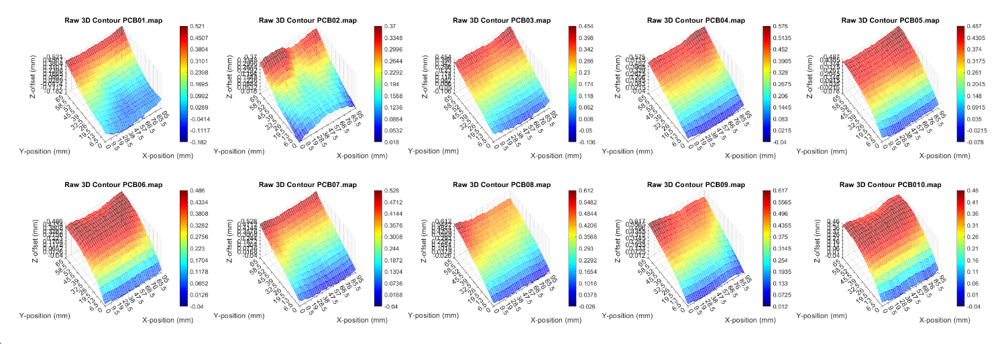The boards were measured to be 100mm by 70mm, and the heightmap routine was specified within a 95mm by 65mm region, with a resolution of 34 points by 16 points, in X- and Y-axes, respectively. Once the heightmaps were obtained for all 10 copper boards, a MATLAB script was developed to ingest the heightmap output files and plot a mesh for visual observation [Fig. 3]. Additionally, data was normalized by X and Y linear approximation of the quadrant averages and similarly plotted. This allowed improved visualization of the local variance in Z height, over X and Y, in the resultant surface plots [Fig. 4].

Figure - MATLAB script output showing raw heightmap data.

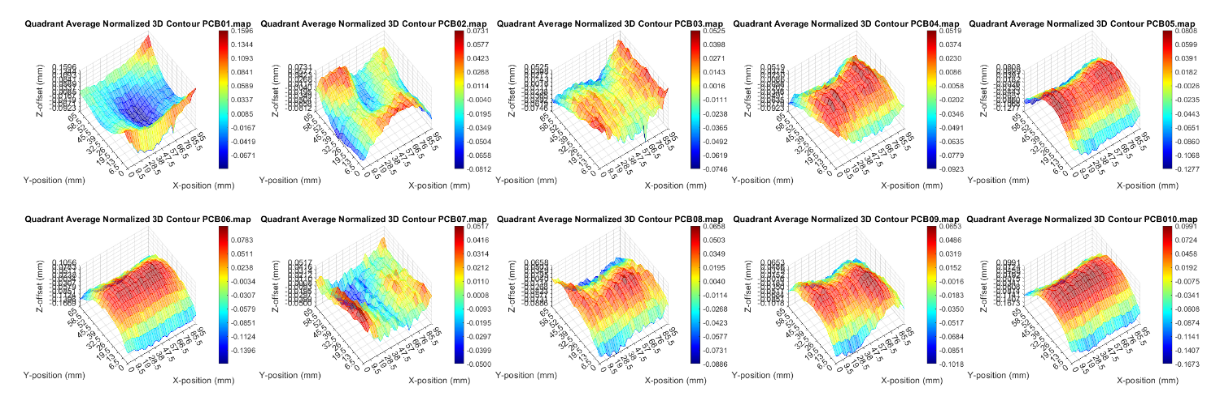

Figure 4 - MATLAB script output showing normalized heightmap data.

## **III. Analysis:**

A tendency for variance to be higher in the center of the Y-axis was noted, with slight reduction in variance at the extremes of the X-axis. Conversely, variance was considerably less at the extremes of the Y-axis, with little or no change along the X-axis at these points. This effect is attributable to the fixturing of the PCBs, where the clamping force imparts some flex, typical convex in the Y-axis. A numerical model with adjustable parameters was developed using GeoGebra[3] that allowed replicating this tendency on a 100mm by 70mm 3D surface [Fig. 5].

Figure - GeoGebra numerical surface model with adjustable parameters.

A matrix of means for the entire dataset was produced by creating a matrix of sums of variance from the local average for each heightmap and dividing each coordinate sum by the size of the entire dataset. This allowed plotting of a single parabolic surface which represents the mean variance, by coordinate, for the entire dataset of 10 boards. Note that each observed surface imparts some effect on the mean surface. Notably, there is a subtle concavity over the X-axis (with lessened variance just at the X-extremes), and a more dominant convexity over the Y-axis (with a taper toward much lower variance at the Y-extremes) [Fig. 6].

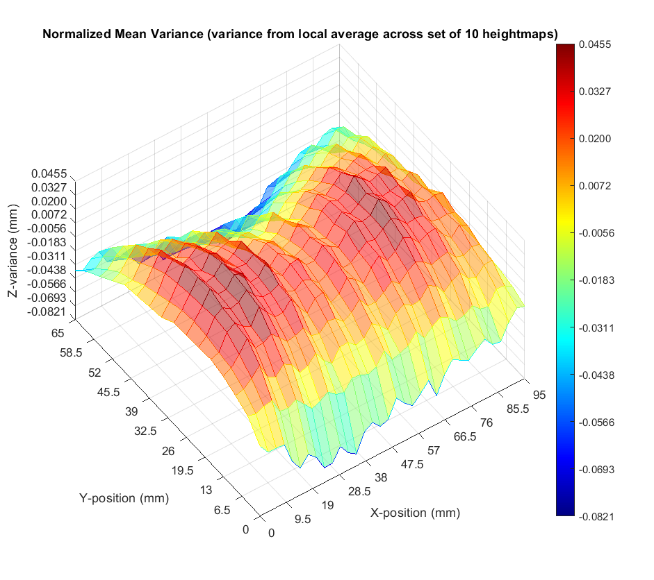

Figure – Normalized mean variance surface, representing the entire dataset across 10 boards.

Adjusting the numerical model in GeoGebra allows approximation of this ‘saddle’ surface [Fig. 7]. In reality, this numerical model would benefit from greater order functions in X and Y, to capture the lessened variance at either dimension’s extremes.

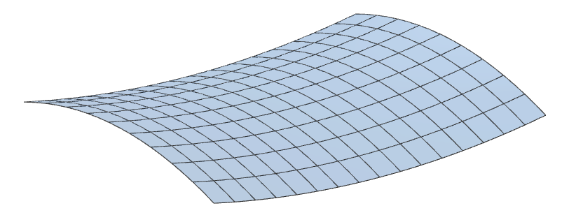

Figure - Numerical representation in GeoGebra of mean variance surface.

Also of note is the consistency of tendencies unique to the X- and Y-axes. A ripple along the X-axis was observed, as well as a sweeping parabola along the Y-axis. Creating vectors of the row and column averages allows plotting in 2D to better observe these features [Fig. 8]. It is suspected that the ripple along the X-axis is induced by the CNC machine itself, likely from a bowed lead screw putting strain on the tool head as it rotates to traverse the gantry along the X-axis. This is likely a common trait among inexpensive desktop CNC machines. Performing a higher resolution heightmap routine would likely reveal that this ripple has a period matching the travel in X per lead screw rotation, which was measured to be roughly 4.3mm. Note that the observed interval is twice this, most likely due to the selected X-resolution of the heightmap coincidentally being near a harmonic of the lead screw rotation interval.

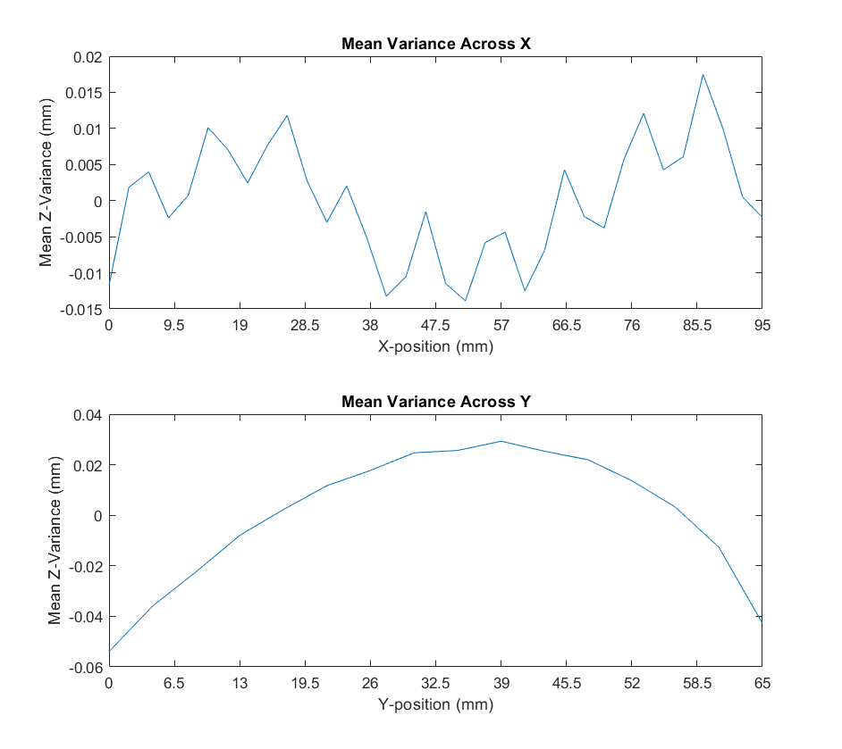

Figure - MATLAB plots of 2D X- and Y-axes mean vectors.

While the normalized mean dataset provides an excellent visual comparison of local variations such as the lead-screw effect described above, the raw mean data is most immediately valuable to real-world applications and is a better model of the actual physical PCB when clamped in the fixture [Fig. 9].

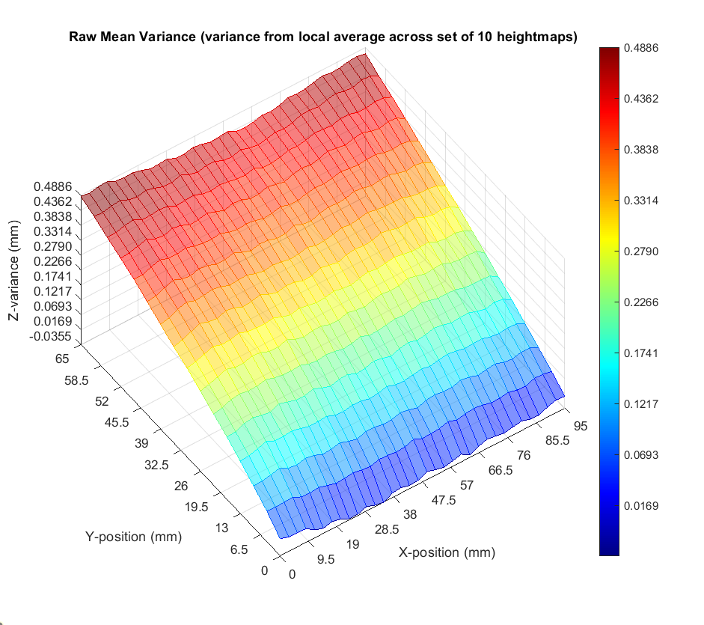

Figure – Raw mean variance surface, representing the entire dataset across 10 boards.

Most immediately noticeable is the strong tendency for one side of the fixture to be nearly 0.5mm higher than the other, with few other features represented. This slope is significant and obfuscates any other local variance features observed in the normalized data. While heightmaps created in the Candle software are accurate enough to account for the subtle variation of the lead screw or other local variance in the PCB, the sloped heightmap observed in the raw mean plot may be applied to any PCB clamped in this fixture without the need for creating a heightmap unique to that specific PCB. This is further explored by creating standard deviation plots from the dataset [Fig. 10 & Fig. 11].

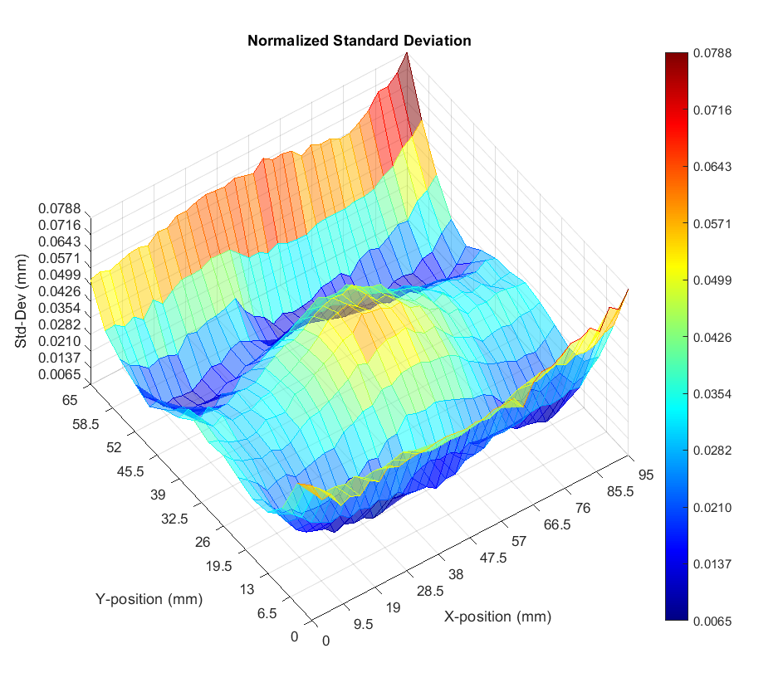

Figure – Normalized standard deviation surface, representing the entire dataset across 10 boards.

The normalized standard deviation surface shows the effect of the quadrant averaging normalization, which presents itself as near-zero deviation in the center of each quadrant. This method skews the consistency of the fixture clamping surface, causing high deviation at these locations. The raw standard deviation provides more useful information [Fig. 10].

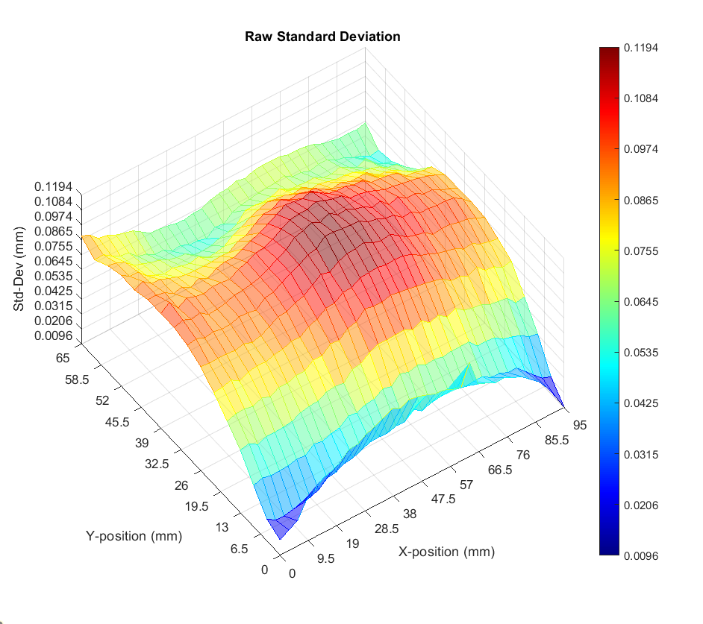

Figure – Raw standard deviation surface, representing the entire dataset across 10 boards.

Standard deviation in the raw data set behaves as expected – with much less deviation at the clamping surfaces. The center of the PCB varies as much as 0.12mm, showing the effect of PCB flexure as the fixture is clamped at consistent torque values. This informs best practices when applying the mean heightmap to an unknown PCB – milling results will be most consistent when fitting smaller designs closer to the lower end of the fixture due to the increased likelihood of the actual PCB position being “on-model” with the mean heightmap.

The small size of the data set must also be addressed. Only ten boards were acquired for testing, and from a single source, limiting the viability of this model somewhat when applied to context outside of this data set. The most prominent feature of the mean data was noted to be induced by the fixture design, which would persist irrespective of board characteristics. Nonetheless, “bootstrapping” of the data set, or resampling via random sampling with replacement, was applied to determine sample error and accuracy.

[…]

## **IV. Results:**

In the context of CNC system calibration, the key concepts in probability modeling that are explored are variance and covariance. Variance, as observed in the heightmaps of copper-clad boards, signifies the local deviation in Z-height [Fig. 6]. Meanwhile, covariance, specifically modeled as a parabolic function, highlights the interdependence between variables, emphasizing its significance in understanding the nuanced relationships within the CNC calibration process [Fig. 8].

Furthermore, while alternative probability models like Markov chains and Monte Carlo simulation find relevance in various engineering contexts, the specificity of CNC calibration demands a nuanced approach centered around variance and covariance modeling.

Given the intricacies observed in the CNC calibration data, a multivariate Gaussian model is chosen. This selection is justified by the dependence of variance on both the X and Y axes, aligning seamlessly with the characteristics revealed in the heightmap dataset.

Heightmap data was found to show a consistent pattern in variance. The edges of the board that were in contact with the fixturing typically did not vary as much, but closer to the center of the board a more pronounced variance was observed. This variance was correlated in the X- and Y-axes and became most pronounced in the center of either axis range. The model that best fits this correlated variance is a parabolic surface in 3D space. A probability model will be produced using MATLAB, which will benefit future development using this CNC machine and fixture.

## **V. MATLAB Code Appendix**

|  |
| --- |
| %% Reset  close all;  clear all;  clc;  %% Colormap  map=[0.0 0.0 1.0  0.0 0.1 1.0  0.0 0.2 1.0  0.0 0.3 1.0  0.0 0.4 1.0  0.0 0.5 1.0  0.0 0.6 1.0  0.0 0.7 1.0  0.0 0.8 1.0  0.0 0.9 1.0  0.0 1.0 1.0  0.0 1.0 0.9  0.0 1.0 0.8  0.0 1.0 0.7  0.0 1.0 0.6  0.0 1.0 0.5  0.0 1.0 0.4  0.0 1.0 0.3  0.0 1.0 0.2  0.0 1.0 0.1  0.0 1.0 0.0  0.1 1.0 0.0  0.2 1.0 0.0  0.3 1.0 0.0  0.4 1.0 0.0  0.5 1.0 0.0  0.6 1.0 0.0  0.7 1.0 0.0  0.8 1.0 0.0  0.9 1.0 0.0  1.0 1.0 0.0  1.0 0.9 0.0  1.0 0.8 0.0  1.0 0.7 0.0  1.0 0.6 0.0  1.0 0.5 0.0  1.0 0.4 0.0  1.0 0.3 0.0  1.0 0.2 0.0  1.0 0.1 0.0  1.0 0.0 0.0];  %% Plot two figures with east colorbar legend  figure(1)  tiledlayout(5,4);  meanVal(10)=zeros;  meanPlot(16,34)=zeros;  meanValRaw(10)=zeros;  meanPlotRaw(16,34)=zeros;  for i=1:1:10  %% Filename selections  map_num="PCB0"+i+".map";    %% Import *.map file and get mesh parameters for parsing and plotting  data=dlmread(map_num,';');  xSize=data(1,3);  ySize=data(1,4);  xRes=data(2,1);  yRes=data(2,2);  xStep=xSize/(xRes-1);  yStep=ySize/(yRes-1);    %% Built plot matrix and parameters  plotData=data;  for j=1:3  plotData(1,:)=[];  end  xPlot=0:xStep:xSize;  xMin=min(xPlot,[],'all');  xMax=max(xPlot,[],'all');  xRange=[xMin xMax];  xSteps=(xMax-xMin)/10;  yPlot=0:yStep:ySize;  yMin=min(yPlot,[],'all');  yMax=max(yPlot,[],'all');  yRange=[yMin yMax];  ySteps=(yMax-yMin)/10;    %% Calculate linear approximations from quadrant average and normalize  % quadrant averages & linear approximation in x:  P1=mean(plotData(1:yRes/2,1:xRes/2),'all');  P2=mean(plotData(1:yRes/2,(xRes/2)+1:xRes),'all');  P3=mean(plotData((yRes/2)+1:yRes,1:xRes/2),'all');  P4=mean(plotData((yRes/2)+1:yRes,(xRes/2)+1:xRes),'all');  Mx_1=(P2-P1)/(xMax/2);  Mx_2=(P4-P3)/(xMax/2);  Mx=(Mx_1+Mx_2)/2; % avg slope in x  % apply normalization in x  for j=1:xRes  for k=1:yRes  plotData(k,j)=plotData(k,j)-Mx*(((j-1)*xStep)-xSize/2);  end  end  % quadrant averages & linear approximation in y:  P1=mean(plotData(1:yRes/2,1:xRes/2),'all');  P2=mean(plotData(1:yRes/2,(xRes/2)+1:xRes),'all');  P3=mean(plotData((yRes/2)+1:yRes,1:xRes/2),'all');  P4=mean(plotData((yRes/2)+1:yRes,(xRes/2)+1:xRes),'all');  My_1=(P3-P1)/(yMax/2);  My_2=(P4-P2)/(yMax/2);  My=(My_1+My_2)/2; % avg slope in y  % apply normalization in y  for j=1:xRes  for k=1:yRes  plotData(k,j)=plotData(k,j)-My*(((k-1)*yStep)-ySize/2);  end  end  % apply normalization in z  zOffs=mean(plotData,'all');  for j=1:xRes  for k=1:yRes  plotData(k,j)=plotData(k,j)-zOffs;  end  end  %% Get normalized mean of whole matrix  meanVal(i)=mean(plotData,'all');  for j=1:xRes  for k=1:yRes  meanPlot(k,j)=meanPlot(k,j)+(plotData(k,j)-meanVal(i));  end  end    %% Calculate z-parameters  zMin=min(plotData,[],'all');  zMax=max(plotData,[],'all');  zRange=[zMin zMax];  zSteps=(zMax-zMin)/10;    % first tile  nexttile  s=mesh(xPlot,yPlot,plotData,'FaceAlpha','0.5');  colormap(map);  title('Quadrant Average Normalized 3D Contour '+map_num);  xlabel('X-position (mm)')  ylabel('Y-position (mm)')  zlabel('Z-offset (mm)')  xlim(xRange);  xticks(xMin:xSteps:xMax);  ylim(yRange);  yticks(yMin:ySteps:yMax);  zlim(zRange);  zticks(zMin:zSteps:zMax);  s.FaceColor = 'flat';  rotate(s, [0 0 1], 180)  view(325,60);  cb=colorbar('Ticks',zMin:zSteps:zMax);  %cb.Layout.Tile='east';    %% Plot second map for comparison  data=dlmread(map_num,';');  xSize=data(1,3);  ySize=data(1,4);  xRes=data(2,1);  yRes=data(2,2);  xStep=xSize/(xRes-1);  yStep=ySize/(yRes-1);    % Build plot matrix and plot parameters  plotData=data;  for j=1:3  plotData(1,:)=[];  end  xPlot=0:xStep:xSize;  xMin=min(xPlot,[],'all');  xMax=max(xPlot,[],'all');  xRange=[xMin xMax];  xSteps=(xMax-xMin)/10;  yPlot=0:yStep:ySize;  yMin=min(yPlot,[],'all');  yMax=max(yPlot,[],'all');  yRange=[yMin yMax];  ySteps=(yMax-yMin)/10;  zMin=min(plotData,[],'all');  zMax=max(plotData,[],'all');  zRange=[zMin zMax];  zSteps=(zMax-zMin)/10;    %% Get raw mean of whole matrix  meanValRaw(i)=mean(plotData,'all');  for j=1:xRes  for k=1:yRes  meanPlotRaw(k,j)=meanPlotRaw(k,j)+(plotData(k,j)-meanValRaw(i));  end  end    nexttile  s=mesh(xPlot,yPlot,plotData,'FaceAlpha','0.5');  colormap(map);  title('Raw 3D Contour '+map_num);  xlabel('X-position (mm)')  ylabel('Y-position (mm)')  zlabel('Z-offset (mm)')  xlim(xRange);  xticks(xMin:xSteps:xMax);  ylim(yRange);  yticks(yMin:ySteps:yMax);  zlim(zRange);  zticks(zMin:zSteps:zMax);  s.FaceColor = 'flat';  rotate(s, [0 0 1], 180)  view(325,60);  cb=colorbar('Ticks',zMin:zSteps:zMax);  %cb.Layout.Tile='east';  end  %% Calculate point means  for j=1:xRes  for k=1:yRes  meanPlot(k,j)=meanPlot(k,j)/10;  meanPlotRaw(k,j)=meanPlotRaw(k,j)/10;  end  end  %% Plot normalized mean set  % calculate z-parameters  zMin=min(meanPlot,[],'all');  zMax=max(meanPlot,[],'all');  zRange=[zMin zMax];  zSteps=(zMax-zMin)/10;  figure(2)  s=mesh(xPlot,yPlot,meanPlot,'FaceAlpha','0.5');  colormap(map);  title('Normalized Mean Variance (variance from local average across set of 10 heightmaps)');  xlabel('X-position (mm)')  ylabel('Y-position (mm)')  zlabel('Z-variance (mm)')  xlim(xRange);  xticks(xMin:xSteps:xMax);  ylim(yRange);  yticks(yMin:ySteps:yMax);  zlim(zRange);  zticks(zMin:zSteps:zMax);  s.FaceColor = 'flat';  rotate(s, [0 0 1], 180)  view(325,60);  cb=colorbar('Ticks',zMin:zSteps:zMax);  %% Plot raw mean set  % recalculate z-parameters  zMin=min(meanPlotRaw,[],'all');  zMax=max(meanPlotRaw,[],'all');  zRange=[zMin zMax];  zSteps=(zMax-zMin)/10;  figure(3)  s=mesh(xPlot,yPlot,meanPlotRaw,'FaceAlpha','0.5');  colormap(map);  title('Raw Mean Variance (variance from local average across set of 10 heightmaps)');  xlabel('X-position (mm)')  ylabel('Y-position (mm)')  zlabel('Z-variance (mm)')  xlim(xRange);  xticks(xMin:xSteps:xMax);  ylim(yRange);  yticks(yMin:ySteps:yMax);  zlim(zRange);  zticks(zMin:zSteps:zMax);  s.FaceColor = 'flat';  rotate(s, [0 0 1], 180)  view(325,60);  cb=colorbar('Ticks',zMin:zSteps:zMax);  %% Plot normalized 2D scatter of mean in X and Y  meanNVarX=mean(meanPlot,1);  meanNVarY=mean(meanPlot,2)';  figure(4)  tiledlayout(2,1)  nexttile  plot(linspace(0,xMax,xRes),meanNVarX)  title('Mean Variance Across X');  xlim(xRange);  xticks(xMin:xSteps:xMax);  xlabel('X-position (mm)')  ylabel('Mean Z-Variance (mm)')  nexttile  plot(linspace(0,yMax,yRes),meanNVarY)  title('Mean Variance Across Y');  xlim(yRange);  xticks(yMin:ySteps:yMax);  xlabel('Y-position (mm)')  ylabel('Mean Z-Variance (mm)') |

[*Published with MATLAB® R2023a*](https://www.mathworks.com/products/matlab)

## **VI. References:**

1. Denvi. (n.d.). Denvi/Candle: GRBL controller application with G-code visualizer written in Qt. GitHub. <https://github.com/Denvi/Candle>
2. George. (2023, March 10). How to utilize height mapping in candle. SainSmart Resource Center. <https://docs.sainsmart.com/article/kj4xzak19j-how-to-utilize-height-mapping-in-candle>
3. Seman, Jacob. “PCB Mesh Model - 3D Calculator.” *GeoGebra*, <www.geogebra.org/3d/gc2grpqr>. Accessed 4 Dec. 2023.
4. Claudet, A., Tran, H., & Su, J.-C. (2008). Quantification of uncertainty in machining operations for on-machine acceptance. Office of Scientific and Technical Information (OSTI). <https://doi.org/10.2172/945903>
5. Ignacio Lira, George Cargill. Uncertainty analysis of positional deviations of CNC machine tools, Precision Engineering, Volume 28, Issue 2, 2004, Pages 232-239, ISSN 0141-6359, <https://doi.org/10.1016/j.precisioneng.2003.06.001>