Research: Work Due for 2/14 (Valentine’s Day Edition)

**General Questions/Comments-**

Let’s go over some math this week, the Planning Algorithms book was somewhat hard to read. (Will be in the questions section).

I like to work in the school libraries, so it isn’t easy to write this document in LaTeX; however, I will upload everything to github in a .md file from now on.

I will be attending the meeting Wednesday, and going forward.

There was quite a lot of reading for this week, and I am not sure I fully understand the content of what I read.

For this week I have done readings for the following papers.

Planning Algorithms by Steven M. LaValle

**General Idea:**

Chapter 4.2) This first part talks about defining the configuration space and how to define the space and perform translations. Afterwords it discusses rotation in a 2D space and leads into quaternions for rotation in a 3D space. Finally the dimension of the C-Space is discussed by the robots kinematics.

Chapter 11.1-11.3) This part I was able to understand the general concept of a lot more than chapter 4. In Part 11.1, the book talks about general mathematical models of sensors and characteristics of them. This followed up into a talk about how the sensor models can be used to cause actions and create a history of the information states of the robot. This went into planning problems, but I am not sure how these work. Part 11.2 is about derived information spaces and how they map from the original history of the states of the robot. First the limitations of the derived information space is discussed then the nondeterministic information spaces and probabilistic information spaces are discussed. For part 11.3 the paper talked about examples and applications of using the models specified in the earlier parts of chapter 11.

**Questions:**

What is x ∈ X referring to? I really don’t ever see them specify X.

What does SO(2) mean? What about SE(2)?

What is the English translations for a few example math proofs (11.28 is a good example)?

**Ideas:**

Problem 16 for Chapter 4-

Suppose five polyhedral bodies float freely in a 3D world. They are each capable of rotating and translating. If these are treated as “one” composite robot, what is the topology of the resulting C-space (assume that the bodies are not attached to each other)? What is its dimension?

Given 4.32, C = C1 x C2 x .. x Cn

So C = C1 x C2 x … x Cn. So the five robots treated as a single robot can be treated as a product of the C space of each robot.

Problem 12 for Chapter 11-

Suppose that a point robot moves in R2 and receives observations from three homing beacons that are not collinear and originate from known locations. Assume that the robot can calibrate the three observations on S1.

(a) Prove that the robot can always recover its position in R2.

(b) What can the robot infer if there are only two beacons?

a) If we know the position of the homing beacons and how long it takes for a signal to get to the robot then we can find the position of the robot in R2. If f(t) is a function that calculates the distance such that f(t) = (Speed of Signal)*Time for robot to get signal. Then we can calculate distance from all of the beacons. The math to figure this out the position (x,y) of the robot can be done by taking f(tn) = sqrt( (xn-x)^2 + (yn-y)^2 ) for the 3 different beacons and solving for the system of equations. This method is similar to what is used by earthquake stations around the US by reading seismograms to determine where an earthquake started. I believe this method also works regardless if the beacons are collinear or not.

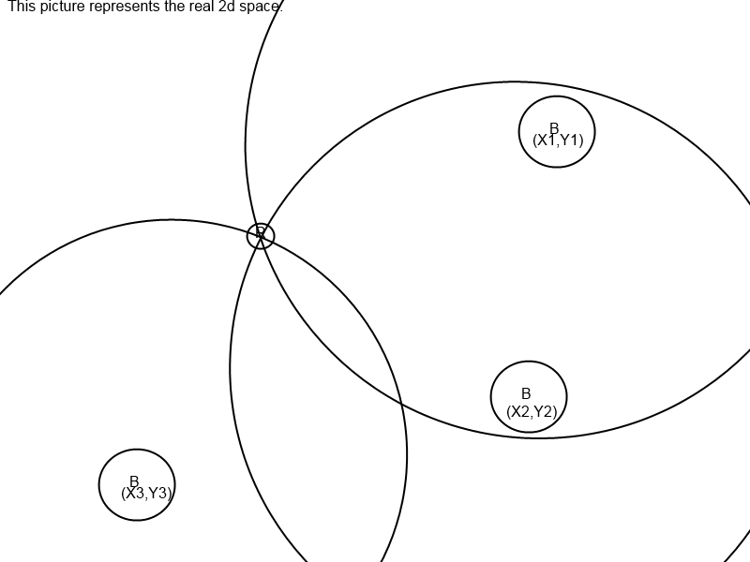

b) If we have 2 beacons then we only know we are in one of two possible locations. A way to get around this is to take 2 or more samples, and compare the results using math similar to (a) and then guessing which space the robot was in. This solution would only be bad if the 2 positions that were possible were very close.

