Juan Cardenas
Module 2.2 Assignment
9/20/2026
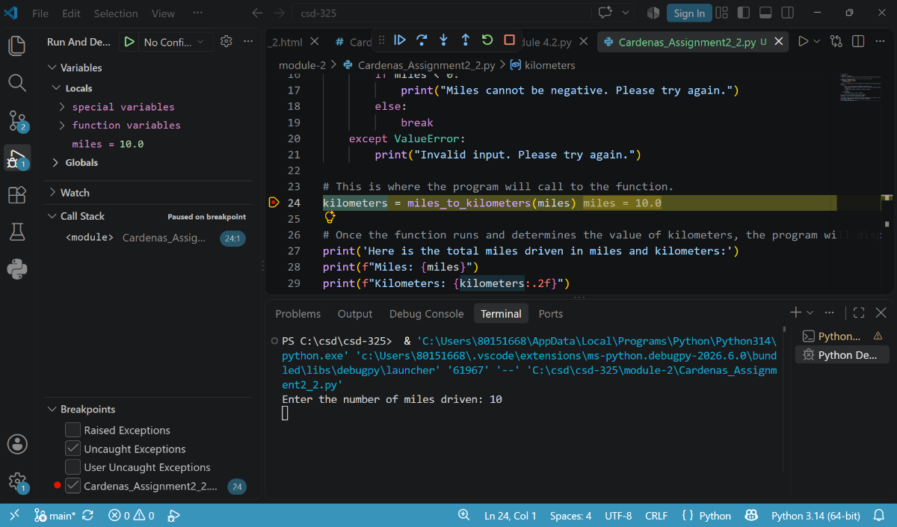
Screenshot #1: First, I set a breakpoint at the function call, “kilometers = miles_to_kilometers(miles).” Next, I entered a value of 10.0 for the “miles” variable before executing the function.
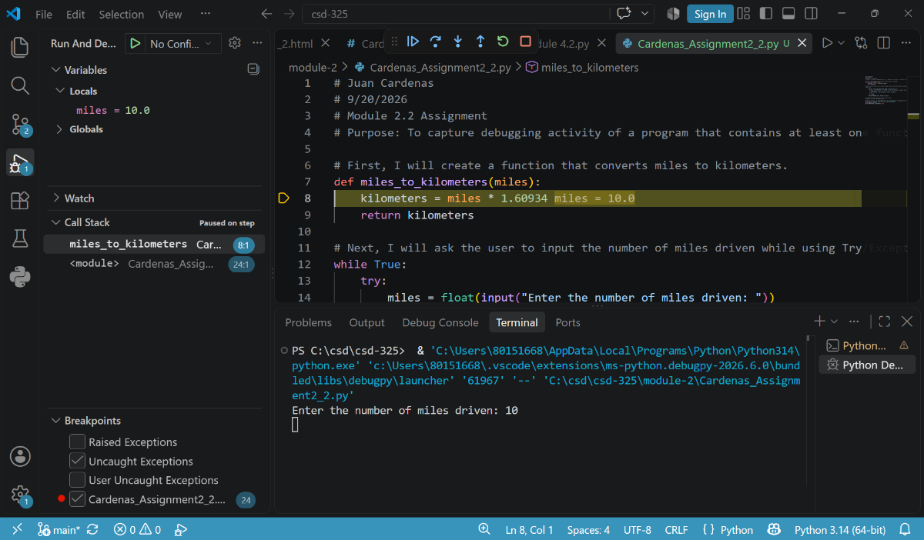
Screenshot #2: I am demonstrating that the debugger has stepped into the “miles_to_kilometers()” function. The highlighted line performs the calculation that converts miles into kilometers.
Screenshot #3: This final screenshot shows the debugger stepping through the calculation. It allows the value of the “kilometers” variable to be evaluated before the function returns the results.
