Juan Cardenas
Module 4.2 Assignment
10/4/2026
Flowchart
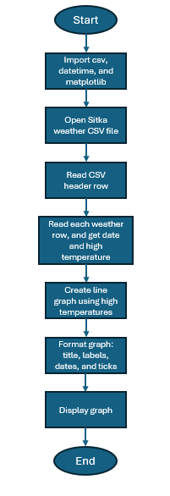
Original code:

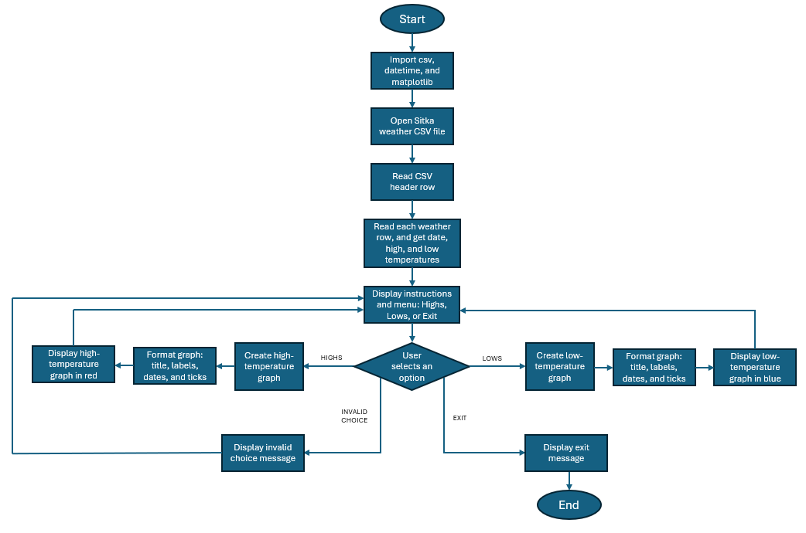
Revised flowchart with changes:

