Juan Cardenas
Module 3.2 Assignment
9/27/2026
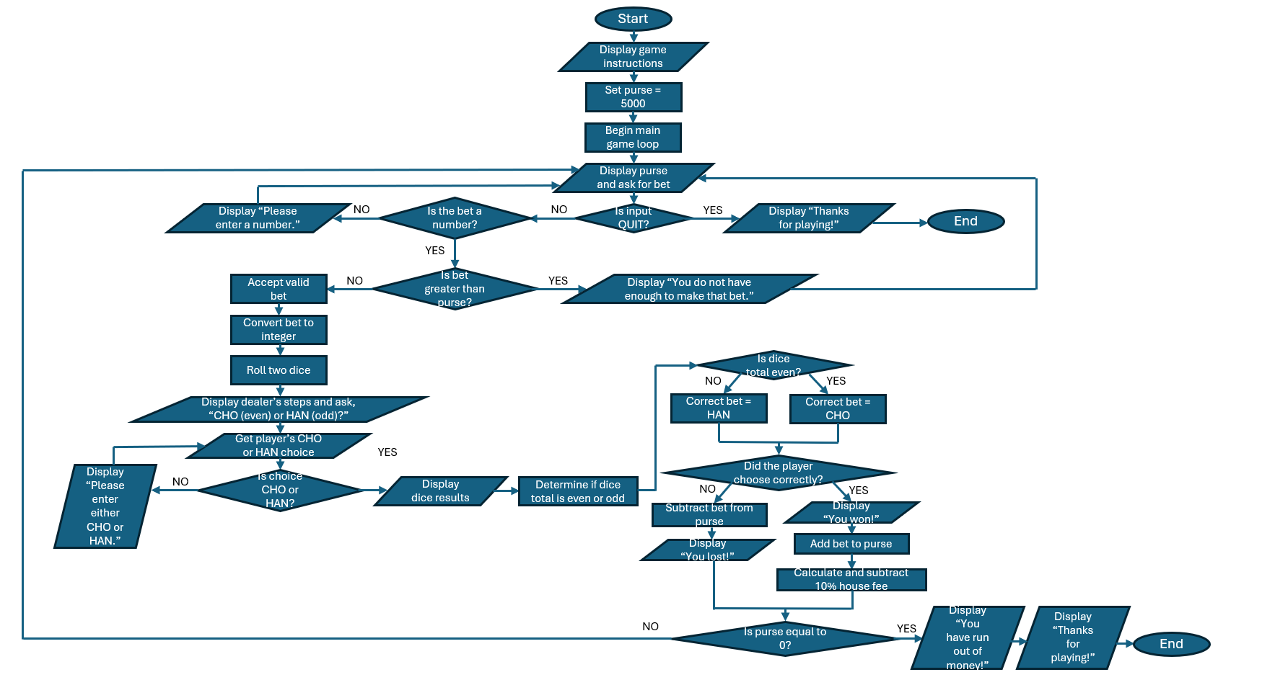
Flowchart

