Juan Cardenas
Module 8.2 Assignment
11/1/2026
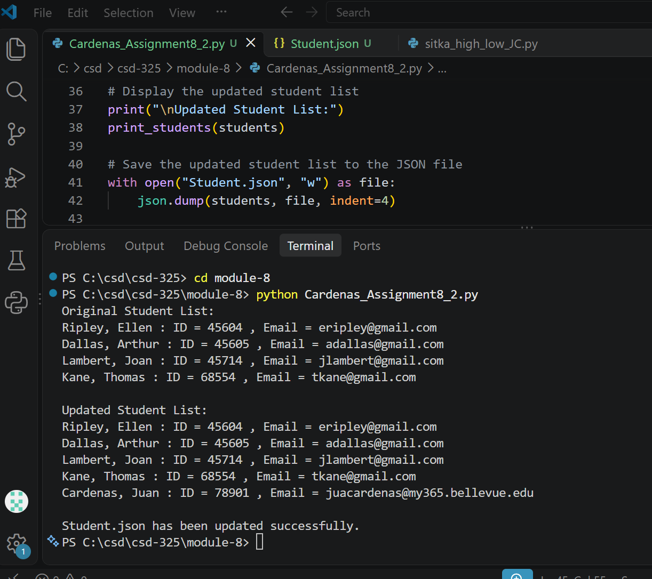
Screenshot #1:
Screenshot #2:
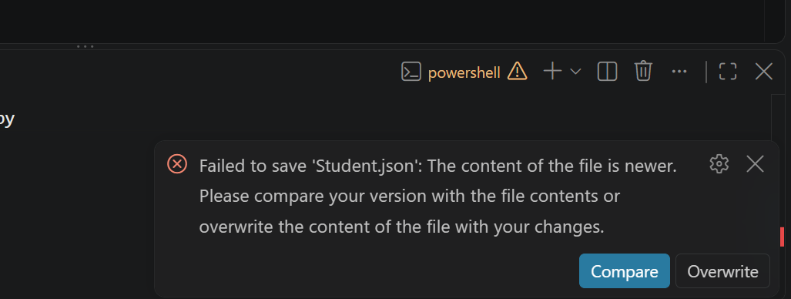

Updated .json file:
[
{
"F_Name": "Ellen",
"L_Name": "Ripley",
"Student_ID": 45604,
"Email": "eripley@gmail.com"
},
{
"F_Name": "Arthur",
"L_Name": "Dallas",
"Student_ID": 45605,
"Email": "adallas@gmail.com"
},
{
"F_Name": "Joan",
"L_Name": "Lambert",
"Student_ID": 45714,
"Email": "jlambert@gmail.com"
},
{
"F_Name": "Thomas",
"L_Name": "Kane",
"Student_ID": 68554,
"Email": "tkane@gmail.com"
},
{
"F_Name": "Juan",
"L_Name": "Cardenas",
"Student_ID": 78901,
"Email": "juacardenas@my365.bellevue.edu"
}
]

Flowchart:


