Juan Cardenas
Module 1.2 Assignment
GitHub repository link: https://github.com/Jc158914/csd-325
GitHub Screenshots:
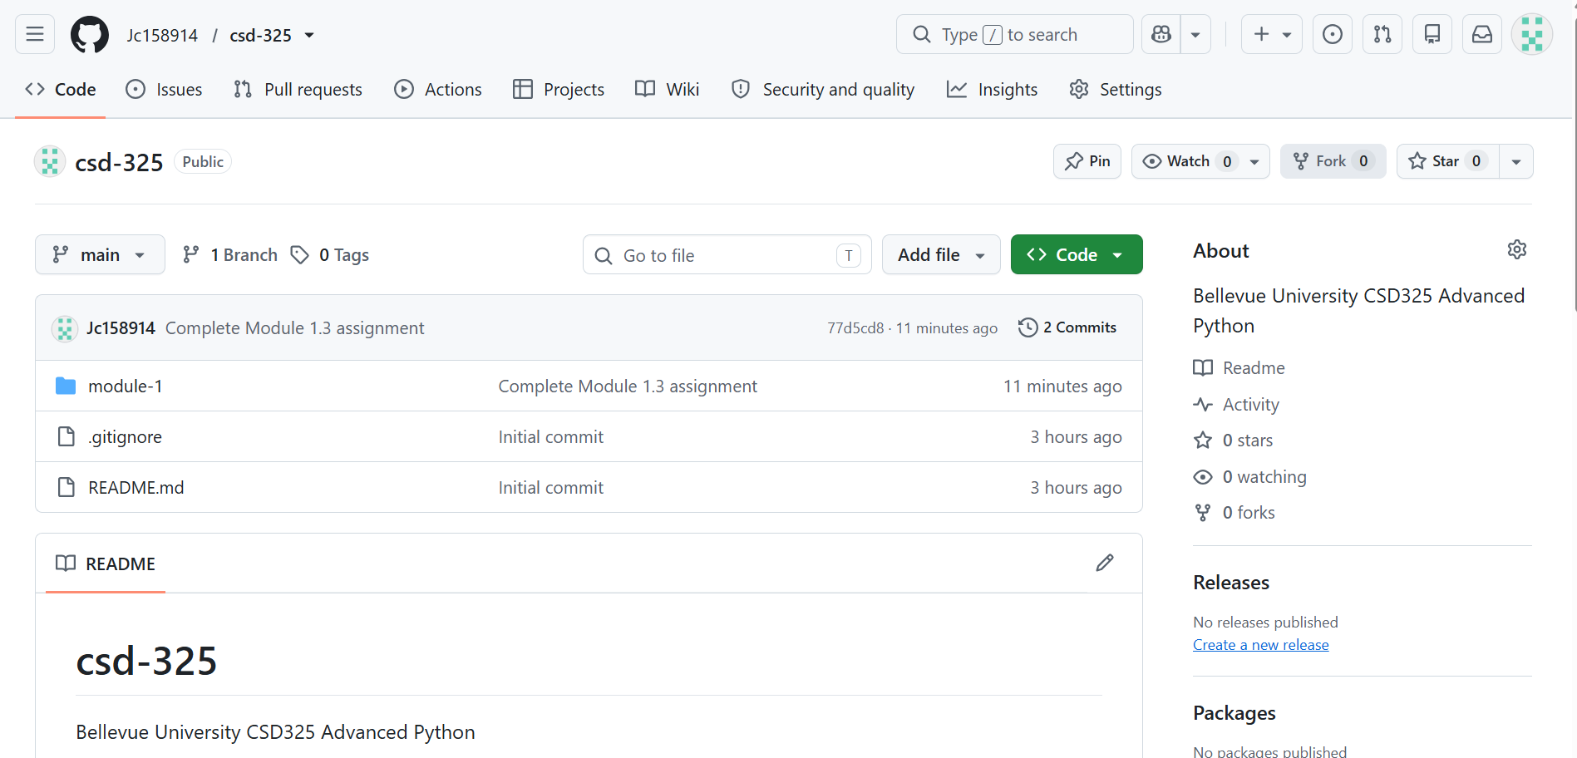
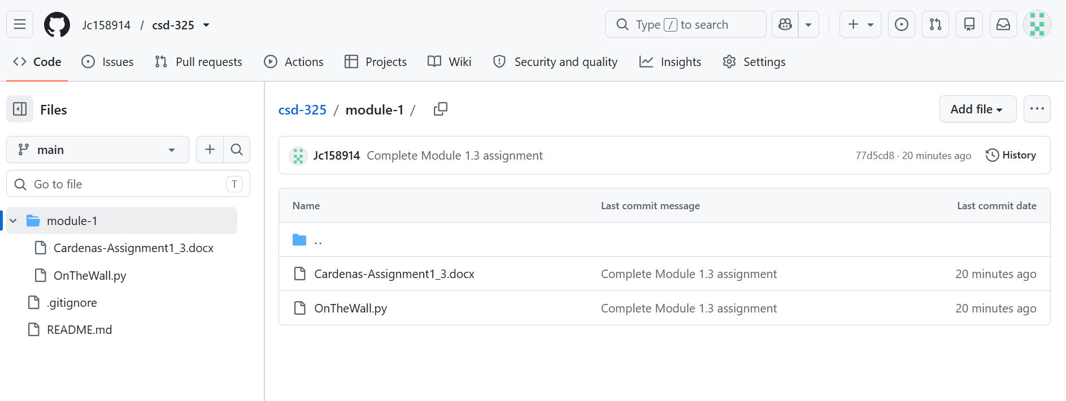Local directory screenshot:
