Juan Cardenas, Josh Herrick, Kao Yang, Kelly Dimick (Group C)
Module 6.2 Assignment
10/18/2026
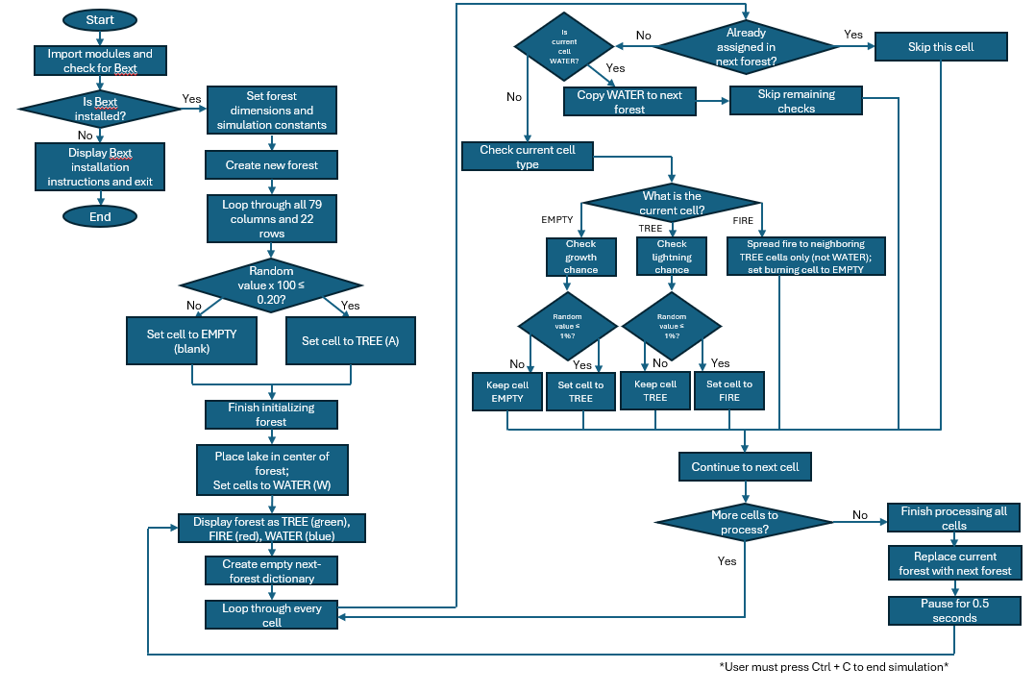
Updated Flowchart

