Juan Cardenas, Josh Herrick, Kao Yang, Kelly Dimick (Group C)
Module 5.2 Assignment
10/11/2026
Flowchart
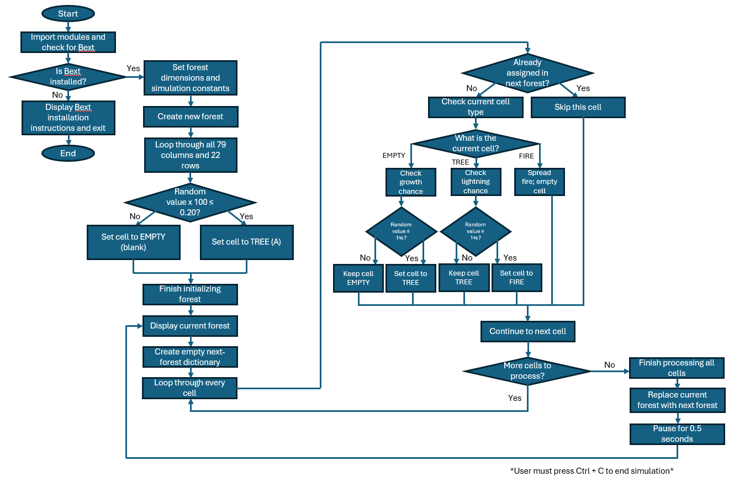

Program Documentation
Pixel assignment rules:
- A pixel (or cell) state can be represented by the following:
  - TREE = ‘A’
  - FIRE = ‘@’
  - EMPTY = ‘ ‘
- When the program runs and a new forest is created, each pixel is assigned a TREE or an EMPTY state based on random probabilities.
- During each simulation step, an empty cell goes through the GROW_CHANCE = 0.01 setting to determine whether it becomes a TREE or remains EMPTY. There is a 1% chance that the empty cell becomes a tree during that step.
- A TREE cell has a 1% chance of catching fire when the simulation checks the FIRE_CHANCE = 0.01 setting. If a cell is already on fire, it can spread the fire to neighboring TREE cells during that simulation step.
- If a cell does not change during the simulation step, its current state is copied into the next forest.
Fire spreading:
- A pixel may become FIRE according to the lightning chance.
- The program uses two loops within elif forest[(x, y)] == FIRE, for ix in range(-1, 2) and for iy in range(-1, 2), to check the burning cell and the eight cells that surround it. To determine if a cell contains a TREE, it then uses if forest.get((x + ix, y + iy)) == TREE. If the program determines that a neighboring coordinate is a TREE, it will assign FIRE to that coordinate in nextForest[(x + ix, y + iy)] = FIRE. If the cell is EMPTY, it will not spread fire to that cell.
- After checking the neighboring cells, the program assigns EMPTY to the original burning cell by executing nextForest[(x, y)] = EMPTY. This essentially means the tree is burning down and will leave an empty space.
Boundary handling:
- The program's forest is 79 cells wide and 22 cells high. It uses the forest.get() method to check coordinates and returns NONE for a coordinate that does not exist. If the value is not TREE or does not exist, the program does not spread fire outside the forest boundaries, and it does not wrap around to the opposite edge.

