Time Series Diagnostic Report
Retail Sales Analysis

Executive Summary
This report presents a comprehensive diagnostic analysis of the retail sales time series dataset. The analysis examines data quality, statistical properties, stationarity, seasonality, trends, and forecastability.
Key Findings:
- Forecastable: Yes - The data exhibits predictable structure suitable for forecasting
- Stationary: No - Requires first-order differencing (d=1)
- Seasonal: Yes - Strong monthly seasonality (period=12)
- Trend: Increasing - Strong upward trend detected

1. Data Quality
The dataset contains 120 monthly observations spanning from January 2015 to December 2024, with no missing values. The data is complete and suitable for analysis.
Metric | Value
Total Observations | 120
Date Range | 2015-01-01 to 2024-12-01
Frequency | monthly
Missing Values | 0 (0%)

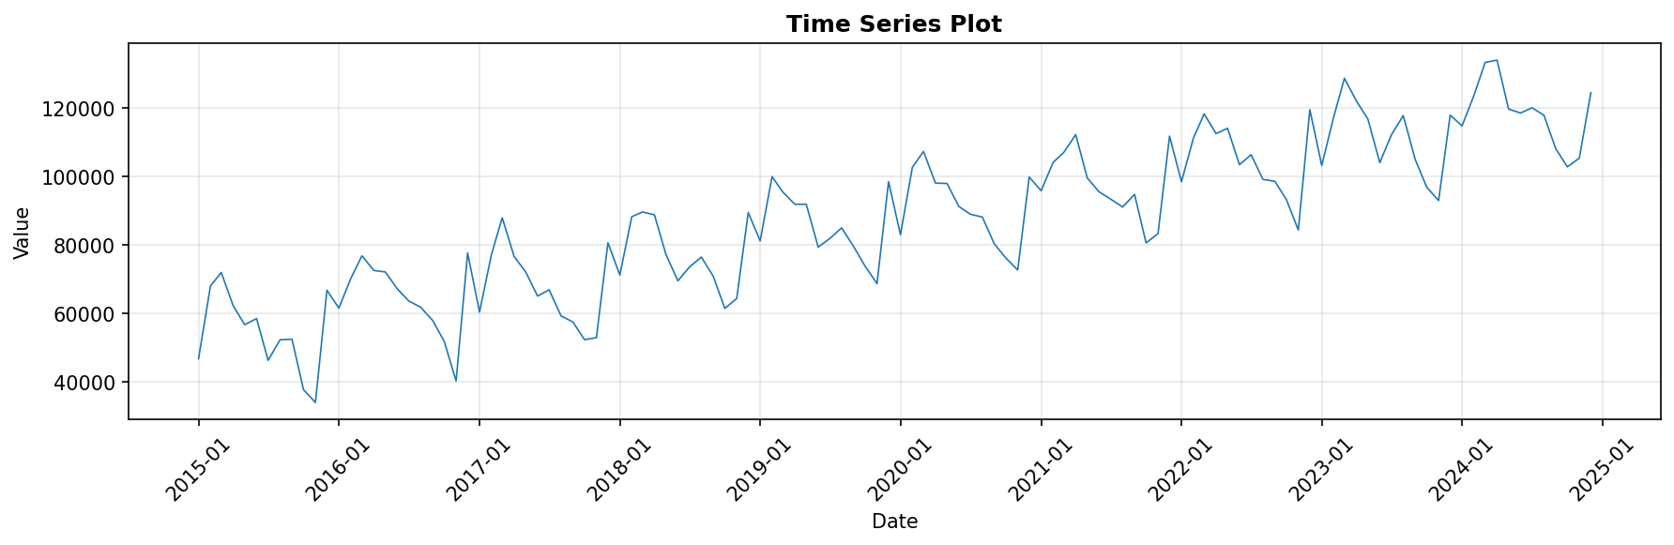

2. Distribution Analysis
The distribution is approximately symmetric with slight negative skewness (-0.09) and platykurtic behavior (kurtosis = -0.72), indicating lighter tails than a normal distribution.
Statistic | Value
Mean | 87131.27
Median | 88524.50
Standard Deviation | 22759.07
Minimum | 33927.00
Maximum | 134022.00
Skewness | -0.0878
Kurtosis | -0.7220

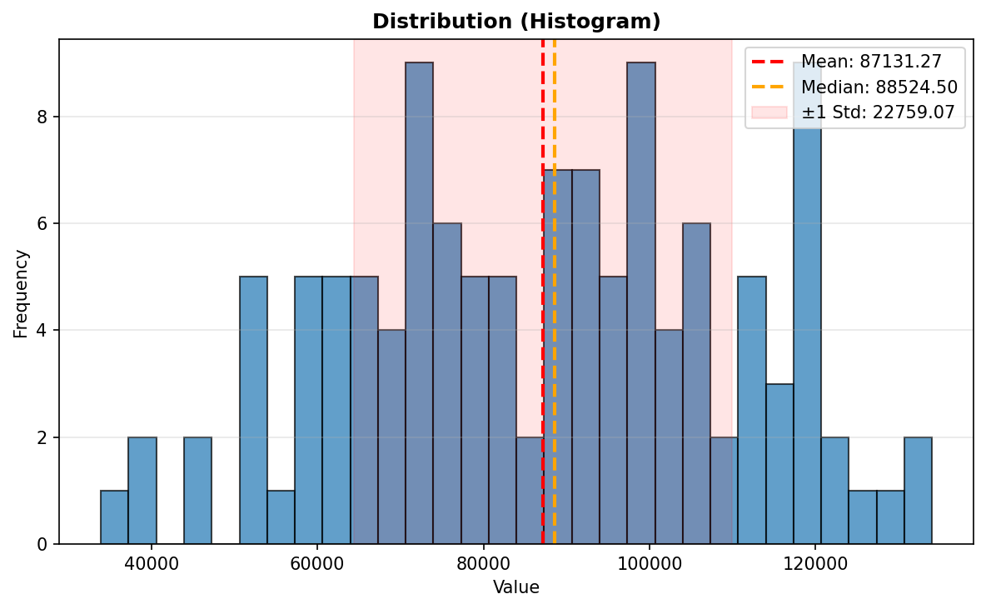

3. Stationarity Analysis
Both the Augmented Dickey-Fuller (ADF) and KPSS tests indicate that the series is non-stationary. First-order differencing (d=1) is required to achieve stationarity for modeling purposes.

Test Results
Test | Result
ADF Statistic | -0.6415
ADF p-value | 0.8613
ADF Conclusion | Non-stationary
KPSS Statistic | 1.6810
KPSS p-value | 0.0100
KPSS Conclusion | Non-stationary
Differencing Required | d=1

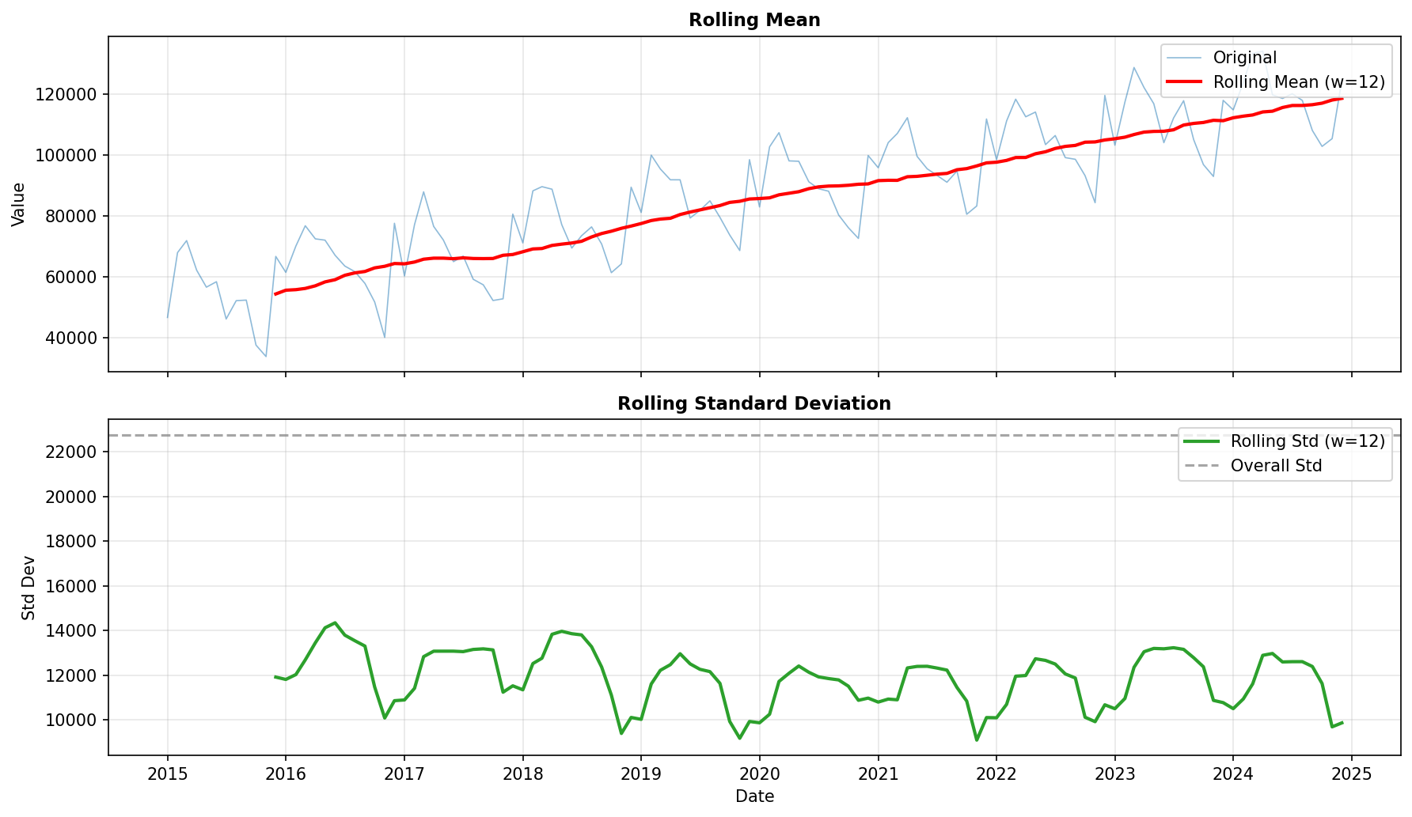

4. Seasonality Analysis
Strong monthly seasonality is detected with a period of 12 months. The seasonal strength of 0.95 indicates that seasonal patterns are highly consistent and predictable across years.
Metric | Value
Seasonal | Yes
Period | 12
Strength | 0.9459 (strong)

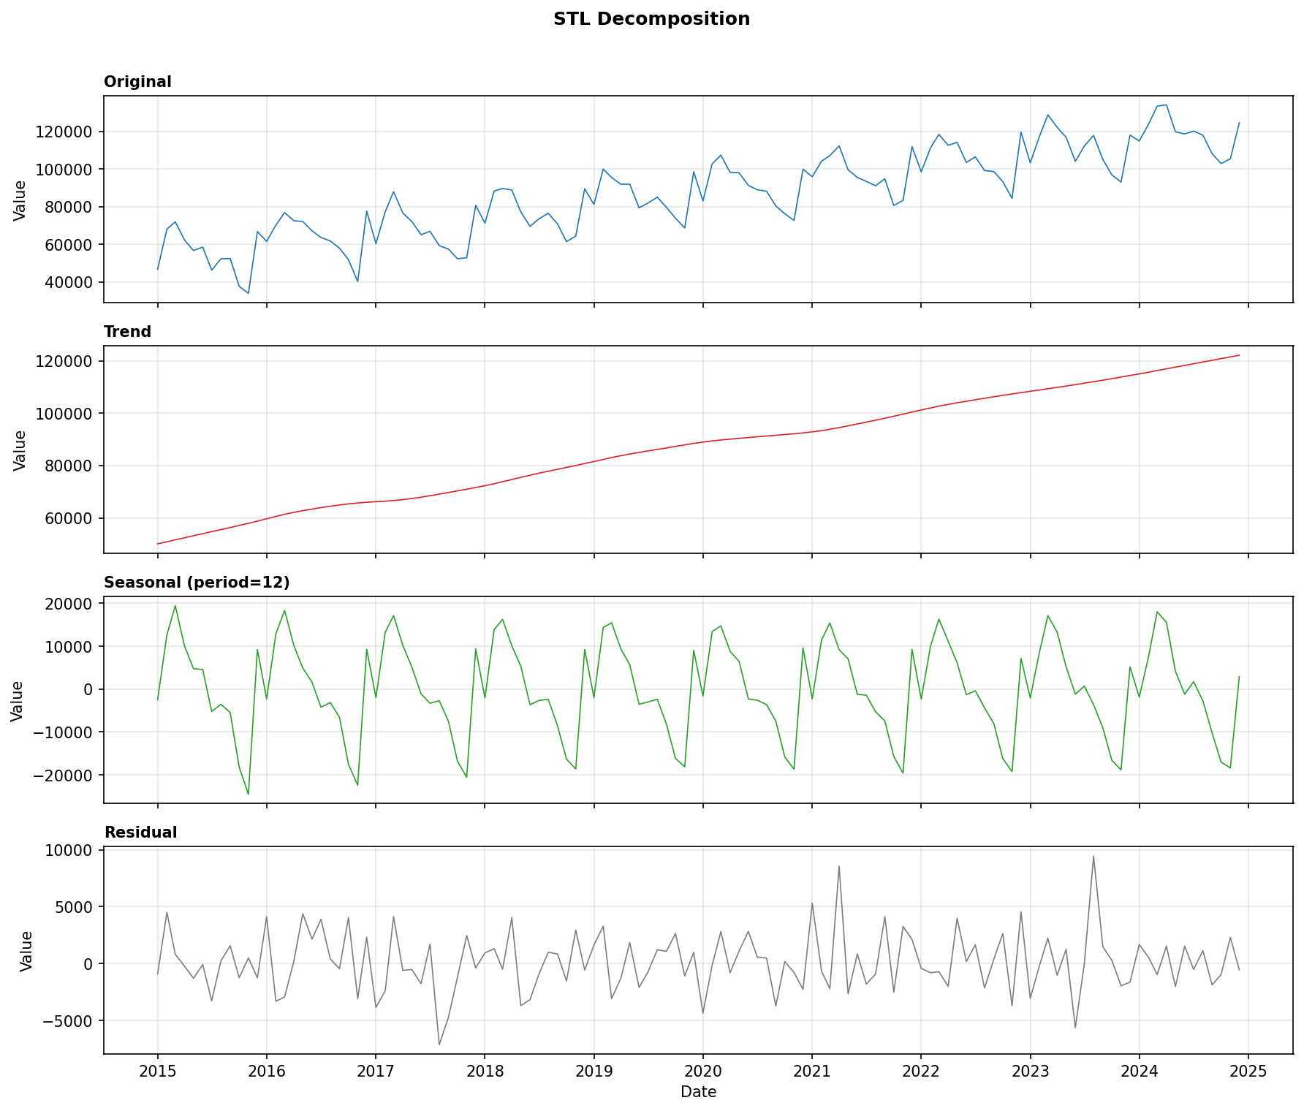

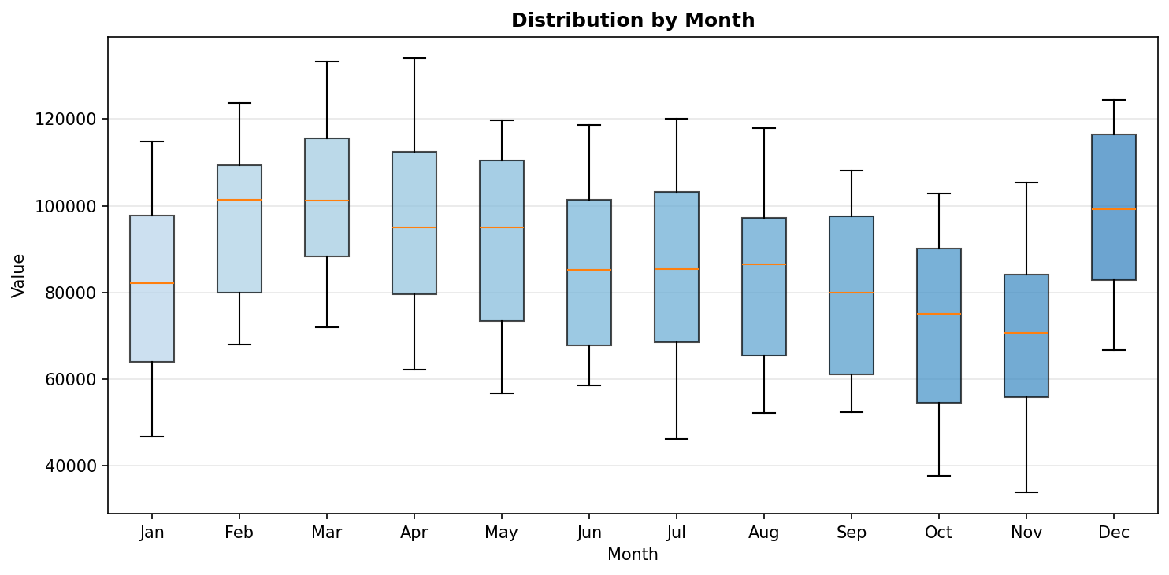

5. Trend Analysis
A strong increasing trend is present with a trend strength of 0.98. This indicates consistent growth in retail sales over the observation period.
Metric | Value
Has Trend | Yes
Direction | increasing
Strength | 0.9837 (strong)
Slope (Normalized) | 0.025717

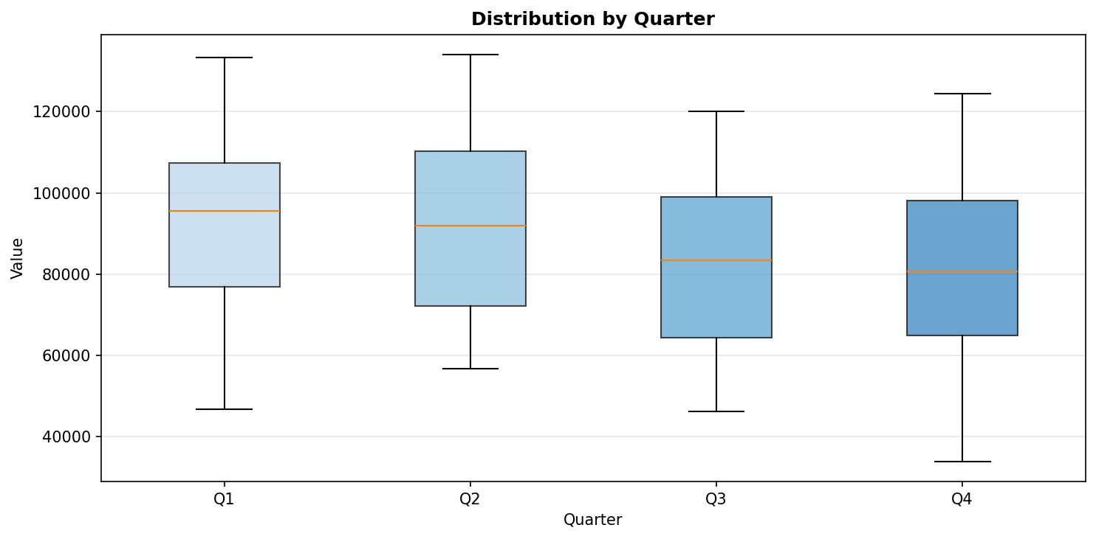

6. Autocorrelation Analysis
Autocorrelation analysis reveals significant correlations at multiple lags, particularly at lag 12 and its multiples, confirming the annual seasonal pattern. The ACF and PACF plots are based on the first-differenced series.

Significant Lags
ACF Lags: 1, 6, 11, 12, 24, 30, 36
PACF Lags: 1, 6, 7, 8, 9, 10, 11, 12, 13, 14

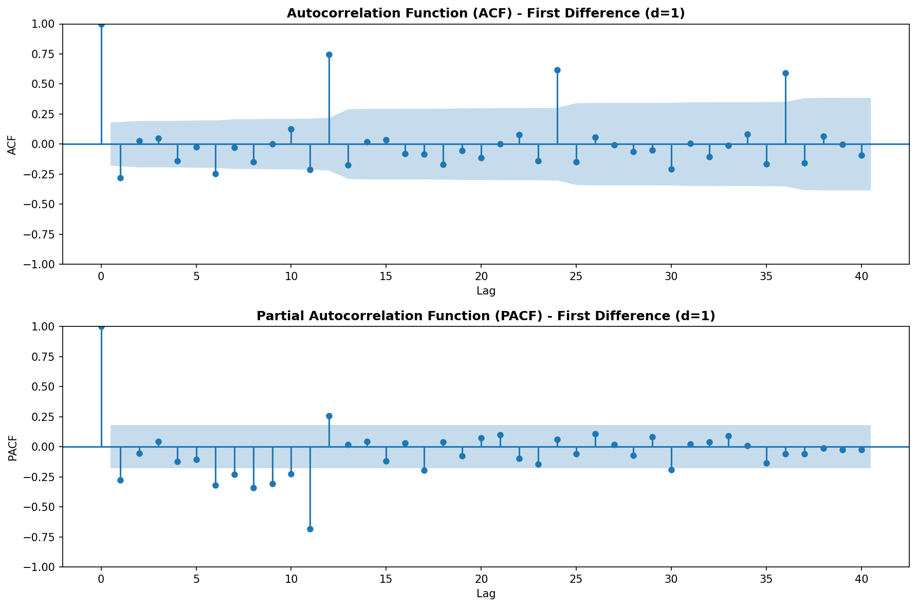

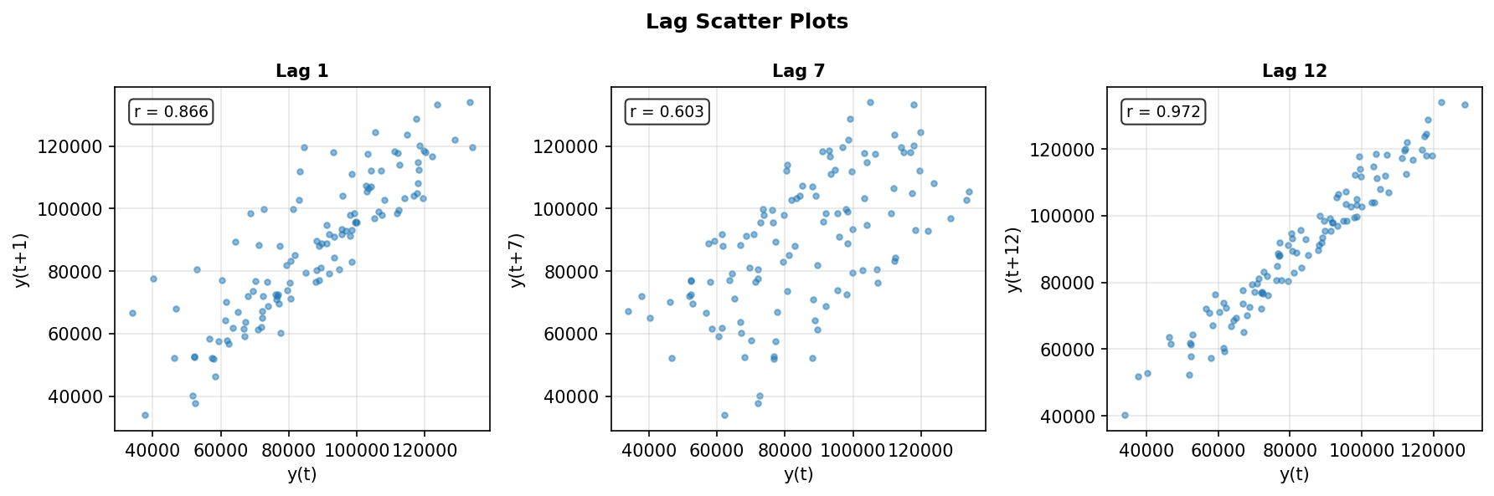

7. Forecastability Assessment
The Ljung-Box test results indicate strong rejection of the white noise hypothesis (p < 0.05 at all lags), confirming that the series contains predictable patterns and is suitable for forecasting.
Test | Result
Ljung-Box (lag 10) | stat=25.12, p=0.0051
Ljung-Box (lag 20) | stat=118.81, p=0.000000
Ljung-Box (lag 23) | stat=122.60, p=0.000000
White Noise | No
Forecastable | Yes

8. Transform Recommendation
The Box-Cox analysis suggests that no transformation is needed (λ ≈ 1), indicating that the variance is stable across the series and the data can be modeled in its original scale.
Metric | Value
Variance Stable | Yes
Box-Cox Lambda | 1.0256
Recommendation | none
Note | Box-Cox λ ≈ 1, no transform needed

9. Conclusions and Recommendations
Based on the comprehensive diagnostic analysis, the following conclusions and recommendations are provided:

Modeling Recommendations
- SARIMA Model: Use a Seasonal ARIMA model with first-order differencing (d=1) and seasonal period of 12
- No Transformation: Model the data in its original scale - no Box-Cox transformation required
- Seasonal Components: Include seasonal AR and MA terms to capture the strong monthly patterns
- Trend Consideration: The strong increasing trend will be captured through the differencing and trend components

Data Characteristics Summary
- The series exhibits strong predictable patterns making it highly suitable for forecasting
- Monthly seasonality is consistent and robust across all years
- The upward trend indicates sustained growth in retail sales
- Data quality is excellent with no missing values
- Variance appears stable, simplifying model selection
End of Report

