ORBliteration

**Technical Design Document**

**Prepared by:**

**Phenomena Studios**

**Contents**

**1. Table of Changes** 3

**2. Executive Summary** 3

**3. Project Summary** 4

**3.1. System Requirements** 4

**3.2. Technical Risks** 4

**4. Architecture** 5

**4.1. Title Screen (Source)** 5

**4.2. Main Menu** 5

**4.3. Options Menu** 6

**4.4. Match Setup** 6

**4.5. Pause Menu** 7

**4.6. Match** 7

**4.7. Main Match Loop** 8

**4.8. Process** 8

**4.9. Process Arena Floor** 9

**4.10. Process Arena Tile** 9

**4.11. Process Player Orb** 10

**5. Coding Standards** **Error! Bookmark not defined.**

**6. Game Scenes** 12

**6.1 Menus** 12

**6.1.1. Title Screen** 12

**6.1.2. Main Menu Screen** 12

**6.1.3. Options Menu** 12

**6.1.4. Match Setup Screen** 12

**6.1.5. Pause Screen** 13

**6.1.6. End of Match Screen** 13

**6.2. Gameplay** 13

**6.2.1. Game screen** 13

**7. Systems to be Implemented** 13

**7.1. Game Menu System** 13

**7.2. Game Play System** 13

**7.3. Rendering System** 15

**7.4. Input System** 15

**7.5. Audio System** 15

**7.6. Debug System** 15

**8. Acceptance Test Plan** 15

# **1. Table of Changes**

|  |  |  |
| --- | --- | --- |
| **Revision Number** | **Date Changed** | **Change Description** |
| 1.0 | 04/08/2015 | Document Created |
| 2.0 | 29/09/2015 | Grammar fixes.  Added the UML diagrams and system descriptions, updated the game mechanics.  Updated the flowcharts and Acceptance Test plan to reflect the game changes. |

# 

# **2. Executive Summary**

Phenomena Studios proposes to design the game ORBliteration for the requirements of the GD2S02 component at Media Design School:

* Local multiplayer: cooperative and/or competitive.
* Simple game play mechanics.
* Single screen 2D arena.
* Clean and neat user interface.

The initial concept of the game ORBliteration addresses the constraints imposed by the requirements of the GD2S02 component:

* The game is to be developed in C++.
* No third party game engine.
* Pre-production phase in week 6.
* Alpha build in week 11.
* Beta build in week 14.
* Gold build in week 16.

Phenomena Studios have discussed the design objectives in order of importance:

* Game Framework
* Rendering System
* Input System
* Controls to be implemented
* Core game mechanics to be implemented
* Visual aesthetics to be implemented

For our initial design concept, ORBliteration addresses each of these objectives while meeting the constraints imposed. The overall production will be monitored by our product backlog identifying all the work items. The Phenomena Studios team will implement the main game framework as well as the rendering system first so that all components of the game can utilise them. The team will focus on the two graphics systems (2D and 3D) next utilising the rendering system. Creating the input system is the final and major system that needs to be in place before the controls and core gameplay can be introduced. Once the main game is finished the team will focus on polishing the game with sound and visual effects to really show off the quality that is expected.

The design will be conveyed to the head of the GD2S02 component at each phase to show our current progress. The presentations will include a playable game demonstration, the Game Design Document and Technical Design Document.

# **3. Project Summary**

## **3.1. System Requirements**

OS: Windows.

External:

* Xbox 360 controller per player.
* Microsoft drivers to read Xbox 360 controller input.

Minimum Requirements:

* 2.0 Ghz Dual Core Processor
* 8 GB RAM
* NVidia Quadro 600 Graphics card
* 20 MB Hard Disk Space
* 2 Xbox 360 Controllers

Recommended Requirements:

* 2.4 Ghz Dual Core Processor
* 16 GB RAM
* NVidia GeForce GTX 760 graphics card or better
* 50 MB Hard Disk Space
* 2-4 Xbox 360 Controllers

## **3.2. Technical Risks**

* Physics calculations being incorrect or wrong formulae used.
* Driver compatibility can cause unexpected crashes or just fail completely.

# **4. Architecture**

## **4.1. Title Screen (Source)**

This is where the game application begins. It displays the title screen and waits for any input to progress to the Main Menu as shown in *Figure 4.0*.

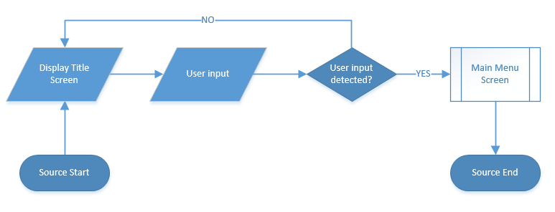

(Figure 4.0: Flow chart for the title screen)

## **4.2. Main Menu**

The main menu screen displays the different menu items and waits for the user to make their choice. The game flow changes depending on which menu item was selected and progresses down the appropriate path as shown in *Figure 4.1*.

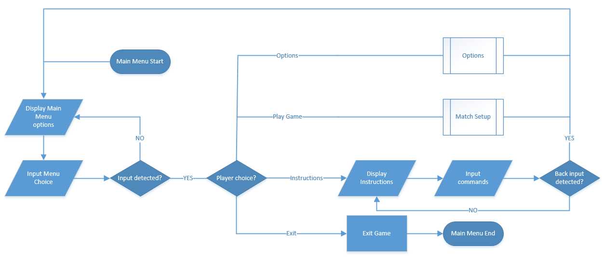

(Figure 4.1: Flow chart for the main menu)

## **4.3. Options Menu**

The options menu displays the changeable options with in the game. These are set up as toggle buttons that allow the user to toggle the game properties on or off. The user can either select a choice to toggle or press the “Back” command (B button) to return to the previous menu as shown in *Figure 4.2*.

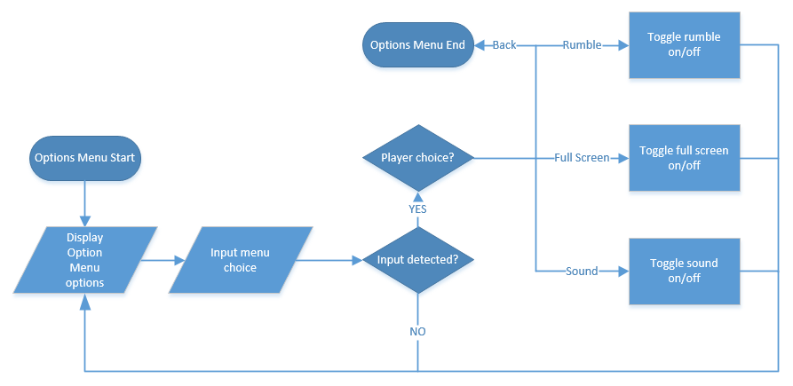

(Figure 4.2: Flow chart for the options menu)

## **4.4. Match Setup**

This displays the Match Setup options and wait for the user to select one of the three options to begin the match or press the “Back” command (B button) to return to the previous menu as shown in *Figure 4.3*.

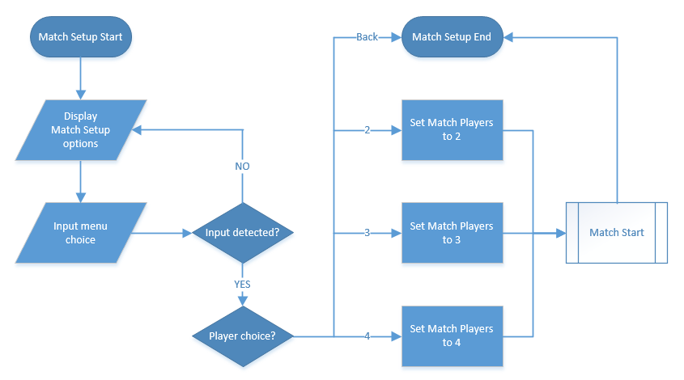

(Figure 4.3: Flow chart for the match setup screen)

## **4.5. Pause Menu**

The Pause Menu screen that displays the pause options and waits for user input to select a menu choice. Game flow changes depending on what choice was selected and progresses down the appropriate path as shown in *Figure 4.4*.

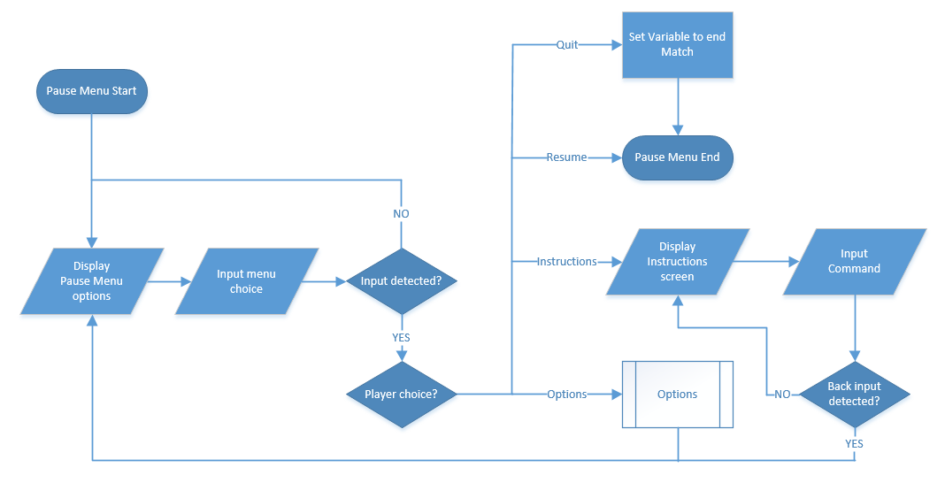

(Figure 4.4: Flow chart for the pause menu)

## **4.6. Match**

The match staging area sets up the game so that all elements are ready before the match begins. It executes the Main Match Loop and once that exits tests to see if the match was quit early or the match was completed. If the game was completed the End of Match screen will display showing the match outcome as shown in *Figure 4.5*.

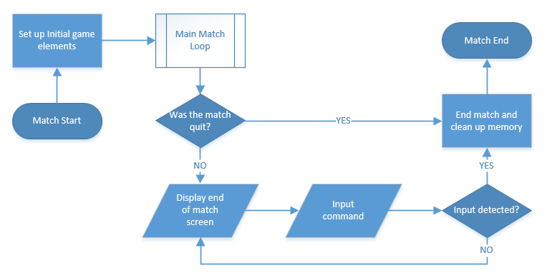

(Figure 4.5: Flow chart for the match screen)

## **4.7. Main Match Loop**

The main game starts with running a short countdown timer before playing the match. Once the countdown timer reaches zero then the game loop loops through taking and processing players input and running through the process subroutine followed by rendering the scene. This also includes the End of Game check to determine whether the match is over or not as shown in *Figure 4.6*.

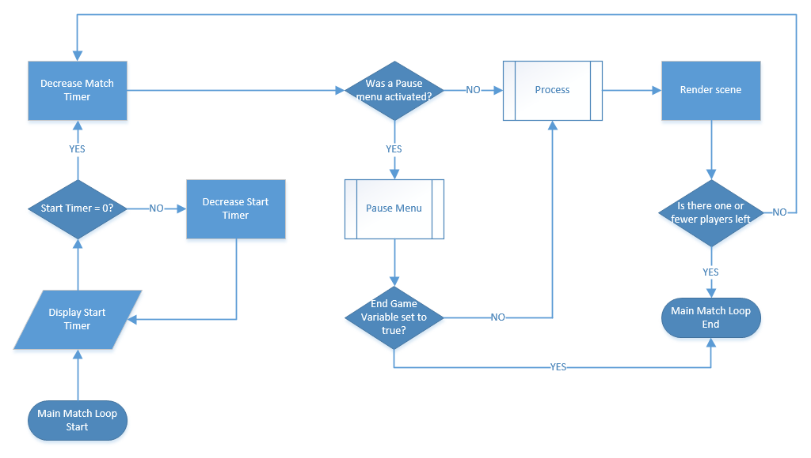

(Figure 4.6: Flow chart for the main game loop)

## **4.8. Process**

The process first handles input, followed by process the Arena Floor, then loops through each Orb to process them as shown in *Figure 4.7.*

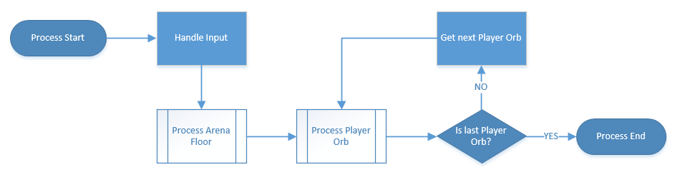

(Figure 4.7: Flow chart for the process)

## **4.9. Process Arena Floor**

The arena floor process checks if it is time to destroy the edge tiles, if so set the destruction sequence on them, else it would loop though the tiles to process them as shown in *Figure 4.8.*

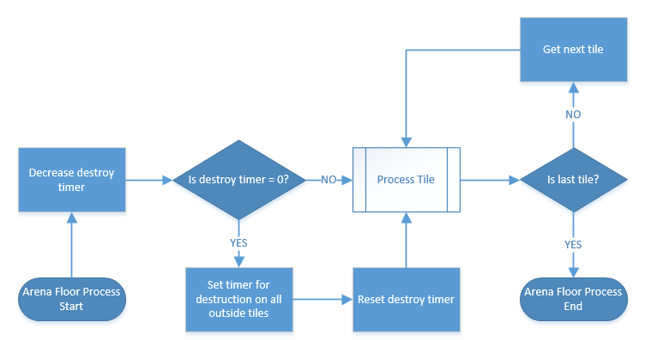

(Figure 4.8: Flow chart for the arena floor process)

## **4.10. Process Arena Tile**

The arena tile process first checks if the tile is active, then checks if the tile is on its destruction sequence in which it would decrease the destroy timer, if the destroy timer reaches zero the tile is then set to inactive (destroyed). If the tile is inactive it is not processed. This is shown in *Figure 4.9.*

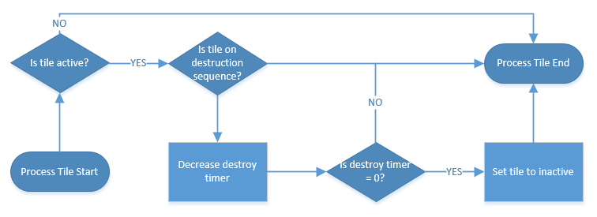

(Figure 4.9: Flow chart for the arena tile process)

## **4.11. Process Player Orb**

The process of the Orbs starts with checking if the orb is active. If the Orb active then Orb to Orb collisions are calculated. The Orb then checks which type of tile is currently underneath it. If the tile is inactive then the Orb is rendered inactive and the player loses but if the tile is active then the type of tile is returned and is used to modify the movement of the Orb along with whether or not the Orb is boosting. The flow chart in *Figure 4.11* shows the flow of the process.

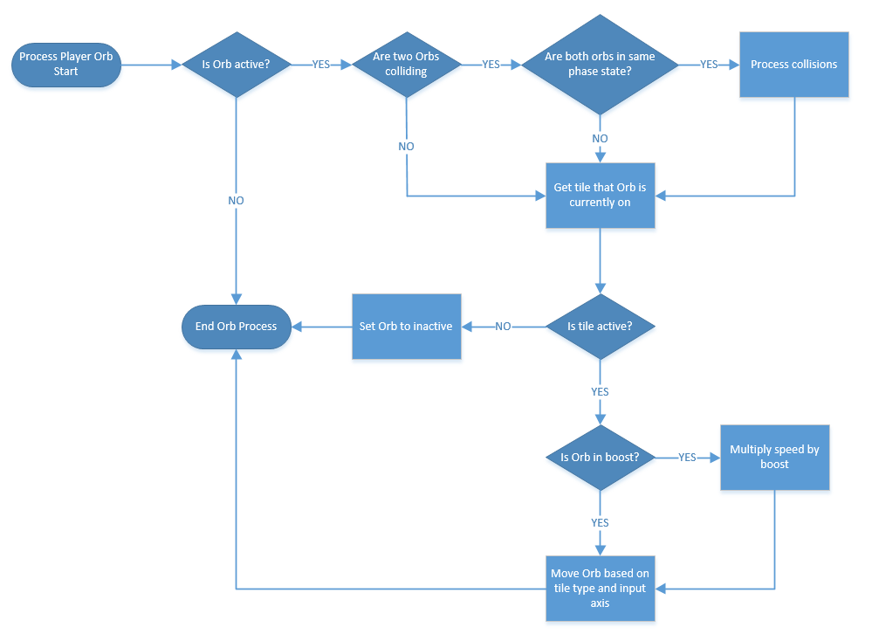

(Figure 4.10: Flow chart for the player orb process)

# **5. Coding Standards**

The coding standards that will be used during this project are outlined below.

* The Media Design School template header as shown in *Figure 5.0* will be included in every source file.
* Appropriate Function headers as shown in *Figure 5.1* will be used in all functions:
* Naming Conventions are as outlined in *Table 5.0*.
* Discrete Functions that perform the task reflected in their name.
* Functions, Loops and Conditional statements will use braces ‘{‘ and ‘}’ placed on new lines

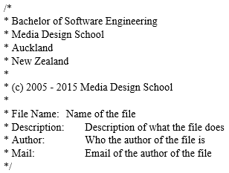

(Figure 5.0: Media Design School Header)

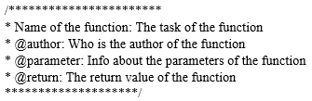

(Figure 5.0: Function Header)

|  |
| --- |
| No variable type prefix. |
| Pointers prefixed with ‘p’ |
| Reference prefixed with ‘r’ |
| Constants prefixed with ‘k’ |
| Static variables prefixed with ‘s_’ |
| Global variables prefixed with ‘g_’ |
| Member variables prefixed with ‘m_’ |
| Passed in parameters prefixed with ‘_’ |
| All variable names begin with a lowercase unless prefixed will be used. |
| All function names begin with Uppercase and have uppercase for the beginning of each word. |

(Table 5.0: Table of naming conventions)

# **6. Game Scenes**

## **6.1 Menus**

Player one has control of all menus (except the pause menu) and uses the left analogue stick of the Xbox 360 controller to move the selection of the menu options. All selectable options will highlight to a different color to show the current selection.

The ‘A’ button on the controller will then be used to confirm the current selection and the ‘B’ button will revert to previous menu (if applicable).

Controls (Xbox 360 controller):

* Left joystick - Menu navigation.
* A button - Confirm selection.
* B button - Revert to previous menu.

### **6.1.1. Title Screen**

The first screen that is loaded upon the game being started.

The only interaction with the title screen is that any key pressed on any connected controller will end the title screen and load the main menu screen.

### **6.1.2. Main Menu Screen**

Selectable Options:

* Start - Loads the player setup screen.
* Instructions - Loads the instructions screen.
* Options - Loads the options screen.
* Exit - Exits the game application.

### **6.1.3. Options Menu**

Selectable Options:

* Full Screen - Toggle full screen mode on and off.
* Sound - Toggle sound output on and off.

### **6.1.4. Match Setup Screen**

Selectable Options:

* 2 - Starts a 2 player game.
* 3 - Starts a 3 player game.
* 4 - Starts a 4 player game.

### **6.1.5. Pause Screen**

The player that initiated the pause is the only one who can navigate or exit the pause menu.

Selectable Options:

* Resume - Resumes the current game.
* Instructions - Loads the instructions screen
* Options - Loads the options screen.
* Quit - Exit game and return to the main menu.

### **6.1.6. End of Match Screen**

Player one pressing any button on the victory screen will return players to the main menu screen.

## **6.2. Gameplay**

### **6.2.1. Game screen**

Each player has their own controller and controls one orb. The left joystick of the controller will determine the movement by increasing the acceleration in the pressed direction. The ‘start’ button will pause the game and bring up the Pause Menu where only the player that paused the game has control.

Controls (Xbox 360 controller):

* Left joystick - Move character
* Left bumper - Activate ‘Phase’ ability
* Right bumper - Activate ‘Boost’ ability
* ‘Start’ button - Open Pause Menu

# **7. Systems to be Implemented**

## **7.1. Game Menu System**

The menu system is the first system that is activated. The menu system displays to the users the current state of the game (including directing the flow into the game play system) and which options are available. This is where the game is set up and begins. A basic UML of the Game Menu System is displayed via the UML diagram in *Figure 7.0.*

## **7.2. Game Play System**

This system controls the game flow, links all other subsystems together and contains the main game processes and loops. The physics of the game are integrated here without the use of a third party API. This is made possible through the Orb class to determine the actions and reactions of the player’s inputs and physics collisions. A basic UML of the Game Play System is displayed via the UML diagram in *Figure 7.1.*

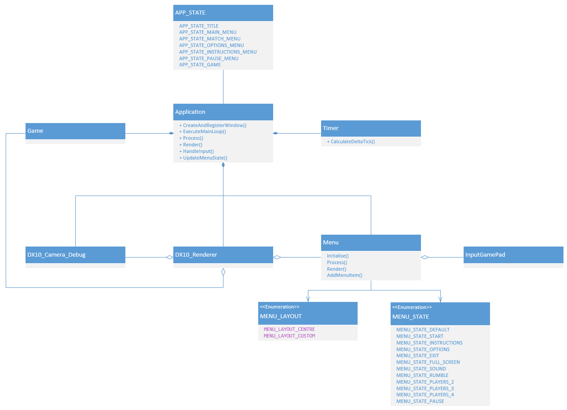

(Figure 7.0: Game Menu System UML)

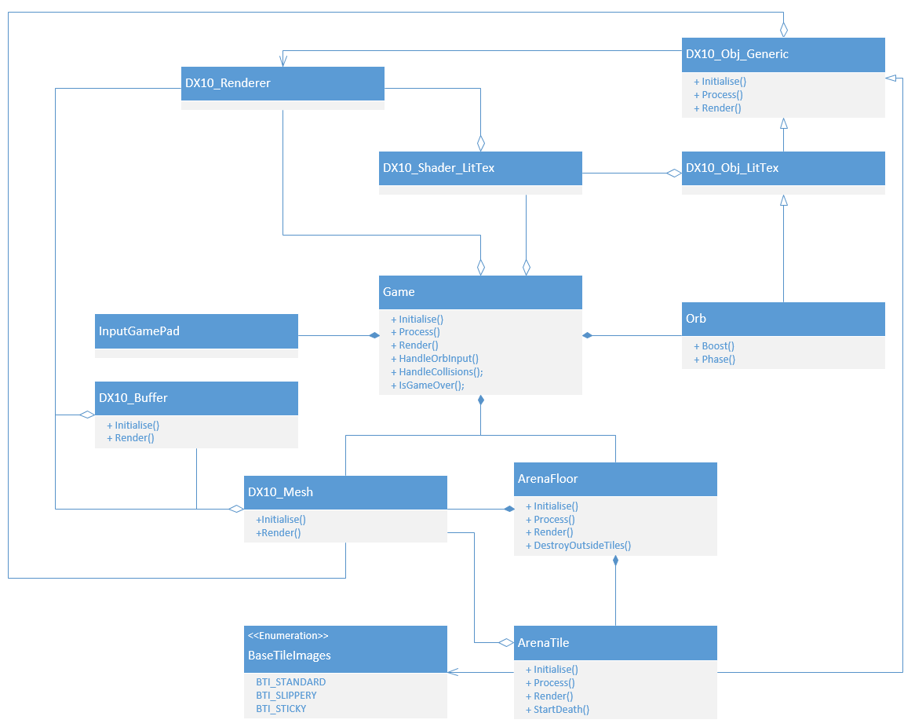

(Figure 7.1: Game Play System UML)

## **7.3. Rendering System**

Allows the processing and rendering of all outputs to the screen. The Rendering system uses DirectX 10 and will be responsible for creating and deleting all assets that will be utilised when rendering any 2D or 3D object to the screen.

## **7.4. Input System**

This system is responsible for taking input from the Xbox 360 controllers, converting the input into usable data for the game loop to process.

## **7.5. Audio System**

This system is responsible for loading, playing and releasing audio assets used within the game. (To be implemented)

## **7.6. Debug System**

The debug system utilised is a simple console window that allows the Phenomena Studios team to output any information to it. This allows the tracking any variables and input so that the game can be debugged during runtime without explicitly using breakpoints.

# **8. Acceptance Test Plan**

|  |  |
| --- | --- |
| **Test ID** | TC_MENU_00 |
| **Description** | Run Game |
| **Pre-Conditions** | * ORBliteration.exe file (with all required files) is available |
| **Current Visual/Audio** | * N/A |
| **Input** | * Run the ORBliteration.exe file |
| **Expected Result** | * The game Splash Screen is displayed |

|  |  |
| --- | --- |
| **Test ID** | TC_MENU_01 |
| **Description** | Main Menu Screen - No Controller |
| **Pre-Conditions** | * The game is on the Main Menu Screen. * No working controller plugged in and connected. |
| **Current Visual/Audio** | * Music playing in the background. * All main menu items are visible:   + Start   + Instructions   + Options   + Exit * “Connect a Xbox control” text is visible and the text blinks |
| **Input** | * Plug in and connect a working controller to the computer. |
| **Expected Result** | * The “Connect an Xbox control” will disappear and the Main Menu Screen can be navigated. |

|  |  |
| --- | --- |
| **Test ID** | TC_MENU_02 |
| **Description** | Main Menu Screen - Transition |
| **Pre-Conditions** | * The game is on the Main Menu Screen. * At least one working Xbox controller plugged in and connected. |
| **Current Visual/Audio** | * Music playing in the background. * All main menu items are visible:   + Start   + Instructions   + Options   + Exit |
| **Input** | * Left analogue stick or DPad to navigate (Up and Down only) * Press the “A” button to select the current menu item. |
| **Expected Result** | * Menu items highlight when at the current selection. * Menu items make a sound when transitioning between menu items. * If “Start” is activated, transition to the match setup screen. * If “Instructions” is activated, the instructions image will pop up. * If “Options” is activated, transition to the options menu screen. * If “Exit” is activated, exits the application. |

|  |  |
| --- | --- |
| **Test ID** | TC_MENU_03 (To be Changed when new implimentation) |
| **Description** | Match Setup Screen - No Controller |
| **Pre-Conditions** | * The game is on the Match Setup Screen. * No working controller plugged in and connected. |
| **Current Visual/Audio** | * Music playing in the background. * Player selections are visible:   + 2   + 3   + 4 * “Xbox controls missing” text is visible |
| **Input** | * Plug in and connect at least two working controllers to the computer. |
| **Expected Result** | * The “Xbox controls missing” will disappear and the Match Setup Menu can be navigated. |

|  |  |
| --- | --- |
| **Test ID** | TC_MENU_04(To be Changed when new implimentation) |
| **Description** | Match Setup Screen - Transition |
| **Pre-Conditions** | * The game is on the Match Setup Screen. * At least two working Xbox controller plugged in and connected. |
| **Current Visual/Audio** | * Music playing in the background. * Player selections are visible:   + 2   + 3   + 4 |
| **Input** | * Left analogue stick and DPad to navigate (Up and Down only) * Press the “A” button to select the current menu item. * Press the “B” button to return to the previous menu. |
| **Expected Result** | * Menu items highlight when at the current selection. * Menu items make a sound when transitioning between menu items. * If “2” is activated, transition to the game with 2 players. * If “3” is activated, transition to the game with 3 players. * If “4” is activated, transition to the game with 4 players. * Pressing the “B” button returns the player to main menu. |

|  |  |
| --- | --- |
| **Test ID** | TC_MENU_05 |
| **Description** | Options Menu Screen – No Controller |
| **Pre-Conditions** | * The game is on the Options Menu Screen. * No working controller plugged in and connected. |
| **Current Visual/Audio** | * Options Menu Screen is visible * “Connect a Xbox control” text is visible and the text blinks |
| **Input** | * Plug in and connect a working controller to the computer. |
| **Expected Result** | * The “Connect an Xbox control” will disappear and the Options Menu can be navigated. |

|  |  |
| --- | --- |
| **Test ID** | TC_MENU_06 |
| **Description** | Options Menu Screen - Transition |
| **Pre-Conditions** | * The game is on the Options Menu Screen. * At least one working Xbox controller plugged in and connected. |
| **Current Visual/Audio** | * Music playing in the background. * All menu items are visible:   + Fullscreen On/Off   + Sound On/Off   + Rumble On/Off |
| **Input** | * Left Analogue stick to navigate (Up and Down only) * Press the “A” button to toggle/select the current menu item. * Press the “B” button to return to the previous menu. |
| **Expected Result** | * Only Player One has input control * Menu items change colour when at the current selection. * Menu items make a sound when transitioning between menu items. * The “Fullscreen” toggles between fullscreen and windowed. * The “Sound” toggles between having sound on or off. * The “Rumble” toggles between having vibration on and off. * Pressing the “B” button returns the player to previous menu. |

|  |  |
| --- | --- |
| **Test ID** | TC_MENU_07 |
| **Description** | Instructions Menu Screen - No Controller |
| **Pre-Conditions** | * The game is on the Instructions Menu Screen. * No working controller plugged in and connected. |
| **Current Visual/Audio** | * Instructions Menu Screen is visible * “Connect a Xbox control” text is visible and the text blinks |
| **Input** | * Plug in and connect a working controller to the computer. |
| **Expected Result** | * The “Connect an Xbox control” will disappear and the Instructions Menu can be navigated. |

|  |  |
| --- | --- |
| **Test ID** | TC_MENU_08 |
| **Description** | Instructions Menu Screen - Transition |
| **Pre-Conditions** | * The game is on the Instruction Menu Screen. * At least one working Xbox controller plugged in and connected. |
| **Current Visual/Audio** | * Music playing in the background. * Instructions are clearly visible |
| **Input** | * Press the “B” button to return to the previous menu. |
| **Expected Result** | * Only Player One has input control * Pressing the “B” button returns the player to previous menu. |

|  |  |
| --- | --- |
| **Test ID** | TC_MENU_09 |
| **Description** | Pause Menu Screen – No Controller |
| **Pre-Conditions** | * The game is on the Pause Menu Screen. * No working controller plugged in and connected. |
| **Current Visual/Audio** | * Pause Menu Screen is visible * “Connect a Xbox controller” text is visible in the position of the player whose controller is missing |
| **Input** | * (Test 01) Plug in and connect one working controller to the computer. * (Test 02) Plug in and connect all required working controller to the computer. |
| **Expected Result** | * (Test 01) The player can manipulate the pause menu, but can’t resume the game (until all required controller are present) * (Test 02) The “Connect an Xbox controller” for each player will disappear |

|  |  |
| --- | --- |
| **Test ID** | TC_MENU_10 |
| **Description** | Pause Menu Screen - Transition |
| **Pre-Conditions** | * The match has started * The game is on the Pause Menu Screen. * The controller that paused the game is connected |
| **Current Visual/Audio** | * Music playing in the background. * All main menu items are clearly visible:   + Resume   + Instructions   + ~~Options (Removed)~~   + Quit * The game has paused |
| **Input** | * Left analogue stick or DPad to navigate (Up and Down only) * Press the “A” button to toggle/select the current menu item. * Press the “B” button to return to the previous menu. |
| **Expected Result** | * Menu items highlight when at the current selection. * Menu items make a sound when transitioning between menu items. * If “Resume” is activated, Resumes Game play. * If “Instructions” is activated, transition to the instructions menu screen. * ~~If “Options” is activated, transition to the options menu screen.~~ * If “Quit” is activated, transitions to the main menu. |

|  |  |
| --- | --- |
| **Test ID** | TC_MENU_11 |
| **Description** | Menu - Sound Test |
| **Pre-Conditions** | * The game is on the Main Menu Screen. * At least one working Xbox controller plugged in and connected. |
| **Current Visual/Audio** | * Music playing in the background. * All main menu items are visible:   + Start   + Instructions   + Options   + Exit |
| **Input** | * Left analogue stick or DPad to navigate (Up and Down only) * Press the “A” button to select the current menu item. * Traverse through the menus to create Sounds * Create over 70+ sound effect |
| **Expected Result** | * Back Ground sound continues to play throughout test |

|  |  |
| --- | --- |
| **Test ID** | TC_GAME_ 00 |
| **Description** | Match Start |
| **Pre-Conditions** | * The match has started * The correct amount of working Xbox controllers are plugged in and connected based on the number of players playing. |
| **Current Visual/Audio** | * Music playing in the background. * The platform is visible with some tiles being different * The correct number of characters are rendered * The start timer is visible |
| **Input** | * N/A |
| **Expected Result** | * The start timer counts down * When the start timer reaches zero the match officially starts   + The match timer becomes visible and starts count down   + Players gain control of their characters |

|  |  |
| --- | --- |
| **Test ID** | TC_GAME_ 01 |
| **Description** | Controller Check |
| **Pre-Conditions** | * At least one of the expected Xbox controllers is not plugged in or connected |
| **Current Visual/Audio** | * “Connect a Xbox control” text is visible * Gameplay is paused |
| **Input** | * Plug in and connect the expected number of working controllers to the computer. |
| **Expected Result** | * Gameplay continues * **(TO BE UPDATED)** |

|  |  |
| --- | --- |
| **Test ID** | TC_GAME_ 02 |
| **Description** | Match Timer |
| **Pre-Conditions** | * The match timer starts count down * The correct amount of working Xbox controllers are plugged in and connected based on the number of players playing. |
| **Current Visual/Audio** | * The timer is visible |
| **Input** | * N/A |
| **Expected Result** | * The match timer counts down. * When the match timer reaches zero, the match officially ends, displaying the results of the match and gameplay ends. |

|  |  |
| --- | --- |
| **Test ID** | TC_GAME_ 03 (TO BE UPDATE) |
| **Description** | Winning a match |
| **Pre-Conditions** | * Game play is in progress * There is only one player left on the arena * The correct amount of working Xbox controllers are plugged in and connected based on the number of players playing. |
| **Input** | * NA |
| **Expected Visual/Audio** | * Victory music playing in the background. * The tiles are visible. * The correct number of characters are rendered. |
| **Expected Result** | * The match ends * Victory music playing in the background. * The results of the match is displayed stating the victor of the match |

|  |  |
| --- | --- |
| **Test ID** | TC_GAME_ 04 |
| **Description** | Match End |
| **Pre-Conditions** | * Game play has ended * The correct amount of working Xbox controllers are plugged in and connected based on the number of players playing. |
| **Current Visual/Audio** | * Results of the match just played. * A “Press A to continue” text is visible |
| **Input** | * A Button |
| **Expected Result** | * When any button is pushed, transition to the main menu. |

|  |  |
| --- | --- |
| **Test ID** | TC_ GAME _05 |
| **Description** | Game - Sound Test |
| **Pre-Conditions** | * The match has started * The correct amount of working Xbox controllers are plugged in and connected based on the number of players playing. |
| **Current Visual/Audio** | * Music playing in the background. * The platform is visible with some tiles being different * The correct number of characters are rendered * The game timer is visible |
| **Input** | * Left analogue stick * Bumper Buttons * Play Game to create over 70+ sound effect |
| **Expected Result** | * Back Ground sound continues to play throughout test |

|  |  |
| --- | --- |
| **Test ID** | TC_GAME_TILE_01 |
| **Description** | Tiles – Fading |
| **Pre-Conditions** | * Game play is in progress * The correct amount of working Xbox controllers are plugged in and connected based on the number of players playing. |
| **Current Visual/Audio** | * Battle music playing in the background. * The tiles are visible. * The correct number of characters are rendered |
| **Input** | * N/A |
| **Expected Result** | * The edge tiles start fading away based on time, randomly from each other and eventually disappearing. * When a player is on a fading tile they are still alive, but when it completely disappears the character dies. |

|  |  |
| --- | --- |
| **Test ID** | TC_GAME_ TILE_02 |
| **Description** | Tiles - Slippery |
| **Pre-Conditions** | * Game play is in progress * The correct amount of working Xbox controllers are plugged in and connected based on the number of players playing. |
| **Current Visual/Audio** | * Battle music playing in the background. * The tiles are visible. * The correct number of characters are rendered |
| **Input** | * N/A |
| **Expected Result** | * The slippery tiles have a cyan glowing edge * When the player is on a slippery tile they lose control of their character until they are no longer on it. |

|  |  |
| --- | --- |
| **Test ID** | TC_GAME_TILE_ 03 |
| **Description** | Tiles - Sticky |
| **Pre-Conditions** | * Game play is in progress * The correct amount of working Xbox controllers are plugged in and connected based on the number of players playing. |
| **Current Visual/Audio** | * Battle music playing in the background. * The tiles are visible. * The correct number of characters are rendered |
| **Input** | * N/A |
| **Expected Result** | * The sticky tiles have a red glowing edge * When the player is on a sticky tile they instantly slow down and move very slowly. |

|  |  |
| --- | --- |
| **Test ID** | TC_GAME_ TILE_04 |
| **Description** | Tiles - Friction |
| **Pre-Conditions** | * Game play is in progress * The correct amount of working Xbox controllers are plugged in and connected based on the number of players playing. |
| **Current Visual/Audio** | * Battle music playing in the background. * The tiles are visible. * The correct number of characters are rendered |
| **Input** | * Move Character then cease input |
| **Expected Result** | * Does the Orb slow down then stop (When not on a slippery Tile) * If on a slippery tile Orb does not slow down |

|  |  |
| --- | --- |
| **Test ID** | TC_GAME_ORB_01 |
| **Description** | Player Movement |
| **Pre-Conditions** | * Game play is in progress * The correct amount of working Xbox controllers are plugged in and connected based on the number of players playing. |
| **Current Visual/Audio** | * Battle music playing in the background. * The tiles are visible. * The correct number of characters are rendered. * The match timer is visible in the top centre of the screen. |
| **Input** | * Left analogue stick |
| **Expected Result** | * When a player moves their analogue stick in a direction (not on a slippery tile)   + The players character accelerates in the same direction   + Either increasing speed if character is moving in the same direction   + Or decreasing speed if character is moving in the opposite direction * Player characters turning movement forms smooth curves with a greater arc the faster the character is moving. |

|  |  |
| --- | --- |
| **Test ID** | TC_GAME_ ORB_02 |
| **Description** | Ability Boost |
| **Pre-Conditions** | * Game play is in progress * The correct amount of working Xbox controllers are plugged in and connected based on the number of players playing. |
| **Current Visual/Audio** | * Battle music playing in the background. * The tiles are visible. * The correct number of characters are rendered |
| **Input** | * Right bumper |
| **Expected Result** | * The boost sound effect plays * The character has a massive momentary increase in speed |

|  |  |
| --- | --- |
| **Test ID** | TC_GAME_ ORB_03 |
| **Description** | Ability Phase |
| **Pre-Conditions** | * Game play is in progress * The correct amount of working Xbox controllers are plugged in and connected based on the number of players playing. |
| **Current Visual/Audio** | * The phase sound effect plays |
| **Input** | * Left bumper |
| **Expected Result** | * The Phase sound effect plays * The character becomes transparent and can avoid collisions from players not in phase. * If both players in phase collision does happen |

|  |  |
| --- | --- |
| **Test ID** | TC_GAME_ ORB_04 (TO BE UPDATED) |
| **Description** | Character Death |
| **Pre-Conditions** | * Game play is in progress * The correct amount of working Xbox controllers are plugged in and connected based on the number of players playing. |
| **Input** | * Left analogue stick * Bumper Buttons |
| **Expected Visual/Audio** | * Battle music playing in the background. * The tiles are visible. * The correct number of characters are rendered. |
| **Expected Result** | * When the player moves beyond the edge of the platform the character dies. * When a tile disappears and the player is moving on it, the character dies. * That player has lost this match, their character disappears and they cannot interfere with the continuing match. |

TO DO:

Does the player One’s UI pop up in the Corner * 4

Check of rounds

|  |  |
| --- | --- |
| **Test ID** | TC_GAME_ ORB_5 |
| **Description** | Collisions |
| **Pre-Conditions** | * Game play has ended * The correct amount of working Xbox controllers are plugged in and connected based on the number of players playing. |
| **Current Visual/Audio** | * Battle music playing in the background. * The tiles are visible. * The correct number of characters are rendered. |
| **Input** | * Collide With opponent |
| **Expected Result** | * Both Players are bounced in the expected direction and force based on the momentum of each player |