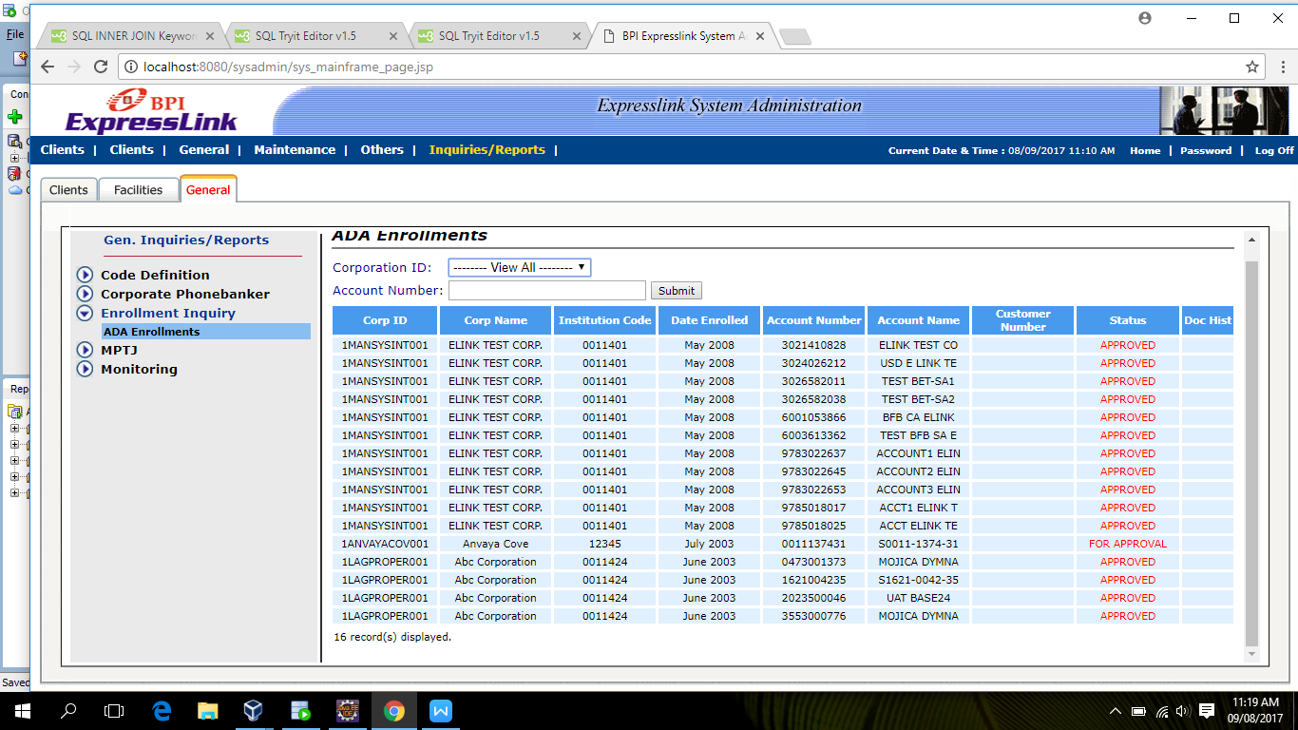

Select Distinct a.CORPID,a.CORPNAME,d.INST_CODE,d.Enrollment_Date,b.ACCTNO,b.ACCTNAME,d.Status from bpi.EL_CLIENT a

inner join bpi.EL_CLIENTACCT b ON a.CorpID=b.CorpID

inner join bpi.EL_USERACCT c on a.corpID=c.CORPID

inner join bpi.El_OPC_ENROLLED d on a.CORPID=d.CORPID

where tag_code='OPC_VALIDATE_ACCOUNT';