- New Screen for ADA Customer Accounts

Use Name | ADA Enrollment Inquiry
Actor | Elink After Sales User
Description | To display merchant codes and details of all enrolled clients.
Pre-Condition | User is enrolled to this facility.
Post-Condition
Basic Workflow | Protoype:  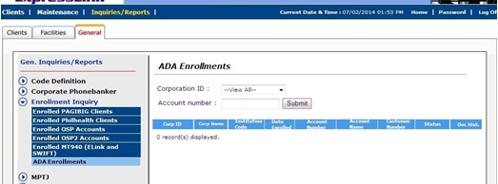  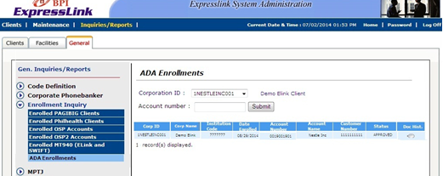
  User Action | System Action
  - User clicks on Elink Client Administration > Inquiries/Reports > General > Enrollment Inquiry> ADA Enrollments  - Select specific search option:  - Corp ID (dropdown with type ahead)  - Account # (text box)  Click Submit | System displays ADA Enrollments screen  Display search result with the ff details:  - Corp ID  - Corp Name  - Institution Code  - Date Enrolled  - Account number  - Account name  - Customer number  - Status  - Doc Hist
Alternative Workflow | None
Special Requirements | None

Technical Specifications

Tables to be Used

bpi.EL_OPC_ENROLLED – look-up for ADA enrollment and history

bpi.EL_USERACCT – will be used for determining the accounts that may be used in searching records (use those with tag_code = 'OPC_VALIDATE_ACCOUNT')

bpi.EL_PRODUCT_FUNC_SUBMENU – records are needed to be inserted in this table to include the function/menu in System Admin

bpi.El_Clients

EL_PRODUCT_FUNC_SUBMENU
Column | Value
PRODUCT_MENU_CODE | ELINK_CLIENT_ADMINISTRATION
PRODUCT_OPTION_CODE | SYS_CLIENTS_INQUIRIES
PRODUCT_FUNCTION_CODE | SYS_INQUIRY_GENERAL
SUBMENU_CODE | VIEW_ENROLLED_OPC
SUBMENU_DESCRIPTION | ADA Enrollments
SUBMENU_GROUP | Enrollment Inquiry
SUBMENU_URL | *** For updating upon finalization of program/scripts ***  May use sys_genrep_enroll_ada.jsp
FILTER_BY_STATUS | N
SEQNO | 6
AUTH_TAG | 1
DISP_ALL_TAG | N

*** Program for the screen (preferably JSP file) should be placed in Elink application server E:\prod\elink\sysadmin\sysadmin-engine\j2ee\home\applications\sysadmin\sysadmin-web\

