Prompts:
a) Weak: Explain regression
Improved Prompt: Explain regression in the context of machine learning and artificial intelligence. Write a short paragraph that defines regression, describes how it learns patterns from data, and provides at least one real-world example of how it is used to predict continuous numerical values. Keep the explanation beginner-friendly and limit the response to 4-6 sentences.
b) Weak: Help me understand SQL
Improved: Teach me the fundamentals of SQL, including SELECT, FROM, WHERE, ORDER BY, and GROUP BY. Use a sample student database with realistic data and provide an example query for each concept. Explain each query line by line, show the expected output, and give me three practice exercises with answers.
c) Weak: Create a dataset
Improved: Create a sample dataset containing 12 rows about online courses. Include the following columns: Course Name, Enrollment Count, and Average Rating. Ensure Enrollment Count is an integer between 50 and 500 and Average Rating is a decimal between 3.0 and 5.0. Present the dataset in a clearly formatted Markdown table, use unique course names, and ensure all values meet the specified ranges.
Why each improved prompt is stronger
The improved prompts are better because they give the AI more details about what kind of answer is needed. For the regression prompt, the added instructions explain exactly what should be included, such as a definition, how regression works, and a real-world example. This helps create a clear and easy-to-understand response instead of a general explanation.
The SQL prompt is better because it provides specific directions about the topics to cover, the type of database to use, and how the information should be presented. By asking for query explanations, sample outputs, and practice exercises, the prompt creates a more complete learning experience for the reader.
The online course dataset prompt is stronger because it clearly defines the number of rows, the column names, the value ranges, and the formatting requirements. These details help ensure the dataset is accurate and organized. Overall, the improved prompts produce better results because they are more specific, provide context, and clearly explain the desired output

Screenshot of responses
- 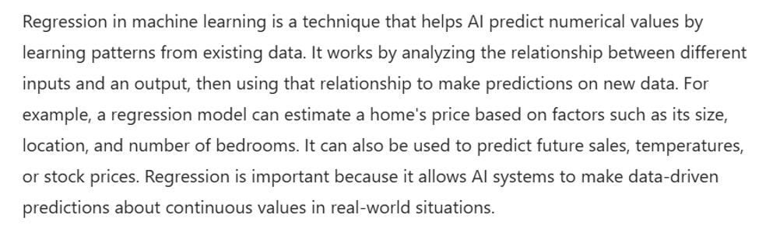

b.) 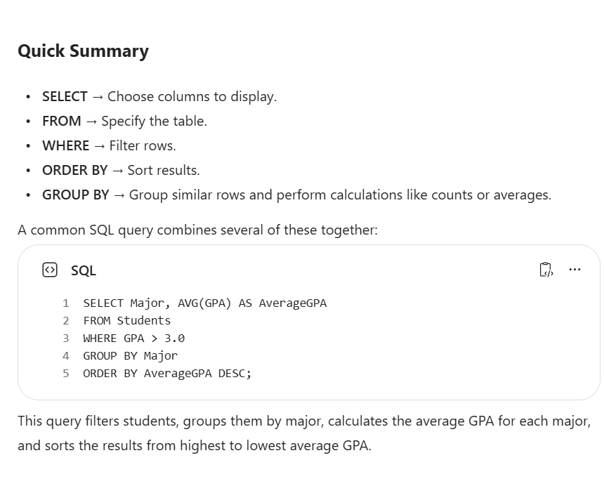

c.) 