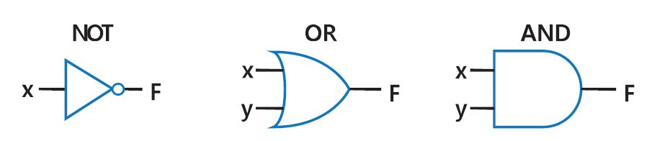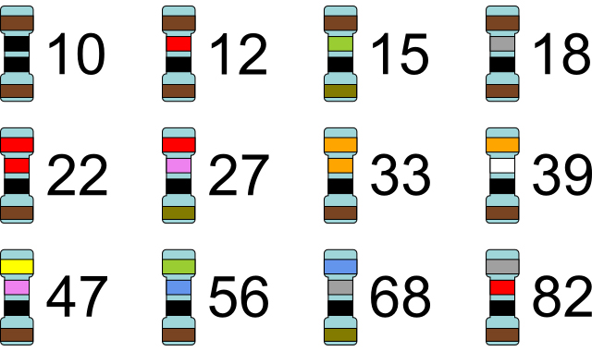

Locked

Unlocked

Start

Coin

Push

Push

Coin