CS350

Final Exam (Chapters 7, 8)

6/20/15

Name: Jamie Edwards

|  |  |  |
| --- | --- | --- |
| Nbr | Ans | Question |
| 1 | **C, E** | Which of the following conditions does ***not*** have to exist in order for deadlock to occur? (Note: there may be more than 1 choice):  [a] Circular wait.  [b] Mutual Exclusion.  [c] Carlos’ smelly feet barking.  [d] Hold and Wait.  [e] Circular Processes. |
| 2 | **F** | True or false:  As far as deadlock occurring, all of the conditions that were discussed in the Deadlock Chapter need to exist simultaneously. |
| 3 | **T** | True or false:  Deadlocks can occur via system calls and locking. |
| 4 | **A** | What type of edge is the following: *Pi* → *Rj* ?  [a] Request Edge.  [b] The Edge of Night.  [c] Assignment Edge.  [d] Heck, I don’t know. |
| 5 | **C** | What type of edge is the following: *Rj → Pi*?  [a] Request Edge.  [b] The Edge of Night.  [c] Assignment Edge.  [d] Heck, I don’t know. |
| 6 | **P1 is holding an instance of R1** | In **Figure 1** (at the end of this Test), please define box “***A***” in the form of:  “____ is requesting/holding an instance of _____” -- or:  “____ is a ___________ Type with ____ ________________ “  in the Answer cell to the left |
| 7 | **P1 is requesting an instance of R2** | In **Figure 1** (at the end of this Test), please define box “***B***” in the form of:  “____ is requesting/holding an instance of _____” -- or:  “____ is a ___________ Type with ____ ________________ “  in the Answer cell to the left |
| 8 | **R4 is a resource with 3 instances** | In **Figure 1** (at the end of this Test), please define box “***C***” in the form of:  “____ is requesting/holding an instance of _____” -- or:  “____ is a ___________ Type with ____ ________________ “  in the Answer cell to the left |
| 9 | **A** | Which of the Figures below represents a Deadlock condition:  [a] Figure 2  [b] Figure 3 |
|  | For questions 10 thru 13, please ***match*** the *correct* ***letter*** from the ***list*** *immediately* ***below*** in this cell to the definitions located in the numbered questions that follow.  [a] Deadlock.  [b] Preemption.  [c] Hold and Wait.  [d] Circular Wait.  [e] Duck Dynasty.  [f] Hold and Wait. | |
| 10 | **C** | must ***guarantee*** that **whenever** a **process *requests*** a **resource**, it does ***not*** ***hold*** *any* ***other*** *resources* |
| 11 | **A** | When this occurs, processes ***never*** ﬁnish executing, and system resources are tied up, preventing other jobs from starting. |
| 12 | **D** | There exists a set {*P*0, *P*1, …, *P*n} of waiting processes such that *P*0 is waiting for a resource that is held by *P*1, *P*1 is waiting for a resource that is held by *P*2, …, *Pn*–1 is waiting for a resource that is held by *P*n, and *P*n is waiting for a resource that is held by *P*0. |
| 13 | **B** | The act of temporarily ***interrupting*** a ***task*** being carried out by a computer system, without requiring its cooperation, and with the intention of ***resuming*** *the* ***task*** at a ***later*** time. |
|  | Questions 14 thru XX refer to Figure 4 Below. You may use your cellphone calculators to do the math if you need to assist you with your answers.  The Scenario is as follows:  **base register** = **300000**  **limit register** = **120900** | |
| 14 | **300000** | What value should go into box “A”?? |
| 15 | **420900** | What value should go into box “B”?? |
| 16 | **300000** | What value should go into box “C”?? |
| 17 | **120900** | What value should go into box “D”?? |
| 18 | **300000-420900** | Observing the diagram in Figure 4, the program can legally access ***all*** addresses ***from*** address ________ ***through*** Address _____________ |
| 19 | **A** | Which of the following **addresses** is generated by the ***CPU***?  [a] Logical Address.  [b] Rick’s Address.  [c] Physical Address.  [d] Hell – call the Post office! |
| 20 | **[ X ]T [ ]F** | True or False:  A process ***must*** be in ***memory*** to be executed. |
| 21 | **[ X ]T [ ]F** | True or False:  Logical address space is only defined by the base register. |
| 22 | **B** | Programs on disk, ready to be brought into memory to execute from a(n)  [a] Address Space  [b] Physical address.  [c] Thread.  [d] Input queue. |
|  | For questions 23 thru XX, please ***match*** the *correct* ***letter*** from the ***list*** *immediately* ***below*** in this cell to the definitions located in the numbered questions that follow.  [a] Compile time.  [b] Transfer time.  [c] Dynamic linking.  [d] Load time.  [e] Party Time.  [f] Static linking.  [g] Execution time.  [h] Internal fragmentation. | |
| 23 | **H** | Allocated memory may be slightly larger than requested memory; this size difference is memory internal to a partition, but not being used. |
| 24 | **G** | Binding delayed until run time ***if*** the process ***can*** be ***moved*** during its execution from one memory segment to another. |
| 25 | **A** | If memory location *is* known a priori (e.g. at ***compile time***), **absolute code** can be generated. |
| 26 | **D** | Must generate **relocatable code** if memory location is not known at ***compile*** time. |
| 27 | **C** | Linking postponed until execution time. |
| 28 | **[ ]T [ X ]F** | True or False:  Processes cannot be **swapped** out of memory. |
| 29 | **∞ The universe is donut shaped: https://en.wikipedia.org/wiki/Three-torus_model_of_the_universe** | ***What*** is ***infinity*** – and… ***does*** the **Universe** have an ***end***? |
| 30 | **Use second bucket to fill fifth bucket.** | Below, there are 6 buckets of water. The first 3 buckets on the left are full of water. Can you make a move with only ***one*** of the buckets of water (however you do it… anything goes!) so that you’ll end up with a pattern of “full bucket, empty bucket, full bucket, empty bucket, full bucket, empty bucket”?? Can it be done???  **O O O** O O O  F F F E E E |
|  |  |  |

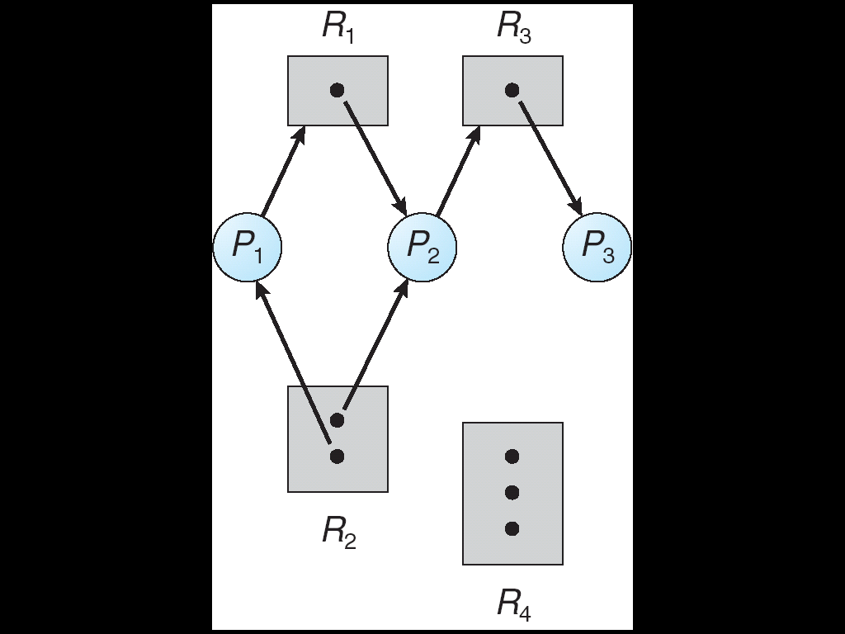

**A**

**C**

**B**

**Figure 1**

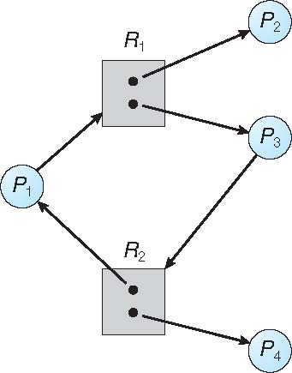

**Figure 3**

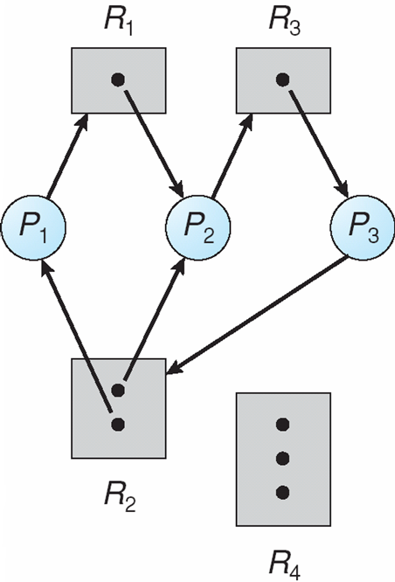

**Figure 2**

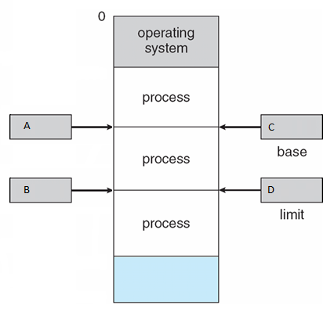

**Figure 4**