**The Brief:**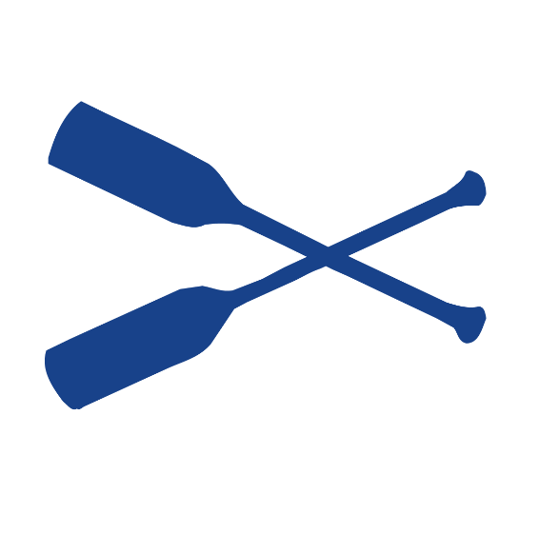

Our client, **Halifax Canoe and Kayak** would like a new website. Obviously, they want it to work across a myriad of devices. They would also like the ability to post information about upcoming adventures and allow visitors to register for trips.

It is your job to design and build them a fully functional website.

**Part 1 – Responsive Frontend**

Our client would like a ‘responsive’ example of the home page.

It must have 2 break points and navigation that toggles in and out

(Please note: The links do not need to work, this is one single content page)

Home Page Home Page with Navigation Homepage 1400px wide or wider

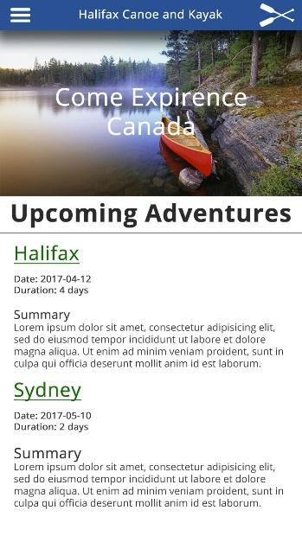 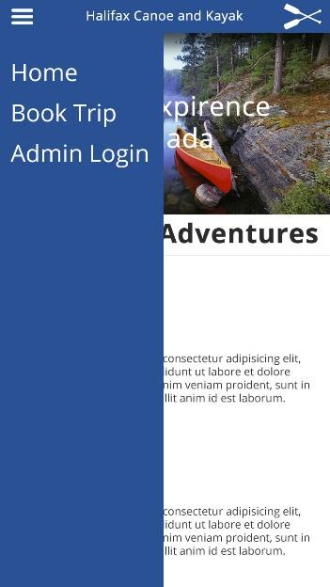 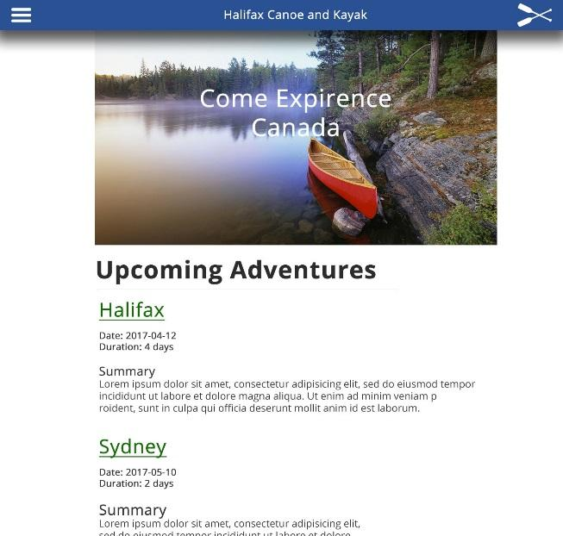

Please note: The text is static in this version, not driven by a database.

**Our client is requesting the following as ‘must haves’:**

* When the hamburger menu is clicked, the menu must ‘toggle’ in and out
* The main content, including the image must get no wider than 1000px
* Below 1000px the main content must be 100% across the screen
* Filler content (Any text will do)

**General Directions**

* Either coding from scratch or using a CSS Framework, create a single HTML page that l**ooks and operates like the above example (see images)**. The project must include html, css, and jQuery. You must, at a minimum, use the assets our client has supplied.

Feel free to go beyond the minimum,

**Supplied Assets:**

* The main image:

<https://raw.githubusercontent.com/Zulinov/skillsProjects/main/canoe.jpg>

* Hamburger icon: <https://raw.githubusercontent.com/Zulinov/skillsProjects/main/hamburger.png>
* Logo:

<https://raw.githubusercontent.com/Zulinov/skillsProjects/main/paddle-white.png>

(Use these as local or external images in your code)

**Submitting Instructions:**

1. Upload your complete project (html file, css file(s), images, etc.) to GitHub.

(You’ll be uploading a bunch, so stay organized)

1. Then post the URL to your project here: <https://skillsforhire2022.slack.com/files/T02TPJLR6MB/F03UZ40R7PC>

**Due Date: August 31st**

This project will build on itself over the next few months as our knowledge continues to grow and we introduce new languages and methods of development.