Homepage

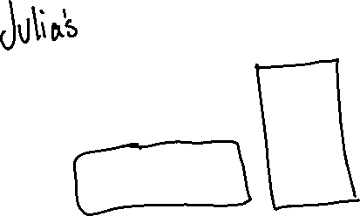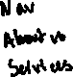

Company Page

About us – We create websites for people. We started this business in 2020 and growing as we continue helping people. We do all types of websites; each website varies in cost. Nice looking designs for a very affordable price.

Our Services

