Trying to understand data.

We have following teams.

"fovro", "Fastun", "Nyxx", "CarSpa", "Motion", "Worthwheel", "Carzio", "Rollovo", "iAuto", "VroomTime", "Kar", "EliteTechs", "Carz", "MileMode", "Automotiq", "RYDI", "EvolutionAuto", "Automovo", "ROBOH", "rimovo", "ottobi", "Evi", "Rusted", "Cjio", "NitroRide", "HXH", "SpeedLabs", "TenQ", "Caraxa", "Blazers", "DriveSwitch", "GIIQ", "Teuso", "Hoqa", "AutoInfinite", "vusk", "DentCenter", "Turbo", "evCU", "Electronically", "Drivat", "Torque", "Drift", "Carvato", "Rush", "Matic", "Wheelic", "Slidyn", "Pitpo", "caralo", "Drivesly", "Xuad", "CarLeap", "Tazox", "Amxu", "Honkli"

To know their performance, following ranking measures are considered.

Scores
Factory Utilisation
Employee Engagement
Interest Coverage
Cumulative Marketing Spend/Rev
eCar Sales
CO2 Penalty
WACC

Data will be read from file having name as date.json.
Each file will contain records for all KPI(mentioned above) .
For more clariry, Each team will be present in each KPI.

What will three button do ? RANK , TEAM and Value.

From my understanding, if user wanted to see day1 performance against WACC, he will select day1 from first drop down and WACC from second drop down, and if he will click team. It will show all teams against WACC, whereas all team will be returned.

if he will select rank, it will display day1 data in order (value) with team name.

What is purpose of value ?

Students who are members of a team taking the module.

Students can view only view their team performance against each KPI measure which are mentioned above. They could view see average of all teams.

Academics who teach this business subject can view all team with their each day performance with average overall for each day and may be all days.

We may use represent graphically each KPI to have better visibility to know “which KPI is more effective to consider performance”.

For Student API view may be like following :

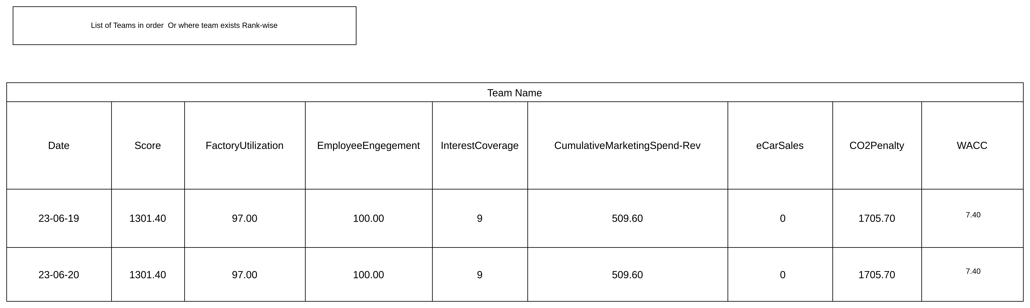

For Academic view will be like following:

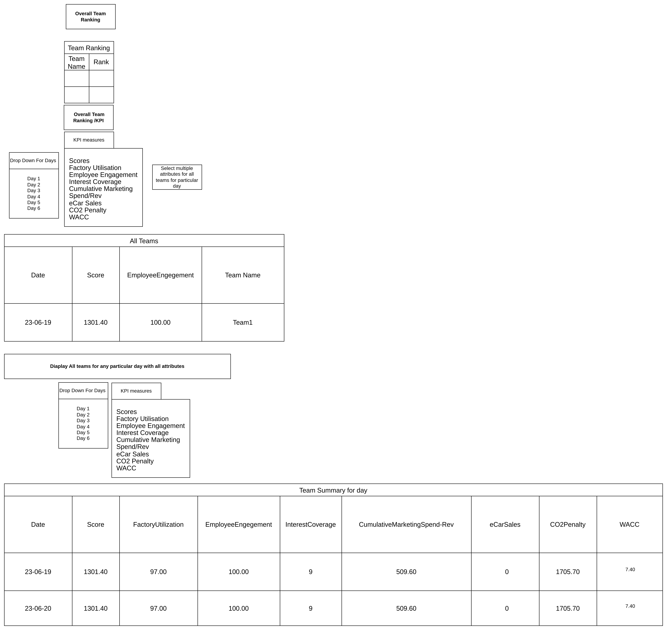

For Staff We can have CRUD Operation for academics, students, and Team that may be separate API with visibility rights with students in team.

To decide which database will be used ? I have few questions ? The file is received on daily basis or only 6 days?

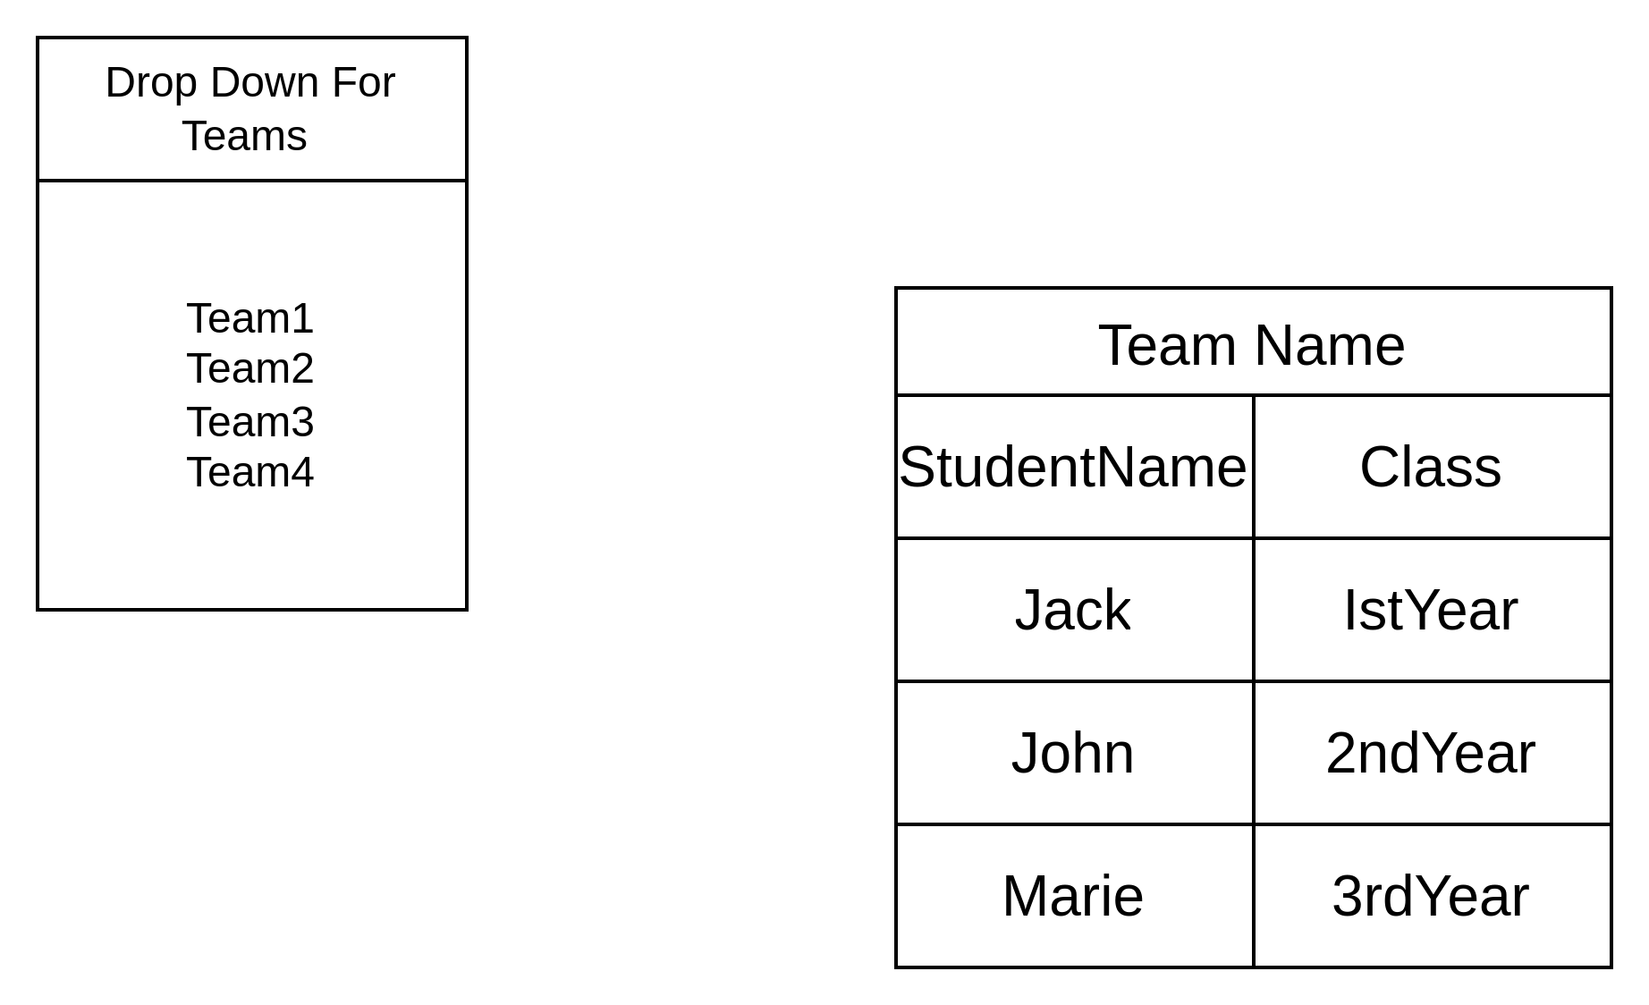
Question
(For myself)
Can I read lists of data from file using spring batch

wacc range(7.40 ~ 7.50)

Factory util (52 ~ 90)

scores (731 ~ 1301.40)

{

wacc : [{},{}],
factoryUTil : [{},{}]

}
to login as use postgres
sudo -u postgres psql
to connect to database
\c databasename
\c data_transformer

DB schema

CREATE USER jcoder WITH PASSWORD 'jcoder' CREATEDB;

CREATE DATABASE data_transformer;

CREATE TABLE IF NOT EXISTS data_transformer.BusinessTeamsKPI
(
id serial PRIMARY KEY,
kpiBusinessMeasure varchar(50),
value decimal(6,2) NOT NULL,
teamName varchar(20),
fileForDate date
);

To see all tables in db

\dt

