**Quick Install Guide for Flutter Framework**

Clone Flutter to a folder on your computer ( I made a src folder in my C: drive to clone into)



Make sure your environment variables are set for Flutter to work.

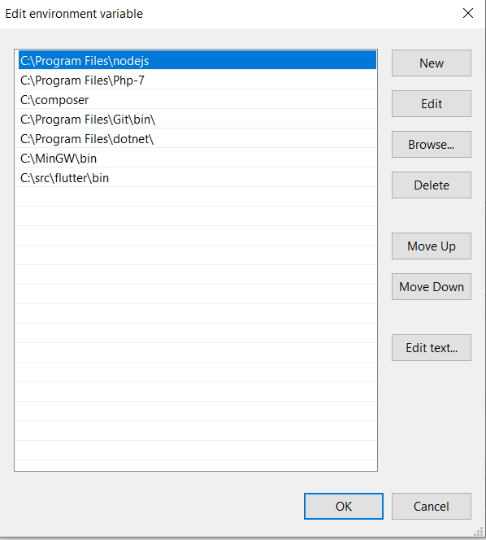

Add path if flutter –version doesn’t work within cmd line.

I ran into an error and added these two line below to my env vars.



**Flutter for Android Studio**

Setting up Flutter in android studio, First open AS and go to file option, next hit settings. Once in the settings panel go to plugins. Type in flutter and install flutter.dev

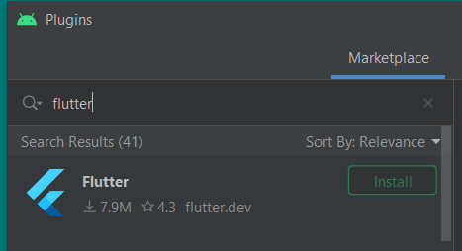

When making a new flutter project make sure you include the SDK Path for Flutter

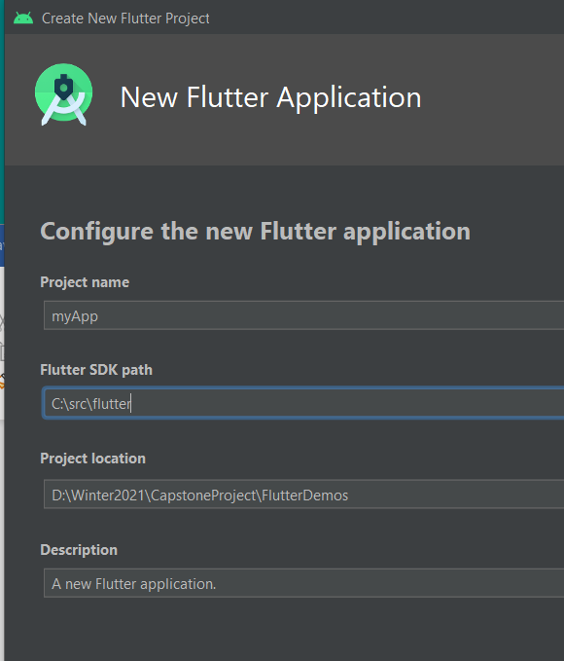

Windows Install Link for Flutter: https://flutter.dev/docs/get-started/install/windows?gclid=CjwKCAjwoc_8BRAcEiwAzJevtX_XAhu-57Lr94a2kyqOGzXaLkz0qaZ-WPlkHOlACDX7ix9-TNwicxoC-FAQAvD_BwE&gclsrc=aw.ds#get-the-flutter-sdk

**Dart**

Some simple information about the Dart language. Dart is an object oriented, strongly typed language with many similarities to Java. Below are some sample code bits and a few notes taken during the intro tutorial.

https://dartpad.dartlang.org/  
Dart language sandbox

Flutter ui built upon with a widget tree method, everything in flutter is a widget

Can use dynamic declaration, may lead to problems later

For small methods, you can return values like:

Int getAge() => age;

Void main(){

Player playerOne = Player()

}

Class Player(){

Int health = 30;

String name = ‘Fighter guy’;

Player(String pName, Int hp)

This.health = hp;

This.name = pName;

}