James Cortes

Assignment: 2.3

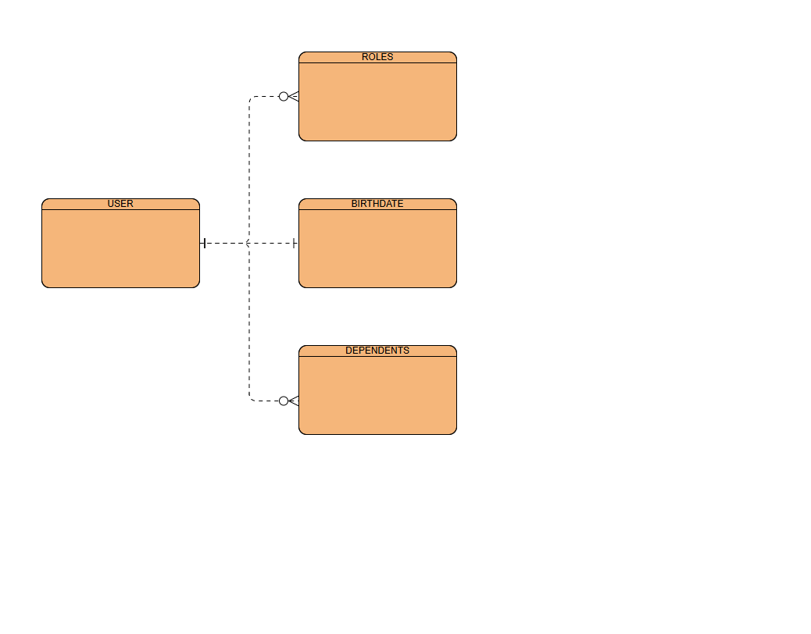

{

"userID": Jcray25

"name": "James Cortes",

"birthdate": "1999-05-29",

"roles": [

{"roleID": 1, "roleName": "Team Member"},

{"roleID": 2, "roleName": "Bike Master"}

],

"dependents": [

{"dependentID": 1, "name": "Milly"},

{"dependentID": 2, "name": "Rosa"}

]

}