James Cortes

Assignment 5.2

The functions I have chosen to observe is NOW (), YEAR (), and CONCAT ()

The NOW() function is used to get the current date and time. Useful for getting the exact time when a record was created. A friendly alias for it could be SELECT NOW AS (Todays Date and time.);

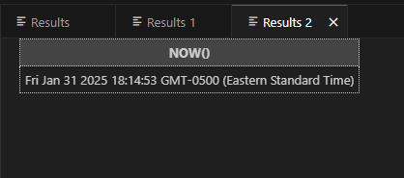

YEAR () is used to get the current year. Useful for getting an exact year. A friendly alias for it could be SELECT YEAR AS (CURDATE);

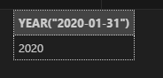

CONCAT () is used to add two or more expression together. Useful for cutting down length of strings. A friendly alias for it could be CONCAT() AS (Address);

