HW #3 GitHub and Git

Sammy Chen Li

November 5, 2018

GitHub link (also published on the class form): <https://github.com/sammychenli>

**Part Three:**

GitHub is a platform primarily for developers (and others) to publish, edit, and improve source code(s). GitHub was founded in 2008 by Chris Wanstrath, PJ Hyett, Tom Preston-Werner, and Scott Chacon. It was built for developers to work with other developers on a project that may have multiple and simultaneous edits. Other similar platforms exist such as Bitbucket, SourceForge, and Kiln. These platforms are extremely helpful for group projects, for both a local and international setting. A developer can make edits without overriding another developer’s edits that are happening at the same time, both of which are documented. Requests to improve a source code can be made by the public, which are handled by developers (also documented). This type of platform allows for an “easier” collaborative group setting as well as easier documentation on a source code.

**Part Four:**

Intro to Git Commits

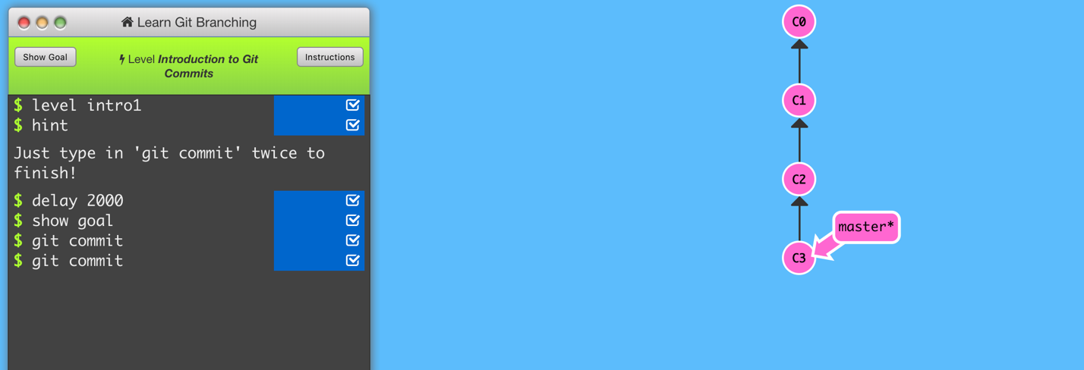

Branching in Git

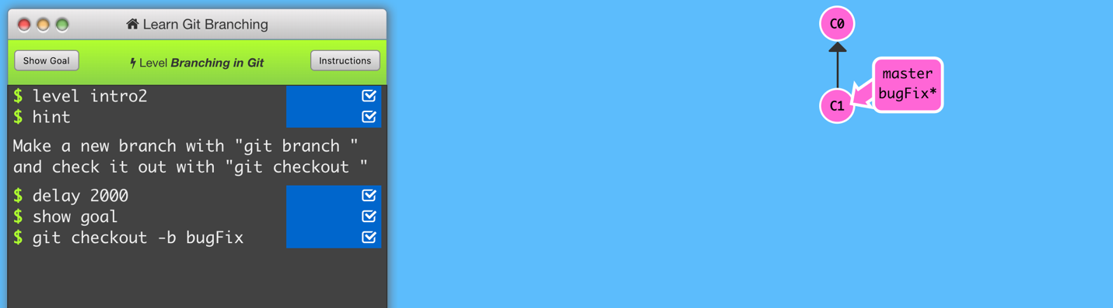

Merging in Git

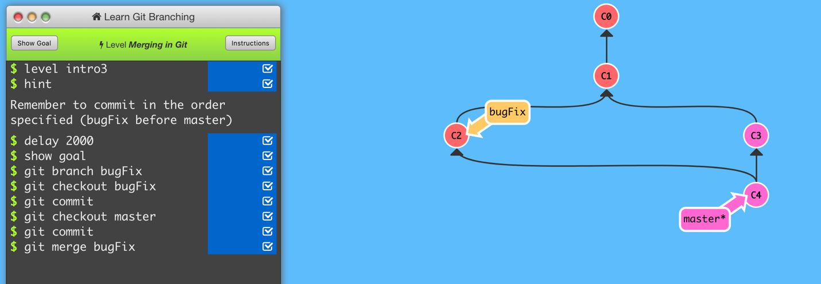

Rebase Introduction

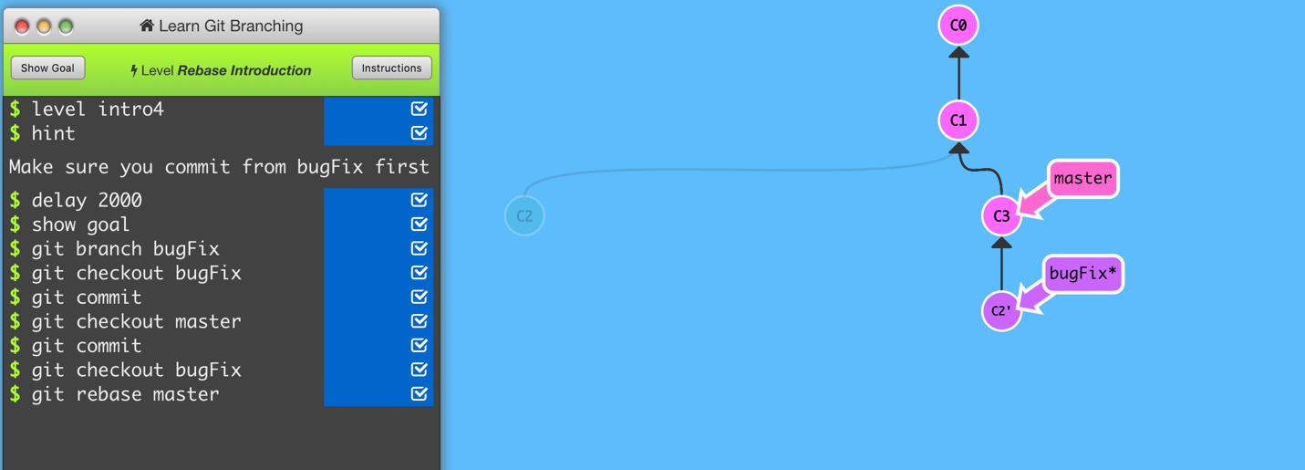

**Part Five:**

* Repository – a collection of a project’s history, including commits
* Commit – a “snapshot” record of a project at a certain time during the project; copy and paste; publish to local repository
* Push – publish content from local repository to remote repository
* Branch – a pointer/reference to a commit; a branch is created for each *new* commit made; “an independent line of development”; the reference pointed to the tip of the branch (most updated commit)
* Fork – an unsynced copy of a repository onto a developer’s personal account; usually used to edit/make changes separately, which can be published back to the original project via a pull request
* Merge – combines two branches (branches “contain” commits) into the *current* branch
* Clone – creates a local copy of a project (including its files, history, and branches); primarily used to copy over to another location
* Pull – updates a local repository with the remote repository; primarily used for developers to reflect the changes on their local environment with the changes made on the remote environment
* Pull request – a request to make changes (i.e. features, updates) on a project; also used as a forum to alert other developers or create a discussion to review the proposed changes

**Part Six:**

Repository Link: <https://github.com/sammychenli/CS3612018>

**Part Seven:**

* Retrieved the README.md file.
* Created a fork in the project and made changes. (added *Chen Li, Sammy November 6, 2018 7:44PM*)
* Created a pull request and submitted it.
* This pull request is then reviewed, which will merge my pull request to the master branch.
* The README.md file is updated.

**Part Eight:**

Link to Issues: <https://github.com/sammychenli/CS3612018/issues/1>

**Part Nine:**

Link to Wiki: <https://github.com/sammychenli/CS3612018/wiki/CS-361-2018>