*Part 3:*

*What is GitHub? When was it created? Why? By who? What similar platforms exist? Why would you use such a platform? (Answer between 5 and 10 lines)*

An Online version of Git where projects are loaded onto repositories. Public Repositories are downloaded-able, collaborate-able, fork-able, and watchable, often times becoming community supported projects. Created by Tom Preston-Werner, Chris Wanstrath, and PJ Hyett in 2008, Github allows the ability for organized online version-control and sharing on independent projects which often support popular software. Github is often compared to Bitbucket.

*Part 4:*

*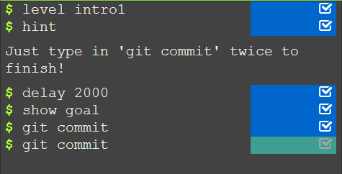*

*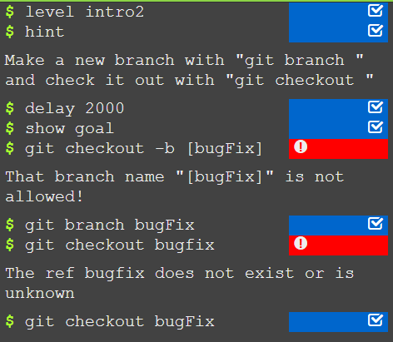*

*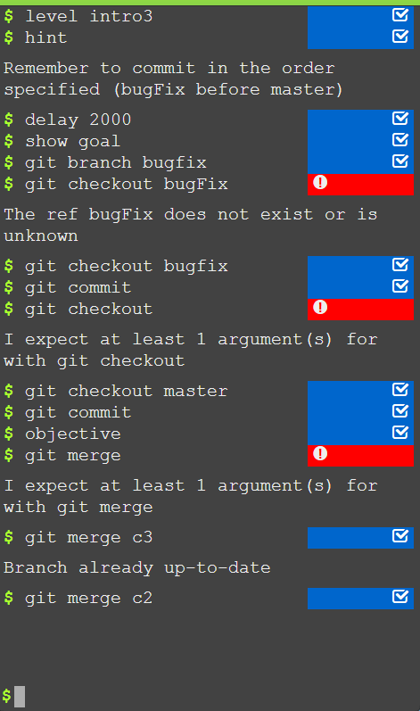*

*Part 5:*

*Define the following terms in the context of Git (2 lines maximum):*

* Repository : Where files (and folders if you set it up right) are kept
* Commit: The storing of changes to a local repository
* Push: The sending of Local commit changes to a remote repository
* Branch: A copy of a repository to make changes to that don’t deviate from the master project
* Fork: A clone or copy of a repository to often make drastic or non-pull supported/approved changes
* Merge: The taking of changes/commits from one branch to another, often from a deviant branch to the Master.
* Clone: A local copy of a repository
* Pull: Adding the changes of a remote repository to a local repository.
* Pull request: A proposed change to a repo that could either be denied or accepted.

Part 7

I didn’t actually use commands but instead used GitHub edit feature which will auto fork and allow you to do a pull request.