# Answer

Q1: **Network Structure:**

x1

y

x2

x3

w1=1

w2=1

w3=1

b=-2.5

|  |  |  |  |  |
| --- | --- | --- | --- | --- |
| C:\Users\ADMINI~1\AppData\Local\Temp\ksohtml13132\wps1.jpg | C:\Users\ADMINI~1\AppData\Local\Temp\ksohtml13132\wps2.jpg | C:\Users\ADMINI~1\AppData\Local\Temp\ksohtml13132\wps3.jpg | X1w1+x2w2+x3w3-2.5 | y (label) |
| 0 | 0 | 0 | -2.5 | 0 |
| 0 | 0 | 1 | -1.5 | 0 |
| 0 | 1 | 0 | -1.5 | 0 |
| 0 | 1 | 1 | -0.5 | 0 |
| 1 | 0 | 0 | -1.5 | 0 |
| 1 | 0 | 1 | -1.5 | 0 |
| 1 | 1 | 0 | -0.5 | 0 |
| 1 | 1 | 1 | 0.5 | 1 |

**Loss Function:** As this is a binary classification problem, we can use Binary Cross-Entropy as the loss function. It measures the error between our model's predictions and the actual data.

Q2:

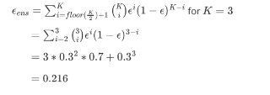

Q3: https://www.kaggle.com/code/mohamedahmed10000/credit-score-eda-prediction-multi-class