Josh Creasey

Data Structures

Dr. Pete Tucker

Final Project Reflection

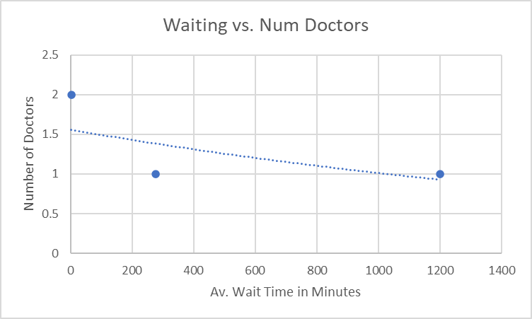For this final project, I chose the emergency room simulation that had given parameters provided by the Whitworth Computer Science department. As part of this reflection, I have been asked to compare the simulation as user identified variables change (the number of doctors and number of nurses). For all comparisons, I will have a fixed rate of 15 patients per hour. When one doctor and one nurse were present, these two individuals were clearly not able to handle the entire emergency room by themselves as the waiting queue piled up to 730 by the end of the simulated week and the average patient wait time skyrocketed to nearly 1200 minutes. When one doctor and one nurse were present, there were only 169 patients in the waiting room and the average wait time for a patient was 277 minutes. Finally, when two doctors and one nurse are working, the waiting room was empty and the average wait time for a patient was 2.5 minutes! Although, these results will most likely change as the simulation is ran over again, the trend that having more staff to treat patients improves the efficiency of emergency room stays the same. It can also be assumed that having more doctors than nurses also helps make the emergency room more efficient as high risk patients can be helped more quickly while nurses handle more low priority patients in the same amount of time. I found that my design changed often and quickly as I was designing this system. It was challenging to think of every aspect of the system before attempting to implement it. I would say that my biggest challenge was trying to figure out how each piece needed to fit together to make a cohesive product that is simple for the user to navigate. This included what classes needed to exist, implementing time into many functions as time is essential in a simulation, and attempting to debug code I was sure was going to work. I spent nearly the last three days planning and writing code to make sure this was successful simulation. I learned a lot through rereading the textbook, researching how different containers function, and truly struggling through each and every piece of this project. I can truly say that this project has helped me to better understand the concepts that were taught in this course. I am excited to see what else is in store as I continue to learn and grow as a software developer.