Full name: Jorge Carlos Varela de la Barrera

UF-ID: 9332-5612

Email: [Jcvarela@live.com](mailto:Jcvarela@live.com)

**How to Compile and run your code**

Github repo: <https://github.com/Jcvarela/ComputerNetwork>

I compile and run my code using Intellij, but I included two runnable jar file on my zip folder.

client.jar -> the client program

server.jar -> server program

To run it just put in the command line

java -jar client.jar hostname port_number

java -jar server.jar port_number

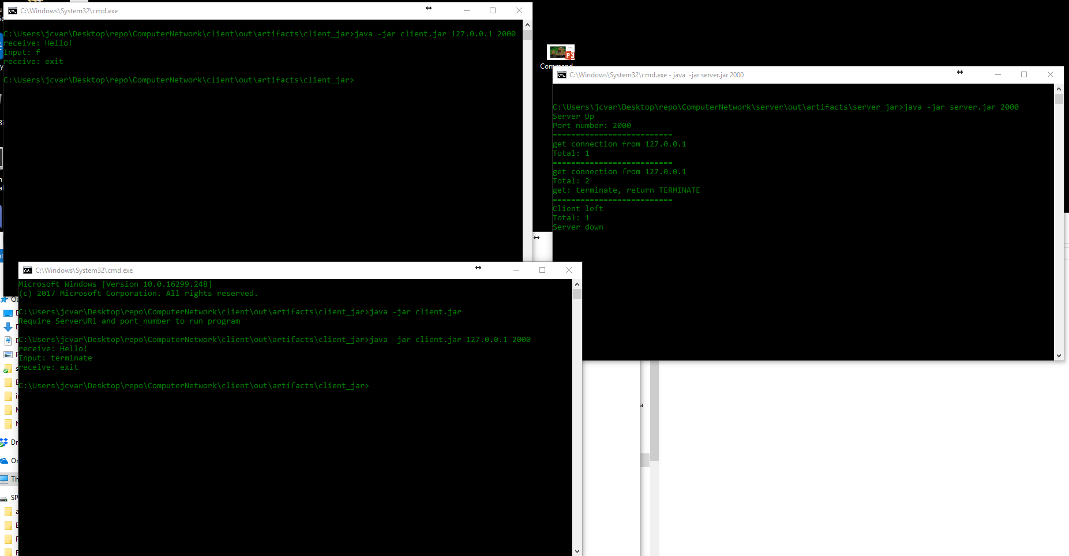

Additional comments:

I created my server such that it could handle multiple clients at the same time.