Sentinel is a policy-first C2 platform that reduces fleet-management workload so operators can out-coordinate enemy drone swarms.

Problem:
Ukraine’s experience shows that drone production can outpace the personnel needed to operate them. In January 2026, President Zelenskyy reported production capacity of approximately 1,000 interceptor drones per day, but warned that “our interceptor drones have already outpaced the number of our operators.” [20]
Expanding the operator pool takes time. In April 2026, Ukrainian air-defence firm Gvardiia reported that training an interceptor pilot from scratch takes approximately three weeks, with unsuccessful candidates reassigned to supporting roles. [21]
These findings highlight a manpower constraint: producing more drones does not automatically create the capacity to deploy them effectively .Sentinel eases this operator bottleneck by reducing the cognitive workload of tracking threats and coordinating a fleet, allowing each operator to supervise more drones while retaining mission control.

In Singapore’s Context:
On 20 January 2026, Russia launched 339 drones alongside a missile barrage against Ukraine. Ukrainian authorities reported that 315 drones were shot down and 24 hit their targets. Ukraine’s interceptor-missile expenditure that night was approximately US$94 million. Despite producing around 1,000 interceptor drones daily, Ukraine lacked enough operators to use them; a shortage Zelenskyy explicitly acknowledged. [22]
A similar attack would pose serious risks in Singapore’s compact urban environment, where homes, businesses and critical infrastructure sit close together. Operators responding to multiple threats would need to assess incoming information and coordinate assets while accounting for buildings, civilians and friendly aircraft. As the number of threats grows, so does the cognitive workload, and the risk of delayed or missed decisions.

Prior Work:

Why The Current Solutions Fail:
Drone Training Academy for skilled operators: Ukraine has reported that it will take the country 3 weeks to train an operator to the right standards to evade and manoeuvre the UAVs. However, with (number of drones produced every week) and (number of drone strikes a day), having (number of pilots trained a day) x (number of drones a pilot will use in a day) is still insufficient. Drone training academies and drone facilities are among the first targets to be hit by drone strikes, which makes them vulnerable. This doesn’t mean we shouldn't build drone training facilities, but scaling drone pilot upskilling is not viable in a land-constrained environment like Singapore, especially while being out-manufactured by a future adversary. Additionally, most drone training focuses on 1-1 drone interceptions, and Singapore's smaller population compared to adversaries with larger populations means fewer willing drone pilot trainees.

Autonomous Drones: Autonomous drones are built to alleviate the manpower constraints of 1-1 Drones. While possessing the ability to be GNSS-denied, Anti-jamming capabilities, mesh-based LoRa network, or camera-based navigation, Autonomous drones are prone to cyberattacks and can turn against operators. Additionally, Autonomous drones do not provide enough control for human operators to know exactly their future flight plans and can inefficiently traverse unnecessary rough terrains

Existing C2 Drone Platform: To mitigate both 1-1 and autonomous drone solutions, military organisations and Defence companies such as ShieldAI, PicoGrid, and Palantir allow defence operators human-in-the-loop control of autonomous drones, enabling micro-corrections to the plan and optimised interception paths. However, for Singapore, foreign defence companies can cause vendor lock-in. In the event of future conflict, foreign governments of these defence software providers can disable access to critical drone software and render our drone production useless. Countries that develop their own C2 platform face extreme cognitive workload, as operators must access thousands of aircraft a day to identify threats and intercept them in a split second.

In summary, using 1-1 drones is heavily reliant on our lack of manpower resources against adversaries that can produce millions of drones every month. Autonomous drone swarms are prone to cyberattacks, which can turn them against our own facilities, while inefficiently mapping the right path to interception. And current C2 command platforms provide too much information for drone operators to make a decision in a split-second.

Our Solution
We built Sentinel as an Agentic C2 platform for quick wartime decision making. One operator is able to unify one coordinated fleets of 20 and more autonomous interceptor drones. Using a mixture of sensor data and drone tasking into a single command layer, operator can control outcomes of the mission rather than pilot individual aircrafts.

We target C2 Operator and Operations Lead in the RSAF Airforce team. The operator should be able to understand the situation, inspect threats and friendly assets, move between tactical and real-world spatial views, open analytic views, and review the evolution of the mission over time.

How it works
Fuse: Using multiple sensors throughout Singapore's map, Sentinel employs confidence scoring to reliably identify aircraft, alleviating concerns about cyber vulnerabilities and false positives. Its on-prem AI justifies decisions, reinforcing security and operational integrity for the audience.

For suspected enemy drones, Operators can utilize further sensors, unit on the ground, current aircraft units at airbase, or specialized reconnaissance drones to gather further intelligence on suspected enemy drones. For enemy drones confirmed to be hostile by the operator, it can be selected on the command screen to be passed onto the coordinate process.

Coordinate: For selected enemy drones, Sentinel Agent identifies the right specialized drones at the right amount to coordinate a drone swarm to ensure a definitive success mission. Using agentic capabilities, Sentinel drafts an optimized flight plan based on the physical specs of the drones (Speed, turning radius, weight etc.) Once approved, drones will automatically be launched to fly towards the target at level 4 Autonomy

Execute: Using digital twin technology, coordinated drone swarms approved by operators will be marked live on the command interface using the same sensor fusion technology. For GNSS denied and network denied environment, the agent on the Sentinel Agent estimates it approximate position based on terrain, average speed and probability of drone failures to determine if it has successfully intercepted the target. While flying, operators can view the constantly changing flight plan and choose to manually fly either of the drones to reorganize its formation.

In collaboration with Wedgetail (Counter Drones fitted for Singapore’s landscape) and Anchor (GNSS-denied camera based navigation for Counter Drones), Operators can view and control the individual drones in the same denied environment despite sensor loss and tight spaces. In addition, our collaboration with Thales to supply their sensors and its data allow Wedgetail’s drones to self coordinate without network and GNSS to re-optimize its flight path to target the interceptor drones.

With the collaboration of 3 teams, Sentinel only requires data integration of military sensors for identifying foreign aircrafts. Sentinel is ready to be implemented with any level of military sensors integrated available.

Cost Economics

Team
The team in Sentinel is a diverse mixed of technical developers, skilled product owners, and commercial leads.

Technical
Yusuf Razak is a computer engineering diploma graduate from Temasek Polytechnic and a former Software and UX developer at SoDrama! where he builds agentic tools to streamline processes and develop capabilities. Some of his previous experience include being the Innovation Lead to turn the makerspace 3D printers into an Industry 4.0 IOT system. As well as building https://buildables.app and Overhaulsg.com where he worked on finetuning mechanical engineering AI and building scalable AI systems.

Product
Jason Chin Wei Sheng: Jason is an AI Developer Engineer in the Digital and Intelligence Service (DIS) of the Singapore Armed Forces. Jason has experience leading a small team in his unit to brainstorm, build, and train AI systems that help military intelligence analysts in the SAF collect & process information faster and more reliably. Beyond development, he serve operationally as an intelligence collector for real-world taskings. Some projects that Jason has worked on include fine-tuning and building an end-to-end LLM pipeline for automated multilingual translation and summarisation, enabling faster, better-informed decision-making in time-critical operational contexts. Jason won the SAF Tier 1 Innovation Award for his contribution in prototyping a pipeline using fine-tuned BERT-based Named Entity Recognition (NER) to extract geospatial entities from intelligence reports and render as interactive markers on a world-map platform to give a unified operational picture combining textual intelligence with the live geospatial context.

Fittra Syaifullah (Mandai Project all the design school major studio project)

Damien Tan is an aerospace engineering diploma graduate from Nanyang Polytechnic specializing in Aeronautical & Aerospace Technology and working as a Admin Support Assistant in MINDEF supporting documentation, reporting, scheduling, coordination and logistics workflows.

Commercial
Chai Chang Yao is a Diploma in Business Polytechnic Graduate and a former startup founder of Buildables. He leads Buildables to develop humanoid applications and maintenance and worked as a service designer for Changi Airport to do empathy service mapping and customer sentiment for facilities’ user experience. Chang Yao worked on fine-tuning LLMs to create, identify and checks for types of errors in interior cabin parts in Aerospace, developed a mechanical engineering model to create CAD models before GPT 6 Astra Hardware capabilities and successfully established pilot pipelines with 6 enterprises to deploy vision-based knowledge transfer to help retiring senior technician pass on their reasoning and know-hows to junior engineers and incoming foreign talents that is unfamiliar with english languages.

Why Sentinel (Competitor Analysis of Sentinel against other C2 platform)

Risk and Mitigation

Timeline and Go-To Market
Within 3 months: With our collaboration with Wedgetail drones, Thales’ sensors, and Anchor’s camera monitoring system, we aim to work with SAF to run the first pilot trial in the SAF Drone Training Center. Based on the feedback with Military Experts and the pilot performance, we’ll use the result to reiterate Sentinel's robustness. At the same time, we’d like to invest in R & D to dogfood Sentinel against Jamming, signal loss, drones trapped in nets.

Within 6 months: Sentinel would like to leverage on CapVista’s Incubation support to connect with foreign defense companies and regional governments on Sentinel Implementation. Additionally, Sentinel can be expanded to non-civilian or public service application such as drone security and drone surveillance at major events against terrorism and unknown security threats. Sentinel can be deployed at critical infrastructures to defend against drone swarms, or reconfigured to manage autonomous assets at factories or hospitals.

Progress of Sentinel

Sentinel V3 is updated to no longer be treated primarily as a map with controls. It should be developed as a modular operational workbench that presents one shared operational state through multiple complementary views.
For the hackathon, Sentinel v3 will remain focused on counter-UAS operations and should demonstrate that use case deeply and credibly. The architecture, however, should avoid assumptions that permanently restrict the platform to drones, military use, or a single data source.
The long-term product direction is a workbench that can be adapted to other operational domains, including Humanitarian Assistance and Disaster Relief (HADR), by changing domain modules, entity types, workflows, data adapters, and visualisations without rebuilding the core application.

Incubation pathways:

(CY) Introduction and Problem Statement:

(fittra) Prior Work & Competitive Landscape:
DARPA's OFFSET programme is the clearest public evidence of the movement pattern Sentinel targets: mixed aerial and ground robots dispersed from a launch point, searched assigned sectors, shared findings into one picture, and re-concentrated only the relevant units on a new finding while others held coverage.

Reported Israeli use of communicating quadcopter groups over Gaza and Ukrainian company Swarmer's reconnaissance strike networking both show the same three ingredients, shared information, divided tasks, and roles that change after launch, moving from research into operational use.

NASA's ACERO and FireSense programmes demonstrate the edge-of-network problem Sentinel must also solve: coordinating multiple aircraft over weak or relayed connectivity, and integrating unfamiliar payloads without losing evidentiary and calibration traceability.

By contrast, the widely cited Libya/Kargu-2 and Abqaiq–Khurais incidents are weak evidence for actual swarming: public evidence supports autonomy-in-a-single-vehicle and a well-planned coordinated salvo respectively, not vehicles exchanging information and changing group behaviour after launch. Sentinel's design bar for "coordination" is set at that higher, behavioural standard, not at drone count or visual formation

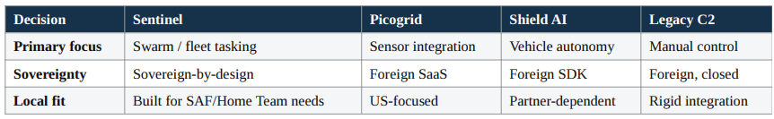

(Yusuf) Technical Approach:

(Yusuf) Test Methodology:

(CY) Results and Discussion:

(fittra) Possible Defence Applications (CONOPS):

Primary applications: A Home Team or SAF incident comander supervising a small coordinated fleet, sensing and inspection drones plus interceptor assets, during a public safety or force-protection incident. Before Sentinel, that commander pilots one aircraft at a time from fragment feeds; after, the commander drafts an objective on a shared map, reviews a ranked plan, and confirms or vetoes with one tap. Deployment constraints: a rugged tablet plus companion computer and fleet gateway, a primary cellular/RF link with mesh fallback, and Singapore’s dense urban, GNSS-constrained terrain as the default - not the exceptional operating condition. Failure behavior is designed to be safe and loud, a lost-link aircraft holds, returns or lands and reports it clearly, never fails silently. Operator training burden is deliberately narrow: 10-15 structured commands with one-tap confirm and an always-available abort.

Secondary: Missions the same core technology serves without re-platforming under the domain of search and rescue, perimeter monitoring, hazardous-site assessment, and general public-safety patrol/observation, each contain a domain module over the same stable core (entity, track, asset, task, evidence), differing only in completion criteria and approval policy. Hazardous-site assessment and general patrol reuse the identical sensing and tasking pipeline with a different payload (gas/thermal sensor in place of EO/IR) and a different completion rule (required readings captured rather than sectors cleared).

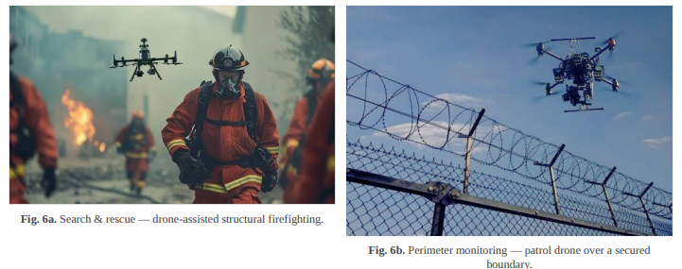

Show-stopper risks, named early: An ambiguous or rushed operator command causing Sentinel to propose the wrong drone or target (mitigated by a small structured command set and mandatory one-tap confirmation with abort); loss of GNSS or comms in dense urban terrain; sensor fusion producing false or duplicate tracks (mitigated by multi-sensor confidence scoring and operator flagging); and single-operator cognitive overload as fleet size grows (mitigated by automatic prioritisation, alert grouping and workload-tested interface iteration).

Integration and no lock-in: the canonical vehicle contract and adapter model let a MINDEF or SAF system owner swap an airframe or sensor family in and back out without stranding the investment. Sovereignty: Sentinel is hosted and controlled locally by design, no foreign SaaS dependency of the kind that would let a licence or cloud service be withdrawn, in contrast to the foreign-SaaS and foreign-SDK dependencies of the competitors.

(fittra) Defensibility:

3 things make Sentinel hard to copy quickly. First, an integration with other like-minded defense startups, each hardware that we currently have (Thales and Wedgetail, plus the MAVLink/PX4 adapters) is validated canonical vehicle contract, and each integration cycle consumes real calendar time, on the order of the 90-day cycle demonstrated in this report, that a competitor must repeat per partner rather than buy once.

Second, sovereignty as a structural advantage; local hosting and control speak directly to MINDEF/SAF data-sovereignty requirements that Picogrid’s foreign SaaS model and Shield AI’s foreign SDK dependency cannot match without a re-architecture of their own product,

Third, the tacit domain tuning that has been configured; the confidence- scoring thresholds and authority-ladder policy are being tuned specifically to Singapore’s dense-urban, GNSS-constrained geography, a form of knowledge that is not published and not quickly recreated from a foreign vendor’s playbook.

Where Sentinel does not yet win; against Shield AI’s onboard vehicle-level autonomy on a single airframe, Sentinel is not competing head -to-head, it does not aim to out-autonomy any one vehicle, Sentinel’s justification is tailored to the fleet level; coordinating multiple vendors’ vehicles under one sovereign authority, which single-vehicle autonomy are not built to do.

(CY) Incubation Plan

Fittra (Appendix)

A.Risks & Mitigation
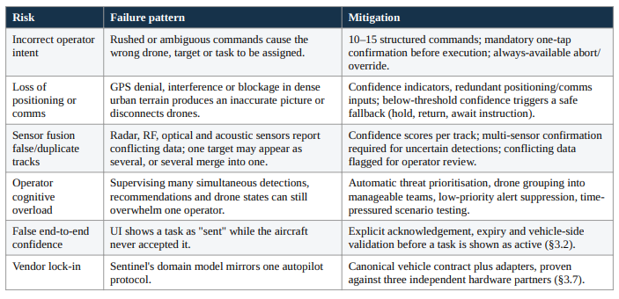

B.Team Overview
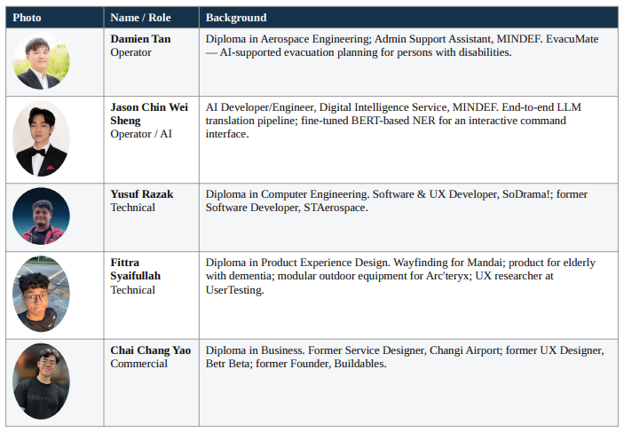

C.Cost-Economics Frameworks

D.Validation Roadmap

E. Related Hardware & Operational Reference Photograph

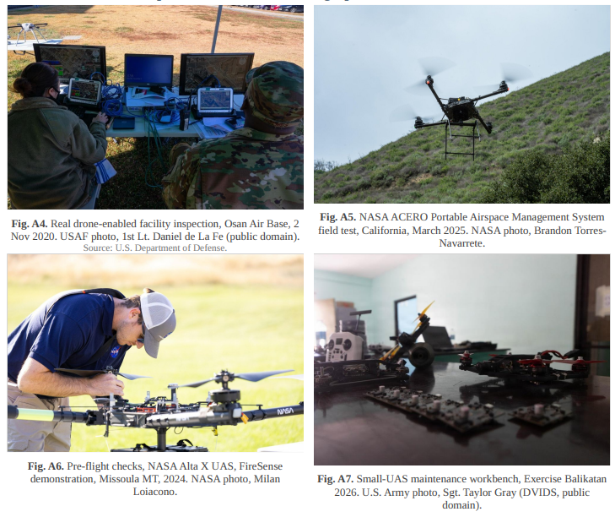

(Fittra) References

- F. Syaifullah, "Sentinel as an End-to-End Drone Operations System," internal case study, NUS Defense-Tech Venture Lab, 16 Sept. 2026
- F. Syaifullah, "Drone Swarms on the Battlefield: How drone groups move, coordinate and adapt in military operations," internal analysis, 2026
- Sentinel Team, "Sentinel: Coordinated Public-Safety Drone Fleet," pitch deck v1.0, 2026.
- NUS Defense-Tech Venture Lab, "Final Deliverables Guidelines — 3-Month Teams," programme document, 2026.
- MAVLink Developer Guide, "Common Message Set" and "Heartbeat/Connection Protocol," mavlink.io.
- PX4 Autopilot, "ROS 2 User Guide" and "uXRCE-DDS Middleware," docs.px4.io.
- NATO Science & Technology Organization, "STANAG 4586, Standard Interfaces of UAV Control System (UCS) for NATO UAV Interoperability."
- Civil Aviation Authority of Singapore, "Unmanned Aircraft Requirements," caas.gov.sg/unmanned-aircraft.
- Singapore Civil Defence Force, "Operational Standby for National Day Parade 2021" and "Leveraging Robotics in SCDF," scdf.gov.sg.
- NASA Ames Research Center, "NASA Demonstrates New Wildland Fire Airspace Management System," 25 Mar. 2025.
- NASA Ames Research Center, "NASA Tests Drones to Provide Micrometeorology, Aid in Fire Response," 13 Feb. 2025.
- U.S. Air Force, "Mongrels Find Air Space with Unmanned Roof Inspections," Osan Air Base, 2 Nov. 2020.
- DVIDS, "Balikatan 2026 Drone Maintenance," 17 Apr. 2026.
- DARPA, "OFFensive Swarm-Enabled Tactics (OFFSET)" programme materials and field-experiment imagery.
- United Nations Security Council, "Panel of Experts on Libya," S/2021/229, 2021.
- Congressional Research Service, "Saudi Oil Facility Attacks," 2019.
- Reuters, "Ukraine's AI-enabled war drones," reporting on Swarmer Ltd.
- Business Insider, "Ukraine burned nearly [millions] battling Russian missiles in one night," 2026.
- Liga.net, "Zelensky: the work of the air force on the Shahed is unsatisfactory," 2026.
- https://www.businessinsider.com/ukraine-pay-per-kill-shahed-drone-interceptor-mykhailo-fedorov-2026-1
- https://www.reuters.com/business/aerospace-defense/private-air-defence-takes-off-ukraine-2026-04-29/
- https://www.businessinsider.com/ukraine-burned-nearly-millions-battling-russian-missiles-one-night-2026-1

