John Czarnek

08/15/2021

IT FDN 110 B Foundations of Programming Python

Assignment 06

Assignment 6

# Introduction

This assignment was about using functions to modifying an existing CD inventory program written by someone else. The functions were to be to replace code identified by TODO statements. The modifications involved defining functions using code that was already in the program, and then calling the function. Examples of these modifications are moving IO code asking user for ID, title and artist for a CD into a function, then calling it when appropriate, creating and calling a function for deleting a CD, deleting a CD, and writing CD data to a file.

# Learning

For this assignment, I read a book chapter, watched videos, and read webpages and documents on my computer. The key thing I learned about was functions, which are a way to organize code into blocks and sometimes to which parameters can be passed and returned. Functions are helpful in order to reduce code duplication, make code reusable in the same script, and to help make code more readable. It can also make modifying code easier, since changes inside a function only have to be made once, as opposed in multiple places if the same thing was done without a function. I worked the examples show in the module documentation and then applied these concepts when modifying the program.

The assignment also introduced classes, and classes were incorporated in the code in a superficial way. Other topics introduced were variable scope and DocString, which is a type of comments added to the first line of the function definition, where useful information about what the function does and what the arguments and return values are.

# Running the Script in Spyder

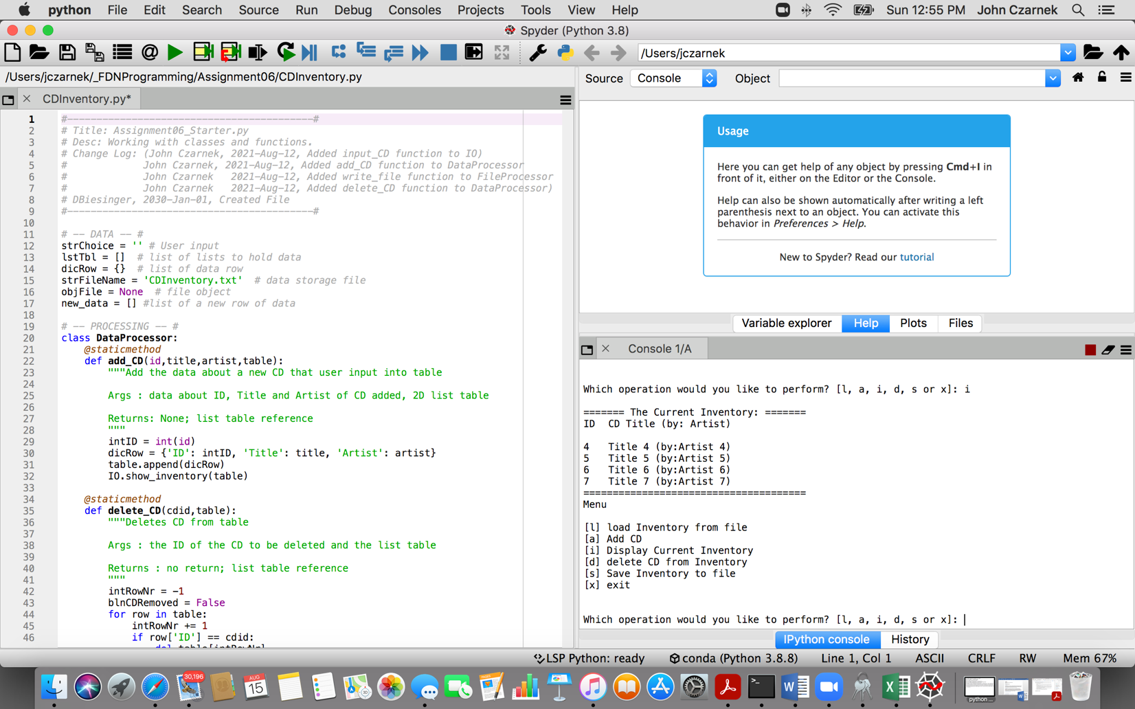

Figure 1- Script running in Spyder

# Running the Script from a Terminal Window

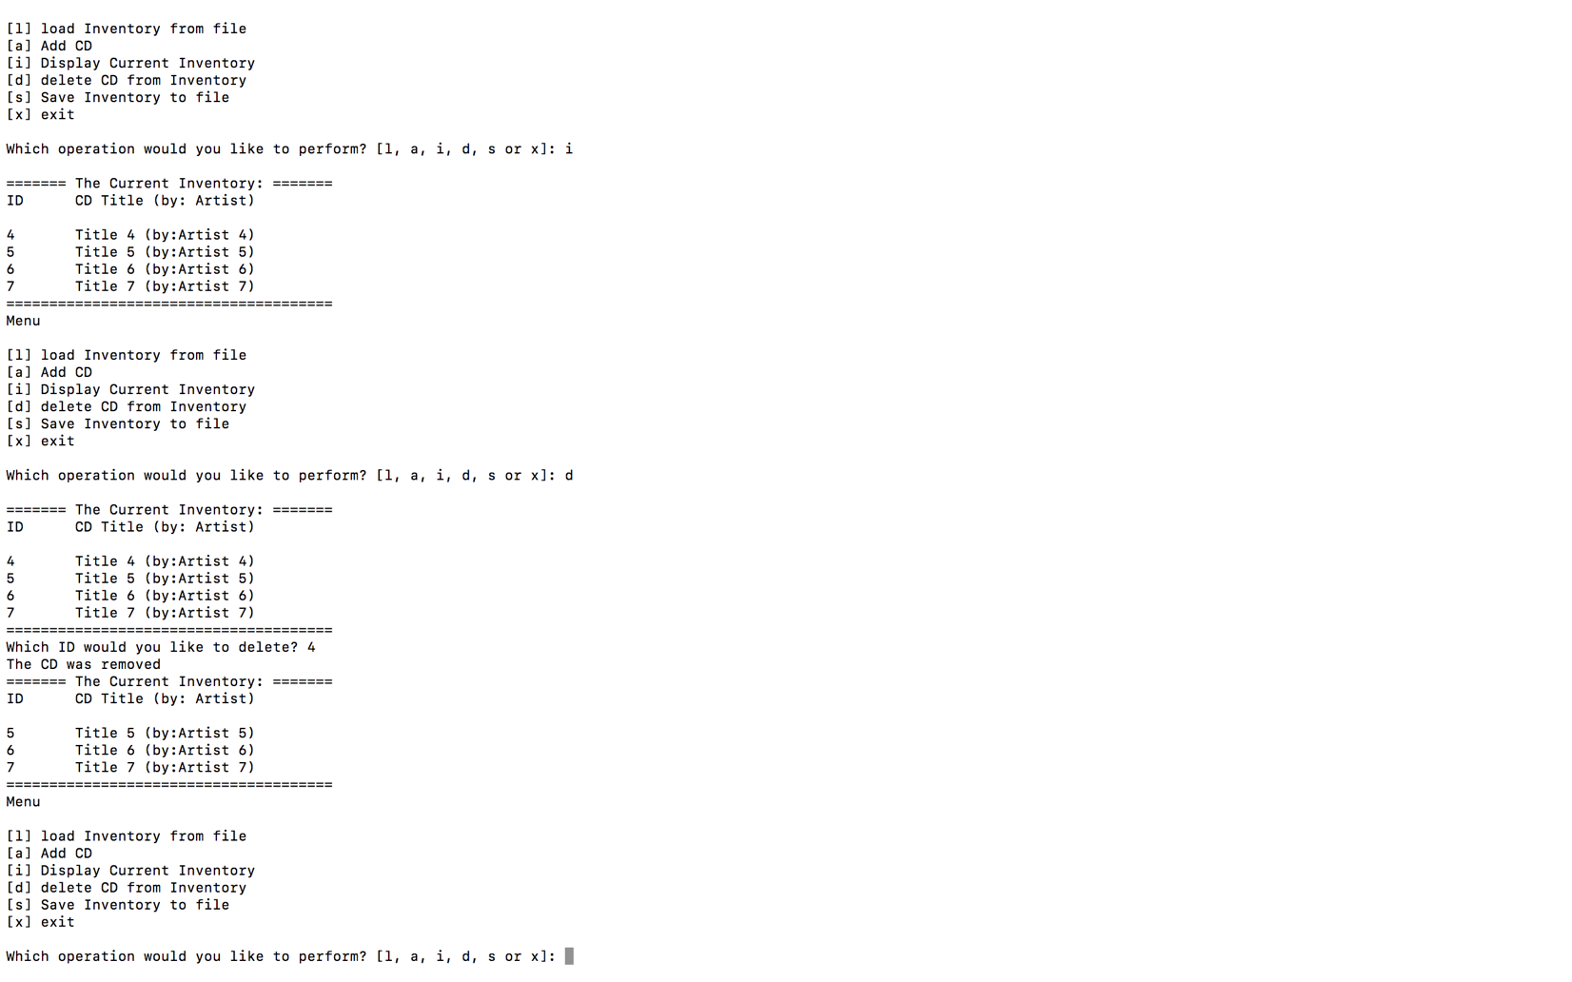

Figure 2 - Script in Terminal Window

# Summary

Functions are relatively easy to use in Python. I spent some time learning about and trying to be consistent with naming convention – tending towards the Python standard of lowercase with underscores between words. One thing I kept doing and correcting myself was naming the attributes in the function definition the same as in the function call. I spent quite a bit of time experimenting with different ways of utilizing functions, and this shows in the functions that I created. For instance, in add_CD, multiple attributes are passed to the function but there is no return, rather the table is a reference type attribute. In input_CD, nothing is passed to the function – it gets data from the user and then returns a choice.

The classes DataProcessor, FileProcessor and IO didn’t seem to do anything in this program, but I suppose that is one way to introduce us to class. I added DocStrings to the functions I created and tried to emulate the usage in the functions that were in the starter script.

.