**Juliane Rebecca S. Dayandante BSIT -3C**

**Web Development**

**Documentation**

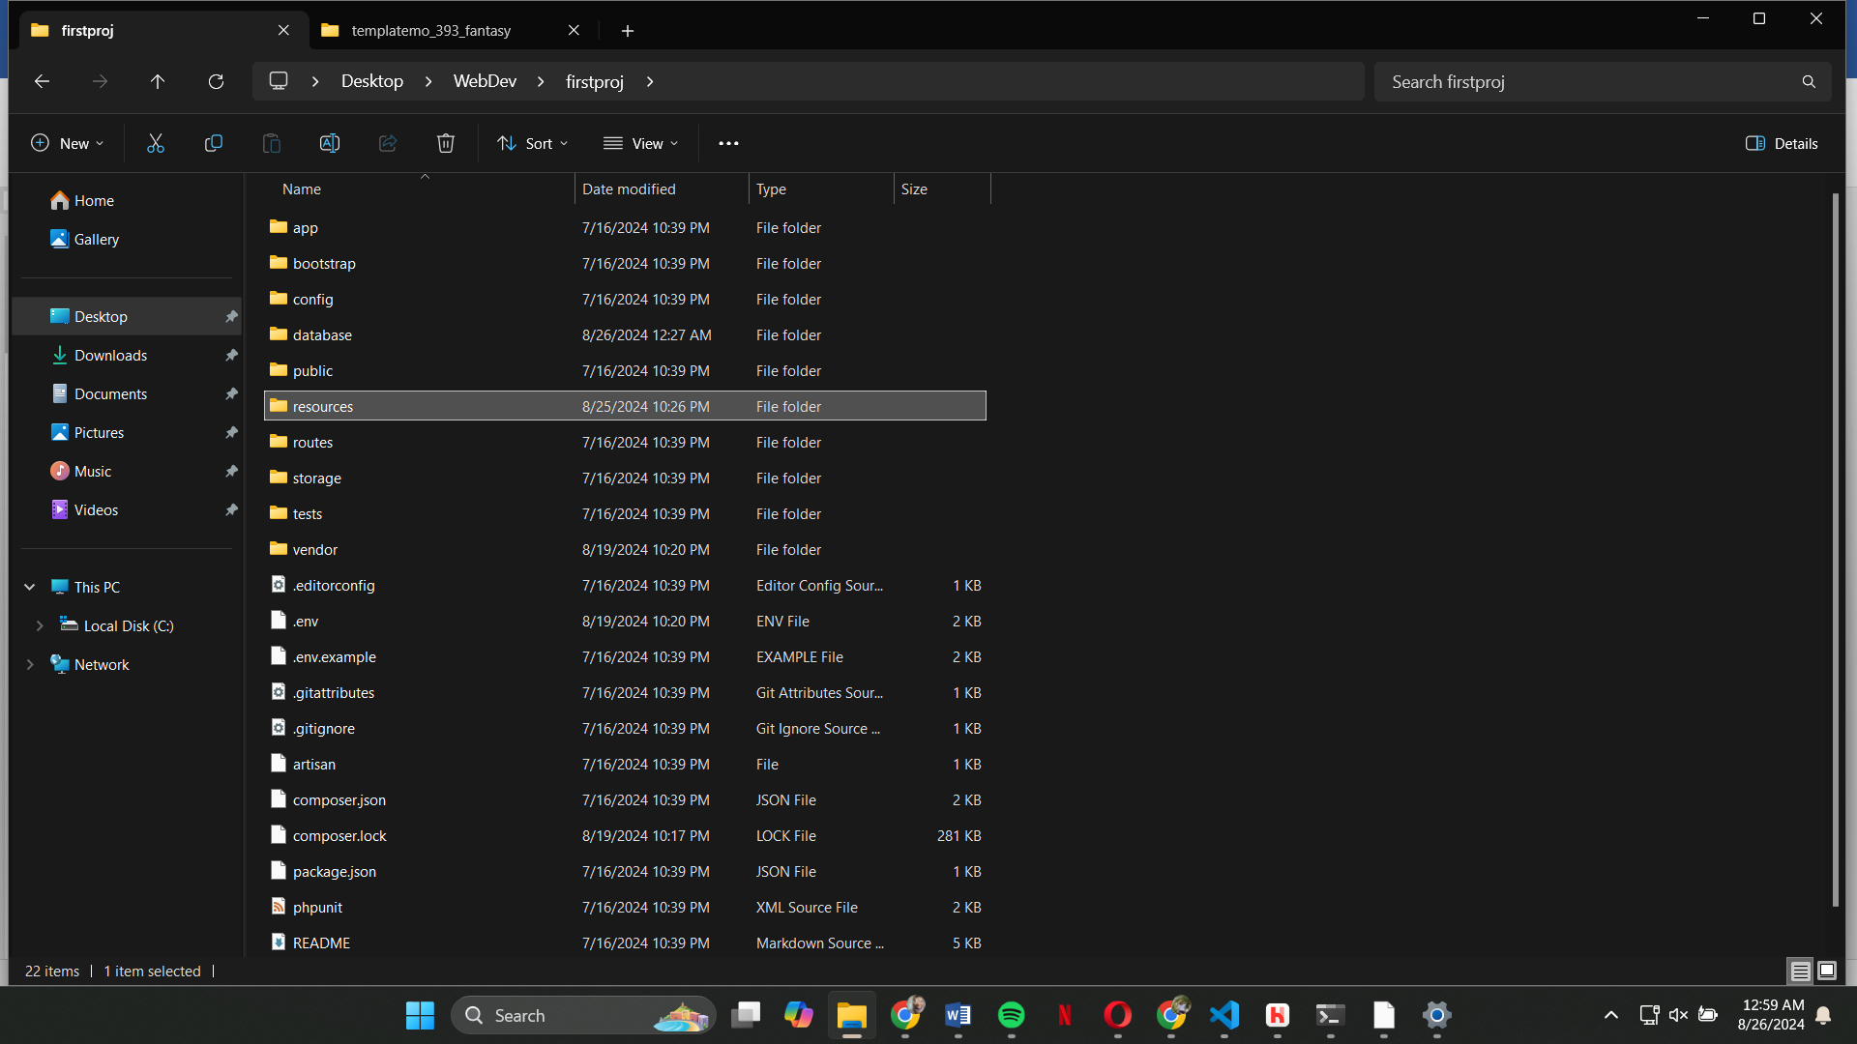**Key Directories and Files**

Contains the core application code including models, controllers, and services

Contains configuration files for various aspects of the application, like database settings, mail configuration, and app-specific settings.

Contains files for bootstrapping the Laravel framework, such as the application startup script and cache files.

Holds database migrations, seeders, and factories.

Entry point for the application (index.php), assets like CSS, JavaScript, and images. This is the directory served by the web server.

Contains views, raw assets (like SCSS or JavaScript), and language files.

Route definitions for the application.

Used for storing logs, cached files, and file uploads.

Test cases for the application.

Contains third-party packages installed via Composer.

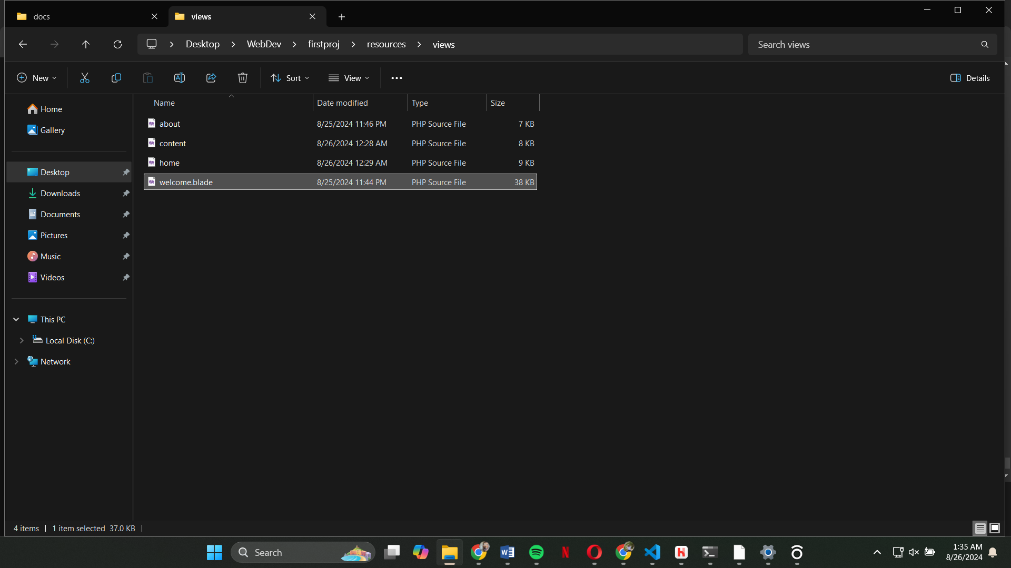

This is a Blade template file, which is a part of the view layer. The provided HTML is here.

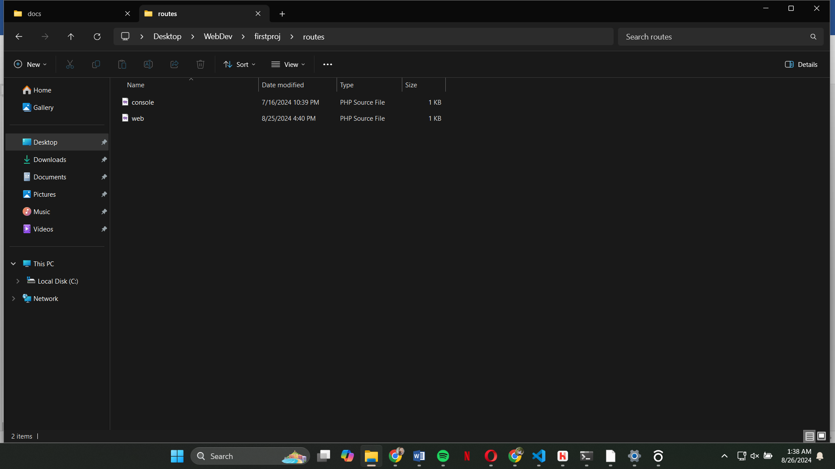

Contains route definitions for web requests.

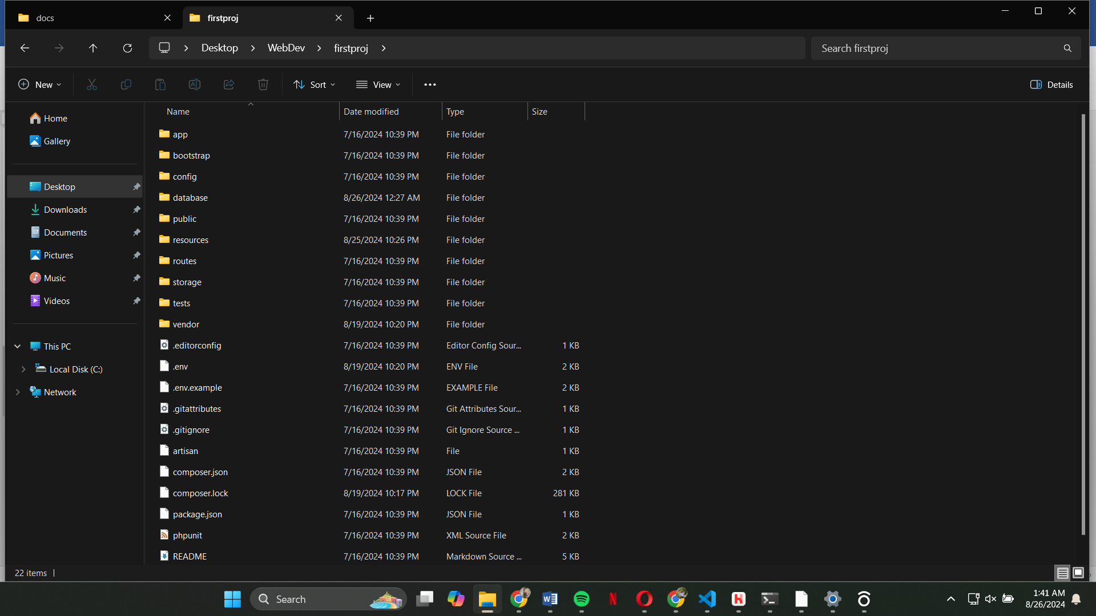

Contains environment-specific configuration values.

**Installation**

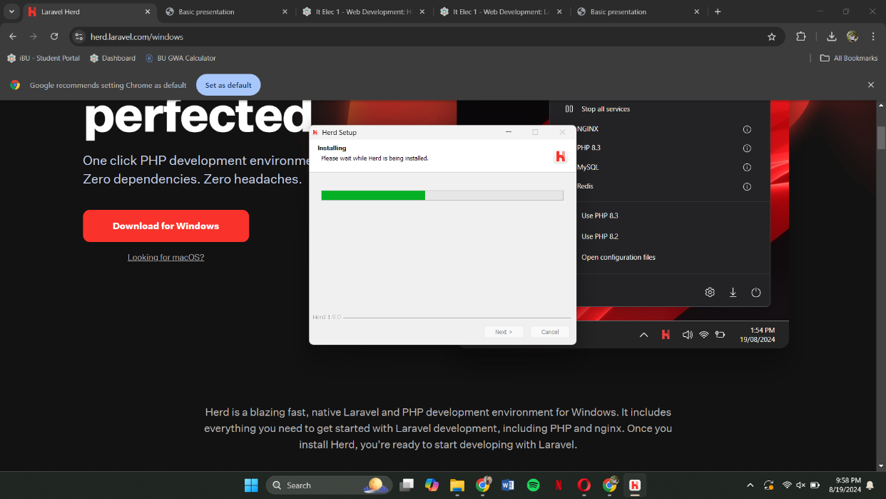

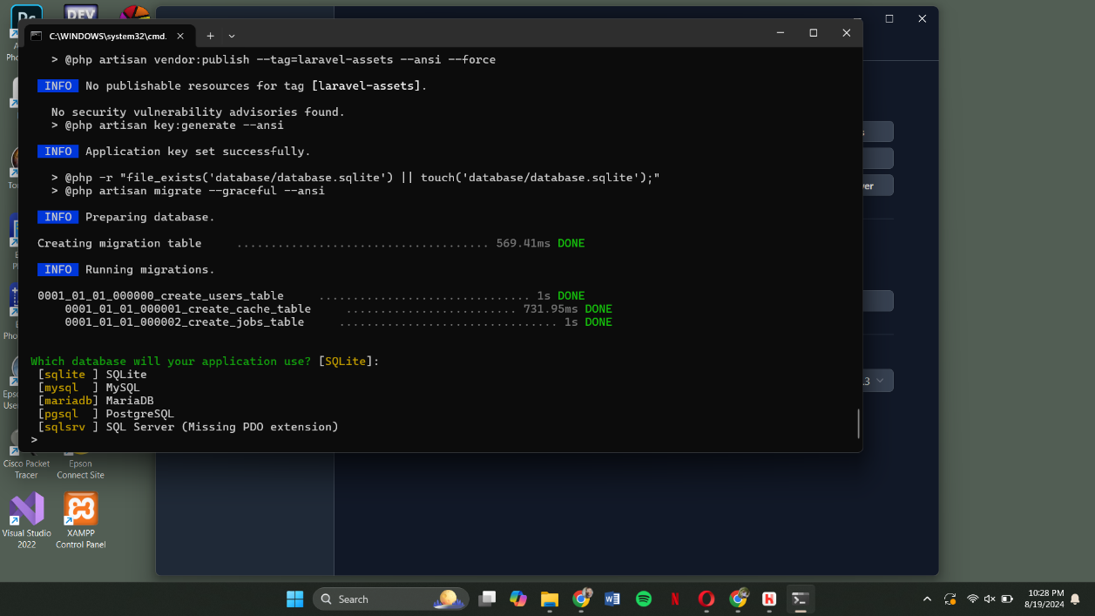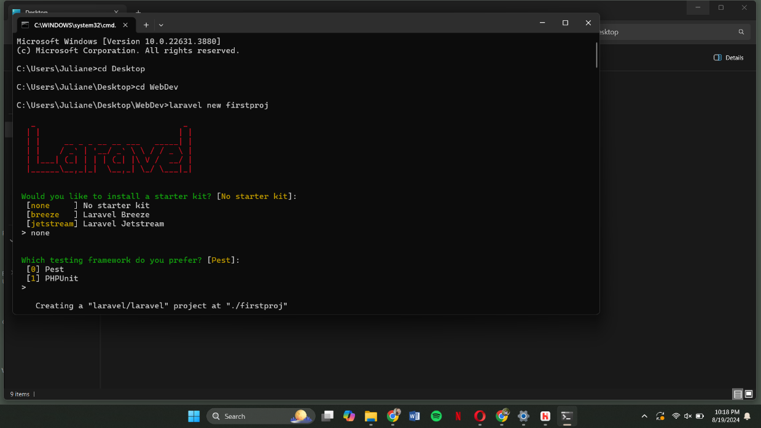**Creating a Laravel Project**

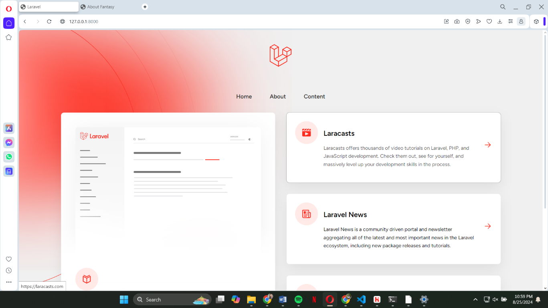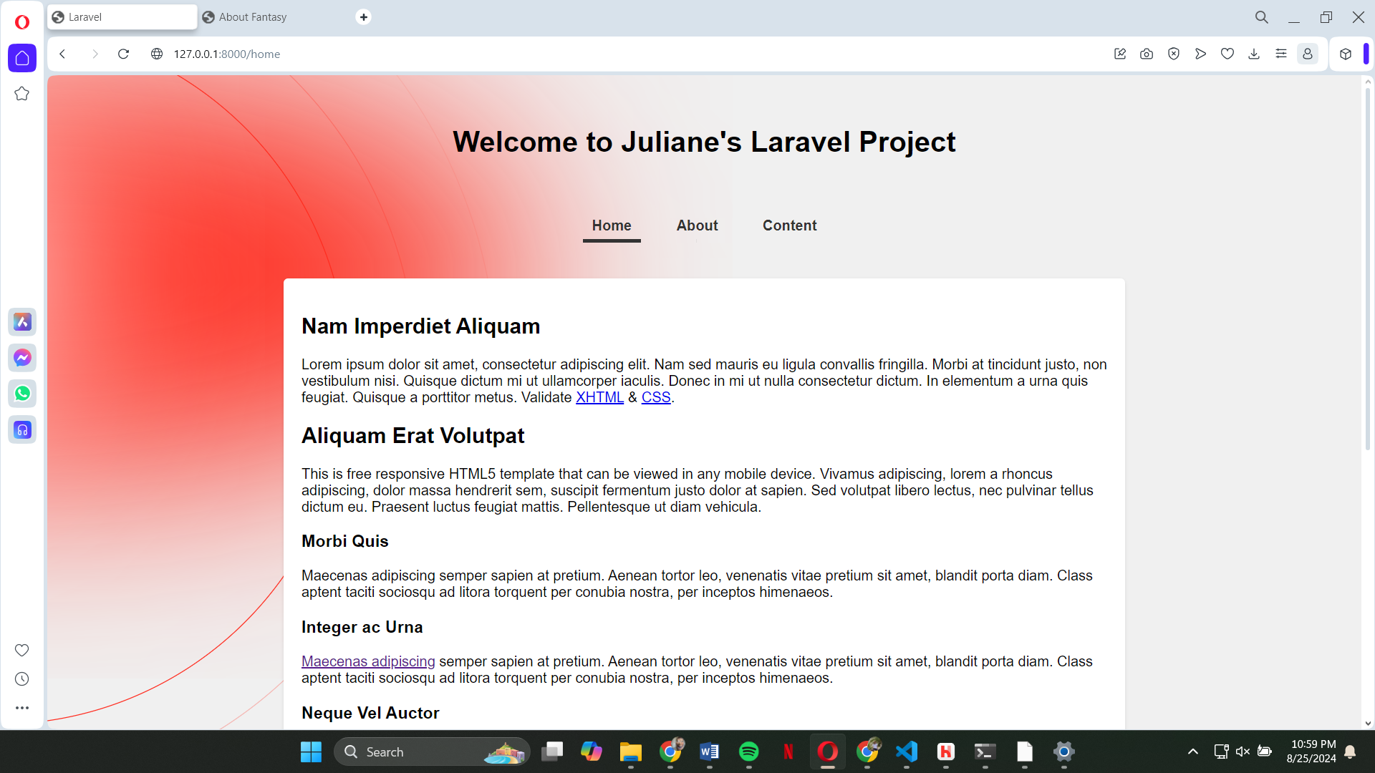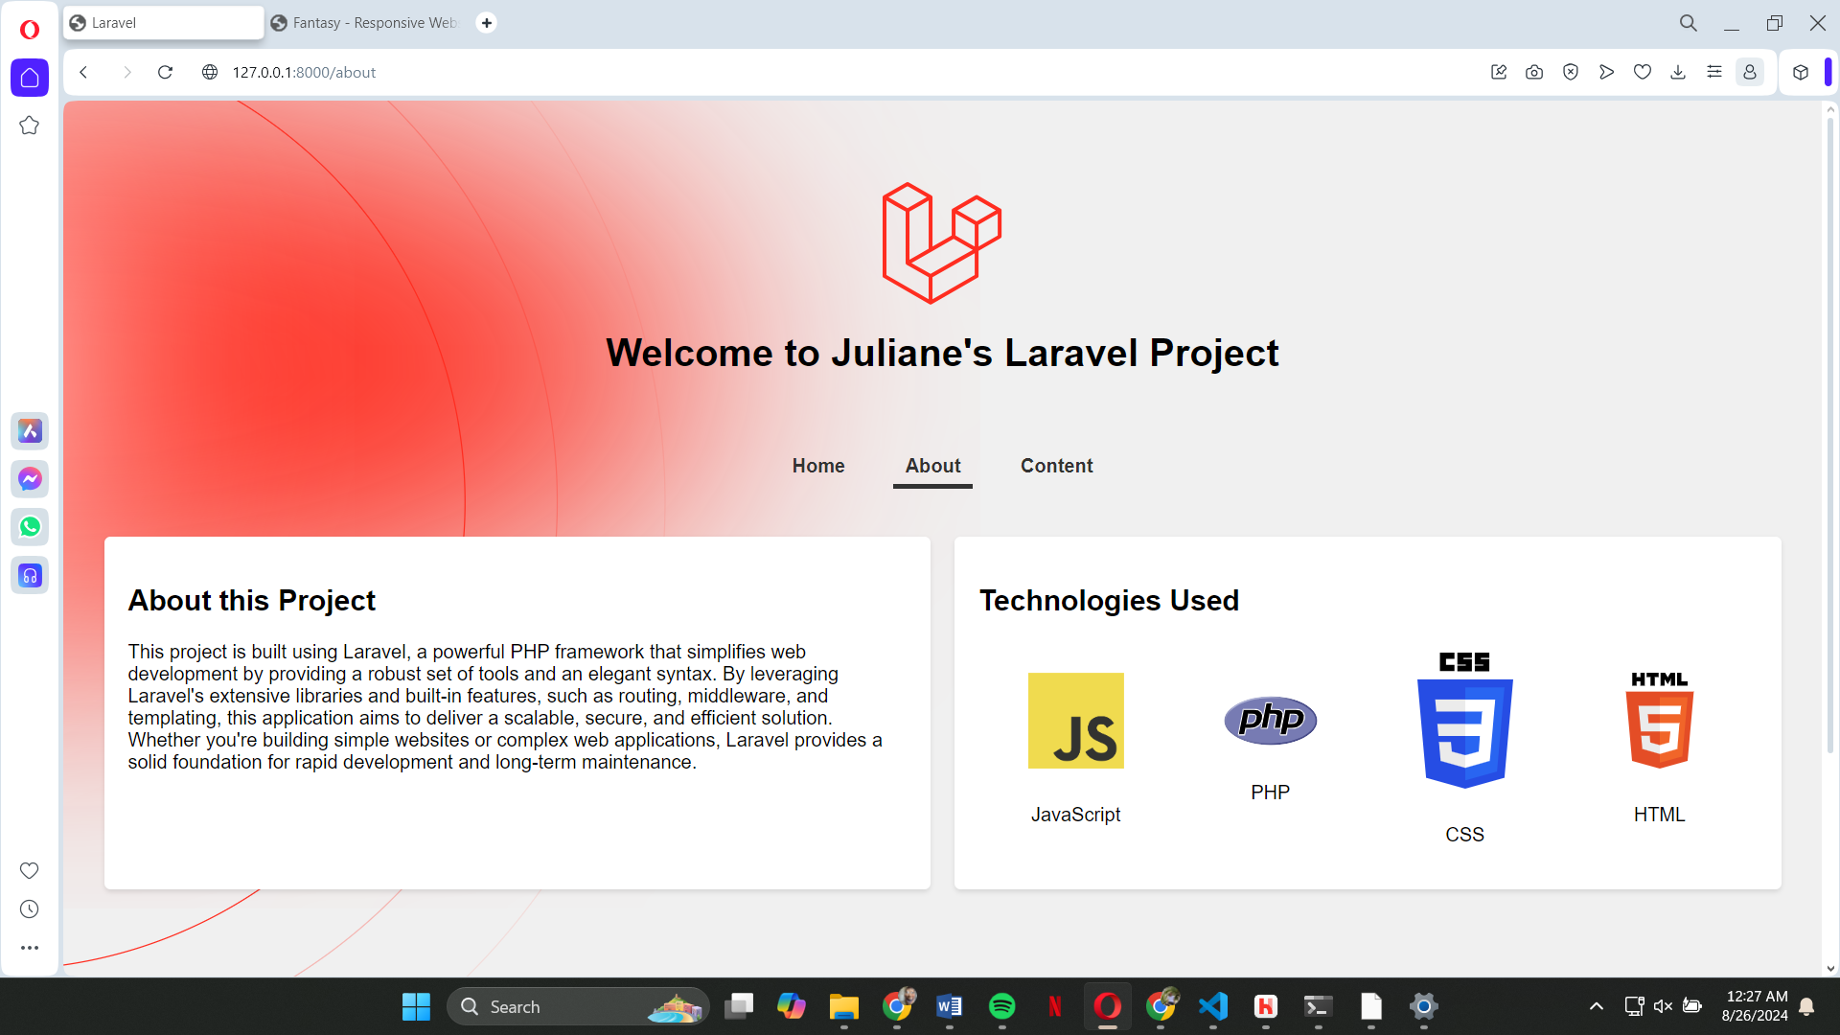**Pages**

