**Juliane Rebecca S. Dayandante**

**BSIT – 3C**

**Web Development**

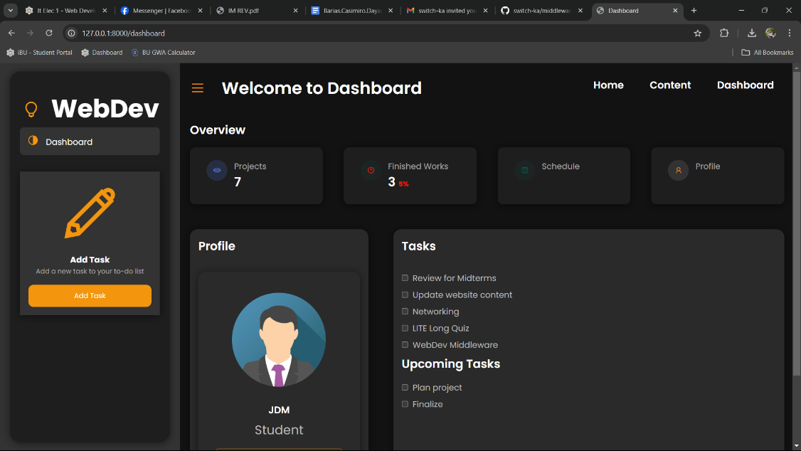

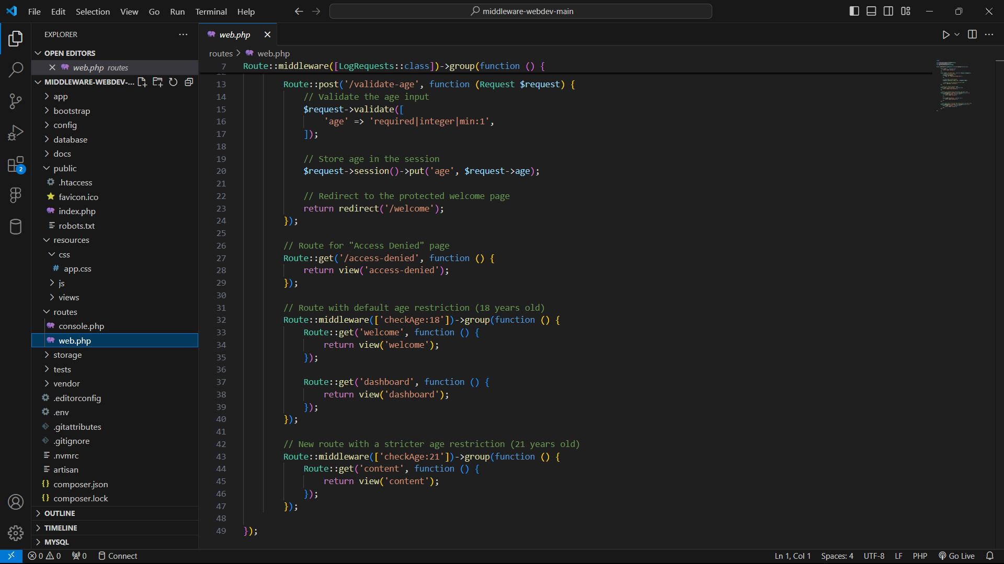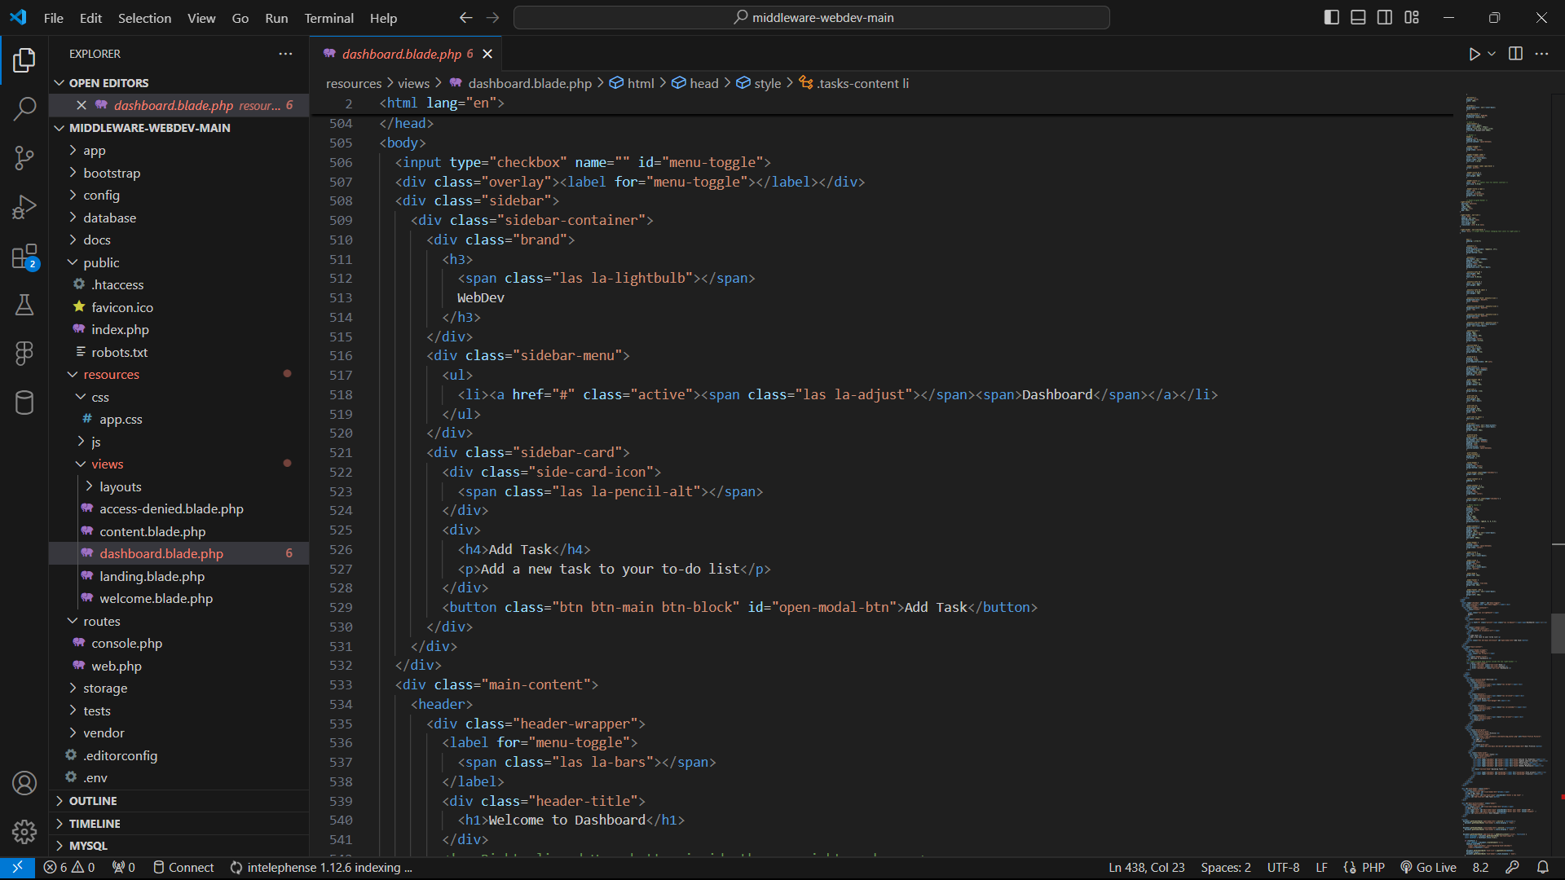

***web.php***

This is the routes with middleware to validate user age and control access. The system handles age verification on form submission and restricts access to specific pages based on age thresholds (18+ for welcome and dashboard, 21+ for content). The middleware LogRequests is applied to log all requests in this group.

***dashboard.php***

I was assigned to design and develop the dashboard interface in this task. It features a sidebar for navigation, a section for displaying task and project overviews, and modals for adding new tasks and editing profile details. I implemented dynamic task management using JavaScript.

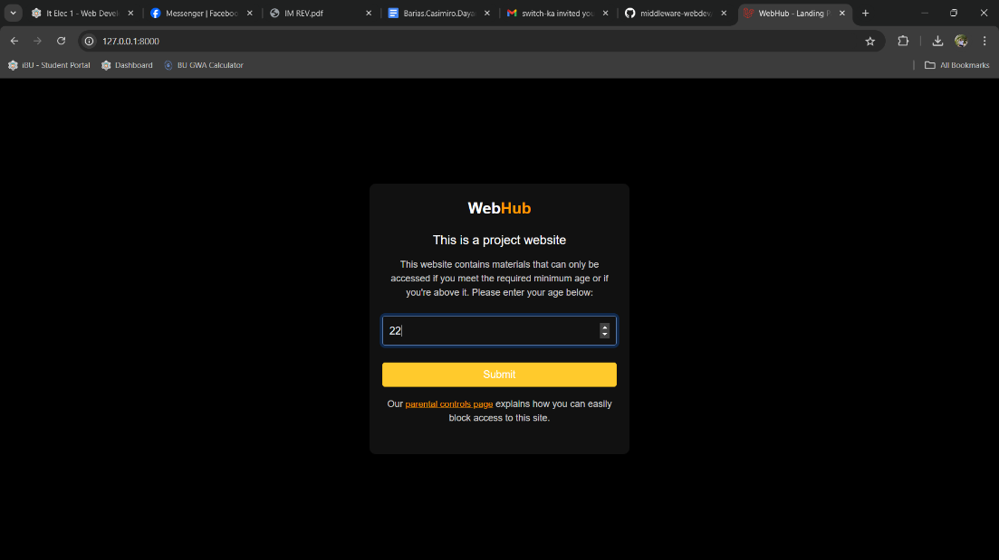

***landing.blade.php***

This page provides an age verification form for users to access restricted content. It features a "WebHub" logo, a brief description, and a form where users can input their age. The form uses Laravel's CSRF token for security and submits the data for validation. Additionally, there's a link to a "parental controls" page, allowing users to manage access

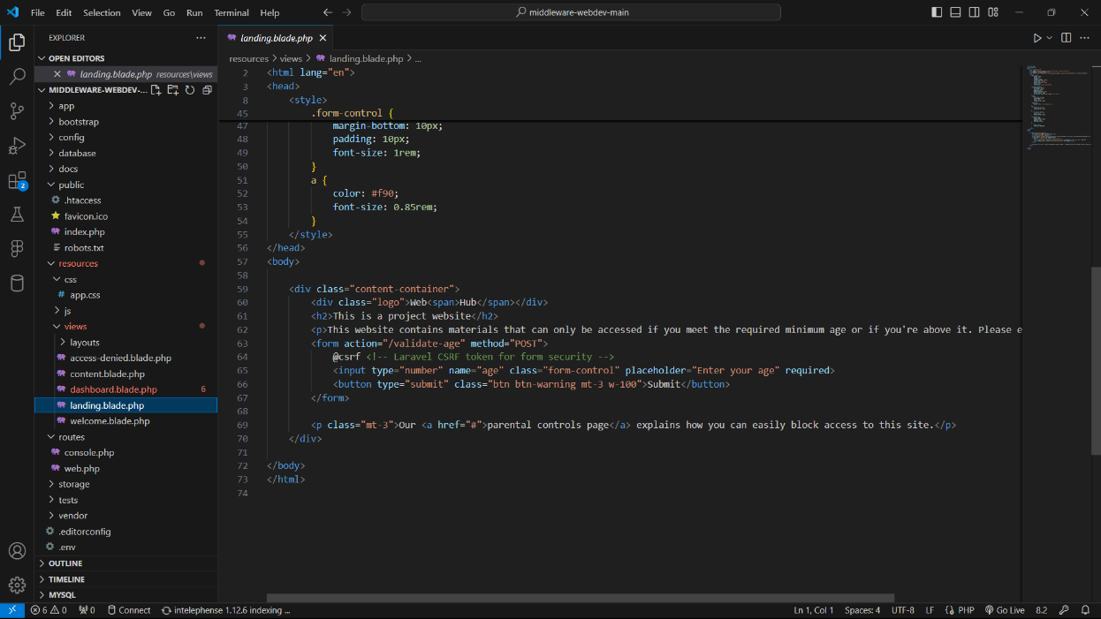

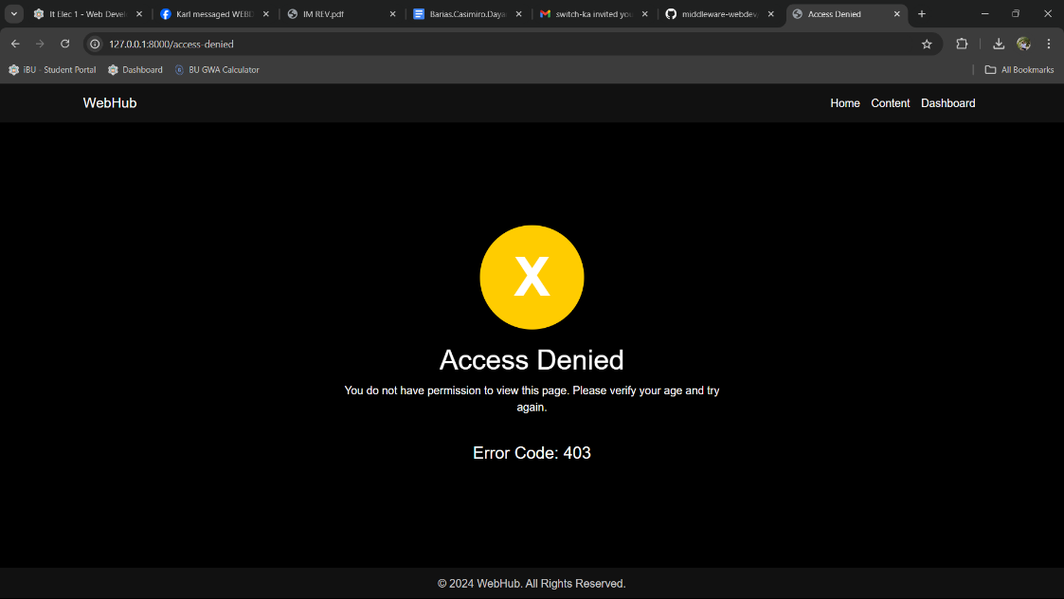

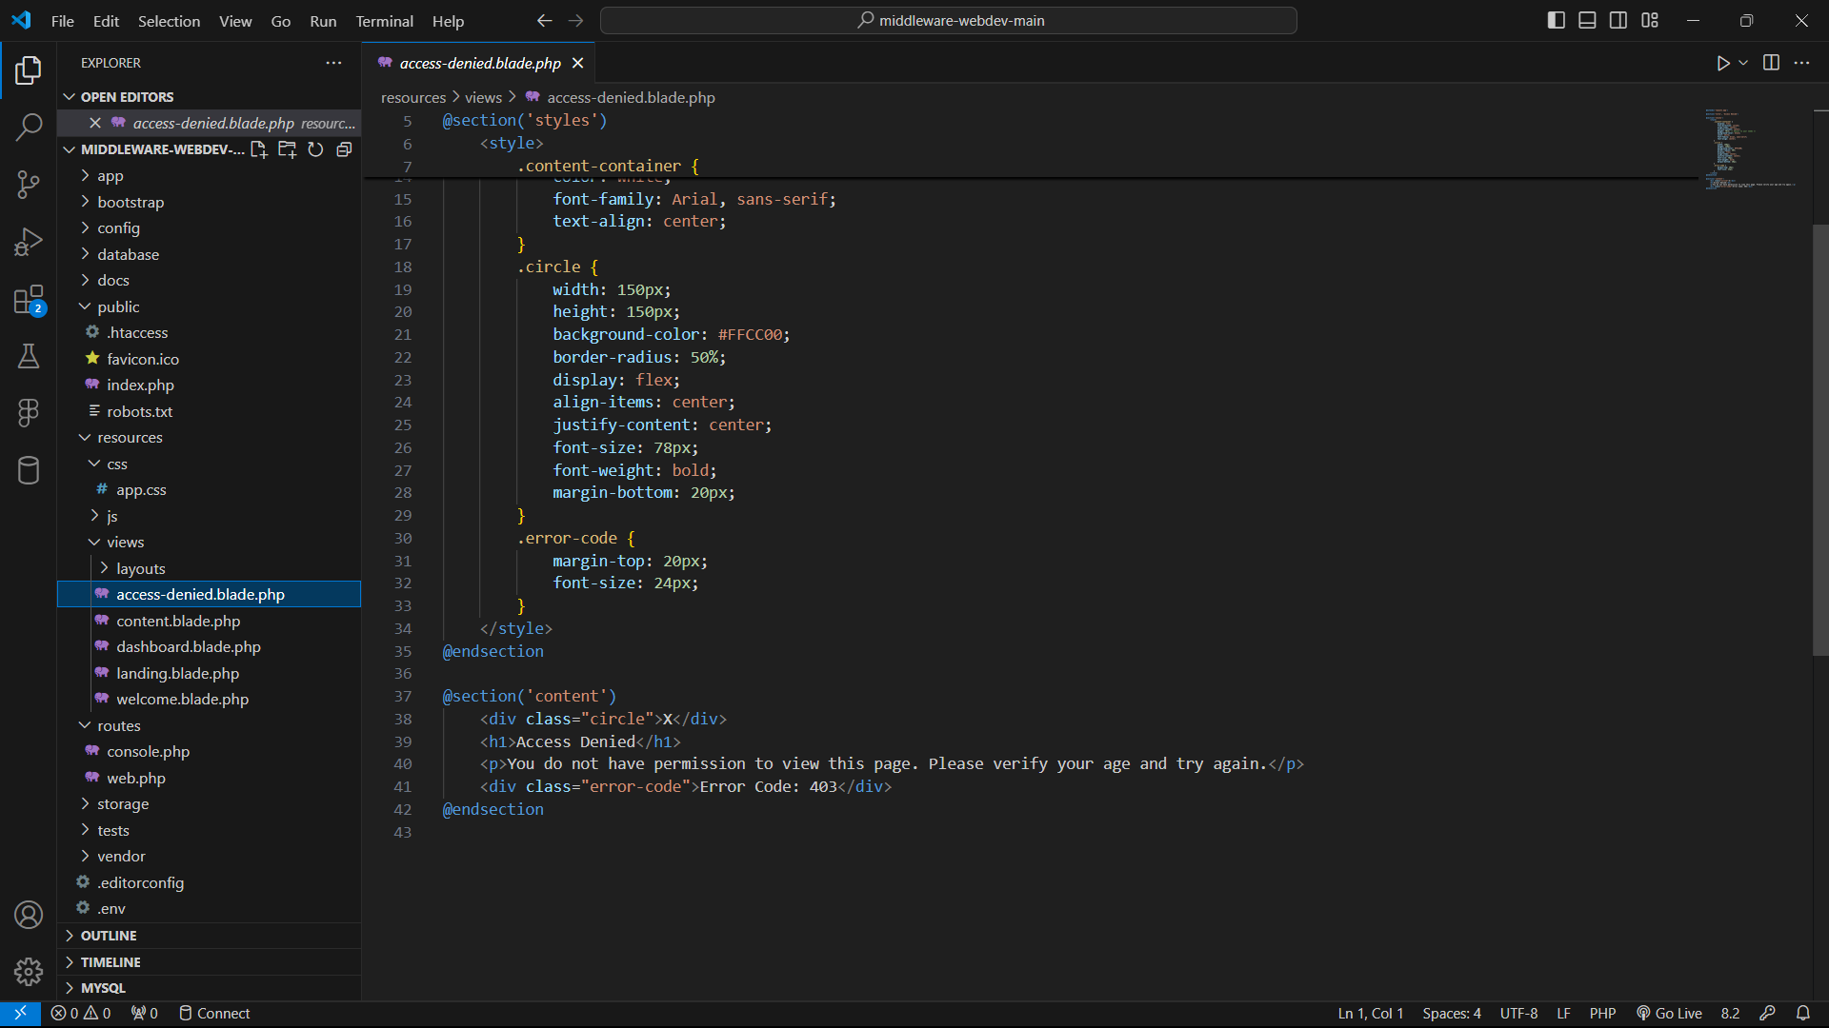

***access-denied.blade.php***

This section displays an "Access Denied" page for users who don’t meet the required age. It shows an "X" symbol, the title "Access Denied," and a message explaining that the user doesn’t have permission to view the page. It also includes an error code "403" to indicate a forbidden access error.

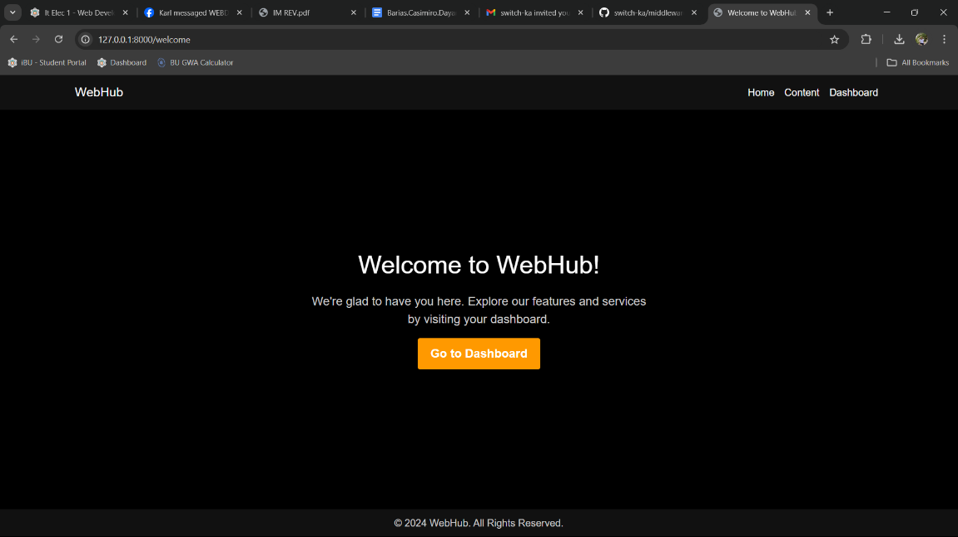

***welcome.blade.php***

After successfully entering the required age, users are redirected to this "Welcome to WebHub" page. It greets the user with a welcome message and provides a brief introduction to the site's features and services. There's also a button that directs users to their dashboard, allowing them to explore further.

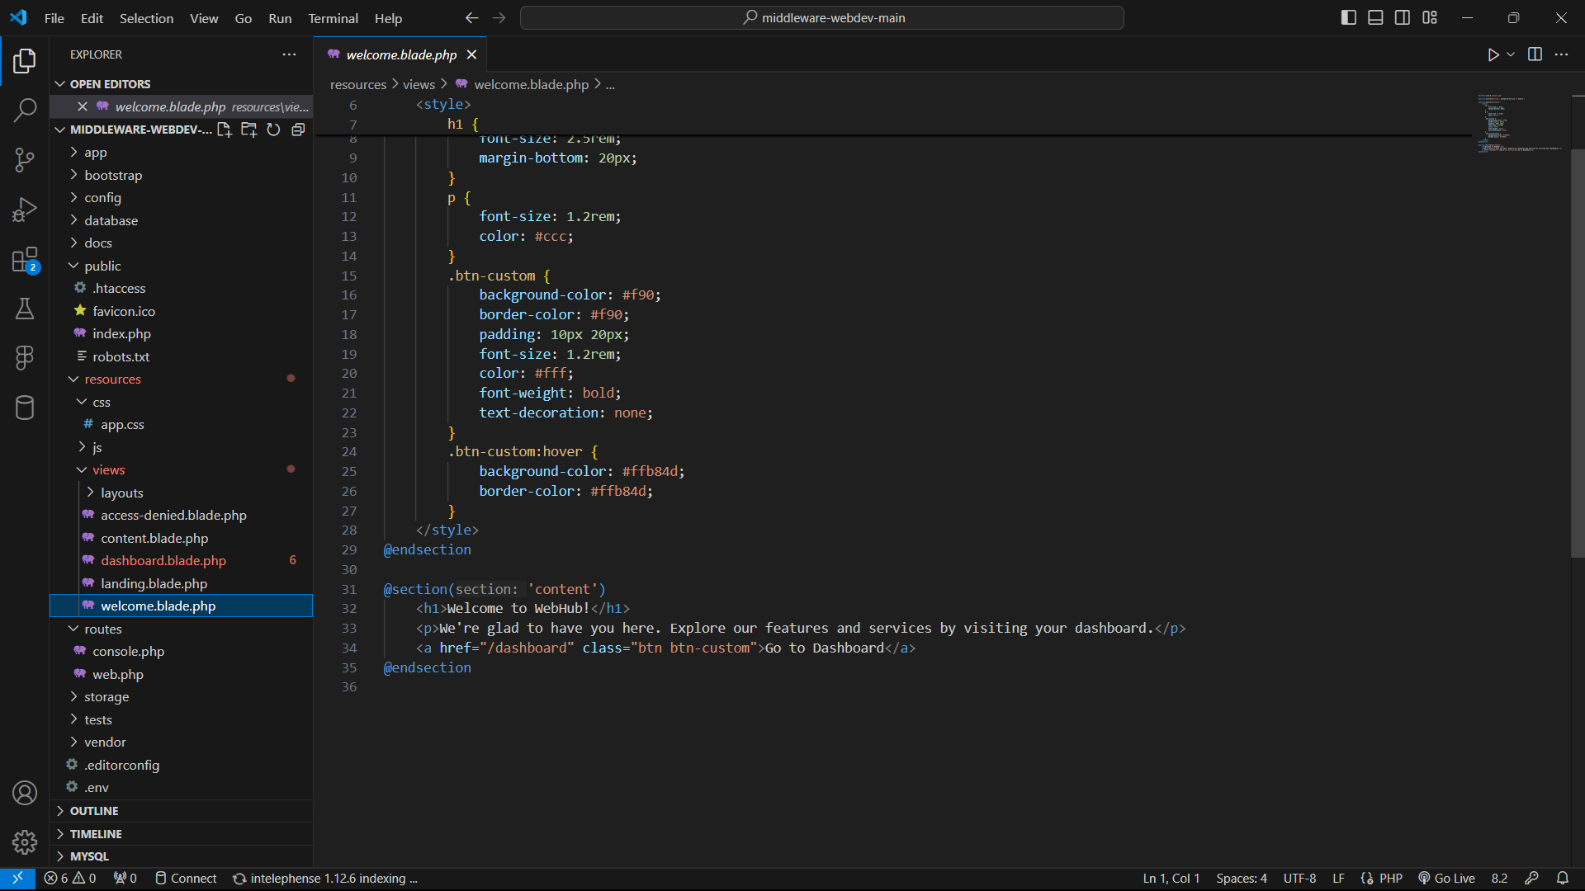

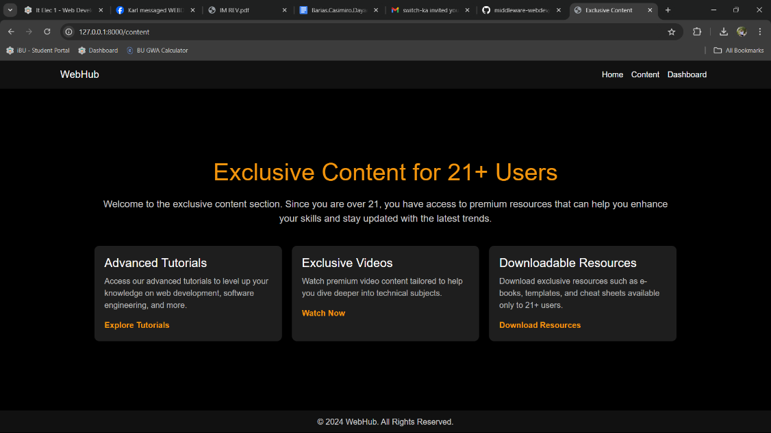

***content.blade.php***

This section is exclusively for users who are 21 years old and above. It features premium content, including advanced tutorials, exclusive videos, and downloadable resources designed to enhance technical skills. If a user is only 18, they will receive an "Access Denied" message when attempting to view this page but can still access the "Welcome" page.

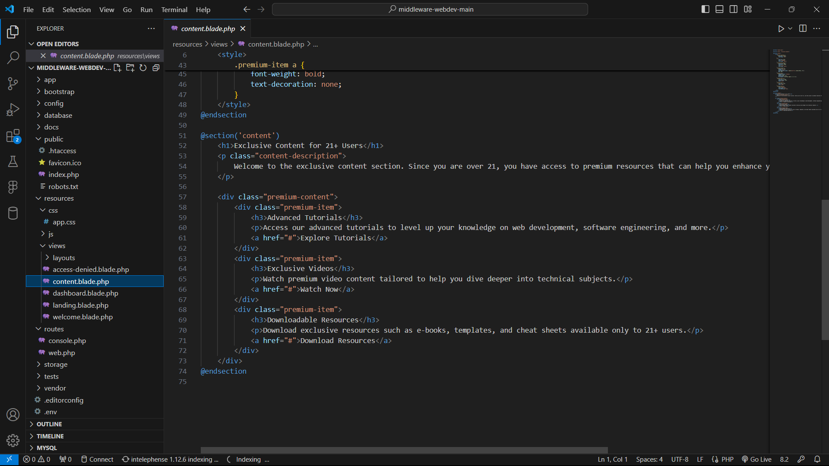

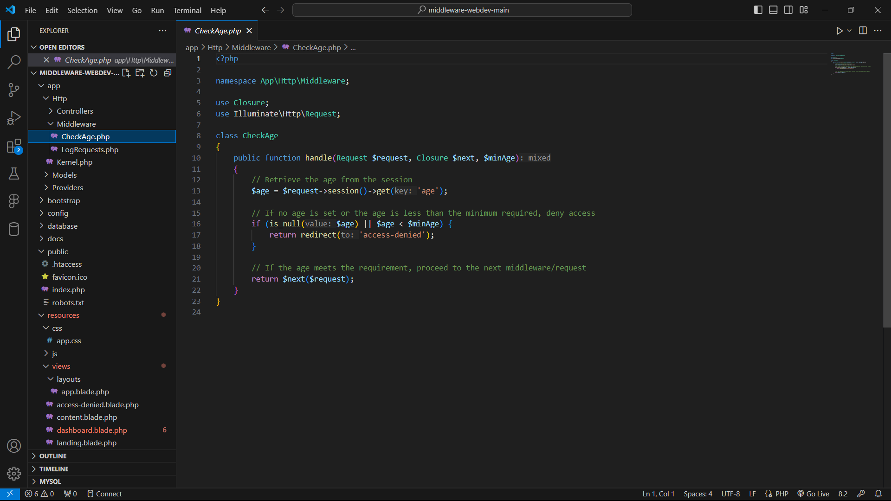

***CheckAge.php***

This code defines the CheckAge middleware in a Laravel application, which uses a parameter to enforce age restrictions. The *handle* method takes a $minAge parameter, allowing routes to specify the minimum required age for access. It checks the user's age from the session; if the age is not set or is below the specified minimum, the user is redirected to an "Access Denied" page. If the age requirement is met, the request continues to the welcome page.

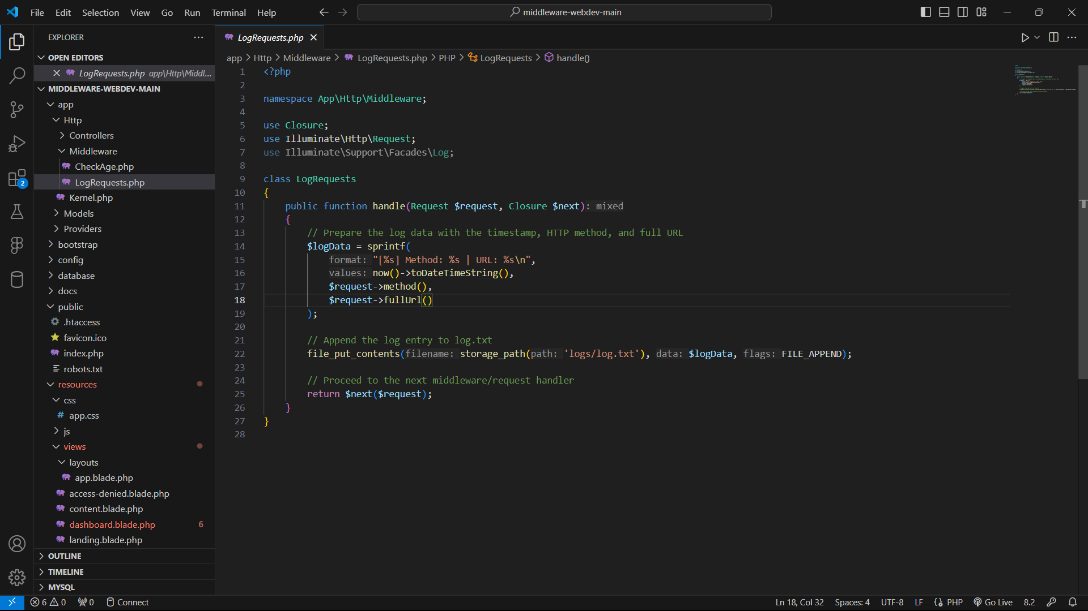

***LogRequests.php***

The LogRequests middleware logs details of incoming HTTP requests, including the timestamp, HTTP method, and URL. It saves this information in a log.txt file in the storage/logs directory. After logging the request, it allows the application to continue processing normally.