Note: Advanced String Slicing
You've seen in lecture that you can slice a string with a call such as s[i:j], which gives you a portion of string s from index i to index j-1. However this is not the only way to slice a string! If you omit the starting index, Python will assume that you wish to start your slice at index 0. If you omit the ending index, Python will assume you wish to end your slice at the end of the string. Check out this session with the Python shell:
>>> s = 'Python is Fun!'
>>> s[1:5]
'ytho'
>>> s[:5]
'Pytho'
>>> s[1:]
'ython is Fun!'
>>> s[:]
'Python is Fun!'
That last example is interesting! If you omit both the start and ending index, you get your original string!
There's one other cool thing you can do with string slicing. You can add a third parameter, k, like this: s[i:j:k]. This gives a slice of the string s from index i to index j-1, with step size k. Check out the following examples:
>>> s = 'Python is Fun!'
>>> s[1:12:2]
'yhni u'
>>> s[1:12:3]
'yoiF'
>>> s[::2]
'Pto sFn'
The last example is similar to the example s[:]. With s[::2], we're asking for the full string s (from index 0 through 13), with a step size of 2 - so we end up with every other character in s. Pretty cool!

Note: The Python 'in' operator
The operators in and not in test for collection membership (a 'collection' refers to a string, list, tuple or dictionary - don't worry, we will cover lists, tuples and dictionaries soon!). The expression
element in coll
evaluates to True if element is a member of the collection coll, and False otherwise.
The expression
element not in col
evaluates to True if element is not a member of the collection coll, and False otherwise.
Note this returns the negation of element in coll - that is, the expression element not in coll is equivalent to the expression not (element in coll).

[Tutorial] Truthy and Falsy values!
discussion posted 9 days ago by Kiara-Elizabeth (Community TA)

Truthy and Falsy Values!

Hi! Welcome to this section. We will discuss Truthy and Falsy values.
Let’s get started!
Sometimes we may find if/elif/else statements like these:
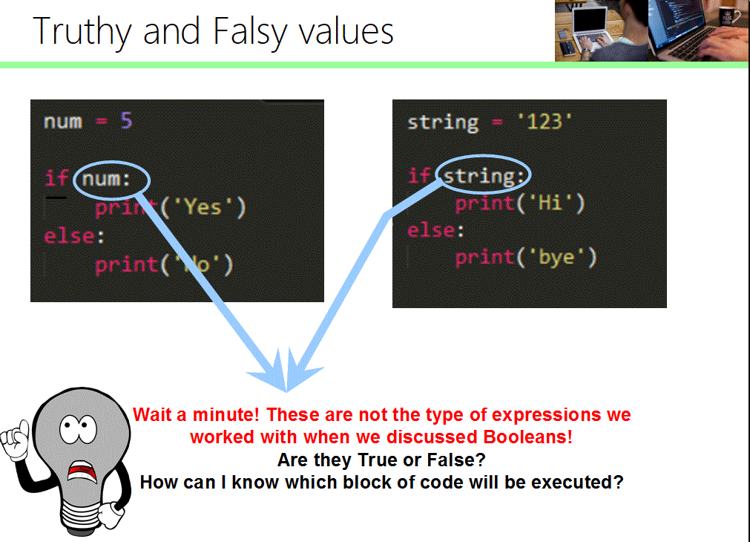
Don’t worry! variables num and string act as Truthy and Falsy values on these examples.
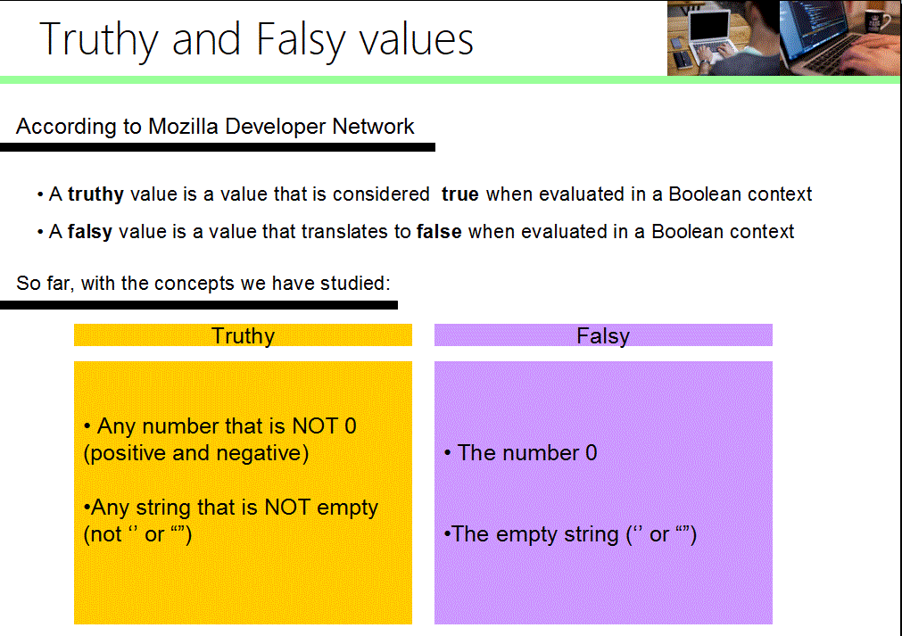

These examples are adapted to what we have learned so far in the course, but in subsequent weeks I will add examples illustrating how data structures that we will study can act as Truthy and Falsy values if they are empty or if they have elements.
NOTE: These concepts was taken from Mozilla Developer Network, the words true and false are NOT capitalized, but you must capitalize them in Python since it’s case sensitive.
Link to Truth Value Testing article in Python Documentation: https://docs.python.org/3/library/stdtypes.html#truth-value-testing

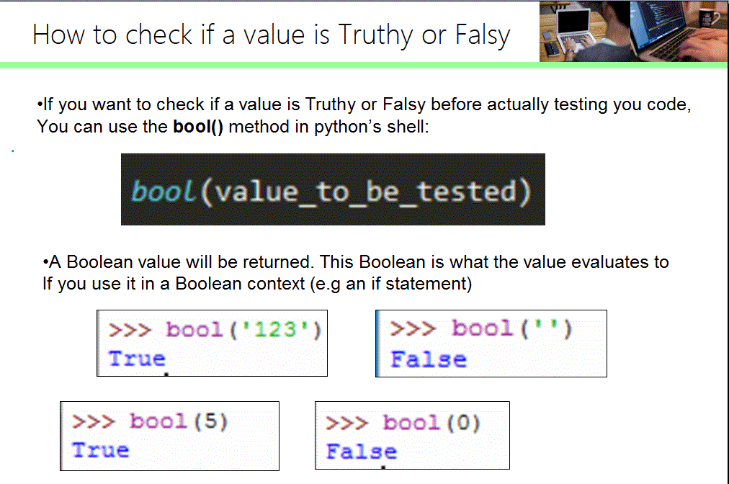

Time to practice!

Here are some examples of how Truthy and Falsy values work in Python’s shell and in a Boolean context (if/elif/else statements and While Loops):

Note: Indentation may look different but this is how its presented when you enter code with several lines directly in Python’s Shell.

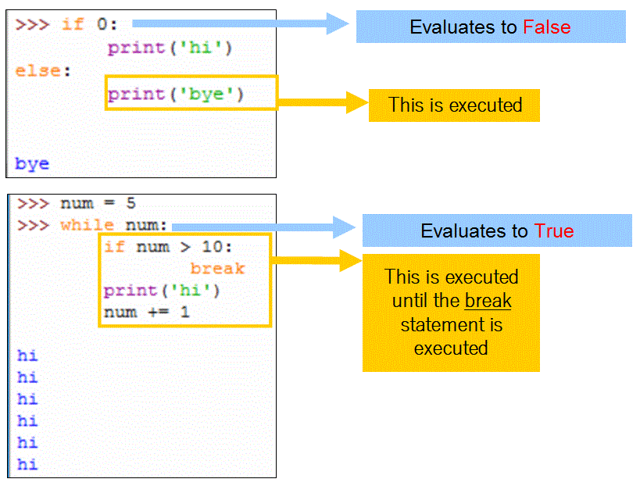
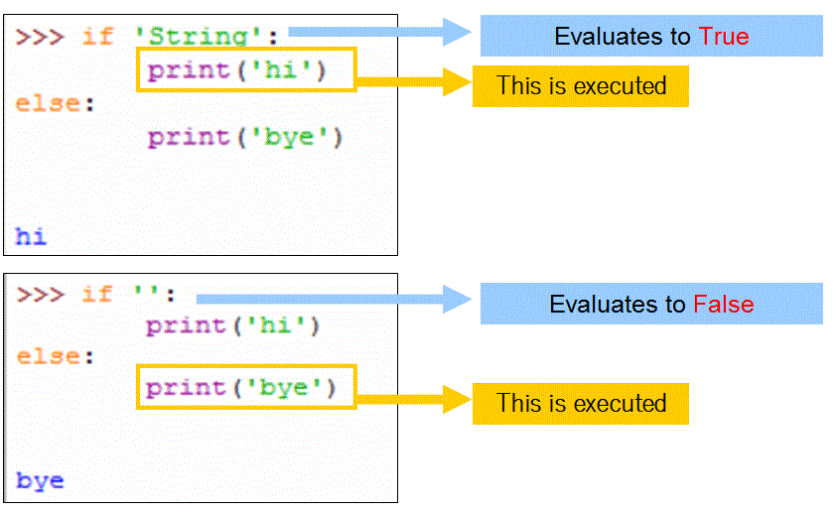

Hope it helps!
If you have any questions, please ask them in the forums or right below this post, your classmates and Community TAs will always be there to help you!

[Tutorial] For loops, While loops and Range Function BEHIND THE SCENES!
discussion posted 10 days ago by Kiara-Elizabeth (Community TA)

Welcome to this section on Loops!

Loops are essential elements in programming. You can build very powerful programs with loops, so let's see how they work behind the scenes, and how range() works, because you will use it in this course and in your future programming projects.
So let's begin!

Let's start with WHILE LOOPS:
In While loops a block of code will be executed for as long as a condition is met. Every time the block of code is executed, the condition will be checked again, and if it evaluates to True, the code inside the loop runs again, otherwise it exits the loop and continues executing the code below it.
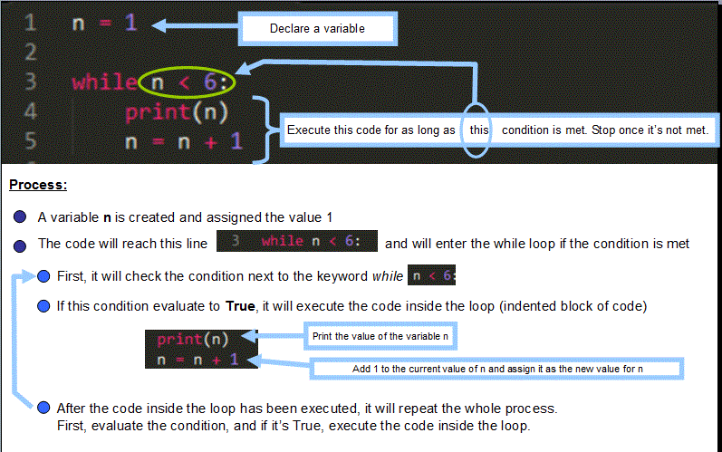
When learning loops, a good strategy is to analyze each step and how values change when the code is executed. In this case, we determine if the code will be executed, the values for the variables involved each time the loop runs and what will be printed on each iteration.
The value of n is updated every time the loop executes. When the condition is checked, the new value of n will determine if the loop runs again or if it stops.
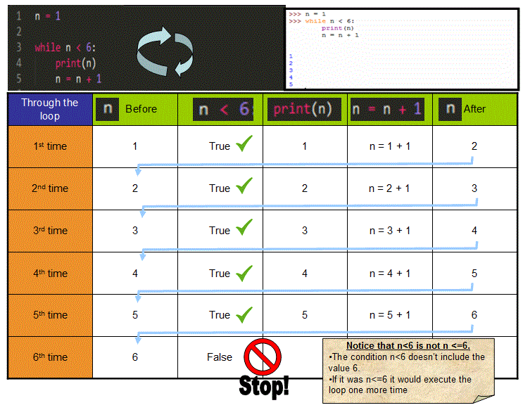

Now let's study FOR LOOPS:
For loops may use the range() function.
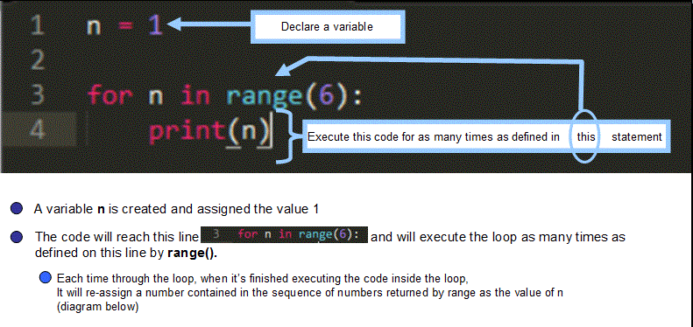
Note: you don't need to declare a variable before a for loop, this was included in the tutorial to illustrate that the value of the variable will be reassigned to the first value provided by range.

The range function
This function returns a series of integers that are determined by the numbers we use inside parentheses ( ).
The general structure of range( ) is range( start, stop, step)
- The start point is the integer from where the sequence will start. (Will be included)
- The stop point is the integer at which the sequence will end (NOT Included)
- The step is the "jump" between one number and the next
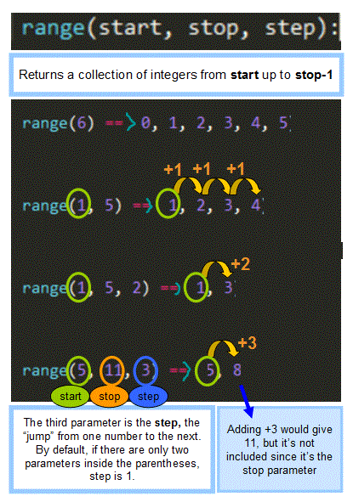
When we execute a for loop with range(), the value of the variable next to the for keyword will be update each time the loop runs, it will be assigned a number in the integer sequence returned by range(). The first time through the loop it will assign the first value in the collection of integers, the second time the second value will be assigned to the variable and so on.
The for loop stops when it reaches the end of the sequence of integers returned by range().
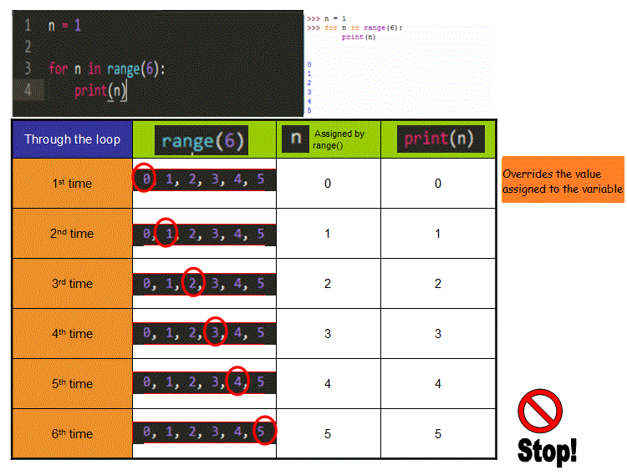
Hope it helps! If you have any questions or comments on this topic, please share them on the forums or right below this topic! You classmates and Community TAs will always be there to help you.
Estefania.

